**APPENDIX A:**

**Snapshots of user interface**

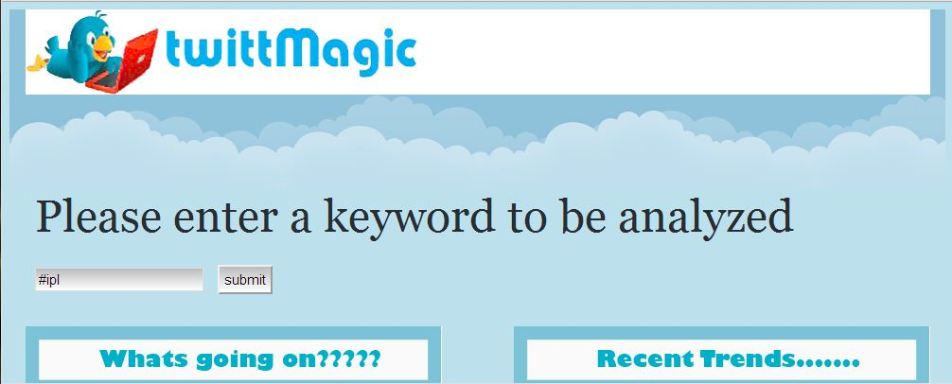

Figure A.1. User Interface to enter query keyword

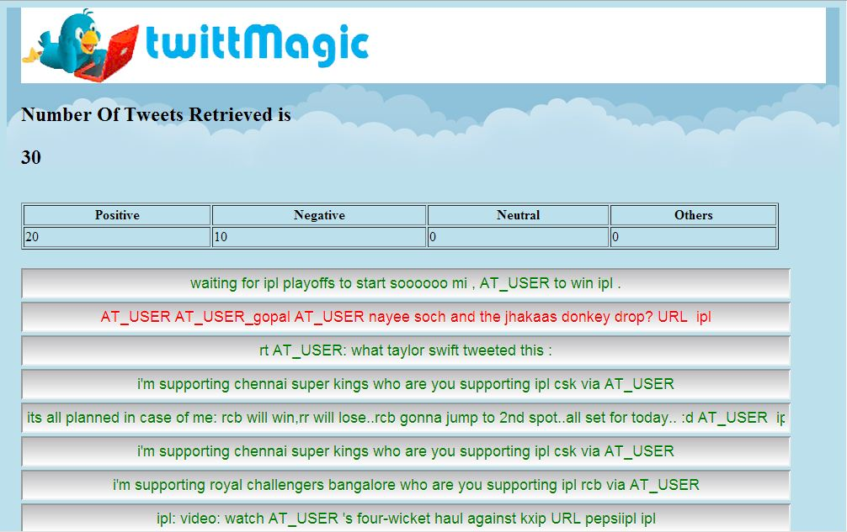

Figure A.2. User interface to show number of tweets retrieved, Classification of tweets and list of tweets .