# Workshop 2

6612054 – Win Yu Maung

6642062 – Thar Lin Htet

Section - 542

1. **TypeScript** – is a programming language used in web developing and it is the advanced version (Superset) of JavaScript because it strongly focuses on typing which JavaScript lack.
2. **Four types of polymorphism are**

Overloading - Same function/operator name with different type definitions,

Parameter coercion - Automatic type conversion for function parameters,

Parametric polymorphism - Functions with type variables that work on any type and

**Subtype Polymorphism -** Functions accept parameters of a type and its subtypes.

1. **Polymorphism supported by TypeScript** – Overloading, Parametric polymorphism, Subtype Polymorphism.
2. **Examples**

* **Overloading**

In this case, function add will be called according to the type of parameter passed.

* **Parametric Polymorphism**

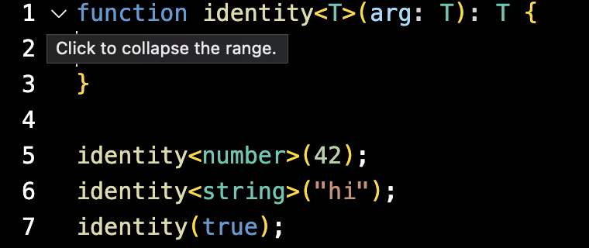

**In this case, identify polymorphism uses generic type T, therefore we can pass multiple**

* **Subtype Polymorphism**

In this case, we can see function of Animal can be called by its sub classes.