Sala Chaturamuk Phaichit Viewer: An Image-Based Rendering Approach to a Thai Pavilion

Win Yu Maung
Vincent Mary School of Engineering, Science and Technology
Suvarnabhumi Campus, Assumption University of Thailand
Samut Prakan, Thailand
u6612054@au.edu
Myat Bhone Thet
Vincent Mary School of Engineering, Science and Technology
Suvarnabhumi Campus, Assumption University of Thailand
Samut Prakan, Thailand
u6611935@au.edu
Min Pyae Hein
Vincent Mary School of Engineering, Science and Technology
Suvarnabhumi Campus, Assumption University of Thailand
Samut Prakan, Thailand
u6511684@au.edu

Abstract—Traditional Thai pavilions, or salas, are an integral part of Thai architectural heritage, yet many remain documented only as isolated photographs with no interactive digital record. This paper presents an image-based rendering viewer for Sala Chaturamuk Phaichit, the four-porched Thai pavilion at the Assumption University Suvarnabhumi campus, which lets a user examine the structure from a range of viewpoints without constructing an explicit 3D model. Photographs are captured along an arc around the pavilion, correspondences between adjacent frames are established through feature matching, and intermediate viewpoints are synthesized by optical-flow view interpolation and assembled into a drag-to-rotate web viewer. This project update adds two things. First, the interpolation is now measured: withholding every second photograph of a 146-photograph closed-loop capture, the synthesized frames reach a mean PSNR of 13.88 dB and SSIM of 0.491 against the real held-out photographs, versus 13.27 dB and 0.479 for the nearest captured frame that a plain object-movie viewer would show. Second, at the course instructor's request, an explicit reconstruction is reported as a separate, clearly-labelled comparison built from the same photographs: a photogrammetry mesh, with per-image sky masking and a fitted cap for the roof crossing that no photograph could see, and a 3D Gaussian splatting model reaching 22.09 dB PSNR on its 19 held-out views. The three are compared on computational cost, viewpoint coverage and image quality; image-based rendering remains the contribution of the work. The third update reports what happened when the reconstruction branch was pushed further. Reconstructing from both August captures together, 352 photographs, failed in four attempts: structure from motion registered 351 of 352 images at sub-pixel reprojection error and still produced folded geometry, traced to the pavilion’s four-fold symmetry and to two phones and three lens configurations sharing one camera model. A re-capture on 5 September 2026 with one phone, one lens and one unbroken 55-minute walk removed every identified cause, and a Gaussian splatting model trained from 395 registered photographs reaches 20.10 dB PSNR on 50 held-out views, 22.33 dB once inconsistently masked sky is excluded. Not one of the 446 photographs looks down at the pavilion, so the roof remains unobserved; that limit is now measured rather than suspected.
Keywords—Thai arts and culture, rendering, image-based rendering, view interpolation, photogrammetry, Gaussian splatting.

Introduction
Sala pavilions are common features of Thai temples, palaces, and university campuses, providing shaded seating and serving as focal points for ceremony and gathering. Sala Chaturamuk Phaichit, the pavilion at the Assumption University Suvarnabhumi campus, was named by HRH Princess Maha Chakri Sirindhorn and is used for Thai cultural ceremonies and university events. While such structures are appreciated in person, few exist in a form that can be explored remotely or preserved digitally beyond ordinary photographs. Full 3D reconstruction can enable remote exploration, but it typically requires dense multi-view stereo or laser scanning that is impractical for a small student project. Image-based rendering offers an alternative: novel views of a scene can be synthesized directly from a sparse set of photographs, without recovering explicit 3D geometry [1]. In this project we apply image-based rendering to Sala Chaturamuk Phaichit, producing an interactive viewer that approximates a walkaround from a modest set of captured photographs. The remainder of this paper reviews related work in image-based rendering, describes our capture and interpolation pipeline, presents results, and discusses the limitations imposed by the pavilion's setting and symmetry.
This version of the report is a project update. Since the previous version the pipeline's hold-out evaluation has been run, so the comparison between the interpolation-based viewer and the naive frame-switching baseline is now a measurement rather than an impression. In addition, the course instructor asked for a 3D model produced by reconstruction methods. That is deliberately outside the image-based rendering premise, so it is reported here as a separate, clearly-labelled comparison (Section III-C and Section IV-D): the same 146 photographs are also fed to a photogrammetry pipeline and to 3D Gaussian splatting, and the three approaches are compared on cost, coverage and quality. The image-based renderer itself remains geometry-free.
This version is the third update and covers the three weeks since Version 4. The reconstruction branch was pushed further, first by attempting to reconstruct from both August captures together, which failed in an instructive way (Section III-C), and then by photographing the pavilion again under a capture protocol written from those failures. The re-capture produced the first reconstruction in the project to run end to end without a geometric failure, and it is reported in Section IV-D with held-out scores, a breakdown of where the score is actually lost, and a measurement of the viewpoints the capture did not cover. A small stone lamp on the same terrace was photographed and reconstructed alongside as a control for a compact subject; it is mentioned only where it clarifies the pavilion result. The image-based renderer itself is unchanged from Version 4.

Literature Review

Object Movies and View Interpolation
Early image-based rendering systems such as QuickTime VR represented an object using a discrete ring of photographs and let a user step between adjacent views to simulate rotation. Chen and Williams introduced view interpolation, using pixel correspondences between image pairs to synthesize intermediate viewpoints and produce smoother transitions than simple frame switching [2]. Seitz and Dyer extended this idea with view morphing, which produces physically plausible in-between views under a simple camera model [3]. These techniques form the basis of the interpolation-based viewer used in this project.

Light Fields and Plenoptic Sampling
A complementary line of work treats image-based rendering as sampling a scene's plenoptic function directly. Light field rendering and the closely related lumigraph represent a scene as a dense array of captured rays, allowing novel views to be reconstructed by resampling this ray database rather than interpolating between a small number of photographs [4]. McMillan and Bishop's plenoptic modeling similarly reconstructs new views directly from range-augmented image data [5]. These methods generally require far denser capture than a single ring of photographs, which motivated the simpler view-interpolation approach used here for a sala captured with an ordinary handheld camera.

Explicit Reconstruction: Photogrammetry and Gaussian Splatting
The methods that image-based rendering sets out to avoid recover geometry first. Structure from motion estimates camera poses and a sparse point cloud from feature correspondences across all images [6]; multi-view stereo then densifies it and a surface is extracted and textured, a pipeline packaged for consumers as photogrammetry [7]. 3D Gaussian splatting [8] instead optimizes a set of anisotropic 3D Gaussians, initialized from the sparse points, so that rasterizing them reproduces the photographs; it renders in real time and reaches high fidelity near the captured viewpoints. Both produce a scene representation that can be viewed from any angle, at the cost of a reconstruction stage, and both inherit the occlusions of the capture: a surface no photograph sees is simply absent. Mesh fairing by Taubin smoothing [9] and the SSIM [10] and LPIPS [11] image metrics are used in the comparison.

Methodology
Our pipeline consists of three stages: image capture around the physical sala, pose recovery through feature correspondence, and view interpolation to synthesize intermediate frames, followed by assembly into an interactive web viewer. Each stage is implemented as a standalone, argument-driven script, chained by a single orchestration script so that every stage's output can be inspected independently. A fourth, separate branch, explicit reconstruction from the same photographs, was added for comparison only and is described in Section III-C; it shares nothing with the image-based pipeline except the input.
Each of these stages is described in the remainder of this section.

Image Capture
Photographs were captured along the safely accessible land-side arc surrounding Sala Chaturamuk Phaichit, walking at an approximately constant camera-to-pavilion distance and a fixed camera height, using the phone's standard 1x lens in landscape orientation and pointing toward the pavilion's centre. Because the adjacent lake and site boundaries prevent a continuous constant-radius path around all four sides, the captured photographs cover a partial arc rather than a complete 360-degree rotation. Capture was carried out across two walks along the same arc, later combined into a single ordered sequence; after excluding a small number of test and misoriented frames, 206 usable photographs remained. Exposure, white balance and focus were locked manually to prevent flicker and refocusing between frames, and capture was carried out under overcast conditions to limit shadow movement. The second capture, salathai_version2 (146 photographs), on which every result in this version is reported, was walked close in along the pavilion's own terrace and garden, which does permit a closed loop; the sequence therefore wraps around, and its mean angular spacing is 360°/146 = 2.47° between captured photographs and 0.82° between displayed frames once two synthesized views are inserted per pair.
A third capture was made on 5 September 2026, after the failure analysed in Section III-C, following a one-page protocol written from that failure: one phone (iPhone 16 Pro), the ultra-wide lens only, so that every frame has the same 14 mm-equivalent focal length (spread 1.00×), one continuous 55-minute session, and no stopping between frames, so that consecutive filenames are consecutive footsteps. 724 photographs were taken, all carrying EXIF, at ISO 50–250, with one frame of the 724 slower than 1/60 s. They were prepared to 1600 px JPEG and divided by subject: 446 of the pavilion in three segments — a full loop at terrace distance (264 frames), a near loop (89) and the interior under the roof (93) — plus 100 of the lamp in three rings at different heights, and 171 from a far radius that have not yet been used. Every clause of the protocol was followed except one: no frames were taken from an elevated position, although Section III-C identifies elevation as the only way to observe the roof. The consequence is measured in Section IV-D.

Pose Recovery and View Interpolation
- SIFT keypoints were extracted and matched between each pair of adjacent images using a FLANN-based matcher with Lowe's ratio test. Matching was restricted to adjacent frames only, since the pavilion is four-porched and close to rotationally symmetric and matching across the full set risks false correspondences between structurally similar faces. Outlier matches were filtered with RANSAC, fitting a fundamental matrix where the two views have sufficient parallax and falling back to a homography where that model is degenerate. Each adjacent pair was additionally checked for the scene displacement between the two photographs, since large displacements exceed what the subsequent optical-flow stage can track; this check flagged 15 of the 205 adjacent pairs in the captured sequence, consistent with a brief pause and a foreground obstruction identified on inspection of the photographs at those points.
- Dense optical flow (Farneback) was computed along each matched pair to build a per-pixel warp field between adjacent viewpoints.
- The warp field was used to generate two intermediate frames per adjacent pair through backward warping. Rather than cross-dissolving the two warped photographs with a fixed weight everywhere, each pair’s two flow fields are first checked against each other with a forward-backward round trip; pixels whose correspondence fails this check are taken from the temporally nearer photograph instead of being blended, with the transition feathered. A blend of two misaligned photographs is exactly a double-exposure ghost, so mistracked regions degrade to a clean cut rather than an artifact. The fraction of pixels failing the check is recorded per pair as a diagnostic.
All real and synthesized frames were ordered by capture sequence and exported as a single sequence for the viewer; for the closed-loop capture the angle of every frame follows directly from its index.

Reconstruction Comparison (Separate from the IBR Pipeline)
Everything in this subsection lives in a separate recon/ directory and never feeds back into the image-based pipeline or its viewer. Two reconstructions were built from the same 146 photographs.

Sky masking
The first photogrammetry attempt turned the overcast sky into geometry: a white sheet draped over the pavilion roof (Fig. 2a). The fix is to tell the engine which pixels are not the object. A sky mask is computed for every photograph as the bright (V > 140), unsaturated (S < 50), gradient-smooth region connected to the top border, morphologically closed and then eroded by 4–5 px so building edges are never eaten (Fig. 1); the 146 masks are passed as per-sample object masks. With masks in place no sky is reconstructed and the roof is captured as far as the photographs see it (Fig. 2b).
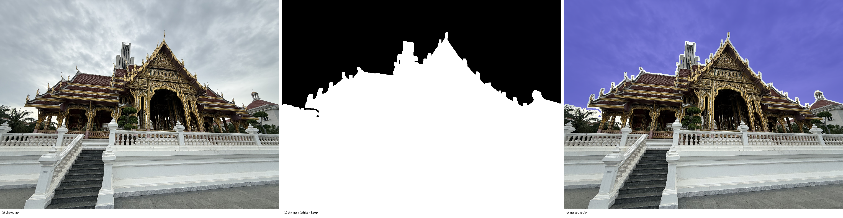
- Sky masking. (a) A photograph from the second capture; (b) its automatically computed mask, white = keep; (c) the masked region overlaid in red. Only regions connected to the top border are treated as sky, so the white balustrade and terrace are untouched.

Photogrammetry
Apple's Object Capture (RealityKit PhotogrammetrySession) was driven from a small command-line tool on an Apple-silicon MacBook Air. At full detail it produced a mesh of 249,999 faces and 125,117 vertices with an 8192 × 8192 texture in 17 minutes of wall-clock time (a medium-detail run gives 96,930 faces). The mesh is exported as usdz.

Version A: reconstruction from both capture sets
The combined capture set had earlier been rejected. COLMAP registered 351 of 352 photographs at 0.99 px mean reprojection error, yet the recovered geometry was folded: the pavilion is four-faced, so views 90 degrees apart are nearly identical and exhaustive matching produced correspondences between different faces, which the mapper resolved into a self-consistent but globally wrong reconstruction. The sub-pixel error is precisely why the failure was invisible in the numbers. That result was, in retrospect, over-generalised: it is a property of COLMAP's exhaustive matching, not of the photographs. Re-running the same 352 images through Object Capture with unordered sample ordering produced a correct, unfolded model at medium detail (100,000 faces, 351 of 352 images used, no masks and no post-processing). It carries visibly better texture than the masked 146-image mesh and an observed rather than fitted roof, at lower geometric resolution. It has not yet been scored against held-out photographs; that measurement is outstanding.
- 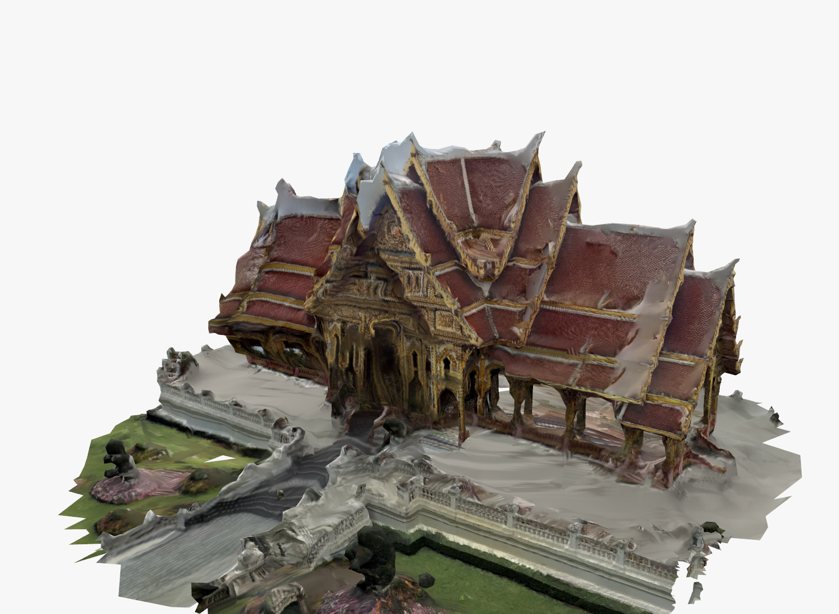
- Version A, reconstructed from all 352 photographs of both captures with no sky masks and no post-processing. Compare the roof texture with Fig. 2(c), where the crossing is a fitted surface.
- 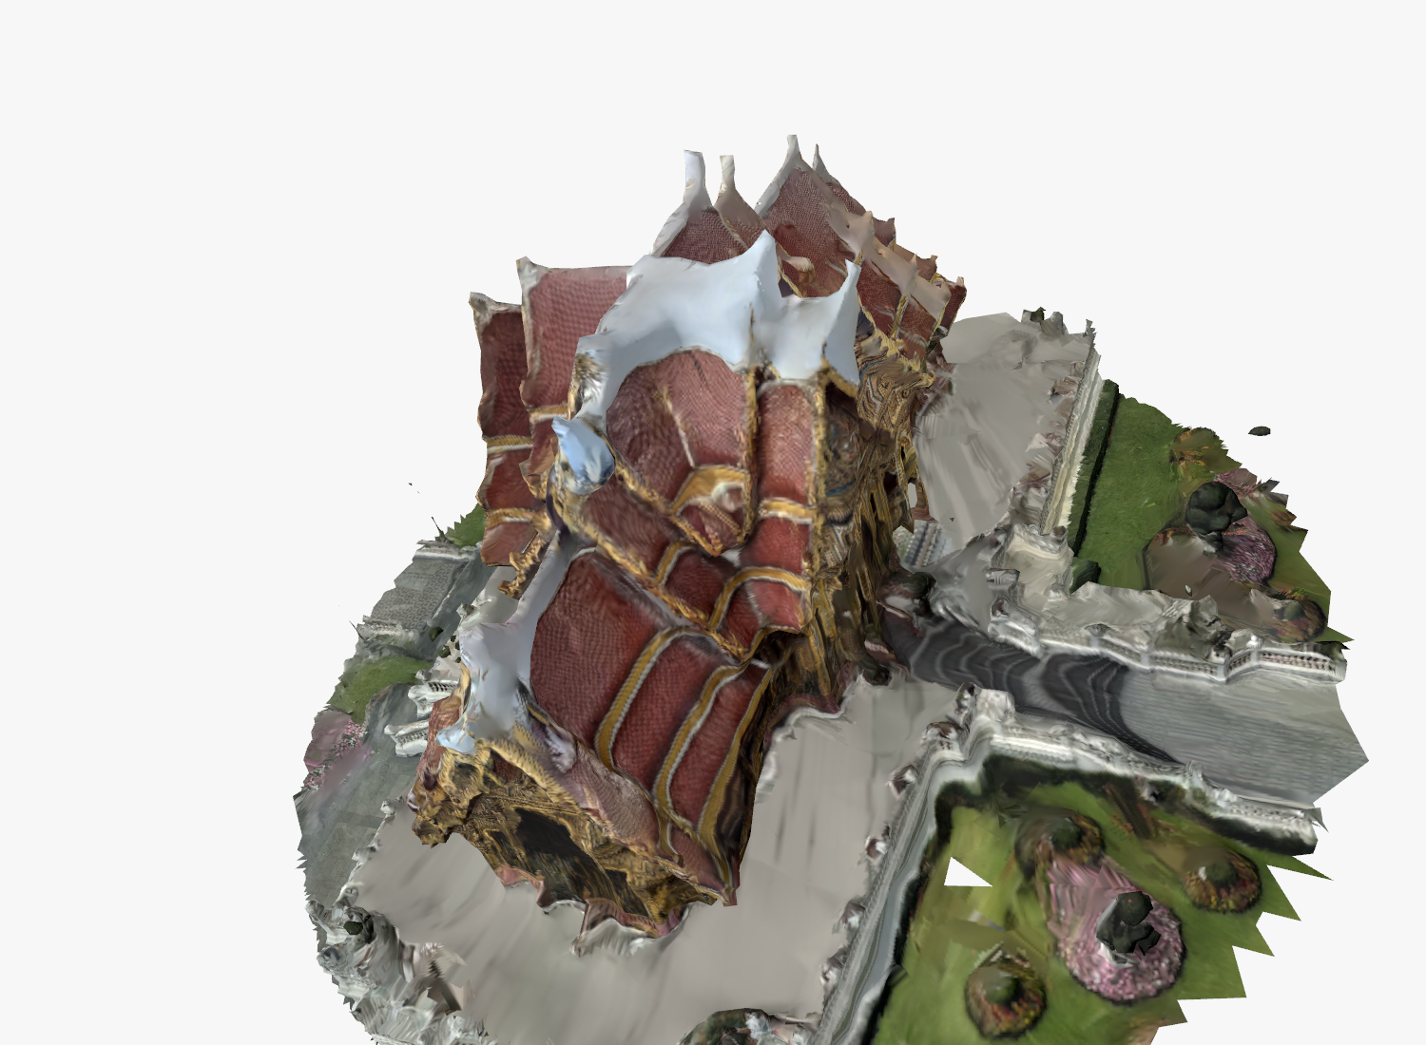
- Version A from an elevated angle. The roof is torn rather than closed: unlike the 146-image mesh, no surface has been generated to cover what the photographs never saw.

Mesh post-processing
Three documented, cosmetic operations follow; the reconstruction itself is not changed. The terrain sheet is cropped to a radius of 2.0 units about the pavilion and its ragged fringe trimmed; sliver faces (corner angle under 4°) are dropped; holes of up to 200 boundary edges are closed and the surface is smoothed with 30 Taubin steps (λ = 0.5, μ = −0.53), which preserves volume so the texture rides along on unchanged coordinates. The final mesh has 165,906 triangles (Fig. 2c).
One region needs more than cosmetics. The four gables meet at a crossing that appears in no photograph: from eye level it is hidden behind the surrounding roofs, so the reconstruction has no surface there, only crumpled sky fragments. Every attempt to hide this failed on inspection (Fig. 3a–c): recolouring the fragments read as melted wax, deleting them opened a hole, texture inpainting filled white with white, a dark occluder below them changed nothing, and a fan of triangles to a single apex read as a tent covering half the roof. What works is modelling the missing surface. A sala chaturamuk's crossing is a cross-gable, h(u, v) = H − s·min(|u|, |v|) in ridge-aligned coordinates, and every parameter is fitted from the real roof around it: the centre is the area-weighted centroid of the top-tier roof faces, the ridge axis the four-fold circular mean of their normals, H the 96th-percentile height of those faces (so real finials stay the highest points) and the slope s = 1.70 (about 60°) the median rise-over-run of their normals. The surface is sampled on a 56 × 56 grid over the 0.58-unit crossing square, conflicting fragments inside its volume are removed, a 40 cm skirt hangs from its edge and its boundary is welded onto the real roof (187 of 220 boundary vertices within 12 cm). It is textured with a plain tile field cut from one photograph (Fig. 3d). This cap is the one part of the mesh that is modelled rather than measured, and it is labelled as such in the viewer.
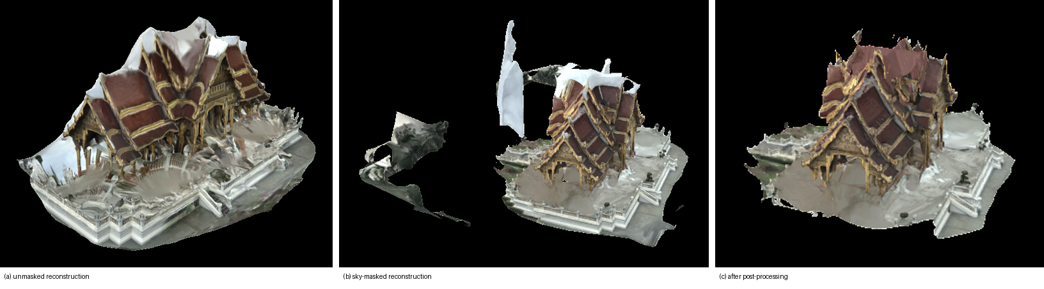
- The photogrammetry mesh at three stages, eye-level view. (a) Unmasked reconstruction: the overcast sky has become a white sheet over the roof. (b) With per-image sky masks. (c) After post-processing, with the fitted crossing cap.
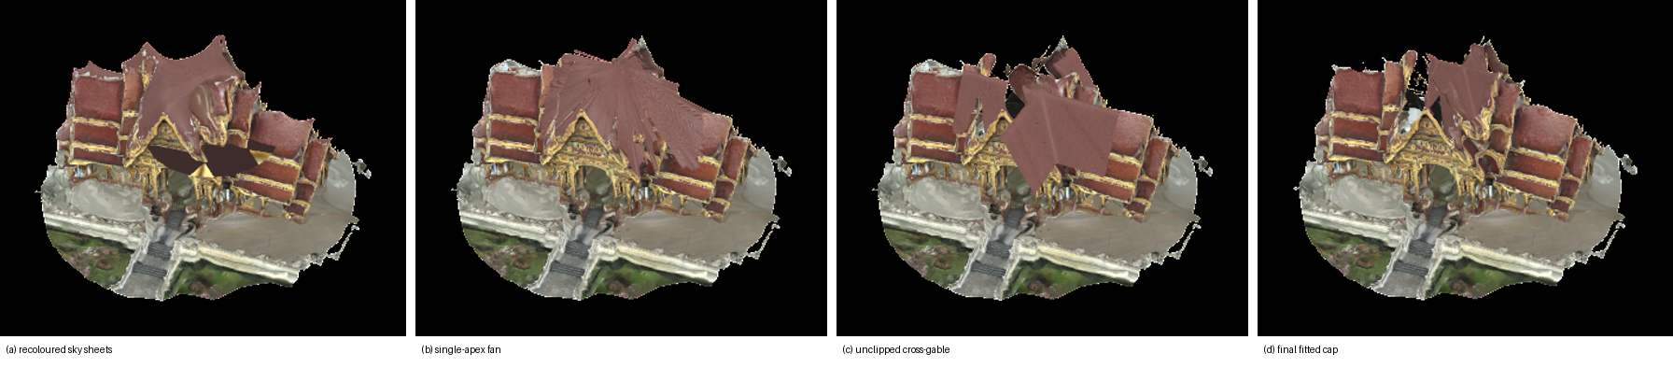
- The roof crossing, elevated view, across the attempts that were rejected on inspection and the final one: (a) recoloured sky fragments; (b) a single-apex fan; (c) the fitted cross-gable before clipping its sampling domain, running out along the wings; (d) the final clipped, skirted and welded cap.

Gaussian splatting
Camera poses were recovered with COLMAP [6] (sequential matching between neighbouring photographs only, for the same symmetry reason as in Section III-B; a single SIMPLE_RADIAL camera; all 146 images registered), the images were undistorted to a pinhole model, and the reference implementation of 3D Gaussian splatting [8] was trained for 30,000 iterations on a Kaggle T4 GPU, about 1 h 36 min. Every eighth photograph (19 views) was withheld from training and used only for scoring; PSNR, SSIM and LPIPS are computed by the implementation's own evaluation script.

Problems encountered
Neither the Gaussian rasteriser nor COLMAP's dense stage builds usefully on Apple silicon; both are hand-written CUDA. The entire route therefore had to move to a free cloud GPU, which is the largest practical difference from photogrammetry, which runs on the laptop itself. Kaggle offers both a P100 and a T4, and the choice silently decides whether training works: the P100 is compute capability 6.0, unsupported by the runtime's PyTorch build, and the CUDA extensions compile successfully on it before training aborts, so the failure surfaces roughly an hour in. TORCH_CUDA_ARCH_LIST is therefore pinned to 7.5 and the device is asserted before any long step. A third obstacle is that /kaggle/input is mounted read-only while the training code writes points3D.ply beside the COLMAP binaries on first load, so the scene must be copied into the writable working directory first.
The output is also not a conventional 3D model. point_cloud.ply stores Gaussians rather than geometry, so it cannot be opened by a mesh viewer or imported into the three.js page used for the mesh, and viewing it requires a dedicated splat renderer. Retrieval proved fragile: only the metrics and rendered views were initially brought back from the notebook, leaving the result as images alone, and on re-download the 30,000-iteration checkpoint returns zero bytes on every attempt. The model in hand is therefore the 15,000-iteration checkpoint of 554,618 Gaussians, while the scores reported below belong to the 30,000-iteration checkpoint. The two should not be conflated.

Reconstruction from the combined captures, and why it failed
Between Versions 4 and 5, four attempts were made to reconstruct from all 352 August photographs (206 in the first capture, 146 in the second), on the reasoning that two capture radii would improve triangulation. Every attempt registered 351 of 352 images at 0.66–0.99 px mean reprojection error, and every one produced camera poses that were internally consistent and geometrically wrong. Because reprojection error cannot detect this, a different test was used. A walk photographed in order should have consecutive cameras close together, so the ratio of the largest consecutive camera step to the median step — scale-invariant, and therefore valid under COLMAP’s arbitrary units — exposes a folded model. The clean second capture alone scores 7.0 on this ratio; the same 146 photographs inside the combined model scored 36.0.
Three causes were found. The first is the four-fold symmetry already noted in Section III-B: exhaustive matching and vocabulary-tree loop detection both propose image pairs 90° apart, and the mapper resolves those false correspondences into a self-consistent fold. Switching to sequential matching with loop detection off took the second capture’s ratio from 36.0 to 5.4, better than its standalone score, and so reproduced in structure from motion the same restriction the image-based pipeline had already applied to optical flow. The second cause is camera intrinsics. Reading the EXIF showed the 352 files to be four camera configurations, not two captures: 131 files with no metadata at all, 75 from an iPhone 17 Pro alternating between 24 MP and 12 MP inside an eleven-minute walk, and 146 from an iPhone 16 Pro six days later. All were downscaled to the same 1600 × 1200 pixels and forced through one shared camera model, so images with different fields of view carried one focal length between them; nothing crashed, and the poses bent to compensate. The third cause is the capture itself: no photograph looked down on the roof, the two sessions were lit differently, and the eye-level ring does not close. The first cause was fixed in software, the second would have cost a full re-run, and the third could only be fixed by photographing again. The attempt log is in Table III.
The transferable finding is that a sub-pixel reprojection error is not evidence of correct geometry under symmetry. Every failed attempt would have passed on that number alone.

Gaussian splatting from the September capture
Camera poses were recovered with COLMAP from the 446 pavilion photographs using sequential matching with loop detection off, as above, and a single camera model, which is now correct because one lens took every frame. The step-ratio test reports 10.0 on the terrace loop and 2.4 on the interior segment, against the 102.2 and 36.0 of the failed combined runs; the near loop reports 14.3, which is a walk whose distance to the building changes sharply rather than a fold, though this was not independently verified. COLMAP returned two disconnected reconstructions, 395 photographs in the main model and 71 in a second, and the main model was trained. The images were undistorted to a pinhole model and the reference implementation of 3D Gaussian splatting [8] was trained for 30,000 iterations on a Kaggle T4, 1 h 43 min of training, with the images held in CPU memory because 446 frames at this resolution exceed the GPU’s 15 GB. Every eighth photograph, 50 views, was withheld for scoring under the protocol of Section III-C, so the result is directly comparable with the 22.09 dB of the 146-photograph model. The lamp was processed identically from its 100 photographs: all registered, 13 held out, 1 h 36 min including structure from motion.
One defect stopped the first run three hours in. COLMAP’s undistorter writes its output flat, while the trainer reads a hard-coded sparse/0/ sub-directory, so the undistorted scene was invisible to it and the run failed only after every expensive stage had completed. This path had never executed before in the project: every earlier attempt stopped at the step-ratio check, and the one model trained for Version 4 used a pre-made pinhole dataset that bypassed undistortion. The defect was therefore not a regression but a stage that had never run. The fix, moving the files as the reference repository’s own conversion script does, was verified on the lamp photographs by loading the result through the trainer’s own reader before the run was repeated, and an assertion now fails at undistortion rather than three hours later.

Viewing
The mesh is shown on a separate page of the web viewer (reconstruction.html), linked from the image-based viewer and linking back, never as a mode of it. Like the rest of the viewer it opens from file:// with no build step: three.js is vendored locally and the mesh is embedded as a base64 glTF binary (165,906 triangles, 4096-px JPEG texture, 11 MB). The Gaussian model is viewed in the SuperSplat web editor (Fig. 9).

Results and Analysis
Both viewers are functional. Two kinds of measurement are reported. Table I gives the hold-out evaluation of the interpolation against real photographs, and Table II compares the image-based renderer with the two reconstructions built from the same photographs. Qualitative observations are kept where they add something the numbers do not show.
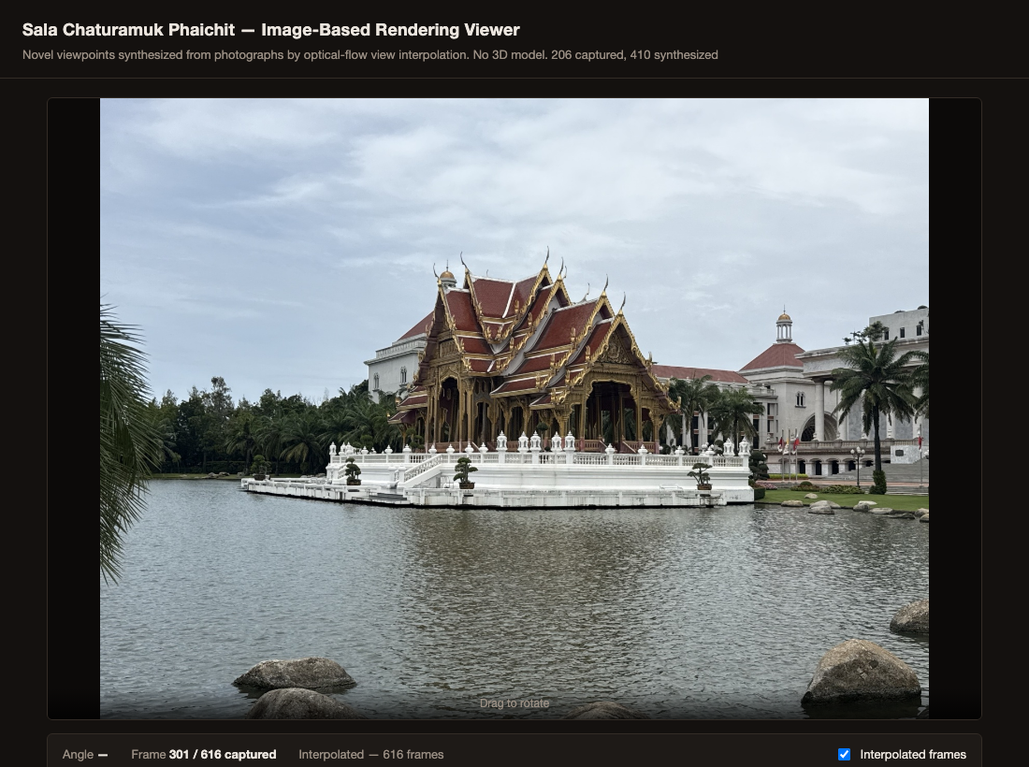
- The interactive viewer displaying a captured photograph roughly midway through the arc (frame 301 of 616).

Baseline Object-Movie Viewer
The baseline viewer switches directly between the captured photographs as the pavilion is rotated, with no frames synthesized in between.

Hold-out protocol. Every second photograph of the closed-loop capture was withheld, leaving 73 captured frames at twice the viewer's operating spacing (4.9°) and 72 real photographs at the midpoints as ground truth. Two frames were synthesized between each remaining pair, at one third and two thirds of the way across, and each was scored against the withheld photograph at the midpoint, once for the flow-interpolated frame and once for the nearest captured frame, i.e. what the baseline viewer shows at that angle. Because no synthesized frame sits exactly at the withheld position, every score carries a residual viewpoint offset of about 0.8°, so the absolute values are conservative for both methods; the comparison between them is like for like.

Result. Over the 144 scored positions the interpolated frames average 13.88 dB PSNR and 0.491 SSIM; the baseline's nearest captured frame averages 13.27 dB and 0.479. The interpolated frame scores higher than the baseline at 135 of the 144 positions on PSNR and 128 on SSIM, a mean gain of 0.60 dB. The per-frame range is 10.2–17.2 dB for the interpolation and 9.8–15.9 dB for the baseline. The absolute level is low for both because the held-out photographs were shot hand-held on a walked loop, so they differ from any synthesized view in position and heading, not only in angle; the gain isolates what interpolation adds on top of that.

At the 2.47° captured spacing the scene moves a median 2.5% of the frame width between adjacent photographs (median 1609 RANSAC inliers per pair, range 283–3982); the baseline changes the whole frame at once by that amount.

5 of the 145 adjacent pairs (3.4%) exceed the 8%-of-frame-width displacement beyond which the flow stage cannot track; at those pairs fine detail such as roof finials is where the interpolation degrades first.

Exposure, white balance and focus were locked and the capture was made under overcast sky; no exposure flicker is visible across the 146 photographs, so the frame-to-frame differences measured above are viewpoint changes, not lighting changes.

Interpolation-Based Viewer
Synthesized frames are inserted between each pair of captured photographs using the optical-flow warp described in Section III.
Over roof edges and eaves the interpolation holds up wherever the flow is consistent: across the sequence the median fraction of pixels failing the forward-backward consistency check is 29.0% per pair, and those pixels fall back to the nearer photograph rather than being blended. The three lowest-scoring positions are frame_0043_i1.jpg (10.2 dB), frame_0042_i1.jpg (10.4 dB), frame_0042_i2.jpg (10.5 dB).
Artifacts are most visible at three identified points in the captured sequence: the join between the two capture sessions, and two locations within the second session — one coinciding with a longer pause between shots and one where a tree branch briefly obstructed the pavilion in the frame. All three were flagged automatically by the per-pair displacement check described in the Methodology before the affected frames were inspected, and the visible artifact at each is consistent with the cause identified in the underlying photographs.
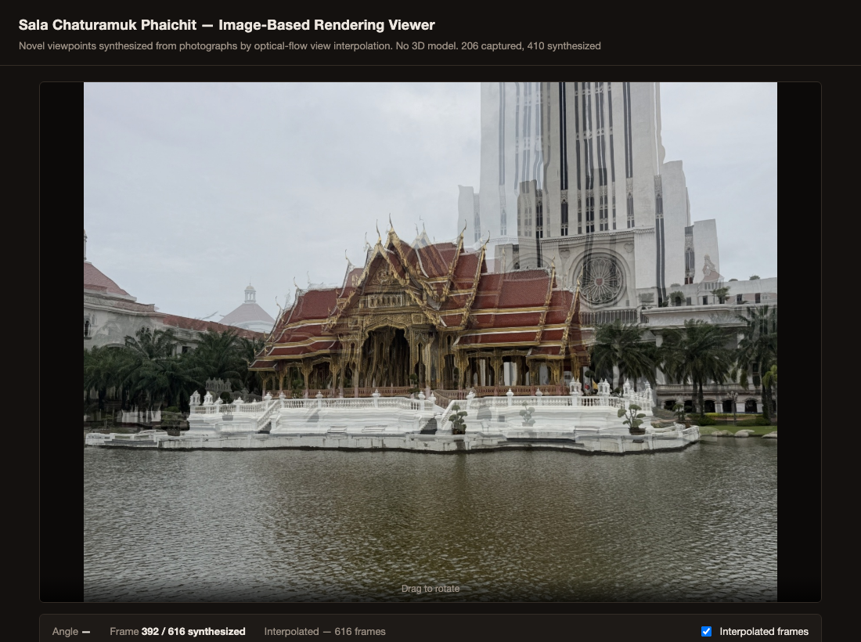
- A synthesized frame at the join between the two capture sessions, showing the double-exposure artifact discussed above.
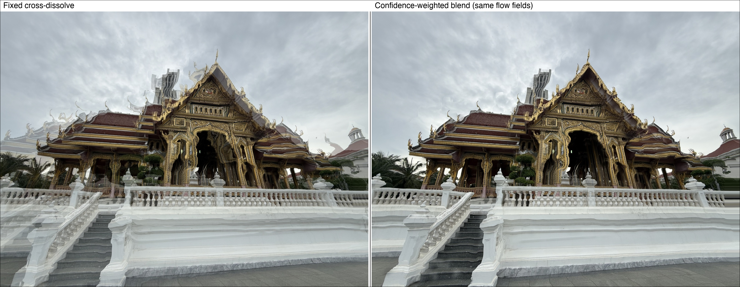
- The same synthesized frame (salathai_version2, between captured frames 41 and 42) under the fixed cross-dissolve and under the confidence-weighted blend, computed from identical flow fields. For this pair 43.2% of pixels fail the forward-backward consistency check and fall back to the nearer photograph, replacing the transparent double staircase and balustrade of the fixed dissolve with a single solid structure.

Quantitative Comparison

Table I reports the frame counts, angular spacing and hold-out scores of the two viewers on the second capture; Table II compares the three approaches on the same photographs. The reconstruction results follow in Section IV-D.
- Viewer parameters and hold-out scores, second capture
 | Viewer Comparison
 | Metric | Baseline | Interp.
1 | Displayed frames | 146 | 438
2 | Mean angular step between displayed frames (deg) | 2.47 | 0.82
3 | PSNR vs. held-out photograph, mean (dB) | 13.27 | 13.88
4 | SSIM vs. held-out photograph, mean | 0.479 | 0.491
- Image-based rendering versus reconstruction
 | Three Approaches, Same 146 Photographs
 | Metric | IBR (ours) | Photogram. | 3DGS
1 | Geometry recovered | none | mesh, 165,906 tri. | ≈0.38 M Gaussians
2 | Compute for synthesis | 151 s, CPU | 17 min, CPU/GPU (M-series) | 1 h 36 min, T4 GPU
3 | Held-out PSNR (dB) | 13.88 (144 frames) | n/a (mesh) | 22.09 (19 views)
4 | Held-out SSIM | 0.491 | n/a (mesh) | 0.785
5 | Viewpoints | captured ring only, no tilt | any; roof crossing modelled | any near ring; artifacts beyond

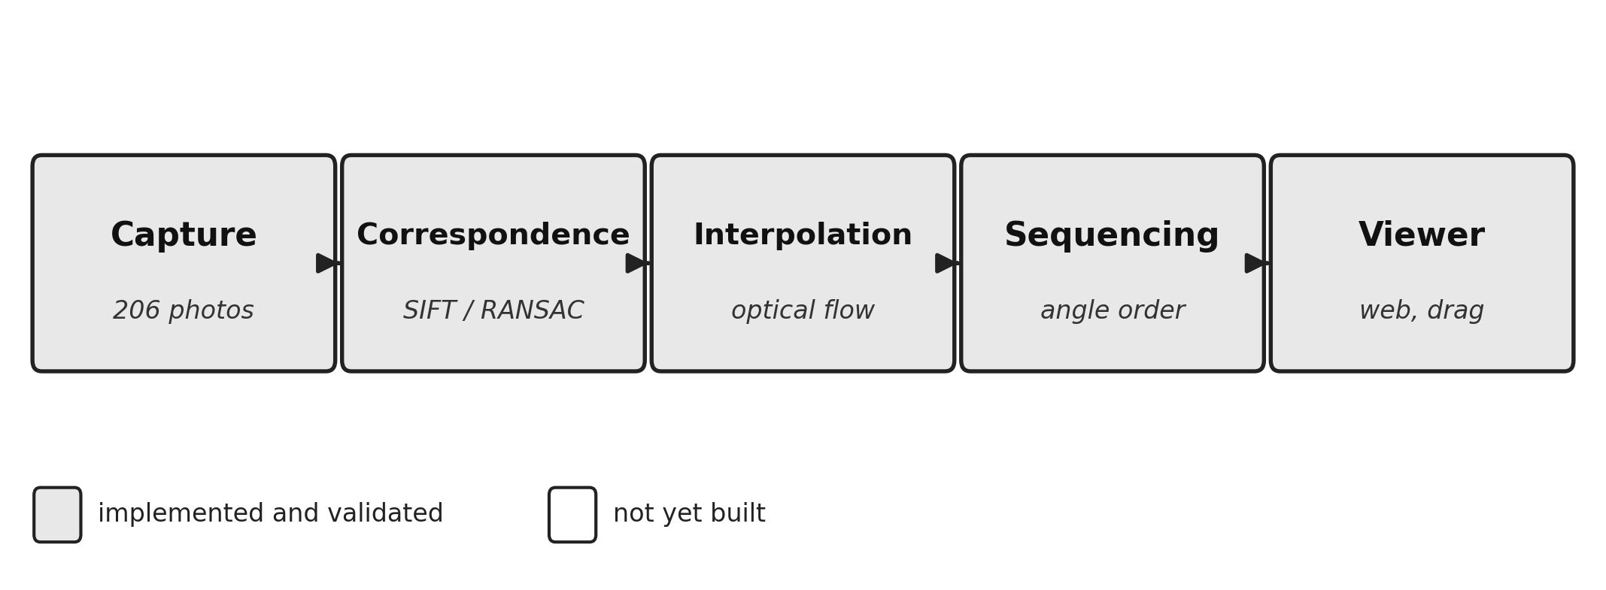
- Overview of the image capture and view interpolation pipeline used to build the Sala Chaturamuk Phaichit viewer.
The pipeline runs end to end on real photographs of the pavilion and produces a working, interactive viewer with no explicit 3D geometry at any stage, which supports the core premise of image-based rendering. Whether the interpolated views are convincing enough to matter, and how they compare quantitatively to the baseline, remains to be established by the measurements above. The most visible limitation observed was double-exposure ghosting in synthesized frames, most pronounced at the join between the two capture sessions but also visible, to a lesser extent, in some pairs well within a single session. Comparing the affected frames against the per-pair displacement diagnostic showed this was not purely a consequence of the session gap: some pairs under the flagging threshold still ghosted on thin, high-contrast structures such as roof finials and a distant background tower silhouetted against open sky, where the default Farneback flow settings could not track fine detail reliably. Raising the flow window size, pyramid levels, iterations, and polynomial-expansion parameters and regenerating both capture sequences with these settings visibly sharpened the pavilion itself in previously ghosted frames, including at the session join described above. A second, independently captured sequence of the same pavilion (salathai_version2, 146 photographs) was shot with deliberately tighter spacing between adjacent positions, directly targeting the root cause rather than only the flow estimator: Farneback flow estimates correspondences from local pixel displacement, so a smaller displacement between adjacent photographs gives it less distance to track and a shorter distance over which its estimate can drift, independent of any parameter tuning. This shows up in the same displacement diagnostic used throughout: the fraction of adjacent pairs flagged fell from 7.3% (15 of 205) in the original capture to 3.4% (5 of 145) in the tighter one. Applying the tuned flow parameters on top of this tighter capture compounds both fixes. The doubling that still survived both was then addressed at the blend itself: as described in the Methodology, pixels whose flow fails a forward-backward consistency check now take the temporally nearer photograph instead of being cross-dissolved, so a pair the flow cannot bridge degrades to a clean cut rather than a double exposure — the comparison shown above isolates exactly this change, holding the flow fields fixed. Across the regenerated sequences the median fraction of pixels failing the check per pair is 35.9% for the original capture and 29.0% for the tighter one, peaking at 90.4% at the join between the two capture sessions, whose synthesized frames are therefore effectively a cut between the two photographs; the doubled pavilion previously visible there is gone. What remains at such extreme pairs is a wavy distortion of fine background structure — most visibly the distant tower — where the flow is coherently wrong in both directions and so passes the consistency check; reshooting that stretch of the arc more densely remains the outstanding fix.

Reconstruction Comparison
Cost. The image-based pipeline synthesizes its 292 in-between frames in 151 s on a laptop CPU with no training and no geometry. The photogrammetry mesh took 17 min on the same laptop, and the Gaussian model 1 h 36 min of GPU training on a rented T4; both also need a structure-from-motion or equivalent pose-recovery stage first.
Coverage. The image-based viewer can only show viewpoints on the captured ring, at the captured height; it cannot tilt or approach. Both reconstructions can be viewed from any angle, but they inherit every occlusion of the capture: the mesh had no surface at the roof crossing until one was modelled (Section III-C), and the Gaussian model is sharp near the ring of training views and degrades to floating and needle-shaped Gaussians when the camera leaves it (Fig. 9). Neither reconstructs what was never photographed; they only make the gap easier to see.
Quality. On held-out photographs the interpolation reaches 13.88 dB / 0.491 and the Gaussian model 22.09 dB / 0.785 (LPIPS 0.346). The two protocols are alike in spirit, real photographs never used in synthesis, but not identical: the interpolation is scored at every second position of the ring, the Gaussian model at every eighth, and the Gaussian model was trained on the other seven eighths at full resolution. The numbers say what each method is: a photograph-to-photograph warp reproduces the held-out photograph closely wherever the flow tracks, and a learned radiance field reproduces it about as well after two orders of magnitude more computation, in exchange for free viewpoint. The mesh has no image score of its own; its quality is geometric (Fig. 2, Fig. 3, Fig. 8) and its texture is the photographs' own.
Coverage is uneven around the ring, not only at the roof. Binning the pavilion core by azimuth in ten-degree sectors, the Gaussian model is persistently sparse from roughly 100 to 160 degrees at 29, 36, 45 and 55 per cent of the median sector density, and the capture's single largest angular gap, 9.8 degrees, falls at the edge of that arc. The Version A mesh is thin over a contiguous arc of about 70 degrees at 18 to 28 per cent of its median. The two were reconstructed by different engines in different arbitrary coordinate frames, so the azimuths are not comparable and no claim is made that they describe the same physical face; what can be said is that each model, independently, fails to consolidate over one continuous sector. The capture covers 350.2 degrees at 2.42 degrees mean spacing, so this is a sensitivity to uneven spacing rather than a missing side, and it argues that a re-capture should even out the ring as well as add elevation.
- 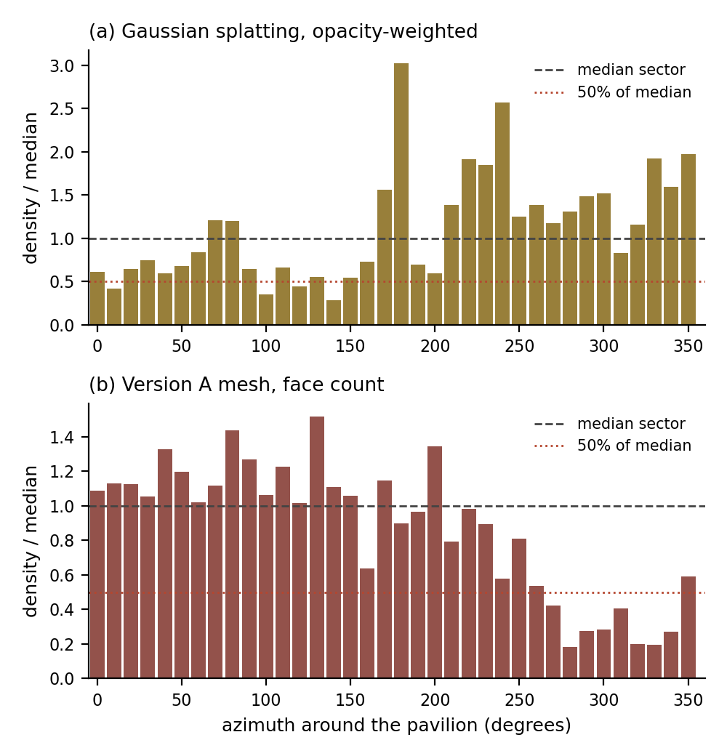
- Reconstruction density by azimuth for the two models, normalised to each model's own median sector. Both thin out over one contiguous arc; the dotted line marks half the median.
- 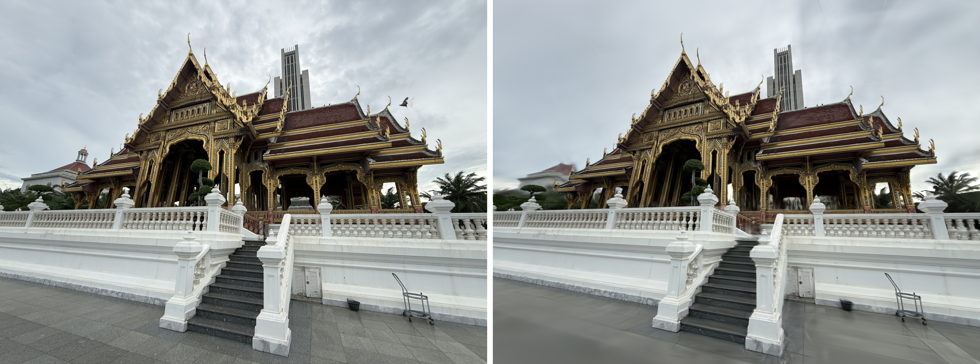
- Gaussian splatting on a held-out photograph: the real photograph (left) beside the model's rendering of the same viewpoint (right), one of the 19 views behind the 22.09 dB figure.
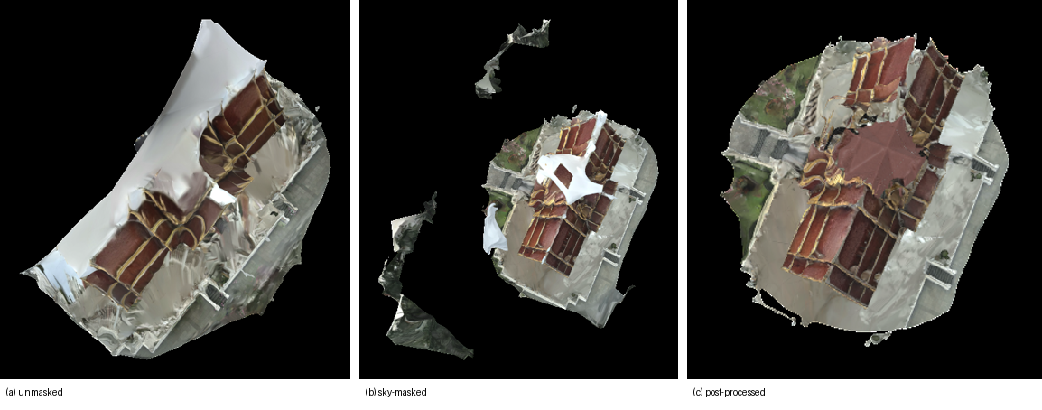
- The same three stages as Fig. 2 seen from above: (a) unmasked, (b) sky-masked, (c) post-processed with the fitted cross-gable cap covering the crossing that no photograph could see.
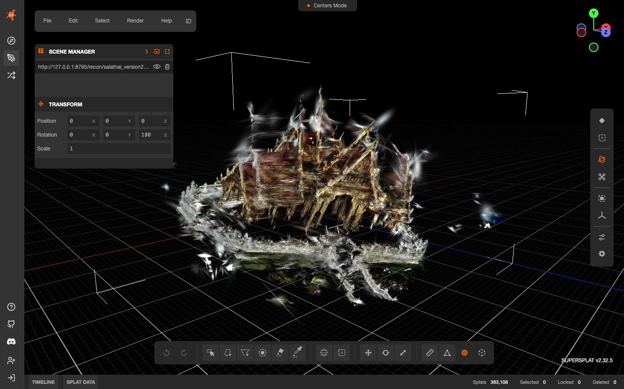
- The 3D Gaussian splatting model loaded in the SuperSplat web editor (383,108 Gaussians in the demo export). The pavilion is recognisable from the training ring; the white camera markers are the 146 recovered poses, and the needle-shaped Gaussians around the roof are the usual artifacts of an eye-level capture with no views from above.
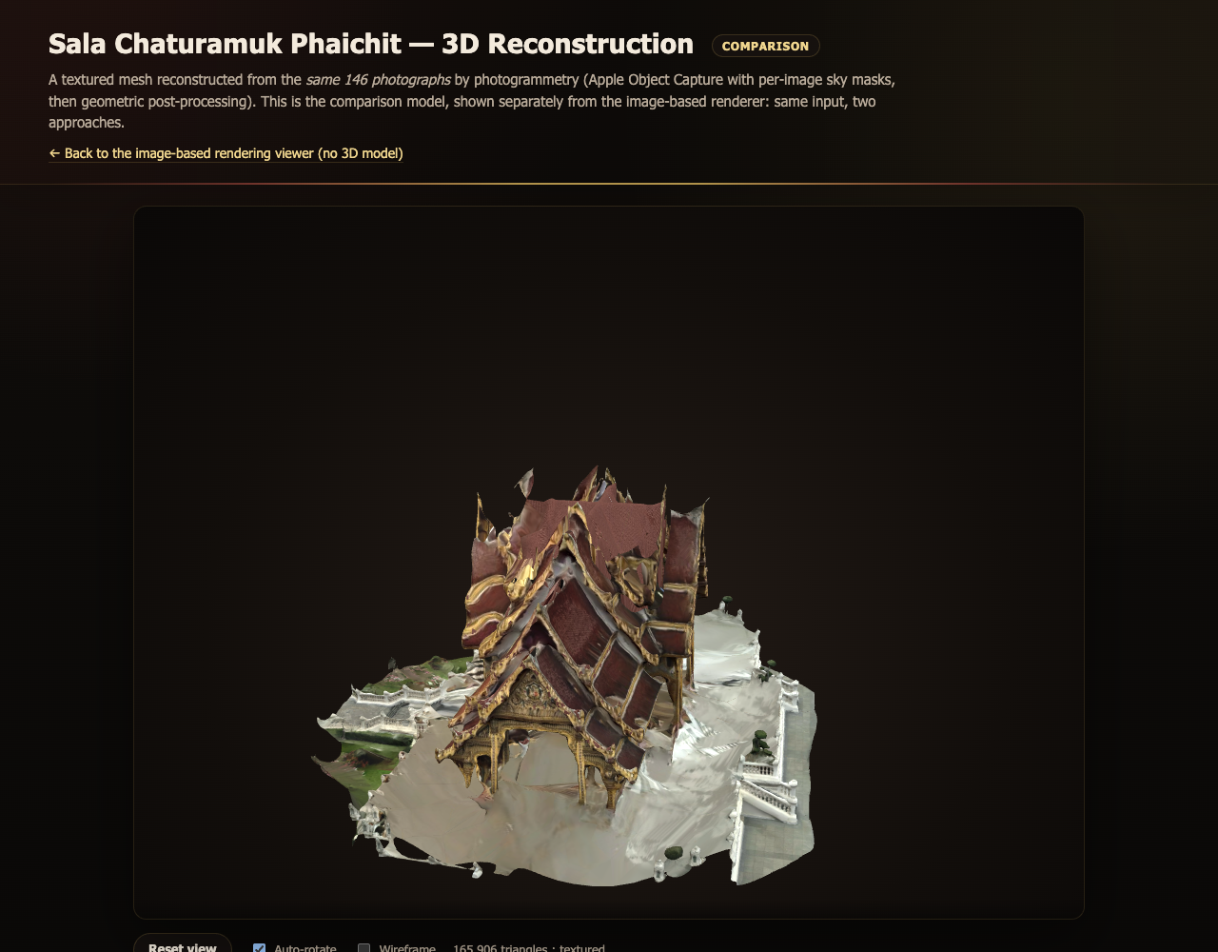
- The reconstruction page of the web viewer, kept separate from the image-based viewer and labelled as a comparison. The mesh is orbited in the browser from file:// with no server; the caption text states that the roof crossing is modelled, not measured.

The combined captures
- Reconstruction attempts on the combined August captures
 | Combined Captures, 352 Photographs
 | Matching | Registered | Reproj. (px) | Step ratio, 1st / 2nd
1 | control: 2nd capture only | 146 / 146 | 0.58 | — / 7.0
2 | exhaustive | 351 / 352 | 0.99 | 102.2 / 36.0
3 | sequential + loop det. | 351 / 352 | 0.66 | 55.3 / 29.2
4 | sequential, no loop det. | 351 / 352 | 0.67 | 27.4 / 5.4
5 | as 4, 1st capture split | 351 / 352 | 0.67 | 16.1, 14.8 / 6.2
Table III records the four attempts and the control. The reprojection error is flat across every row while the step ratio falls by an order of magnitude, which is the whole argument in one table: the number the pipeline reports did not move, and the number that measures the failure did. After the fourth attempt the first capture’s two halves sat at 16.1 and 14.8, either side of the pass threshold of 15.0 and statistically indistinguishable, and the combined set was abandoned in favour of a re-capture.

The September model
- Gaussian splatting, August second capture versus the September capture
 | Three Models, Same Protocol
 | Metric | Aug. (146) | Sep. pavilion | Sep. lamp
1 | Photos / registered | 146 / 146 | 446 / 395 | 100 / 100
2 | Training time, 30k it. | 1 h 36 m | 1 h 43 m | 1 h 36 m
3 | Gaussians, full field | 554,618* | 653,917 | 1,053,976
4 | Gaussians after object crop | — | 291,764 | 163,756
5 | Held-out views | 19 | 50 | 13
6 | PSNR, mean (dB) | 22.09 | 20.10 | 15.93
7 | PSNR range (dB) | — | 10.45–25.61 | 10.07–22.34
8 | SSIM | 0.785 | 0.739 | 0.707
9 | LPIPS | 0.346 | 0.342 | 0.314
*15,000-iteration checkpoint; the 30,000-iteration model scored in Version 4 was never recovered from the notebook.
Both September models trained without a geometric failure, the first time in the project that the pipeline ran from photographs to a scored model without intervention. Table IV sets them beside the 146-photograph model of Version 4. The pavilion’s headline score, 20.10 dB, is 2 dB below that model, which at first sight is a regression for three times the photographs. Fig. 15 shows what the number is made of: from the photographed viewpoints the render is close to photographic, with the gold ornament, the red tiles and the balustrade resolved, and the best view reaches 25.24 dB; the worst, 10.45 dB, is a frame in which the sky mask blackened the sky in irregular patches that the model, having seen the same sky untouched in neighbouring frames, does not reproduce. The next subsection quantifies this.
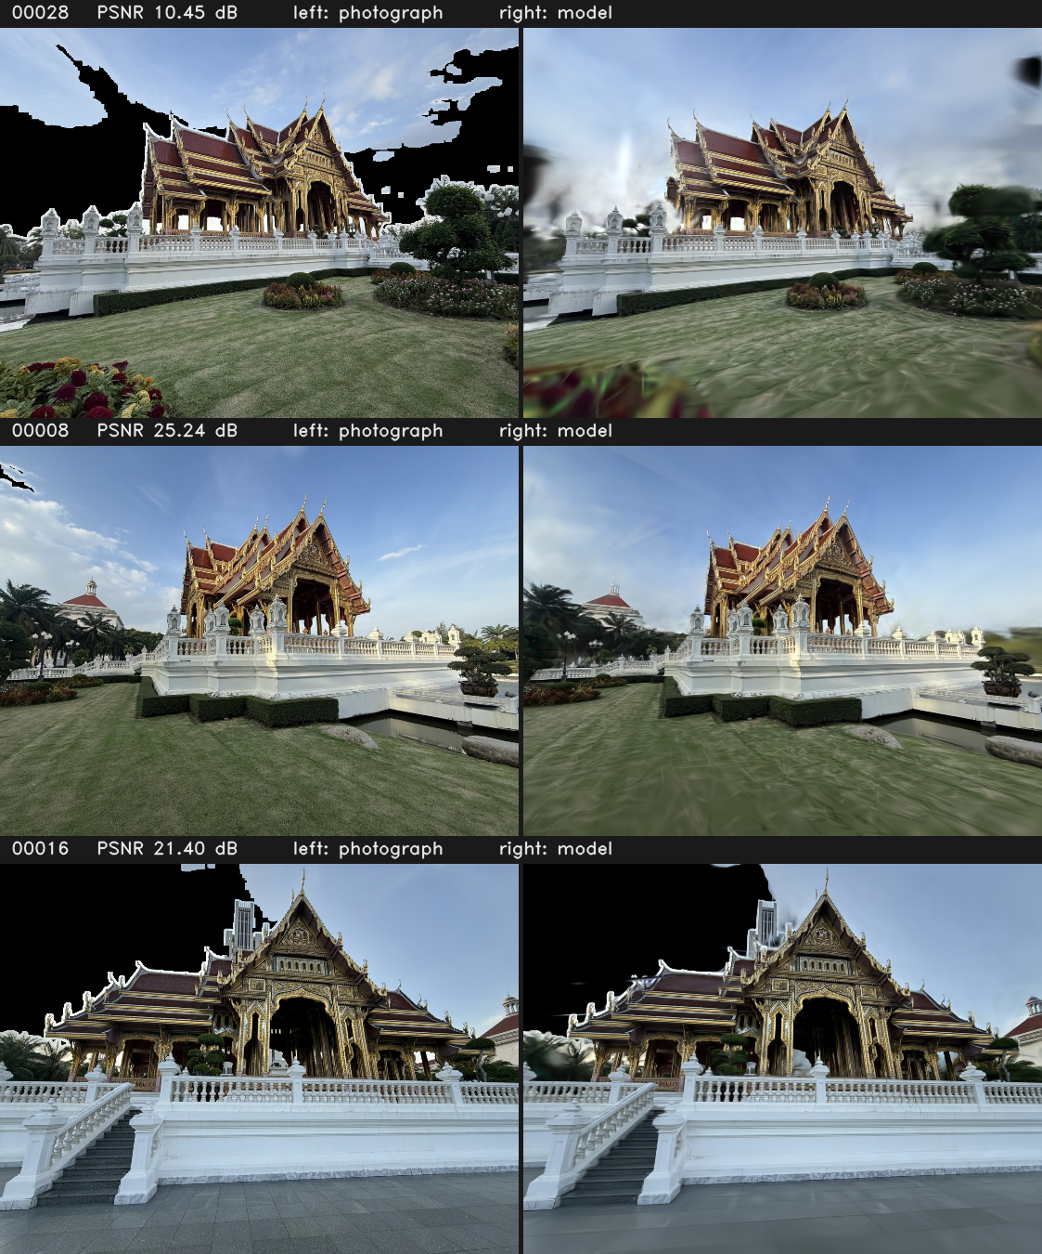
- Three of the 50 held-out photographs (left) beside the model’s rendering of the same viewpoint (right), with their scores. The lowest-scoring frame, top, is one in which the sky mask fired in patches; the same sky is untouched in the middle frame. The pavilion itself renders comparably in all three.

Where the score is lost
Recomputing PSNR over sub-regions of the same renders, with no retraining, separates the subject from the frame around it (Fig. 16). Over the whole frame the pavilion scores 20.10 dB. Excluding the pixels the sky mask blackened, 11.8% of the average frame, it scores 22.33 dB, a gain of 2.40 dB. Over the central region the subject occupies it scores 20.89 dB, and 25.56 dB on its best view. The mask is the cause: the HSV-and-gradient rule of Section III-C fires on some frames and not on others, so the same patch of sky is black in one training view and blue in the next, the model learns a compromise, and it is penalised against both. This costs 2.2–2.4 dB, roughly forty times what doubling the training budget would buy (below), and it is fixable in software without new photographs.
The lamp makes the same point more sharply. It scores 15.93 dB over the whole frame, 20.25 dB over the region it occupies and 30.01 dB there on its best view, because a small object photographed from 3.6 m leaves most of the frame filled with a lake, a treeline and buildings a hundred metres away, on which a 3.6 m orbit gives no parallax and which the model can only render as smear. Its low headline number is a framing artefact, not a worse reconstruction. The implication for both subjects is that a single whole-frame PSNR is not a measure of how well the subject reconstructed; where the subject is a minority of the frame, the number mostly reports the background. This parallels the finding of Section III-C, that sub-pixel reprojection error is not evidence of correct geometry, and has the same moral: the standard summary statistic answers a different question from the one being asked. Region-decomposed scores are reported beside the headline from this version on.
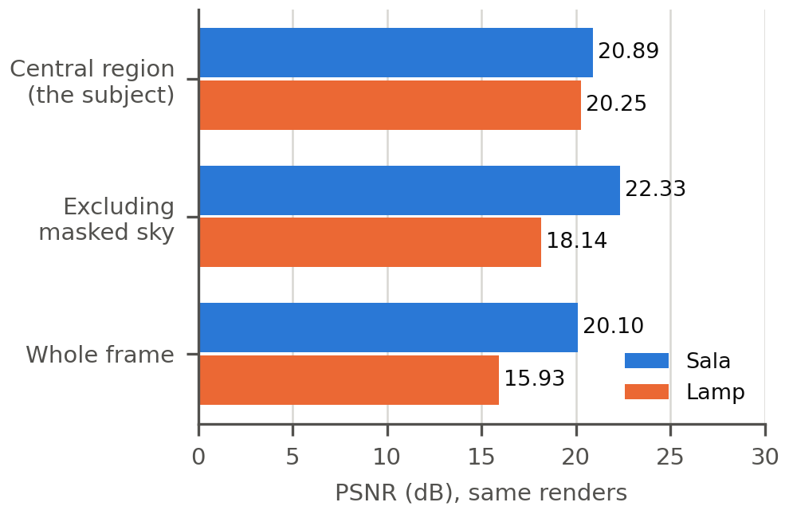
- PSNR recomputed over sub-regions of the same held-out renders. The pavilion gains 2.4 dB once the inconsistently masked sky is excluded; the lamp, a small subject in a large frame, gains 4.3 dB over the region it occupies.

The interior did not join the exterior
COLMAP produced two disconnected sub-models for the pavilion and only the larger was trained. The second holds 71 photographs, 20 of which also appear in the main model and 51 of which do not, and cross-referencing those 51 against the capture manifest shows that every one belongs to the interior segment: of 93 interior photographs, 42 bound to the exterior walk and 51 did not. The cause is ordinary. Standing under the roof, the camera sees painted ceiling and columns and almost nothing it saw from the terrace, so without frames that observe both at once, sequential matching finds no bridge, and COLMAP correctly reports two reconstructions rather than inventing a link. The model published as the pavilion is therefore the exterior. The remedy belongs in the next capture: a handful of transition frames taken in a doorway, turning slowly from outside to inside, so the two halves share features. The 71 interior photographs are already reconstructed and could be trained as a separate model for about 40 minutes of GPU time.

The roof was not photographed
Version 4 closed with the roof crossing as the one surface hidden from every eye-level viewpoint, and the capture protocol named elevated positions as the only route to observing it. The re-capture followed every other clause of the protocol and omitted this one, and the consequence can now be measured rather than described. Taking the elevation of every camera about the centre of the reconstructed pavilion, with the world up-vector derived from the cameras’ own up axes (mean agreement 0.97, so the capture was level), 374 of the 395 registered cameras lie between −30° and 0°, 21 lie below −30°, and none lies above the horizontal; the highest viewpoint in the capture is −10° (Fig. 17). Azimuth coverage is complete, 12 of 12 thirty-degree sectors with 22 photographs in the thinnest, so the deficiency is entirely in elevation. Not one of the 446 photographs looks down at the pavilion. The upper surfaces of the roof were never observed, so no Gaussian was ever placed on them, and no amount of optimisation can create one. Viewed from above in the interactive viewer the roof opens into a hollow shell (Fig. 18), not because the model is under-trained but because a radiance field contains only what was seen. The lamp, photographed in three rings spanning −43° to +43°, resolves from far more directions and shows the difference elevation makes, but it too has nothing overhead. The roof therefore remains unobserved by choice of viewpoint, not by limitation of method, and the project now holds a measurement of the gap rather than an impression of it.
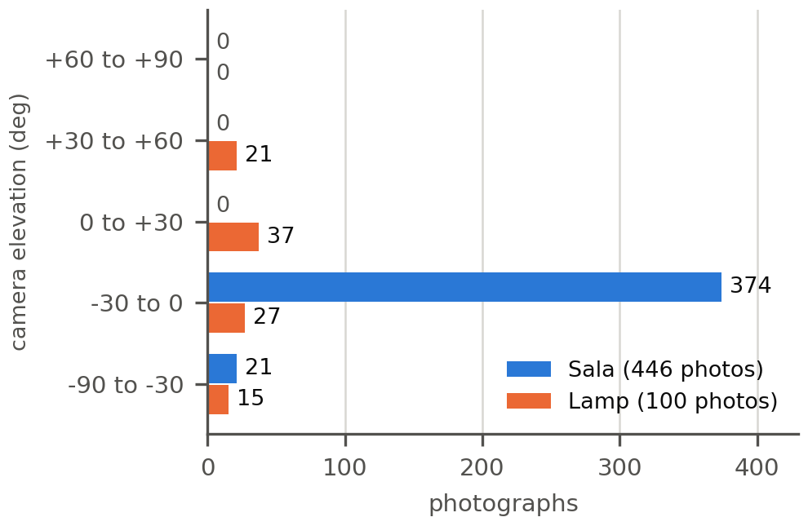
- Camera elevation about the subject for the two September captures. Every pavilion camera is at or below −10°; the lamp’s three rings reach +43°. Neither has a view from overhead.
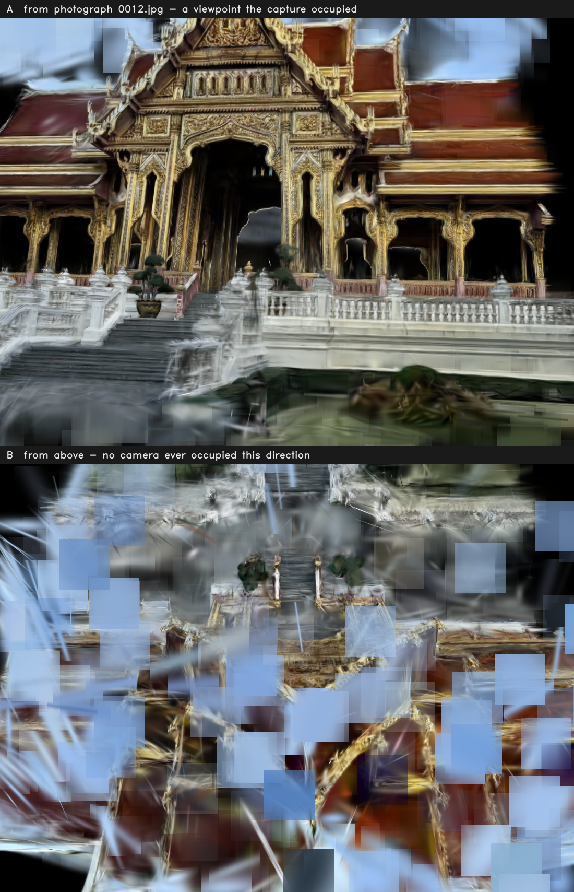
- The same September model rendered from two viewpoints. A: from the pose of photograph 0012, one the capture occupied. B: from above, a direction no camera ever occupied; the roof that was never photographed is not there to render.

Was 30,000 iterations enough?
Hollow regions invite the question of whether the model is simply under-trained, and it can be answered from the training logs rather than by eye. The mean L1 loss per 5,000 iterations falls from 0.0919 to 0.0429 over the run, and the final 5,000 iterations improved it by only 4.0% (Fig. 19). Fitting a power-law decay to the post-densification regime and extrapolating predicts 0.0413 at 40,000 iterations (−3.0%), 0.0404 at 60,000 (−5.1%) and an asymptote of 0.0396 (−6.9%), which bounds what any amount of further training could ever achieve at about +0.3 dB. Fixing the sky mask is worth 2.4 dB and costs no GPU time. One implementation detail bears on any attempt to extend a run: the reference implementation decays the position learning rate to its floor at 30,000 iterations, so resuming a finished checkpoint continues at that floor and yields less than the extrapolation; reaching the predicted values requires a fresh run with the longer schedule. Thirty thousand iterations was the correct stopping point, and training is not the binding constraint on any result in this version.
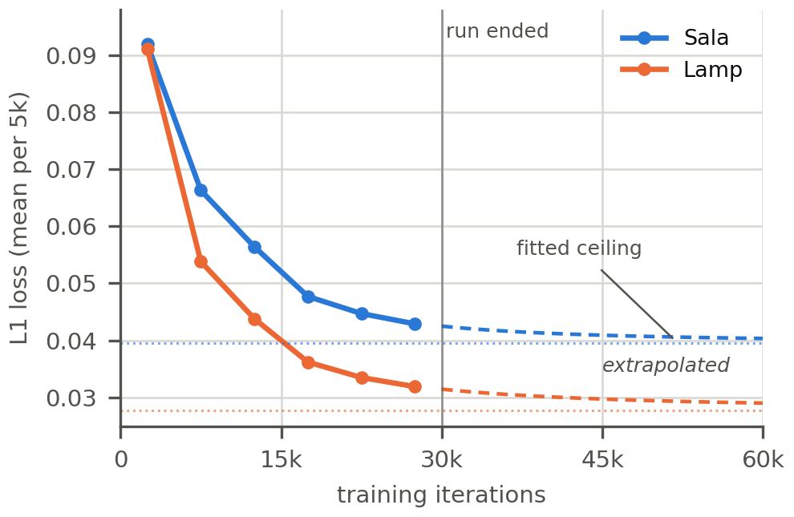
- Training loss per 5,000 iterations for the two September models, with the fitted decay extrapolated beyond the end of the run and its asymptote marked. Both curves are within 7–12% of the most that any further training could achieve.

Viewing
The September model is published as an interactive page of the web viewer beside the image-based renderer and the mesh, and linked from the index. It embeds the model as base64 in a JavaScript global and reads the renderer from a vendored splat library, so the page opens from file:// with no server and no build step, the constraint the rest of the viewer observes; the vendored renderer was extended by six lines to accept per-page camera poses and an opening view, and the Version 4 page renders exactly as before. The published model is the cropped field of 291,764 Gaussians rather than the full 653,917, which follows from the region analysis above: the discarded Gaussians are the background that scores around 10 dB, and including them would make the page heavier and worse. The page states its own limits with the measured numbers, including that the roof is unobserved above −10°.

Conclusion
We presented an image-based rendering viewer for Sala Chaturamuk Phaichit, the four-porched Thai pavilion at the Assumption University Suvarnabhumi campus. Photographs captured along an arc around the pavilion were combined with optical-flow view interpolation to produce a working, interactive web viewer with no 3D geometry at any stage. The interpolation is now measured: against real photographs withheld from a 146-photograph closed-loop capture, the synthesized frames reach 13.88 dB PSNR and 0.491 SSIM, against 13.27 dB and 0.479 for the frame-switching baseline. At the instructor's request the same photographs were also reconstructed explicitly, as a photogrammetry mesh and as a 3D Gaussian splatting model, and the three were compared on the same input. The comparison sharpens the premise rather than undermining it: reconstruction buys free viewpoint at the price of a reconstruction stage and two orders of magnitude more computation, and it cannot show what was never photographed, which for this pavilion is the roof crossing hidden from every eye-level viewpoint. Two constraints specific to the subject shaped all three methods: the lake limits where a camera can stand, and the four-fold symmetry forces matching to be restricted to neighbouring photographs. Future work is a capture from an elevated position, which would close the roof for the reconstructions and add a second ring for the image-based viewer, and a user study of perceived smoothness to set beside the objective scores.
Since Version 4 the reconstruction branch has been taken as far as the photographs allow. Reconstructing from both August captures together failed four times in a way the standard numbers could not see, and each cause — four-fold symmetry, mixed phones and lenses, and an eye-level capture — was traced to a measurement rather than a suspicion. A re-capture under a protocol written from those failures produced the first end-to-end reconstruction of the project: a 3D Gaussian splatting model of the pavilion from 395 photographs at 20.10 dB on held-out views, 22.33 dB once the inconsistently masked sky is excluded, and close to photographic from the viewpoints that were photographed. What limits it is now measured: a sky mask that is not consistent between views, worth over 2 dB and fixable in software; an interior that did not bind to the exterior for want of transition frames; and a roof that no camera has yet looked down on, the one clause of the protocol that was not carried out. Training is not the limit, since the loss curve bounds all further gain at under 7%. The recurring lesson of the last two versions is that the failures were in verification rather than in method: a reprojection error, a whole-frame PSNR and a pipeline stage were each trusted before being checked against what they actually measured. The next capture needs elevated viewpoints and doorway transition frames. The image-based viewer, which remains the contribution of the work, is unchanged, and now stands beside a reconstruction that is good where it was photographed and honest about where it was not.

References
- R. Szeliski, Computer Vision: Algorithms and Applications, 2nd ed. Cham, Switzerland: Springer, 2022.
- S. E. Chen and L. Williams, “View interpolation for image synthesis,” in Proc. 20th Annu. Conf. Comput. Graph. Interact. Tech. (SIGGRAPH ’93), Anaheim, CA, USA, 1993, pp. 279–288.
- S. M. Seitz and C. R. Dyer, “View morphing,” in Proc. 23rd Annu. Conf. Comput. Graph. Interact. Tech. (SIGGRAPH ’96), New Orleans, LA, USA, 1996, pp. 21–30.
- M. Levoy and P. Hanrahan, “Light field rendering,” in Proc. 23rd Annu. Conf. Comput. Graph. Interact. Tech. (SIGGRAPH ’96), New Orleans, LA, USA, 1996, pp. 31–42.
- L. McMillan and G. Bishop, “Plenoptic modeling: An image-based rendering system,” in Proc. 22nd Annu. Conf. Comput. Graph. Interact. Tech. (SIGGRAPH ’95), Los Angeles, CA, USA, 1995, pp. 39–46.

- J. L. Schönberger and J.-M. Frahm, “Structure-from-motion revisited,” in Proc. IEEE Conf. Comput. Vis. Pattern Recognit. (CVPR), Las Vegas, NV, USA, 2016, pp. 4104–4113.
- Apple Inc., “Creating 3D objects from photographs,” Apple Developer Documentation, RealityKit Object Capture. [Online]. Available: https://developer.apple.com/documentation/realitykit/creating-3d-objects-from-photographs
- B. Kerbl, G. Kopanas, T. Leimkühler, and G. Drettakis, “3D Gaussian splatting for real-time radiance field rendering,” ACM Trans. Graph., vol. 42, no. 4, Art. no. 139, Jul. 2023.
- G. Taubin, “A signal processing approach to fair surface design,” in Proc. 22nd Annu. Conf. Comput. Graph. Interact. Tech. (SIGGRAPH ’95), Los Angeles, CA, USA, 1995, pp. 351–358.
- Z. Wang, A. C. Bovik, H. R. Sheikh, and E. P. Simoncelli, “Image quality assessment: From error visibility to structural similarity,” IEEE Trans. Image Process., vol. 13, no. 4, pp. 600–612, Apr. 2004.
- R. Zhang, P. Isola, A. A. Efros, E. Shechtman, and O. Wang, “The unreasonable effectiveness of deep features as a perceptual metric,” in Proc. IEEE/CVF Conf. Comput. Vis. Pattern Recognit. (CVPR), Salt Lake City, UT, USA, 2018, pp. 586–595.

