Two Gaussian-Splatting Reconstructions from the September Re-Capture of Sala Chaturamuk Phaichit, and What Still Limits Them

Win Yu Maung
Vincent Mary School of Engineering, Science and Technology
Suvarnabhumi Campus, Assumption University of Thailand
Samut Prakan, Thailand
u6612054@au.edu
Myat Bhone Thet
Vincent Mary School of Engineering, Science and Technology
Suvarnabhumi Campus, Assumption University of Thailand
Samut Prakan, Thailand
u6611935@au.edu
Min Pyae Hein
Vincent Mary School of Engineering, Science and Technology
Suvarnabhumi Campus, Assumption University of Thailand
Samut Prakan, Thailand
u6511684@au.edu

Abstract—The 5 September 2026 re-capture removed every cause identified in the Version 5 failure analysis, and for the first time in this project a reconstruction ran end to end. Two 3D Gaussian Splatting models were trained: the pavilion, from 395 registered photographs, scoring 20.10 dB PSNR on 50 held-out views, and an adjacent stone lamp, from 100 photographs, scoring 15.93 dB on 13. This report documents both the failure that preceded them and the result, and argues that the headline PSNR is the wrong number to read. Decomposed by image region, the same renders score 22.33 dB and 18.14 dB once sky-mask artefacts are excluded, and 20.89 dB and 20.25 dB over the region the subject occupies. Three limits remain, none of them a training limit: a sky mask that is not consistent between views, worth 2.2–2.4 dB; an interior that never bound to the exterior, leaving 51 of 93 interior photographs untrained; and a capture in which not one camera looks down at the pavilion, so the roof is unobserved. A fitted extrapolation of the training loss bounds all remaining benefit from further optimisation at 7–12 per cent, against 2.4 dB available from a software fix.
Keywords—3D Gaussian splatting, structure from motion, novel view synthesis, capture planning, held-out evaluation, Thai pavilion

Summary
The re-capture worked. For the first time in this project a reconstruction ran end to end — structure-from-motion, undistortion, 30,000 iterations of Gaussian splatting, held-out scoring and export — without a single geometric failure. Two models came out of it.
- TABLE 1. The two models produced by the September re-capture.
 | Photographs | Registered | Gaussians (cropped) | PSNR | SSIM | LPIPS
Sala | 446 | 395 | 291,764 | 20.10 dB | 0.739 | 0.342
Lamp | 100 | 100 | 163,756 | 15.93 dB | 0.707 | 0.314

Both are scored on held-out photographs the model never saw — every eighth frame, 50 for the sala and 13 for the lamp — using the same protocol as the 146-image version2 model reported in Version 4 (22.09 dB, 0.785, 0.346 at 15,000 iterations), so the three are comparable.
The single most transferable finding of this round: the reported PSNR is dominated by parts of the photograph that are not the subject. Sky that the mask blackened inconsistently, and distant scenery no orbit could constrain, account for most of the loss. A single headline number conceals a reconstruction that is good where it was photographed and absent where it was not.
Three limits remain, and none of them is a training limit:
- TABLE 2. What still limits the result.
# | Limit | Status
1 | The sky mask fires on some frames and not others, so the same tree is black in one view and textured in the next | Measured, costs 2.2–2.4 dB, fixable in software
2 | The interior never bound to the exterior; COLMAP filed it as a second reconstruction and it was never trained | Measured, 51 of 93 interior photographs unused
3 | Not one photograph looks down at the pavilion — the highest viewpoint is −10° elevation | Requires new photographs. Named in the Version 5 failure analysis and not acted on

What the Failure Analysis Asked For, and What Happened
Section 9 of version5_failure_analysis.md listed three actions in order of cost. Recording the outcome honestly matters more than recording the plan.
- TABLE 3. Continuity with the previous round.
# | Recommended | Outcome
1 | Re-run COLMAP on the 352-photograph set with single_camera_per_folder | Not done, and correctly so. Superseded by action 3, which removed the cause rather than working around it
2 | Train and report whatever that produced | Not applicable — the combined set was abandoned
3 | Re-shoot: one camera, one session, one focal length, unbroken chain, elevated positions from floor 6 or higher | Done, except the elevated positions. Every other clause was satisfied exactly. The elevation clause was not, and it had been named "the only route to an observed roof"

The re-capture solved every cause the failure analysis identified — and reproduced, untouched, the one cause it had flagged as needing height.

The 5 September Capture
724 photographs, one continuous 55-minute session, iPhone 16 Pro, ultra-wide 2.22 mm lens.
- TABLE 4. The capture that failed, against the capture that worked.
Property | Combined Aug set (failed) | 5 Sep set
Cameras | 2 phones (iPhone 17 Pro, 16 Pro) | 1
Lens configurations | 3 | 1
35 mm-equivalent focal spread | 7× (24–100 mm) | 1.00× (14 mm on every frame)
Sessions | 2, six days apart | 1
Frames with no EXIF | 131 | 0
Frames slower than 1/60 s | not measurable | 1 of 724
ISO range | not measurable | 50–250

This is the fix. Every mechanism identified in the failure analysis — one intrinsic forced across incompatible sensors, invisible because downscaling to 1600 px gives different fields of view identical pixel dimensions — is structurally impossible on a single-lens capture.
- TABLE 5. Prepared subsets. Seven 16:9 frames were dropped.
Subject | Frames | Size | Segments
sala | 446 | 1600×1200 | Sala 360 (264), Sala 360 Near (89), Sala Inside (93)
lamp | 100 | 1200×1600 | Higher (30), Middle (33), Lower (37)
far | 171 | 1600×1200 | not yet trained

Attempt Log
- TABLE 6. Runs in this round.
# | Date | Subject | Outcome
1 | 7 Sep | lamp | Failed at training. FileNotFoundError: sparse/0/images.bin
2 | 7 Sep | lamp | Succeeded. 1 h 35 m 35 s wall clock, 1.97 GB output
3 | 7 Sep | sala | Succeeded. 1 h 43 m 16 s of training alone

No run in this round produced a folded or geometrically wrong reconstruction. That is the difference between this week and the five attempts documented in the failure analysis. The fold diagnostic — maximum consecutive-camera step divided by the median step, scale-invariant, with a healthy reference of 7.0 from the clean 146-image capture — reports:
- TABLE 7. Fold ratios. The failed combined runs reported 102.2 and 36.0.
Capture | Segment | Frames | max/median | Jumps > 5×
Sala | Sala 360 | 264 | 10.0 | 2 (0.8%)
Sala | Sala 360 Near | 89 | 14.3 | 17 (19.3%)
Sala | Sala Inside | 42 | 2.4 | 0
Lamp | Higher | 30 | 3.7 | 0
Lamp | Middle | 33 | 2.9 | 0
Lamp | Lower | 37 | 2.4 | 0

Sala 360 Near is the one number to keep an eye on: at 14.3, with 19.3% of its steps beyond five times the median, it sits just under the 15.0 gate, and it passed on a threshold the failure analysis itself called arbitrary. It is a near-orbit of a large building where the photographer’s distance changes sharply, so a genuine walk break is the likelier explanation than a fold — but it was not independently verified, and it should not be quoted as if it had been.

The Defect That Stopped the First Run
colmap image_undistorter --output_type COLMAP writes its output as sparse/{cameras,images,points3D}.bin, flat. The 3DGS function readColmapSceneInfo reads sparse/0/, a path it hardcodes. The undistorted scene was therefore invisible to the trainer and the run died three hours in, after all the expensive work had completed.
The reason this was not caught earlier is worth stating plainly: the undistort-to-train path had never once executed in this project. Every earlier attempt died at the fold check before reaching it, and the one model that did train used a pre-made pinhole dataset that bypassed undistortion entirely. The defect was not a regression. It was a section of the pipeline that had never run.
The fix is to move the files into sparse/0/ after undistortion, which is what the 3DGS repository’s own convert.py does. It was verified locally before re-running — COLMAP 4.1.1 over all 100 real lamp photographs, then loaded back through 3DGS’s own colmap_loader.py: 100 images, one PINHOLE camera at 1191×1588, 45,393 points at 0.434 px mean reprojection error. An assertion now fails at undistortion rather than three hours later.

Results
395 of 446 photographs, 30,000 iterations, NVIDIA T4 ×2, 1 h 43 m 16 s.
- TABLE 8. Measured results for both models.
Metric | Sala | Lamp
PSNR | 20.096 dB | 15.932 dB
SSIM | 0.7392 | 0.7068
LPIPS | 0.3418 | 0.3140
Held-out views | 50 | 13
Per-view PSNR range | 10.45 – 25.61 dB | 10.07 – 22.34 dB
Gaussians, full field | 653,917 | 1,053,976
Gaussians after object crop | 291,764 | 163,756

The lamp registered every photograph and produced the cleanest fold ratios in the project, yet scores nearly 4.2 dB below the sala. The next section explains why, and the explanation is not that the lamp reconstructed worse.
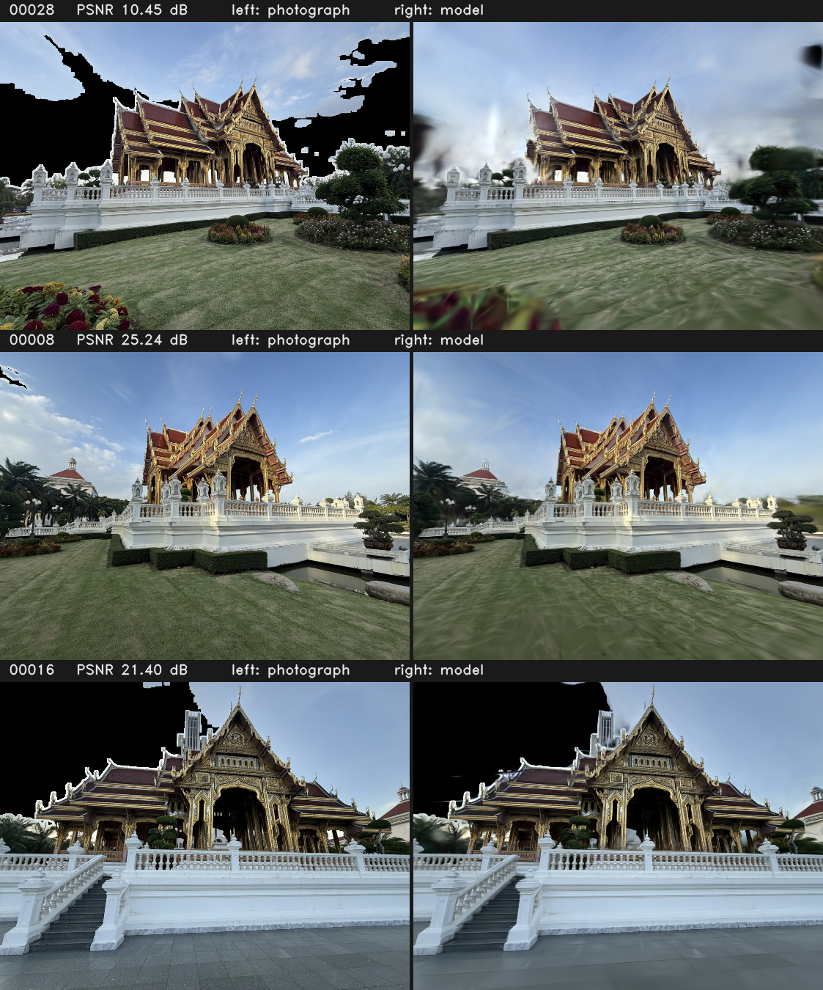
- Fig. 1. Held-out photographs of the pavilion beside the model’s own render of the same pose. Top: the worst-scoring view. Below: two typical ones. The structure is reproduced; the sky behind it is not.

Where the Score Is Actually Lost
Recomputing PSNR over sub-regions of the same renders, with no retraining:
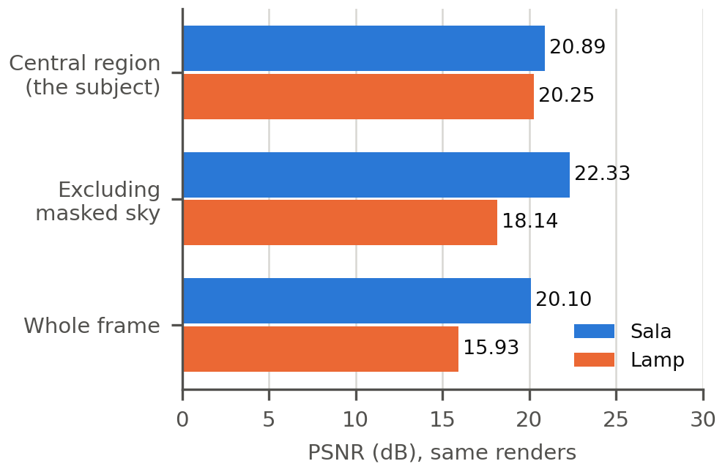
- Fig. 2. The same renders, scored over three regions. Excluding pixels the sky mask blackened lifts both models by more than 2 dB; over the region the subject occupies the two are within 0.6 dB of each other.
- TABLE 9. Region-decomposed scores.
Region | Sala | Lamp
Whole frame | 20.10 dB | 15.93 dB
Excluding pixels the sky mask blackened | 22.33 dB (+2.40) | 18.14 dB (+2.21)
Central region — the subject | 20.89 dB | 20.25 dB
Best single held-out view, central region | 25.56 dB | 30.01 dB
Blackened pixels, share of average frame | 11.8% | 17.4%

The lamp’s low headline number is a framing artefact. Over the region the lamp occupies it scores 20.25 dB and reaches 30.01 dB on its best view — comparable to the sala, and on its best view better than anything else in the project. Its whole-frame number is low because a small object photographed from 3.6 m leaves most of the frame filled with a lake, a treeline and buildings a hundred metres away, which a 3.6 m orbit gives no parallax on and therefore cannot constrain. The model renders them as smear, and PSNR counts every one of those pixels.
The sky mask costs more than any hyperparameter. The HSV-and-gradient mask fires on some frames and not on others: in held-out views 00007 and 00009 the ground truth shows open sky, while in 00012 the same sky is black. The model cannot satisfy both, so it learns a compromise and is penalised in both. This is worth 2.2–2.4 dB — roughly forty times what doubling the training budget would buy — and it is fixable in software, without new photographs.
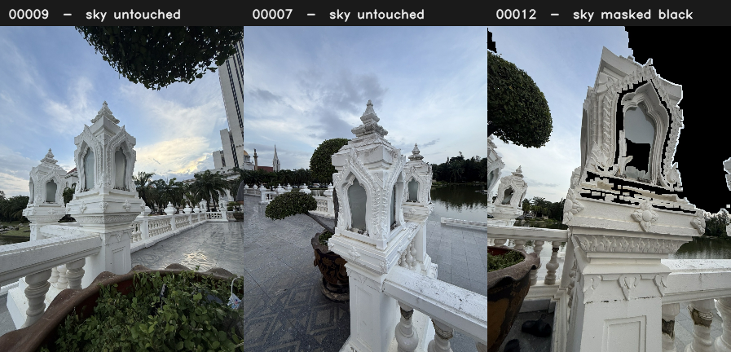
- Fig. 3. The sky mask is not consistent between views. The same overcast sky is left textured in two held-out frames and painted black in a third. Every blackened pixel is scored against a render that cannot match both cases.
Implication for the paper. A single whole-frame PSNR is not a measure of how well the subject reconstructed. Where the subject occupies a minority of the frame, the number is mostly reporting the background. This parallels the finding of the previous round — that sub-pixel reprojection error is not evidence of correct geometry — and has the same moral: the standard summary statistic answers a different question than the one being asked.

The Interior Never Joined the Exterior
COLMAP produced two disconnected sub-models for the sala, and 3DGS trained only the larger.
- TABLE 10. The split reconstruction.
Sub-model | Images | Trained
sparse/0 | 395 | yes
sparse/1 | 71 | no
In both | 20 | —
Exclusive to sparse/1 | 51 | no

Those 51 photographs are not a random scatter. Cross-referenced against the capture manifest, every one of them belongs to the Sala Inside folder. Of 93 interior photographs, 42 bound to the exterior walk and 51 did not.
The cause is ordinary and worth naming: standing under the roof, the camera sees painted ceiling and columns and almost nothing it saw from the terrace. Without frames that observe both at once, sequential matching finds no bridge, and COLMAP correctly reports two reconstructions rather than inventing a link between them. The model published as "the sala" is therefore the exterior.
The fix is cheap and belongs in the next capture: a handful of deliberate transition frames taken standing in the doorway, turning slowly from outside to inside, so the two halves share features. The 71 images in sparse/1 are already reconstructed and could be trained as a separate interior model at any time for roughly 40 minutes of GPU.

The Roof Was Never Photographed
Measuring the elevation of every camera about the centre of the reconstructed object, using a world up-vector derived from the cameras’ own up axes (mean agreement 0.97, i.e. the capture was level):
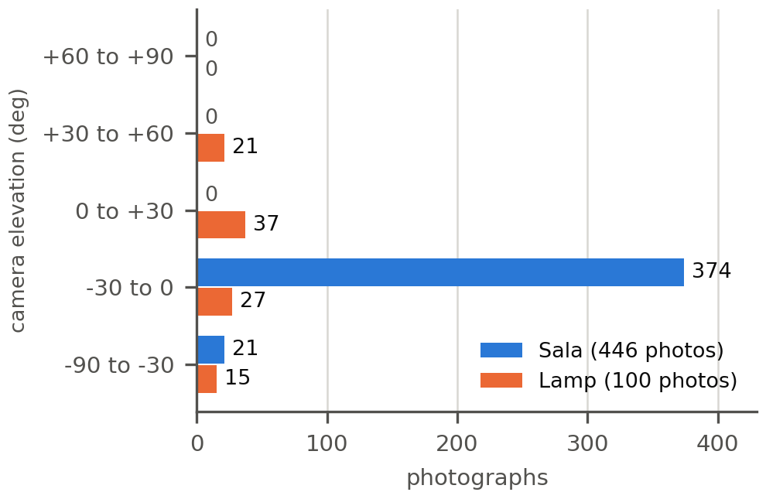
- Fig. 4. Camera elevation about the subject. Every sala photograph sits at or below the horizon; the upper hemisphere is empty. The lamp’s three orbits reach +43° but nothing overhead.
Azimuth coverage is complete for both — 12 of 12 sectors, thinnest 22 photographs for the sala and 4 for the lamp. The deficiency is entirely in elevation.
Not one of the 446 sala photographs looks down at the pavilion. The upper surfaces of the roof were never observed, so no Gaussian was ever placed on them and no amount of optimisation can create one. Viewed from above, the roof opens into a hollow shell — not because the model is undertrained, but because a radiance field contains only what was seen.
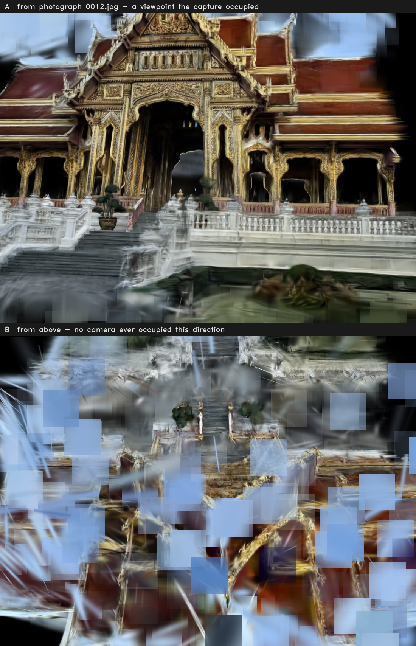
- Fig. 5. The same model, two viewpoints. A: rendered from the pose of a photograph the capture actually took. B: rendered looking down from above, a direction no camera ever occupied. Nothing distinguishes these two renders except whether the viewpoint was photographed.
This is the same limitation reported in the previous round, whose section 9.3 specified the remedy: elevated positions from floor 6 or higher of the main building’s east facade. The re-capture followed every other instruction and omitted this one. The honest conclusion is that the roof remains unobserved by choice of viewpoint, not by limitation of method, and that the project now has a direct measurement of the gap rather than an impression of it.

Was 30,000 Iterations Enough?
Yes, and the question can be answered quantitatively rather than by eye. Mean training L1 loss per 5,000 iterations, read from the TensorBoard event files:
- TABLE 11. Training loss, binned.
 | 0–5k | 5–10k | 10–15k | 15–20k | 20–25k | 25–30k
Lamp | 0.0911 | 0.0538 | 0.0438 | 0.0362 | 0.0335 | 0.0319
Sala | 0.0919 | 0.0663 | 0.0564 | 0.0477 | 0.0447 | 0.0429

The final 5,000 iterations improved the loss by 4.8% (lamp) and 4.0% (sala). Fitting L(t) = c + A·t^−b over the post-densification regime (16k–30k, after densification stops at 15,000) and extrapolating:
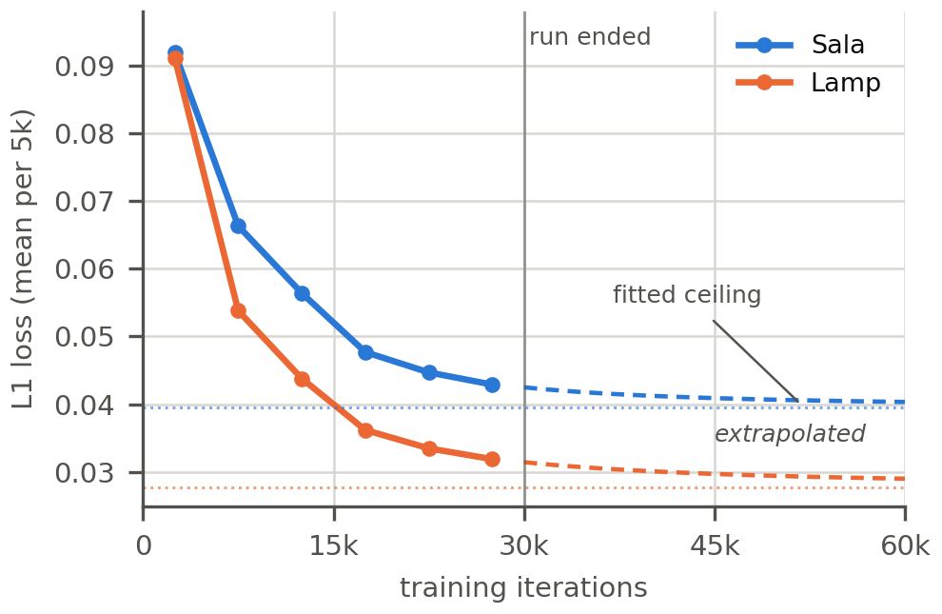
- Fig. 6. Measured loss (solid) with the fitted extrapolation (dashed) and its asymptote (dotted). The asymptote bounds what any amount of further training could achieve.
- TABLE 12. Extrapolated training loss.
Iterations | Lamp | Sala
30,000 (measured) | 0.0319 | 0.0429
40,000 | 0.0302 (−4.3%) | 0.0413 (−3.0%)
60,000 | 0.0291 (−7.8%) | 0.0404 (−5.1%)
∞ (fitted asymptote) | 0.0278 (−11.7%) | 0.0396 (−6.9%)

The asymptote is the important row: it bounds what any amount of further training could ever achieve. For the sala that ceiling is 6.9%, worth on the order of +0.3 dB, and roughly half of it would be reached by 40,000 iterations at a cost of about 2 h 20 m of additional GPU. For comparison, fixing the sky mask is worth 2.40 dB and costs no GPU at all.
One implementation detail bears on any attempt to extend a run: 3DGS decays the position learning rate over position_lr_max_steps, which defaults to 30,000. Resuming a finished 30,000-iteration checkpoint therefore continues at the floor of that schedule, where Gaussians barely move, and yields materially less than the extrapolation above. Reaching the predicted values requires a fresh run with --iterations 40000 so that the schedule stretches.
Conclusion: 30,000 iterations was the correct stopping point. Training is not the binding constraint on any result in this report.

The Viewer
Both models are published as interactive pages alongside the existing image-based renderer and photogrammetry mesh, and linked from index.html. Consistent with the project’s standing constraint, these are the clearly-labelled reconstruction comparison arm and are never mixed into the image-based rendering pipeline.
- TABLE 13. Published viewer pages.
Page | Model
sala.html | September capture, 291,764 Gaussians, 395 poses
lamp.html | 163,756 Gaussians, 100 poses
splat.html | August version2 capture, retained for comparison

Each embeds its model as base64 in a JavaScript global and reads the renderer from vendor/splat.js (antimatter15/splat, MIT), so the pages open from file:// with no server and no build step — the same constraint the rest of the viewer observes. The vendored renderer was extended by six lines to accept per-page camera poses and an opening view matrix; pages that supply neither are unaffected, so the existing splat.html renders exactly as before.
The published models are the cropped fields, not the full ones. This is deliberate: the discarded Gaussians are the background that scores around 10 dB, and including them would make the pages both heavier and worse. The sala page shows 291,764 of 653,917 Gaussians; the lamp page 163,756 of 1,053,976. Both pages state their own limitations, with the measured numbers, rather than presenting a headline score without context.
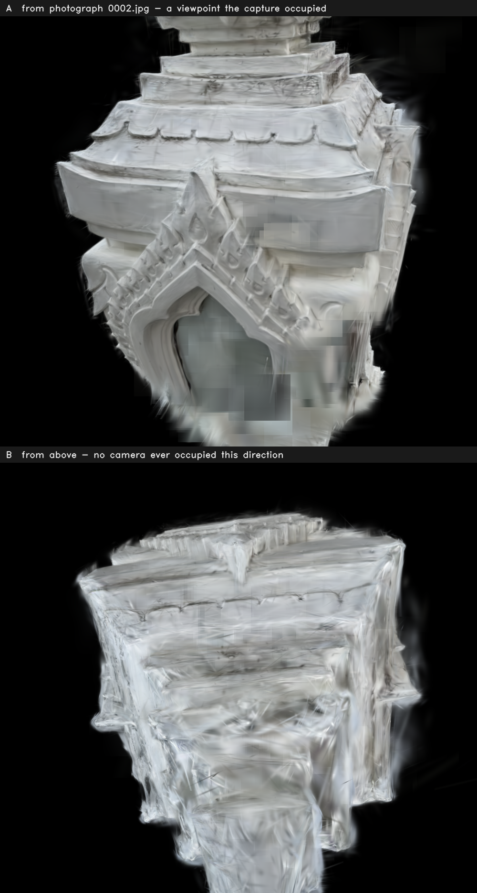
- Fig. 7. The lamp model. A: from a photographed pose, where the mouldings resolve cleanly. B: from above, outside the envelope its three orbits covered.

Process Failures, and What They Cost
- TABLE 14. Process failures.
Failure | Cost | Correction
A pipeline path — undistort to train — that had never been executed was assumed to work | One full Kaggle run, ~3 h | Verified locally end to end against 3DGS’s own loader before re-running
The fold check was applied to captures whose frame ordering could not be verified | Two runs rejected on a test that did not apply | Gated to captures with verified ordering; now warns rather than aborting
The sky mask was never checked for consistency between views, only for whether it ate the subject | 2.2–2.4 dB in every reported score | Measured this round; not yet fixed
The elevated-viewpoint instruction was not carried through to the capture plan | The roof is unobserved for a second consecutive round | Must appear in the capture one-pager as a required segment, not a recommendation
Full-frame PSNR was quoted for four rounds without asking what share of the frame is subject | Understated every object-scale result | Region-decomposed scores reported alongside the headline from this round on

The pattern across this round and the last is consistent: the failures were in verification, not in the method. Every one was a case of a number or a stage being trusted without being checked against what it actually measured.

What Version 6 Should Do
In order of cost.
- Fix the sky mask, retrain nothing. Enforce view-consistency — either mask nothing and let the crop remove distant floaters, or segment the sky per-frame with a model that does not flip between adjacent views. Worth 2.2–2.4 dB, zero GPU.
- Constrain the viewer’s camera to the photographed envelope (−30° to 0° for the sala, −43° to +43° for the lamp) so unobserved directions cannot be flown into. No retraining; removes the most visible artefact in the published pages.
- Train the interior sub-model from sparse/1. 71 photographs already reconstructed, ~40 min GPU, and it adds content that currently exists in no model.
- Train the far set — 171 photographs, prepared and untouched, at a second capture radius.
- Re-shoot for elevation. 40–60 frames between +30° and +60°, plus doorway transition frames so the interior binds. This is the only route to an observed roof and to a single connected model, and it is now the third round in which it has been the outstanding item.
Do not spend GPU on more iterations. The extrapolation above bounds the entire remaining benefit at 7–12% of training loss, against a 2.4 dB gain available from a software fix.

Reproducing the Numbers
- TABLE 15. Where every number in this report comes from.
Claim | Source
Capture EXIF, focal-length spread, ISO, shutter | PIL.Image.getexif() over the 5 Sep HEIC originals; pillow-heif for decoding
Segment counts | CV_Photos_prepared/{sala,lamp}_manifest.csv
Registration counts, fold ratios | Kaggle run logs; notebook cells 8 and 9
Two sub-models, and which images are in each | COLMAP sparse/{0,1}/images.bin, decoded from the binary record format
Held-out scores | results.json, 3DGS metrics.py, every 8th frame held out via --eval
Per-view scores | model/per_view.json
Region-decomposed PSNR | Recomputed from model/test/ours_30000/{gt,renders}/*.png; background = pixels below value 18 in either image
Loss curves and extrapolation | model/events.out.tfevents.*, parsed from the TFRecord/protobuf stream
Camera elevation coverage | cameras.json positions against the median of the cropped model’s Gaussian centres; world up from the mean of the cameras’ own up axes
Gaussian counts | .splat file size ÷ 32 bytes per row; PLY element vertex header
Renders in Figs. 1, 4 and 5 | CPU EWA splat rasteriser written for this report: 3D covariance from quaternion and scale, projected through the perspective Jacobian, alpha-composited back to front

Raw outputs are in Term-Project/kaggle_out/{sala,lamp}/. The notebooks are resumable: every expensive stage banks to /kaggle/working and is restored before any work is redone, so re-running the same file after a failure skips whatever already completed.

