Sala Chaturamuk Phaichit Viewer: An Image-Based Rendering Approach to a Thai Pavilion

Win Yu Maung
Vincent Mary School of Engineering, Science and Technology
Suvarnabhumi Campus, Assumption University of Thailand
Samut Prakan, Thailand
u6612054@au.edu
Myat Bhone Thet
Vincent Mary School of Engineering, Science and Technology
Suvarnabhumi Campus, Assumption University of Thailand
Samut Prakan, Thailand
u6611935@au.edu
Min Pyae Hein
Vincent Mary School of Engineering, Science and Technology
Suvarnabhumi Campus, Assumption University of Thailand
Samut Prakan, Thailand
u6511684@au.edu

Abstract—Traditional Thai pavilions, or salas, are an integral part of Thai architectural heritage, yet many remain documented only as isolated photographs with no interactive digital record. This paper presents an image-based rendering viewer for Sala Chaturamuk Phaichit, the four-porched Thai pavilion at the Assumption University Suvarnabhumi campus, which lets a user examine the structure from a range of viewpoints without constructing an explicit 3D model. Photographs are captured along an arc around the pavilion, correspondences between adjacent frames are established through feature matching, and intermediate viewpoints are synthesized by optical-flow view interpolation and assembled into a drag-to-rotate web viewer. This project update adds two things. First, the interpolation is now measured: withholding every second photograph of a 146-photograph closed-loop capture, the synthesized frames reach a mean PSNR of 13.88 dB and SSIM of 0.491 against the real held-out photographs, versus 13.27 dB and 0.479 for the nearest captured frame that a plain object-movie viewer would show. Second, at the course instructor's request, an explicit reconstruction is reported as a separate, clearly-labelled comparison built from the same photographs: a photogrammetry mesh, with per-image sky masking and a fitted cap for the roof crossing that no photograph could see, and a 3D Gaussian splatting model reaching 22.09 dB PSNR on its 19 held-out views. The three are compared on computational cost, viewpoint coverage and image quality; image-based rendering remains the contribution of the work.
Keywords—Thai arts and culture, rendering, image-based rendering, view interpolation, photogrammetry, Gaussian splatting.

Introduction
Sala pavilions are common features of Thai temples, palaces, and university campuses, providing shaded seating and serving as focal points for ceremony and gathering. Sala Chaturamuk Phaichit, the pavilion at the Assumption University Suvarnabhumi campus, was named by HRH Princess Maha Chakri Sirindhorn and is used for Thai cultural ceremonies and university events. While such structures are appreciated in person, few exist in a form that can be explored remotely or preserved digitally beyond ordinary photographs. Full 3D reconstruction can enable remote exploration, but it typically requires dense multi-view stereo or laser scanning that is impractical for a small student project. Image-based rendering offers an alternative: novel views of a scene can be synthesized directly from a sparse set of photographs, without recovering explicit 3D geometry [1]. In this project we apply image-based rendering to Sala Chaturamuk Phaichit, producing an interactive viewer that approximates a walkaround from a modest set of captured photographs. The remainder of this paper reviews related work in image-based rendering, describes our capture and interpolation pipeline, presents results, and discusses the limitations imposed by the pavilion's setting and symmetry.
This version of the report is a project update. Since the previous version the pipeline's hold-out evaluation has been run, so the comparison between the interpolation-based viewer and the naive frame-switching baseline is now a measurement rather than an impression. In addition, the course instructor asked for a 3D model produced by reconstruction methods. That is deliberately outside the image-based rendering premise, so it is reported here as a separate, clearly-labelled comparison (Section III-C and Section IV-D): the same 146 photographs are also fed to a photogrammetry pipeline and to 3D Gaussian splatting, and the three approaches are compared on cost, coverage and quality. The image-based renderer itself remains geometry-free.

Literature Review

Object Movies and View Interpolation
Early image-based rendering systems such as QuickTime VR represented an object using a discrete ring of photographs and let a user step between adjacent views to simulate rotation. Chen and Williams introduced view interpolation, using pixel correspondences between image pairs to synthesize intermediate viewpoints and produce smoother transitions than simple frame switching [2]. Seitz and Dyer extended this idea with view morphing, which produces physically plausible in-between views under a simple camera model [3]. These techniques form the basis of the interpolation-based viewer used in this project.

Light Fields and Plenoptic Sampling
A complementary line of work treats image-based rendering as sampling a scene's plenoptic function directly. Light field rendering and the closely related lumigraph represent a scene as a dense array of captured rays, allowing novel views to be reconstructed by resampling this ray database rather than interpolating between a small number of photographs [4]. McMillan and Bishop's plenoptic modeling similarly reconstructs new views directly from range-augmented image data [5]. These methods generally require far denser capture than a single ring of photographs, which motivated the simpler view-interpolation approach used here for a sala captured with an ordinary handheld camera.

Explicit Reconstruction: Photogrammetry and Gaussian Splatting
The methods that image-based rendering sets out to avoid recover geometry first. Structure from motion estimates camera poses and a sparse point cloud from feature correspondences across all images [6]; multi-view stereo then densifies it and a surface is extracted and textured, a pipeline packaged for consumers as photogrammetry [7]. 3D Gaussian splatting [8] instead optimizes a set of anisotropic 3D Gaussians, initialized from the sparse points, so that rasterizing them reproduces the photographs; it renders in real time and reaches high fidelity near the captured viewpoints. Both produce a scene representation that can be viewed from any angle, at the cost of a reconstruction stage, and both inherit the occlusions of the capture: a surface no photograph sees is simply absent. Mesh fairing by Taubin smoothing [9] and the SSIM [10] and LPIPS [11] image metrics are used in the comparison.

Methodology
Our pipeline consists of three stages: image capture around the physical sala, pose recovery through feature correspondence, and view interpolation to synthesize intermediate frames, followed by assembly into an interactive web viewer. Each stage is implemented as a standalone, argument-driven script, chained by a single orchestration script so that every stage's output can be inspected independently. A fourth, separate branch, explicit reconstruction from the same photographs, was added for comparison only and is described in Section III-C; it shares nothing with the image-based pipeline except the input.
Each of these stages is described in the remainder of this section.

Image Capture
Photographs were captured along the safely accessible land-side arc surrounding Sala Chaturamuk Phaichit, walking at an approximately constant camera-to-pavilion distance and a fixed camera height, using the phone's standard 1x lens in landscape orientation and pointing toward the pavilion's centre. Because the adjacent lake and site boundaries prevent a continuous constant-radius path around all four sides, the captured photographs cover a partial arc rather than a complete 360-degree rotation. Capture was carried out across two walks along the same arc, later combined into a single ordered sequence; after excluding a small number of test and misoriented frames, 206 usable photographs remained. Exposure, white balance and focus were locked manually to prevent flicker and refocusing between frames, and capture was carried out under overcast conditions to limit shadow movement. The second capture, salathai_version2 (146 photographs), on which every result in this version is reported, was walked close in along the pavilion's own terrace and garden, which does permit a closed loop; the sequence therefore wraps around, and its mean angular spacing is 360°/146 = 2.47° between captured photographs and 0.82° between displayed frames once two synthesized views are inserted per pair.

Pose Recovery and View Interpolation
- SIFT keypoints were extracted and matched between each pair of adjacent images using a FLANN-based matcher with Lowe's ratio test. Matching was restricted to adjacent frames only, since the pavilion is four-porched and close to rotationally symmetric and matching across the full set risks false correspondences between structurally similar faces. Outlier matches were filtered with RANSAC, fitting a fundamental matrix where the two views have sufficient parallax and falling back to a homography where that model is degenerate. Each adjacent pair was additionally checked for the scene displacement between the two photographs, since large displacements exceed what the subsequent optical-flow stage can track; this check flagged 15 of the 205 adjacent pairs in the captured sequence, consistent with a brief pause and a foreground obstruction identified on inspection of the photographs at those points.
- Dense optical flow (Farneback) was computed along each matched pair to build a per-pixel warp field between adjacent viewpoints.
- The warp field was used to generate two intermediate frames per adjacent pair through backward warping. Rather than cross-dissolving the two warped photographs with a fixed weight everywhere, each pair’s two flow fields are first checked against each other with a forward-backward round trip; pixels whose correspondence fails this check are taken from the temporally nearer photograph instead of being blended, with the transition feathered. A blend of two misaligned photographs is exactly a double-exposure ghost, so mistracked regions degrade to a clean cut rather than an artifact. The fraction of pixels failing the check is recorded per pair as a diagnostic.
All real and synthesized frames were ordered by capture sequence and exported as a single sequence for the viewer; for the closed-loop capture the angle of every frame follows directly from its index.

Reconstruction Comparison (Separate from the IBR Pipeline)
Everything in this subsection lives in a separate recon/ directory and never feeds back into the image-based pipeline or its viewer. Two reconstructions were built from the same 146 photographs.

Sky masking
The first photogrammetry attempt turned the overcast sky into geometry: a white sheet draped over the pavilion roof (Fig. 2a). The fix is to tell the engine which pixels are not the object. A sky mask is computed for every photograph as the bright (V > 140), unsaturated (S < 50), gradient-smooth region connected to the top border, morphologically closed and then eroded by 4–5 px so building edges are never eaten (Fig. 1); the 146 masks are passed as per-sample object masks. With masks in place no sky is reconstructed and the roof is captured as far as the photographs see it (Fig. 2b).
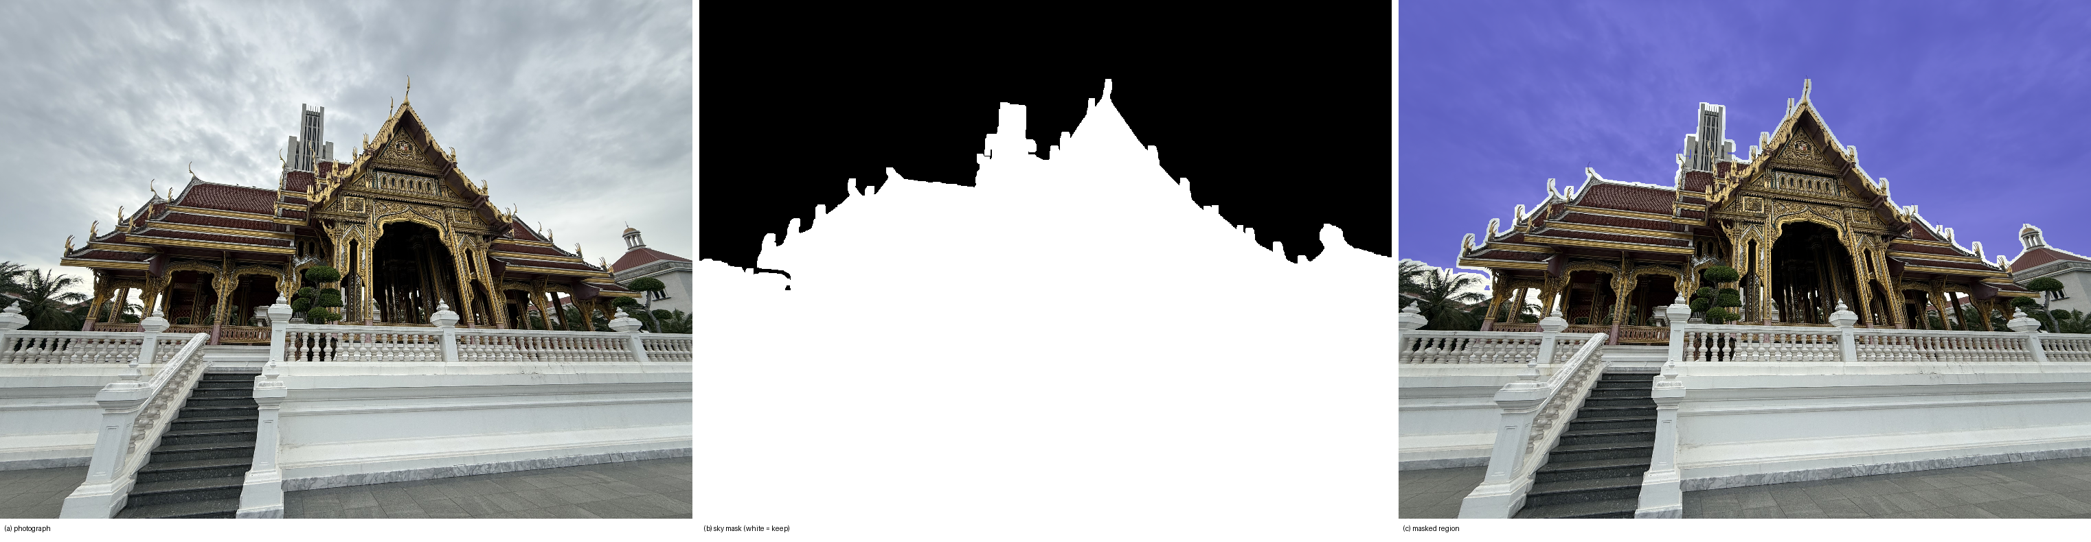
- Sky masking. (a) A photograph from the second capture; (b) its automatically computed mask, white = keep; (c) the masked region overlaid in red. Only regions connected to the top border are treated as sky, so the white balustrade and terrace are untouched.

Photogrammetry
Apple's Object Capture (RealityKit PhotogrammetrySession) was driven from a small command-line tool on an Apple-silicon MacBook Air. At full detail it produced a mesh of 249,999 faces and 125,117 vertices with an 8192 × 8192 texture in 17 minutes of wall-clock time (a medium-detail run gives 96,930 faces). The mesh is exported as usdz.

Mesh post-processing
Three documented, cosmetic operations follow; the reconstruction itself is not changed. The terrain sheet is cropped to a radius of 2.0 units about the pavilion and its ragged fringe trimmed; sliver faces (corner angle under 4°) are dropped; holes of up to 200 boundary edges are closed and the surface is smoothed with 30 Taubin steps (λ = 0.5, μ = −0.53), which preserves volume so the texture rides along on unchanged coordinates. The final mesh has 165,906 triangles (Fig. 2c).
One region needs more than cosmetics. The four gables meet at a crossing that appears in no photograph: from eye level it is hidden behind the surrounding roofs, so the reconstruction has no surface there, only crumpled sky fragments. Every attempt to hide this failed on inspection (Fig. 3a–c): recolouring the fragments read as melted wax, deleting them opened a hole, texture inpainting filled white with white, a dark occluder below them changed nothing, and a fan of triangles to a single apex read as a tent covering half the roof. What works is modelling the missing surface. A sala chaturamuk's crossing is a cross-gable, h(u, v) = H − s·min(|u|, |v|) in ridge-aligned coordinates, and every parameter is fitted from the real roof around it: the centre is the area-weighted centroid of the top-tier roof faces, the ridge axis the four-fold circular mean of their normals, H the 96th-percentile height of those faces (so real finials stay the highest points) and the slope s = 1.70 (about 60°) the median rise-over-run of their normals. The surface is sampled on a 56 × 56 grid over the 0.58-unit crossing square, conflicting fragments inside its volume are removed, a 40 cm skirt hangs from its edge and its boundary is welded onto the real roof (187 of 220 boundary vertices within 12 cm). It is textured with a plain tile field cut from one photograph (Fig. 3d). This cap is the one part of the mesh that is modelled rather than measured, and it is labelled as such in the viewer.
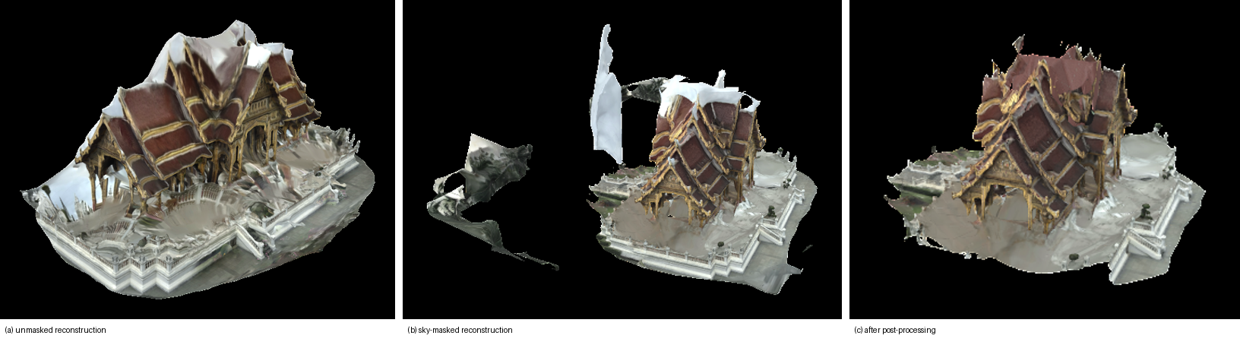
- The photogrammetry mesh at three stages, eye-level view. (a) Unmasked reconstruction: the overcast sky has become a white sheet over the roof. (b) With per-image sky masks. (c) After post-processing, with the fitted crossing cap.
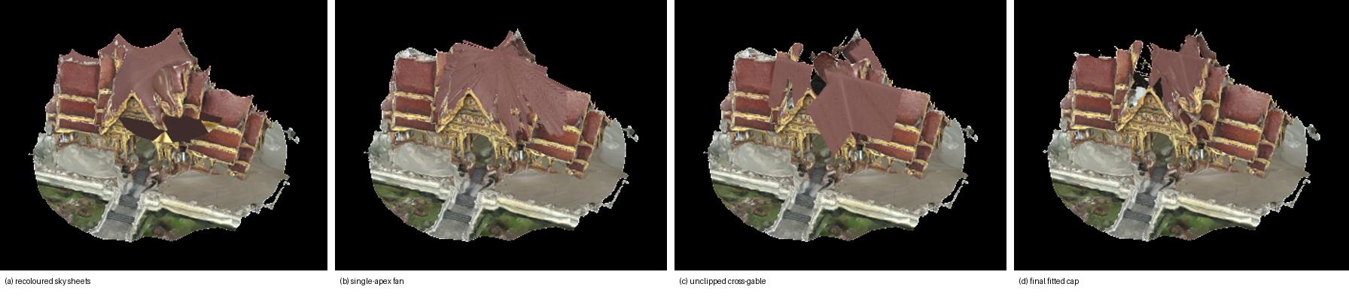
- The roof crossing, elevated view, across the attempts that were rejected on inspection and the final one: (a) recoloured sky fragments; (b) a single-apex fan; (c) the fitted cross-gable before clipping its sampling domain, running out along the wings; (d) the final clipped, skirted and welded cap.

Gaussian splatting
Camera poses were recovered with COLMAP [6] (sequential matching between neighbouring photographs only, for the same symmetry reason as in Section III-B; a single SIMPLE_RADIAL camera; all 146 images registered), the images were undistorted to a pinhole model, and the reference implementation of 3D Gaussian splatting [8] was trained for 30,000 iterations on a Kaggle T4 GPU, about 1 h 36 min. Every eighth photograph (19 views) was withheld from training and used only for scoring; PSNR, SSIM and LPIPS are computed by the implementation's own evaluation script.

Viewing
The mesh is shown on a separate page of the web viewer (reconstruction.html), linked from the image-based viewer and linking back, never as a mode of it. Like the rest of the viewer it opens from file:// with no build step: three.js is vendored locally and the mesh is embedded as a base64 glTF binary (165,906 triangles, 4096-px JPEG texture, 11 MB). The Gaussian model is viewed in the SuperSplat web editor (Fig. 9).

Results and Analysis
Both viewers are functional. Two kinds of measurement are reported. Table I gives the hold-out evaluation of the interpolation against real photographs, and Table II compares the image-based renderer with the two reconstructions built from the same photographs. Qualitative observations are kept where they add something the numbers do not show.
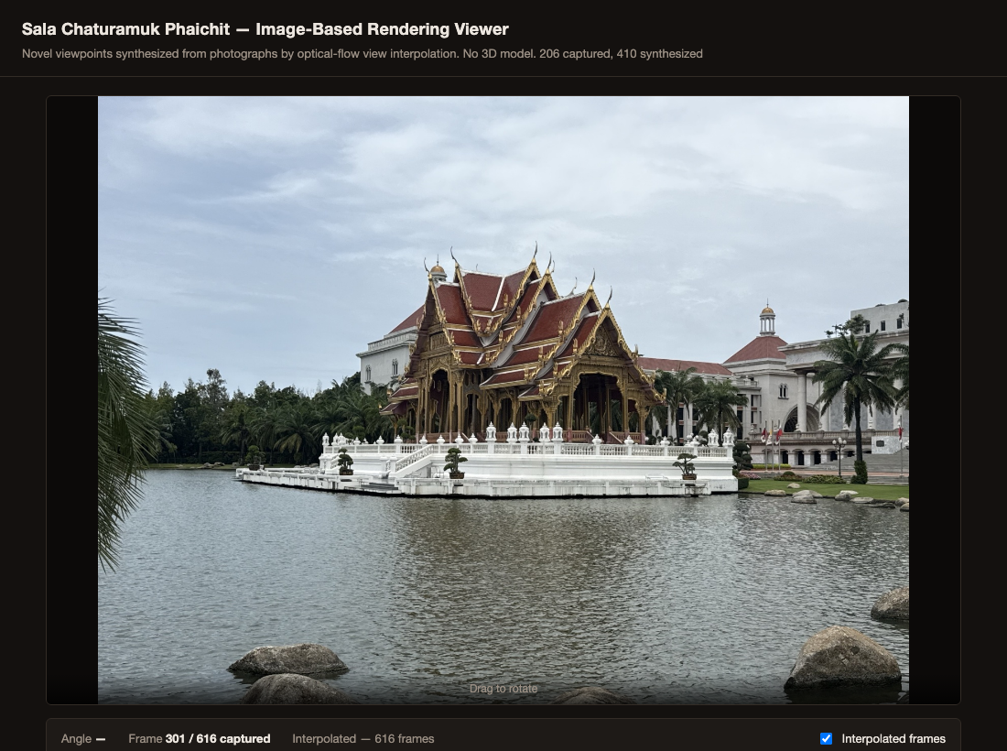
- The interactive viewer displaying a captured photograph roughly midway through the arc (frame 301 of 616).

Baseline Object-Movie Viewer
The baseline viewer switches directly between the captured photographs as the pavilion is rotated, with no frames synthesized in between.

Hold-out protocol. Every second photograph of the closed-loop capture was withheld, leaving 73 captured frames at twice the viewer's operating spacing (4.9°) and 72 real photographs at the midpoints as ground truth. Two frames were synthesized between each remaining pair, at one third and two thirds of the way across, and each was scored against the withheld photograph at the midpoint, once for the flow-interpolated frame and once for the nearest captured frame, i.e. what the baseline viewer shows at that angle. Because no synthesized frame sits exactly at the withheld position, every score carries a residual viewpoint offset of about 0.8°, so the absolute values are conservative for both methods; the comparison between them is like for like.

Result. Over the 144 scored positions the interpolated frames average 13.88 dB PSNR and 0.491 SSIM; the baseline's nearest captured frame averages 13.27 dB and 0.479. The interpolated frame scores higher than the baseline at 135 of the 144 positions on PSNR and 128 on SSIM, a mean gain of 0.60 dB. The per-frame range is 10.2–17.2 dB for the interpolation and 9.8–15.9 dB for the baseline. The absolute level is low for both because the held-out photographs were shot hand-held on a walked loop, so they differ from any synthesized view in position and heading, not only in angle; the gain isolates what interpolation adds on top of that.

At the 2.47° captured spacing the scene moves a median 2.5% of the frame width between adjacent photographs (median 1609 RANSAC inliers per pair, range 283–3982); the baseline changes the whole frame at once by that amount.

5 of the 145 adjacent pairs (3.4%) exceed the 8%-of-frame-width displacement beyond which the flow stage cannot track; at those pairs fine detail such as roof finials is where the interpolation degrades first.

Exposure, white balance and focus were locked and the capture was made under overcast sky; no exposure flicker is visible across the 146 photographs, so the frame-to-frame differences measured above are viewpoint changes, not lighting changes.

Interpolation-Based Viewer
Synthesized frames are inserted between each pair of captured photographs using the optical-flow warp described in Section III.
Over roof edges and eaves the interpolation holds up wherever the flow is consistent: across the sequence the median fraction of pixels failing the forward-backward consistency check is 29.0% per pair, and those pixels fall back to the nearer photograph rather than being blended. The three lowest-scoring positions are frame_0043_i1.jpg (10.2 dB), frame_0042_i1.jpg (10.4 dB), frame_0042_i2.jpg (10.5 dB).
Artifacts are most visible at three identified points in the captured sequence: the join between the two capture sessions, and two locations within the second session — one coinciding with a longer pause between shots and one where a tree branch briefly obstructed the pavilion in the frame. All three were flagged automatically by the per-pair displacement check described in the Methodology before the affected frames were inspected, and the visible artifact at each is consistent with the cause identified in the underlying photographs.
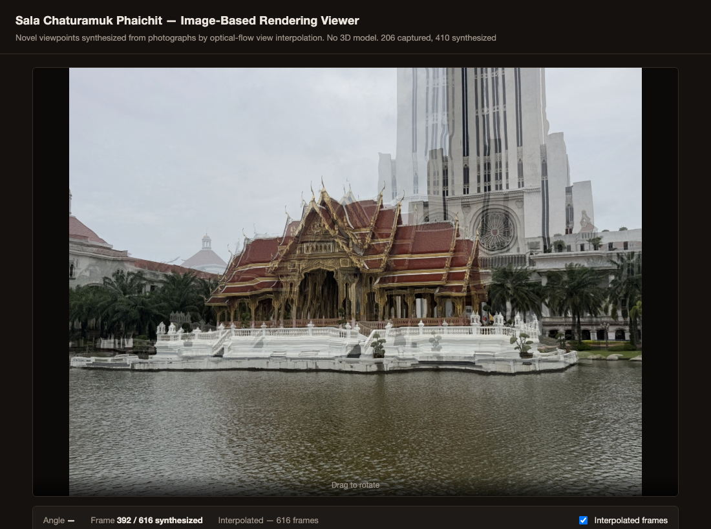
- A synthesized frame at the join between the two capture sessions, showing the double-exposure artifact discussed above.
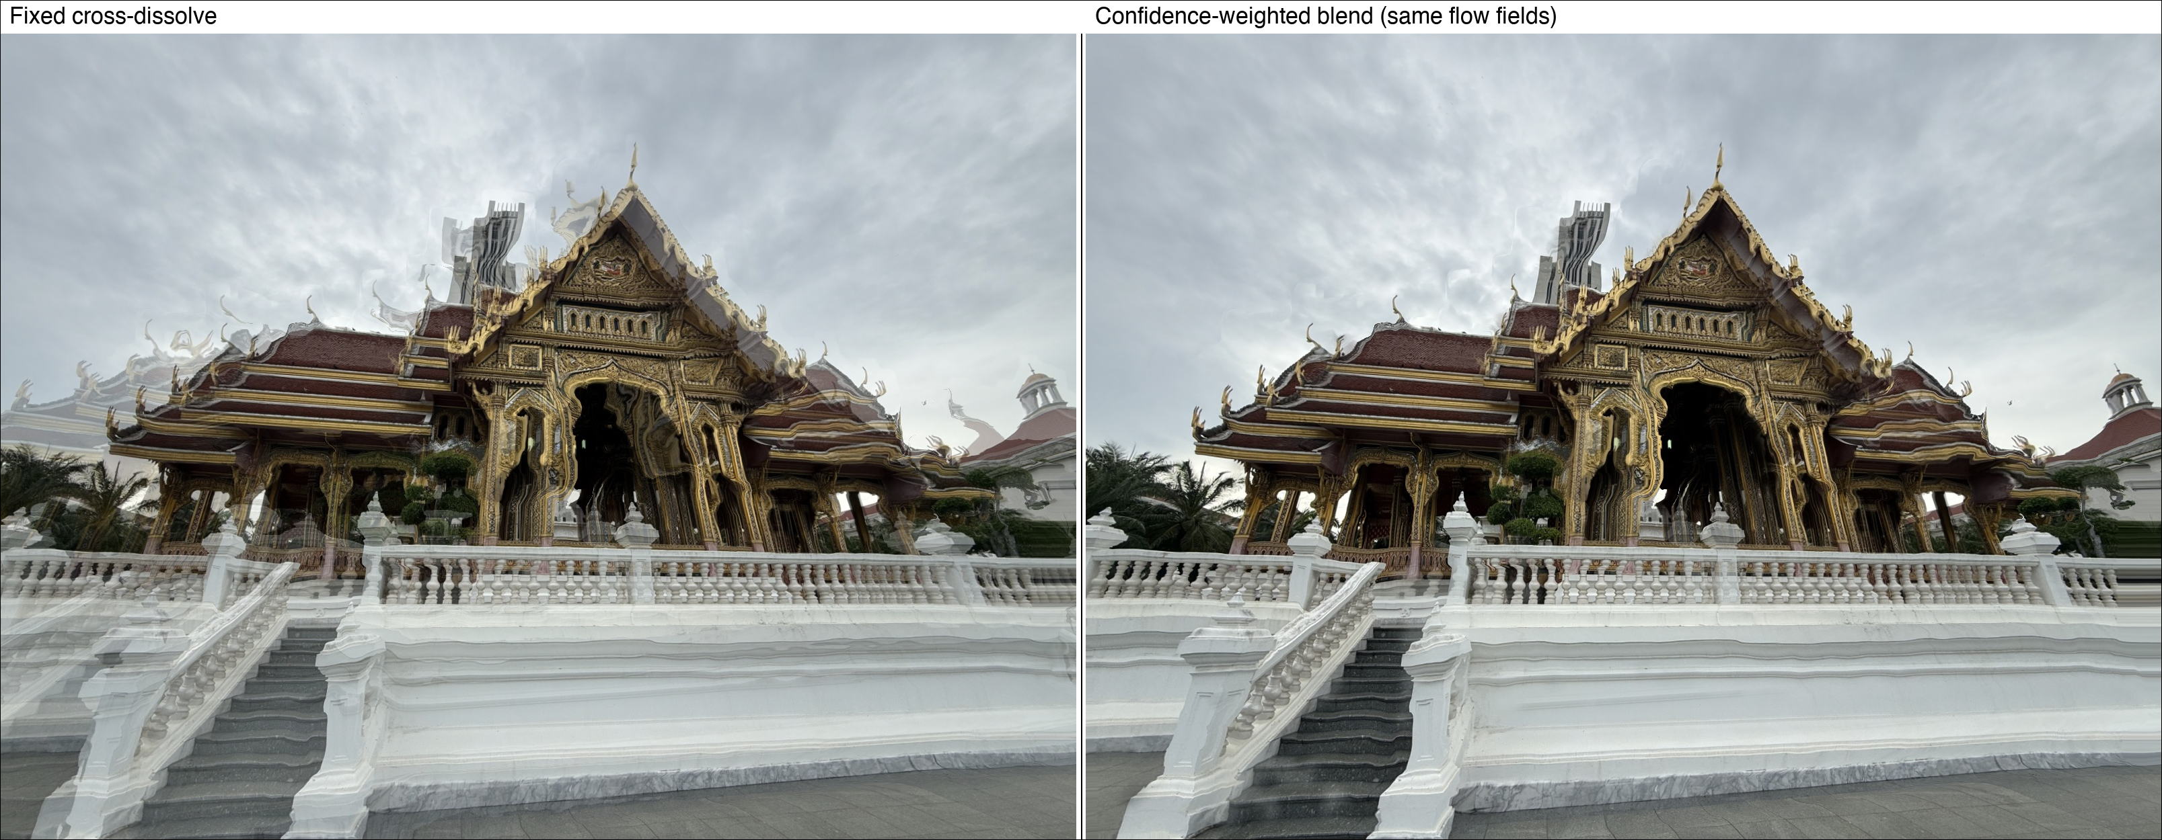
- The same synthesized frame (salathai_version2, between captured frames 41 and 42) under the fixed cross-dissolve and under the confidence-weighted blend, computed from identical flow fields. For this pair 43.2% of pixels fail the forward-backward consistency check and fall back to the nearer photograph, replacing the transparent double staircase and balustrade of the fixed dissolve with a single solid structure.

Quantitative Comparison

Table I reports the frame counts, angular spacing and hold-out scores of the two viewers on the second capture; Table II compares the three approaches on the same photographs. The reconstruction results follow in Section IV-D.
- Viewer parameters and hold-out scores, second capture
 | Viewer Comparison
 | Metric | Baseline | Interp.
1 | Displayed frames | 146 | 438
2 | Mean angular step between displayed frames (deg) | 2.47 | 0.82
3 | PSNR vs. held-out photograph, mean (dB) | 13.27 | 13.88
4 | SSIM vs. held-out photograph, mean | 0.479 | 0.491
- Image-based rendering versus reconstruction
 | Three Approaches, Same 146 Photographs
 | Metric | IBR (ours) | Photogram. | 3DGS
1 | Geometry recovered | none | mesh, 165,906 tri. | ≈0.38 M Gaussians
2 | Compute for synthesis | 151 s, CPU | 17 min, CPU/GPU (M-series) | 1 h 36 min, T4 GPU
3 | Held-out PSNR (dB) | 13.88 (144 frames) | n/a (mesh) | 22.09 (19 views)
4 | Held-out SSIM | 0.491 | n/a (mesh) | 0.785
5 | Viewpoints | captured ring only, no tilt | any; roof crossing modelled | any near ring; artifacts beyond

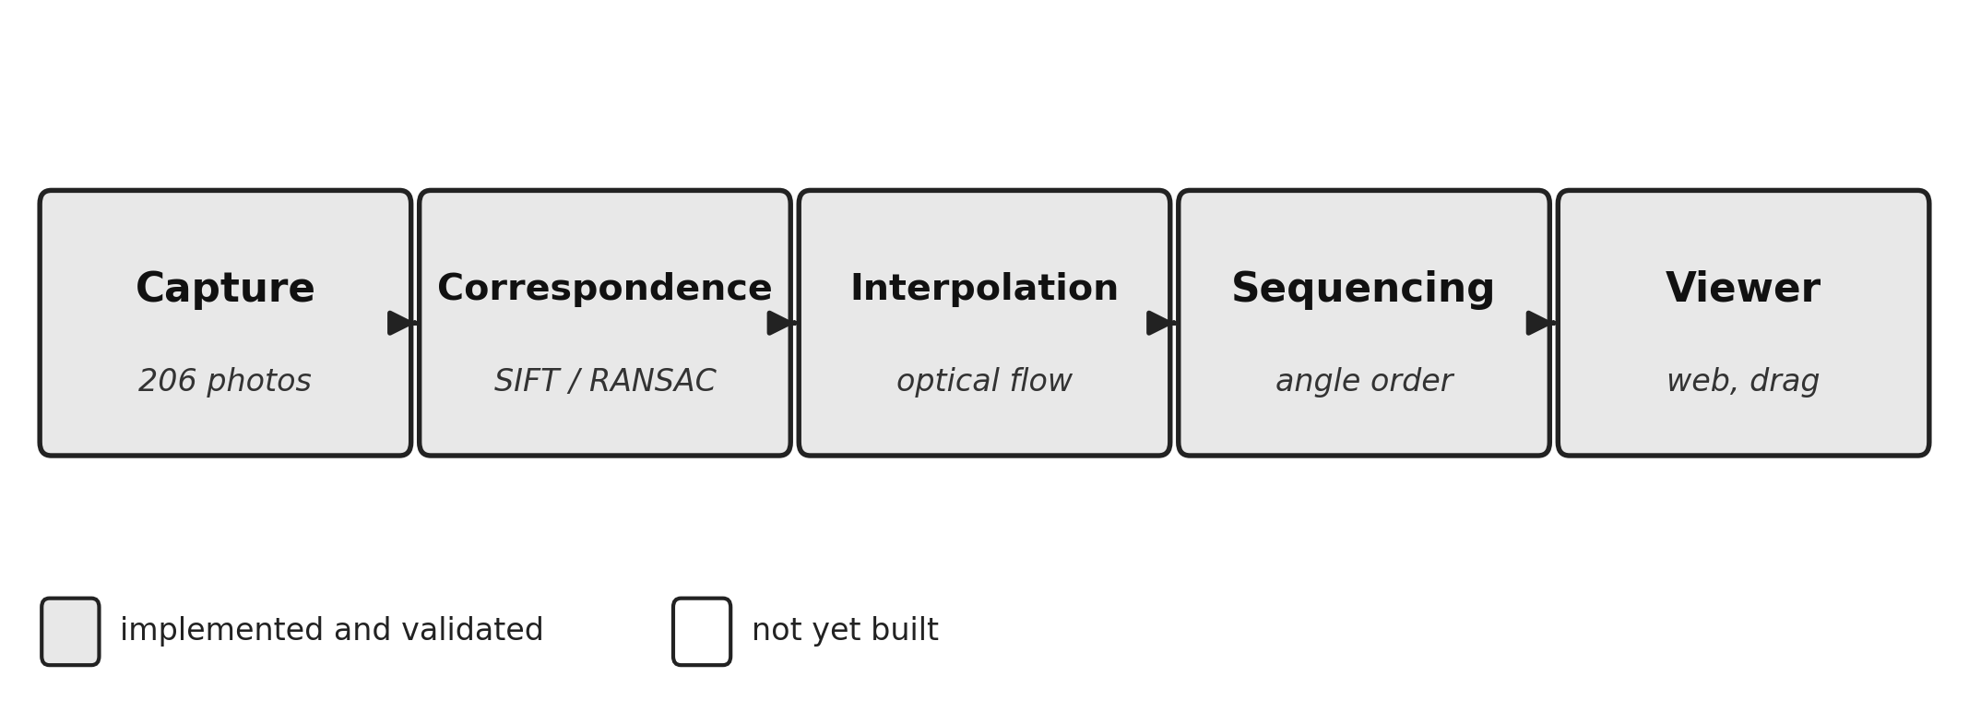
- Overview of the image capture and view interpolation pipeline used to build the Sala Chaturamuk Phaichit viewer.
The pipeline runs end to end on real photographs of the pavilion and produces a working, interactive viewer with no explicit 3D geometry at any stage, which supports the core premise of image-based rendering. Whether the interpolated views are convincing enough to matter, and how they compare quantitatively to the baseline, remains to be established by the measurements above. The most visible limitation observed was double-exposure ghosting in synthesized frames, most pronounced at the join between the two capture sessions but also visible, to a lesser extent, in some pairs well within a single session. Comparing the affected frames against the per-pair displacement diagnostic showed this was not purely a consequence of the session gap: some pairs under the flagging threshold still ghosted on thin, high-contrast structures such as roof finials and a distant background tower silhouetted against open sky, where the default Farneback flow settings could not track fine detail reliably. Raising the flow window size, pyramid levels, iterations, and polynomial-expansion parameters and regenerating both capture sequences with these settings visibly sharpened the pavilion itself in previously ghosted frames, including at the session join described above. A second, independently captured sequence of the same pavilion (salathai_version2, 146 photographs) was shot with deliberately tighter spacing between adjacent positions, directly targeting the root cause rather than only the flow estimator: Farneback flow estimates correspondences from local pixel displacement, so a smaller displacement between adjacent photographs gives it less distance to track and a shorter distance over which its estimate can drift, independent of any parameter tuning. This shows up in the same displacement diagnostic used throughout: the fraction of adjacent pairs flagged fell from 7.3% (15 of 205) in the original capture to 3.4% (5 of 145) in the tighter one. Applying the tuned flow parameters on top of this tighter capture compounds both fixes. The doubling that still survived both was then addressed at the blend itself: as described in the Methodology, pixels whose flow fails a forward-backward consistency check now take the temporally nearer photograph instead of being cross-dissolved, so a pair the flow cannot bridge degrades to a clean cut rather than a double exposure — the comparison shown above isolates exactly this change, holding the flow fields fixed. Across the regenerated sequences the median fraction of pixels failing the check per pair is 35.9% for the original capture and 29.0% for the tighter one, peaking at 90.4% at the join between the two capture sessions, whose synthesized frames are therefore effectively a cut between the two photographs; the doubled pavilion previously visible there is gone. What remains at such extreme pairs is a wavy distortion of fine background structure — most visibly the distant tower — where the flow is coherently wrong in both directions and so passes the consistency check; reshooting that stretch of the arc more densely remains the outstanding fix.

Reconstruction Comparison
Cost. The image-based pipeline synthesizes its 292 in-between frames in 151 s on a laptop CPU with no training and no geometry. The photogrammetry mesh took 17 min on the same laptop, and the Gaussian model 1 h 36 min of GPU training on a rented T4; both also need a structure-from-motion or equivalent pose-recovery stage first.
Coverage. The image-based viewer can only show viewpoints on the captured ring, at the captured height; it cannot tilt or approach. Both reconstructions can be viewed from any angle, but they inherit every occlusion of the capture: the mesh had no surface at the roof crossing until one was modelled (Section III-C), and the Gaussian model is sharp near the ring of training views and degrades to floating and needle-shaped Gaussians when the camera leaves it (Fig. 9). Neither reconstructs what was never photographed; they only make the gap easier to see.
Quality. On held-out photographs the interpolation reaches 13.88 dB / 0.491 and the Gaussian model 22.09 dB / 0.785 (LPIPS 0.346). The two protocols are alike in spirit, real photographs never used in synthesis, but not identical: the interpolation is scored at every second position of the ring, the Gaussian model at every eighth, and the Gaussian model was trained on the other seven eighths at full resolution. The numbers say what each method is: a photograph-to-photograph warp reproduces the held-out photograph closely wherever the flow tracks, and a learned radiance field reproduces it about as well after two orders of magnitude more computation, in exchange for free viewpoint. The mesh has no image score of its own; its quality is geometric (Fig. 2, Fig. 3, Fig. 8) and its texture is the photographs' own.
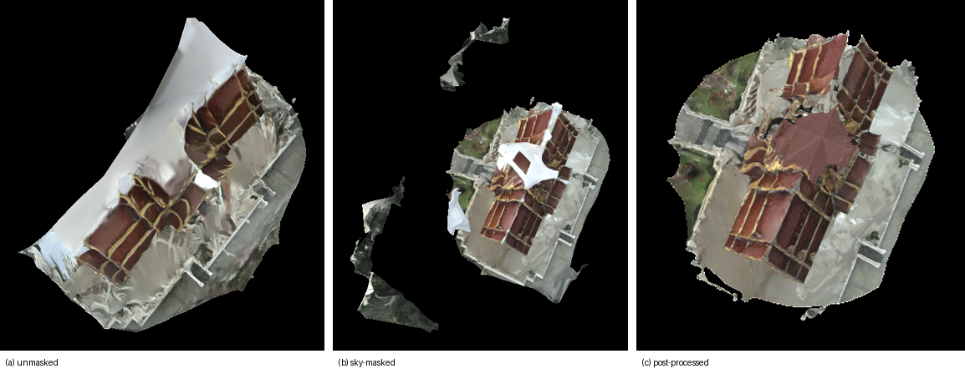
- The same three stages as Fig. 2 seen from above: (a) unmasked, (b) sky-masked, (c) post-processed with the fitted cross-gable cap covering the crossing that no photograph could see.
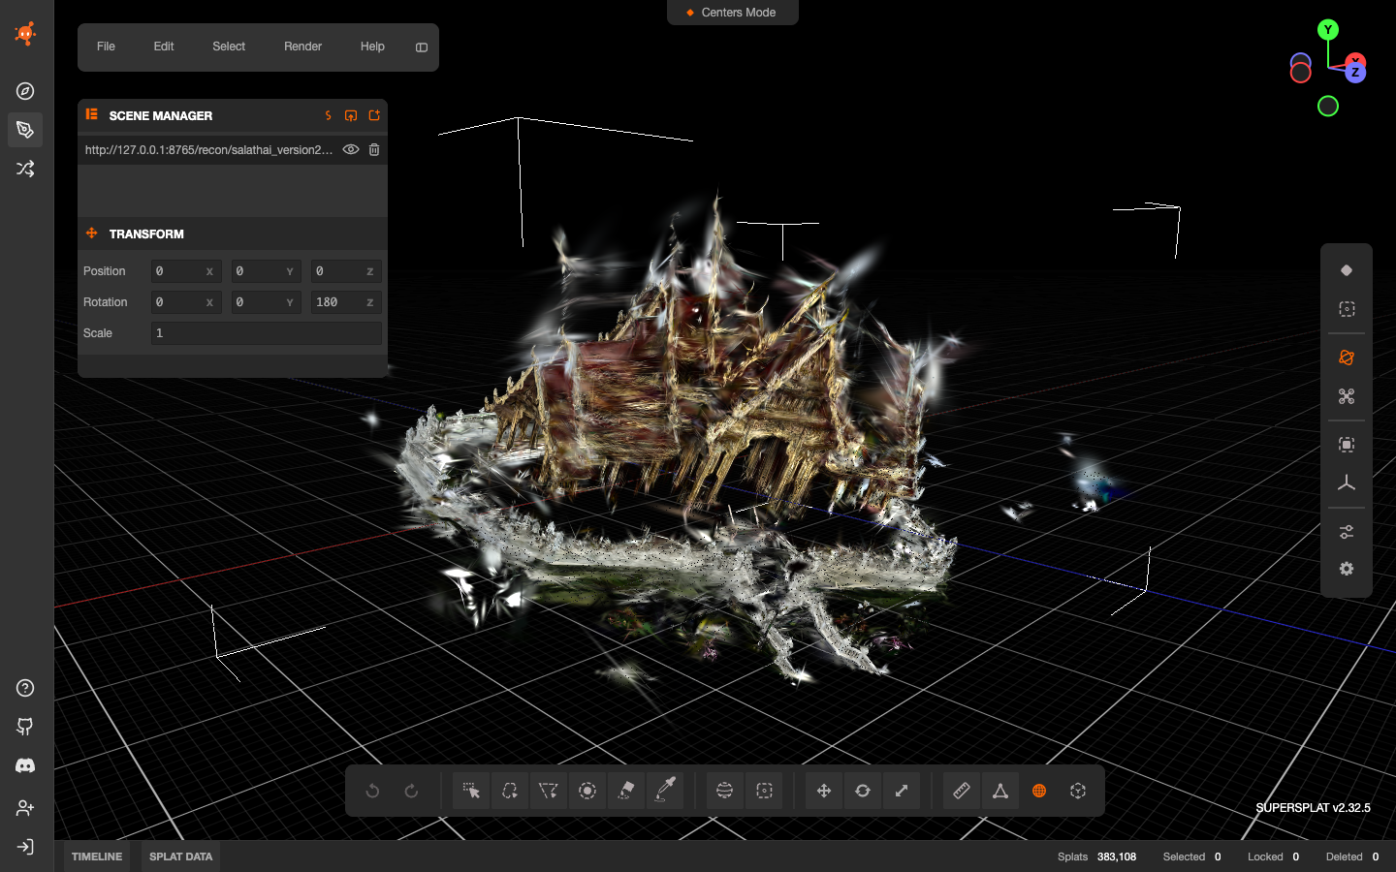
- The 3D Gaussian splatting model loaded in the SuperSplat web editor (383,108 Gaussians in the demo export). The pavilion is recognisable from the training ring; the white camera markers are the 146 recovered poses, and the needle-shaped Gaussians around the roof are the usual artifacts of an eye-level capture with no views from above.
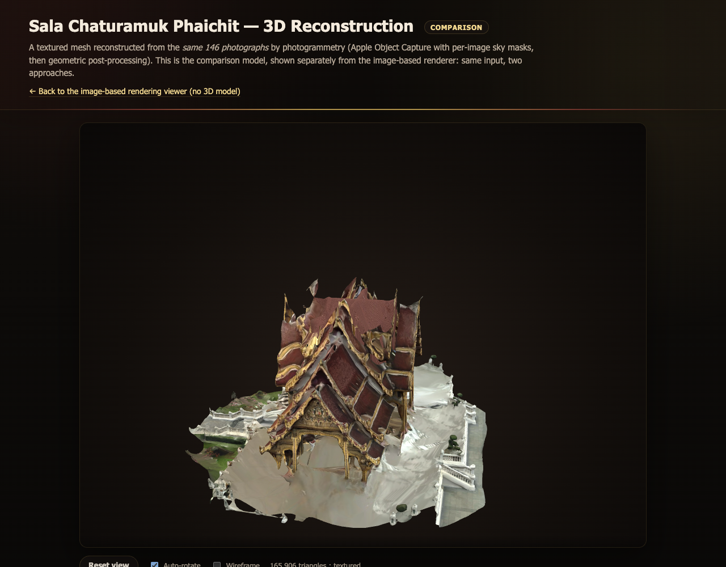
- The reconstruction page of the web viewer, kept separate from the image-based viewer and labelled as a comparison. The mesh is orbited in the browser from file:// with no server; the caption text states that the roof crossing is modelled, not measured.

Conclusion
We presented an image-based rendering viewer for Sala Chaturamuk Phaichit, the four-porched Thai pavilion at the Assumption University Suvarnabhumi campus. Photographs captured along an arc around the pavilion were combined with optical-flow view interpolation to produce a working, interactive web viewer with no 3D geometry at any stage. The interpolation is now measured: against real photographs withheld from a 146-photograph closed-loop capture, the synthesized frames reach 13.88 dB PSNR and 0.491 SSIM, against 13.27 dB and 0.479 for the frame-switching baseline. At the instructor's request the same photographs were also reconstructed explicitly, as a photogrammetry mesh and as a 3D Gaussian splatting model, and the three were compared on the same input. The comparison sharpens the premise rather than undermining it: reconstruction buys free viewpoint at the price of a reconstruction stage and two orders of magnitude more computation, and it cannot show what was never photographed, which for this pavilion is the roof crossing hidden from every eye-level viewpoint. Two constraints specific to the subject shaped all three methods: the lake limits where a camera can stand, and the four-fold symmetry forces matching to be restricted to neighbouring photographs. Future work is a capture from an elevated position, which would close the roof for the reconstructions and add a second ring for the image-based viewer, and a user study of perceived smoothness to set beside the objective scores.

References
- R. Szeliski, Computer Vision: Algorithms and Applications, 2nd ed. Cham, Switzerland: Springer, 2022.
- S. E. Chen and L. Williams, “View interpolation for image synthesis,” in Proc. 20th Annu. Conf. Comput. Graph. Interact. Tech. (SIGGRAPH ’93), Anaheim, CA, USA, 1993, pp. 279–288.
- S. M. Seitz and C. R. Dyer, “View morphing,” in Proc. 23rd Annu. Conf. Comput. Graph. Interact. Tech. (SIGGRAPH ’96), New Orleans, LA, USA, 1996, pp. 21–30.
- M. Levoy and P. Hanrahan, “Light field rendering,” in Proc. 23rd Annu. Conf. Comput. Graph. Interact. Tech. (SIGGRAPH ’96), New Orleans, LA, USA, 1996, pp. 31–42.
- L. McMillan and G. Bishop, “Plenoptic modeling: An image-based rendering system,” in Proc. 22nd Annu. Conf. Comput. Graph. Interact. Tech. (SIGGRAPH ’95), Los Angeles, CA, USA, 1995, pp. 39–46.

- J. L. Schönberger and J.-M. Frahm, “Structure-from-motion revisited,” in Proc. IEEE Conf. Comput. Vis. Pattern Recognit. (CVPR), Las Vegas, NV, USA, 2016, pp. 4104–4113.
- Apple Inc., “Creating 3D objects from photographs,” Apple Developer Documentation, RealityKit Object Capture. [Online]. Available: https://developer.apple.com/documentation/realitykit/creating-3d-objects-from-photographs
- B. Kerbl, G. Kopanas, T. Leimkühler, and G. Drettakis, “3D Gaussian splatting for real-time radiance field rendering,” ACM Trans. Graph., vol. 42, no. 4, Art. no. 139, Jul. 2023.
- G. Taubin, “A signal processing approach to fair surface design,” in Proc. 22nd Annu. Conf. Comput. Graph. Interact. Tech. (SIGGRAPH ’95), Los Angeles, CA, USA, 1995, pp. 351–358.
- Z. Wang, A. C. Bovik, H. R. Sheikh, and E. P. Simoncelli, “Image quality assessment: From error visibility to structural similarity,” IEEE Trans. Image Process., vol. 13, no. 4, pp. 600–612, Apr. 2004.
- R. Zhang, P. Isola, A. A. Efros, E. Shechtman, and O. Wang, “The unreasonable effectiveness of deep features as a perceptual metric,” in Proc. IEEE/CVF Conf. Comput. Vis. Pattern Recognit. (CVPR), Salt Lake City, UT, USA, 2018, pp. 586–595.

