Sala Chaturamuk Phaichit Viewer: An Image-Based Rendering Approach to a Thai Pavilion

Win Yu Maung
Vincent Mary School of Engineering, Science and Technology
Suvarnabhumi Campus, Assumption University of Thailand
Samut Prakan, Thailand
u6612054@au.edu
Myat Bhone Thet
Vincent Mary School of Engineering, Science and Technology
Suvarnabhumi Campus, Assumption University of Thailand
Samut Prakan, Thailand
u6611935@au.edu
Min Pyae Hein
Vincent Mary School of Engineering, Science and Technology
Suvarnabhumi Campus, Assumption University of Thailand
Samut Prakan, Thailand
u6511684@au.edu

Abstract—Traditional Thai pavilions, or salas, are an integral part of Thai architectural heritage, yet many remain documented only as isolated photographs with no interactive digital record. This paper presents an image-based rendering viewer for Sala Chaturamuk Phaichit, the four-porched Thai pavilion at the Assumption University Suvarnabhumi campus, which allows a user to examine the structure from a range of viewpoints without constructing an explicit 3D model. A sequence of photographs is captured along an accessible arc around the pavilion, correspondences between adjacent frames are established through feature matching, and intermediate viewpoints are synthesized through optical-flow-based view interpolation. The resulting frames are assembled into a web viewer driven by click-and-drag input. We discuss two constraints specific to this subject: the adjacent lake restricts the capture path to a partial arc, and the pavilion's four-fold rotational symmetry introduces a risk of false feature correspondences between structurally similar faces.
Keywords—Thai arts and culture, rendering, image-based rendering, view interpolation.

Introduction
Sala pavilions are common features of Thai temples, palaces, and university campuses, providing shaded seating and serving as focal points for ceremony and gathering. Sala Chaturamuk Phaichit, the pavilion at the Assumption University Suvarnabhumi campus, was named by HRH Princess Maha Chakri Sirindhorn and is used for Thai cultural ceremonies and university events. While such structures are appreciated in person, few exist in a form that can be explored remotely or preserved digitally beyond ordinary photographs. Full 3D reconstruction can enable remote exploration, but it typically requires dense multi-view stereo or laser scanning that is impractical for a small student project. Image-based rendering offers an alternative: novel views of a scene can be synthesized directly from a sparse set of photographs, without recovering explicit 3D geometry [1]. In this project we apply image-based rendering to Sala Chaturamuk Phaichit, producing an interactive viewer that approximates a walkaround from a modest set of captured photographs. The remainder of this paper reviews related work in image-based rendering, describes our capture and interpolation pipeline, presents results, and discusses the limitations imposed by the pavilion's setting and symmetry.

Literature Review

Object Movies and View Interpolation
Early image-based rendering systems such as QuickTime VR represented an object using a discrete ring of photographs and let a user step between adjacent views to simulate rotation. Chen and Williams introduced view interpolation, using pixel correspondences between image pairs to synthesize intermediate viewpoints and produce smoother transitions than simple frame switching [2]. Seitz and Dyer extended this idea with view morphing, which produces physically plausible in-between views under a simple camera model [3]. These techniques form the basis of the interpolation-based viewer used in this project.

Light Fields and Plenoptic Sampling
A complementary line of work treats image-based rendering as sampling a scene's plenoptic function directly. Light field rendering and the closely related lumigraph represent a scene as a dense array of captured rays, allowing novel views to be reconstructed by resampling this ray database rather than interpolating between a small number of photographs [4]. McMillan and Bishop's plenoptic modeling similarly reconstructs new views directly from range-augmented image data [5]. These methods generally require far denser capture than a single ring of photographs, which motivated the simpler view-interpolation approach used here for a sala captured with an ordinary handheld camera.

Methodology
Our pipeline consists of three stages: image capture around the physical sala, pose recovery through feature correspondence, and view interpolation to synthesize intermediate frames, followed by assembly into an interactive web viewer. Each stage is implemented as a standalone, argument-driven script, chained by a single orchestration script so that every stage's output can be inspected independently.
Each of these stages is described in the remainder of this section.

Image Capture
Photographs were captured along the safely accessible land-side arc surrounding Sala Chaturamuk Phaichit, walking at an approximately constant camera-to-pavilion distance and a fixed camera height, using the phone's standard 1x lens in landscape orientation and pointing toward the pavilion's centre. Because the adjacent lake and site boundaries prevent a continuous constant-radius path around all four sides, the captured photographs cover a partial arc rather than a complete 360-degree rotation. Capture was carried out across two walks along the same arc, later combined into a single ordered sequence; after excluding a small number of test and misoriented frames, 206 usable photographs remained. Exposure, white balance and focus were locked manually to prevent flicker and refocusing between frames, and capture was carried out under overcast conditions to limit shadow movement. [To record: start angle, end angle, and mean angular spacing, to be finalized from the camera's recorded heading at each shot.]

Pose Recovery and View Interpolation
- SIFT keypoints were extracted and matched between each pair of adjacent images using a FLANN-based matcher with Lowe's ratio test. Matching was restricted to adjacent frames only, since the pavilion is four-porched and close to rotationally symmetric and matching across the full set risks false correspondences between structurally similar faces. Outlier matches were filtered with RANSAC, fitting a fundamental matrix where the two views have sufficient parallax and falling back to a homography where that model is degenerate. Each adjacent pair was additionally checked for the scene displacement between the two photographs, since large displacements exceed what the subsequent optical-flow stage can track; this check flagged 15 of the 205 adjacent pairs in the captured sequence, consistent with a brief pause and a foreground obstruction identified on inspection of the photographs at those points.
- Dense optical flow (Farneback) was computed along each matched pair to build a per-pixel warp field between adjacent viewpoints.
- The warp field was used to generate two intermediate frames per adjacent pair through backward warping and cross-dissolving, filling the gaps between captured angles.
All real and synthesized frames were ordered by capture sequence and exported as a single sequence for the viewer; per-frame angles remain to be added once the capture headings noted in the previous subsection are finalized.

Results and Analysis
Both viewers have been built and are functional; the specific quantitative and perceptual measurements below remain to be completed. We evaluate the viewer qualitatively by comparing the naive frame-switching baseline with the interpolation-based version, and by noting where each approach breaks down.
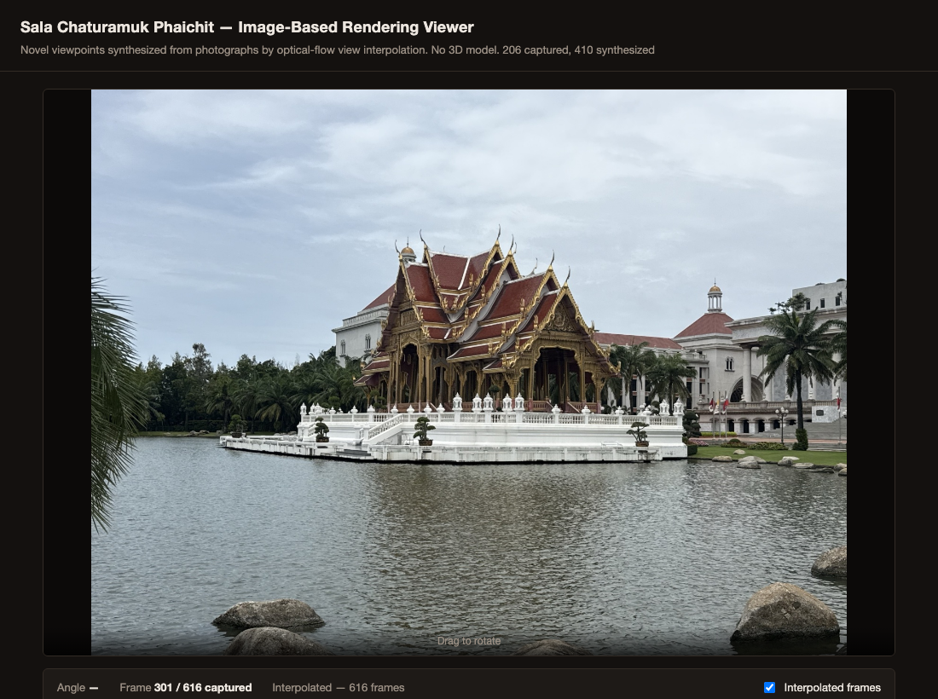
- The interactive viewer displaying a captured photograph roughly midway through the arc (frame 301 of 616).

Baseline Object-Movie Viewer
The baseline viewer switches directly between the captured photographs as the pavilion is rotated, with no frames synthesized in between.

[To record] Whether rotation reads as discrete jumps rather than continuous motion.

[To record] How the comfortable viewing angle depends on capture density.

[To record] The angular spacing at which rotation begins to feel discontinuous.

[To record] Whether fine roof-tile detail changes abruptly between frames.

[To record] Whether shadows shift position at frame boundaries despite locked exposure.

Interpolation-Based Viewer
Synthesized frames are inserted between each pair of captured photographs using the optical-flow warp described in Section III.
[To record] Whether rotation over the roof edges and eaves remains smooth, and where flow tracking holds up.
Artifacts are most visible at three identified points in the captured sequence: the join between the two capture sessions, and two locations within the second session — one coinciding with a longer pause between shots and one where a tree branch briefly obstructed the pavilion in the frame. All three were flagged automatically by the per-pair displacement check described in the Methodology before the affected frames were inspected, and the visible artifact at each is consistent with the cause identified in the underlying photographs.
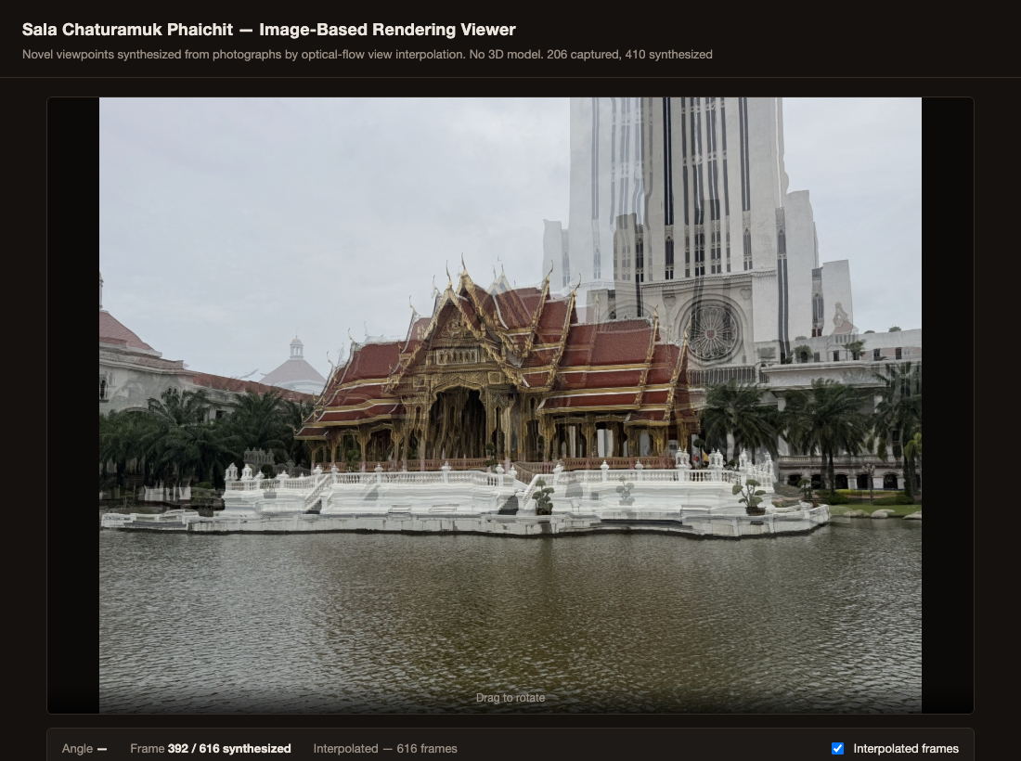
- A synthesized frame at the join between the two capture sessions, showing the double-exposure artifact discussed above.

Quantitative Comparison

A short side-by-side comparison of both viewers has not yet been carried out. Table I reports the frame counts the pipeline actually produced; the remaining rows are pending confirmation of the measured capture angles and a small user test for perceived smoothness.
- Viewer parameters
 | Viewer Comparison
 | Metric | Baseline | Interp.
1 | Displayed frames | 206 | 616
2 | Mean angular step between displayed frames | TBD | TBD
3 | Perceived rotation smoothness (1–5, user test) | TBD | TBD

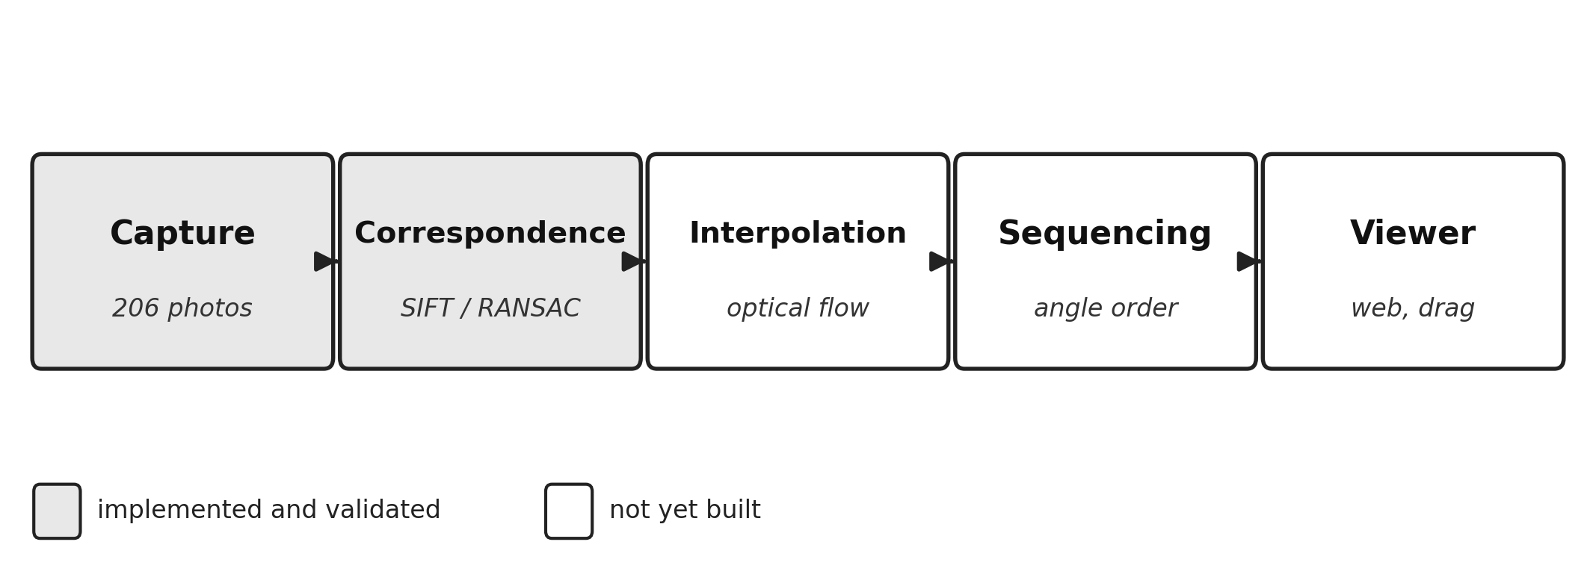
- Overview of the image capture and view interpolation pipeline used to build the Sala Chaturamuk Phaichit viewer.
The pipeline runs end to end on real photographs of the pavilion and produces a working, interactive viewer with no explicit 3D geometry at any stage, which supports the core premise of image-based rendering. Whether the interpolated views are convincing enough to matter, and how they compare quantitatively to the baseline, remains to be established by the measurements above. The most visible limitation observed so far follows directly from the site's geography: the lake forced the capture to be split across two separate walks rather than one continuous arc, and the frames synthesized at the join between them are not yet smooth, as shown above. Closing this gap — either by capturing both sessions closer together in time and vantage, or by capturing a single continuous walk — is the planned improvement for the coming week.

Conclusion
We presented an image-based rendering viewer for Sala Chaturamuk Phaichit, the four-porched Thai pavilion at the Assumption University Suvarnabhumi campus. A sequence of photographs captured along the accessible arc around the pavilion was combined with optical-flow-based view interpolation to produce a working, interactive web-based viewer; whether it offers smoother rotation than a naive frame-switching baseline is assessed qualitatively above, pending a full quantitative comparison. Two constraints specific to this subject shaped the work: the adjacent lake prevents a complete circular capture path, and the pavilion's four-fold rotational symmetry complicates feature matching between structurally similar faces. Future work includes capturing from a boat or elevated position to close the arc, adding multiple rings at different elevations to support tilt as well as rotation, and comparing optical-flow interpolation against learned view-synthesis methods.

References
- R. Szeliski, Computer Vision: Algorithms and Applications, 2nd ed. Cham, Switzerland: Springer, 2022.
- S. E. Chen and L. Williams, “View interpolation for image synthesis,” in Proc. 20th Annu. Conf. Comput. Graph. Interact. Tech. (SIGGRAPH ’93), Anaheim, CA, USA, 1993, pp. 279–288.
- S. M. Seitz and C. R. Dyer, “View morphing,” in Proc. 23rd Annu. Conf. Comput. Graph. Interact. Tech. (SIGGRAPH ’96), New Orleans, LA, USA, 1996, pp. 21–30.
- M. Levoy and P. Hanrahan, “Light field rendering,” in Proc. 23rd Annu. Conf. Comput. Graph. Interact. Tech. (SIGGRAPH ’96), New Orleans, LA, USA, 1996, pp. 31–42.
- L. McMillan and G. Bishop, “Plenoptic modeling: An image-based rendering system,” in Proc. 22nd Annu. Conf. Comput. Graph. Interact. Tech. (SIGGRAPH ’95), Los Angeles, CA, USA, 1995, pp. 39–46.

