ER DIAGRAM

n

1

1

1

1

1

Enroller

Pays

Changes

Enrolls_in

Payment

Batches

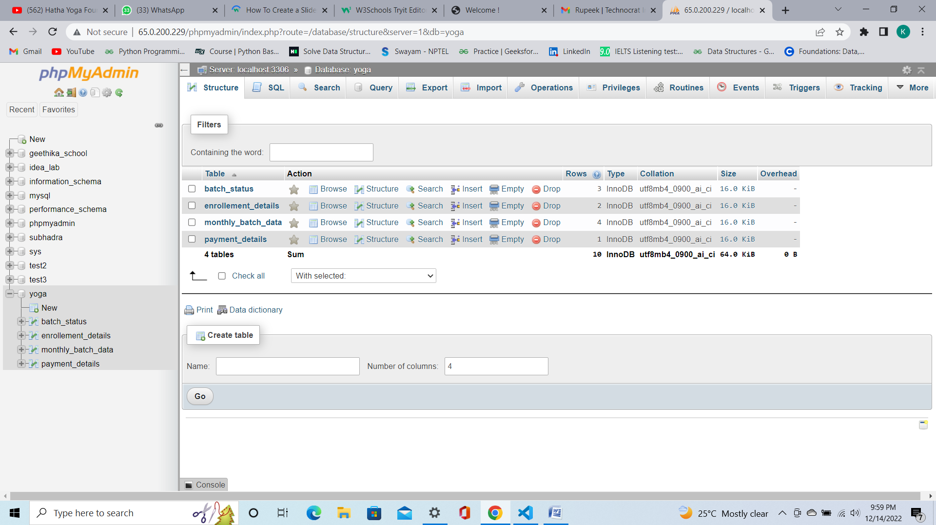

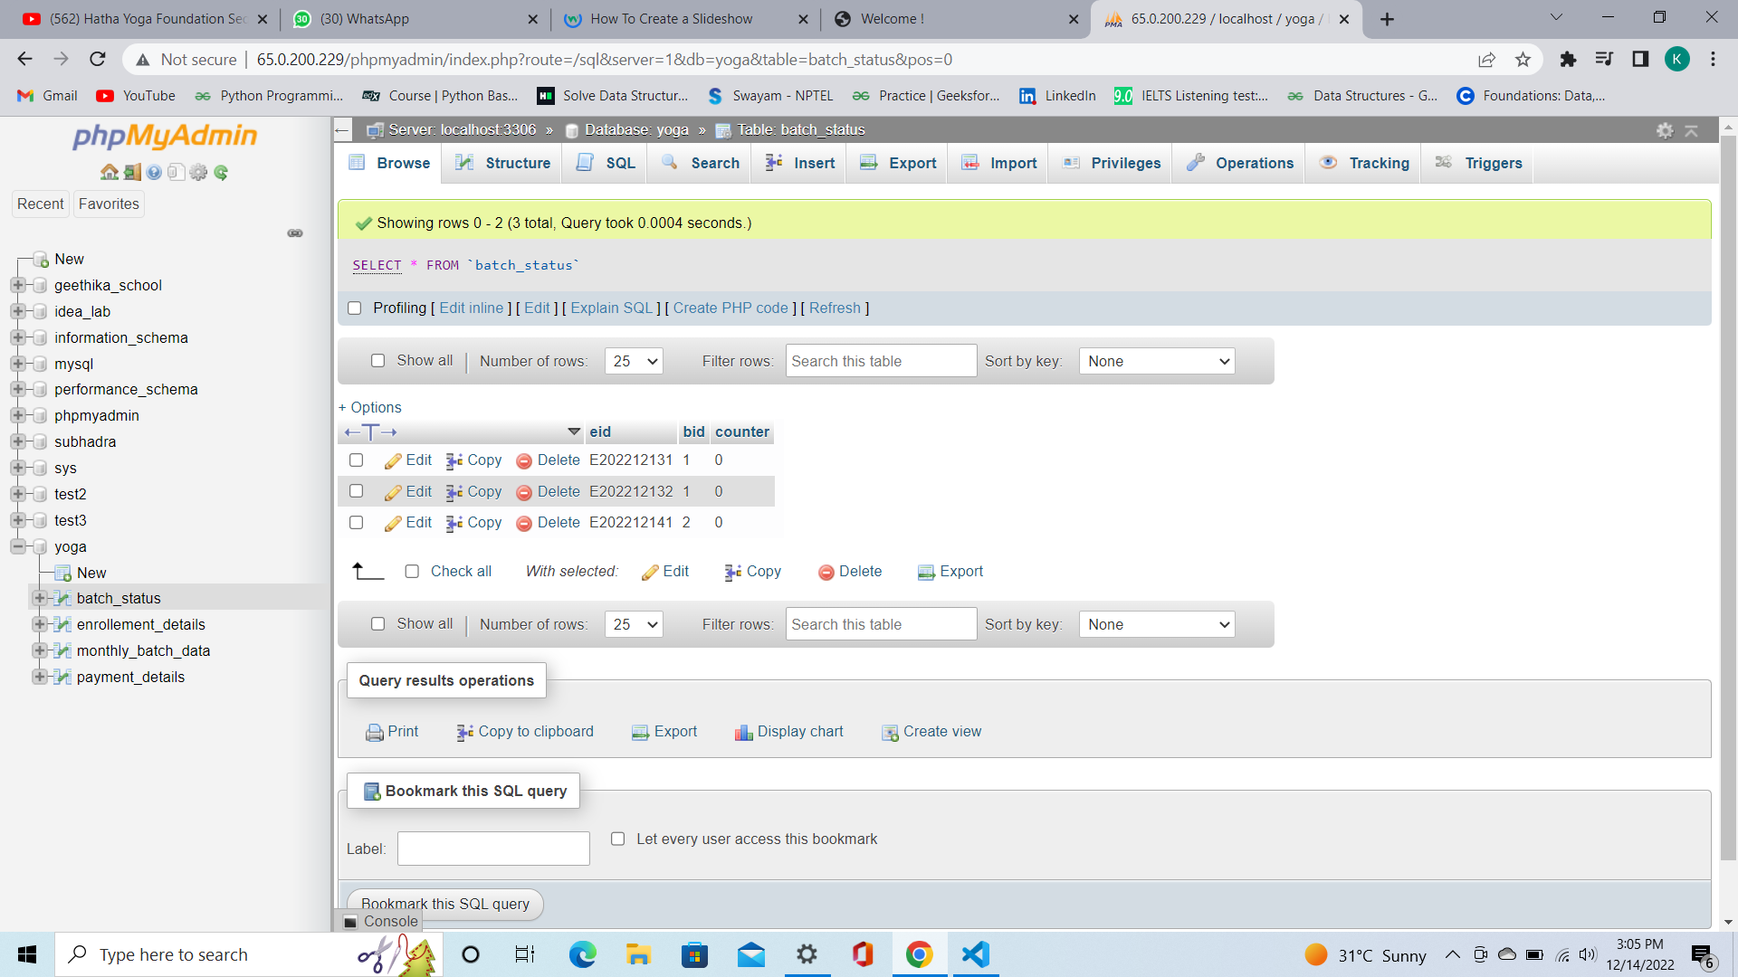

Batch_status Table

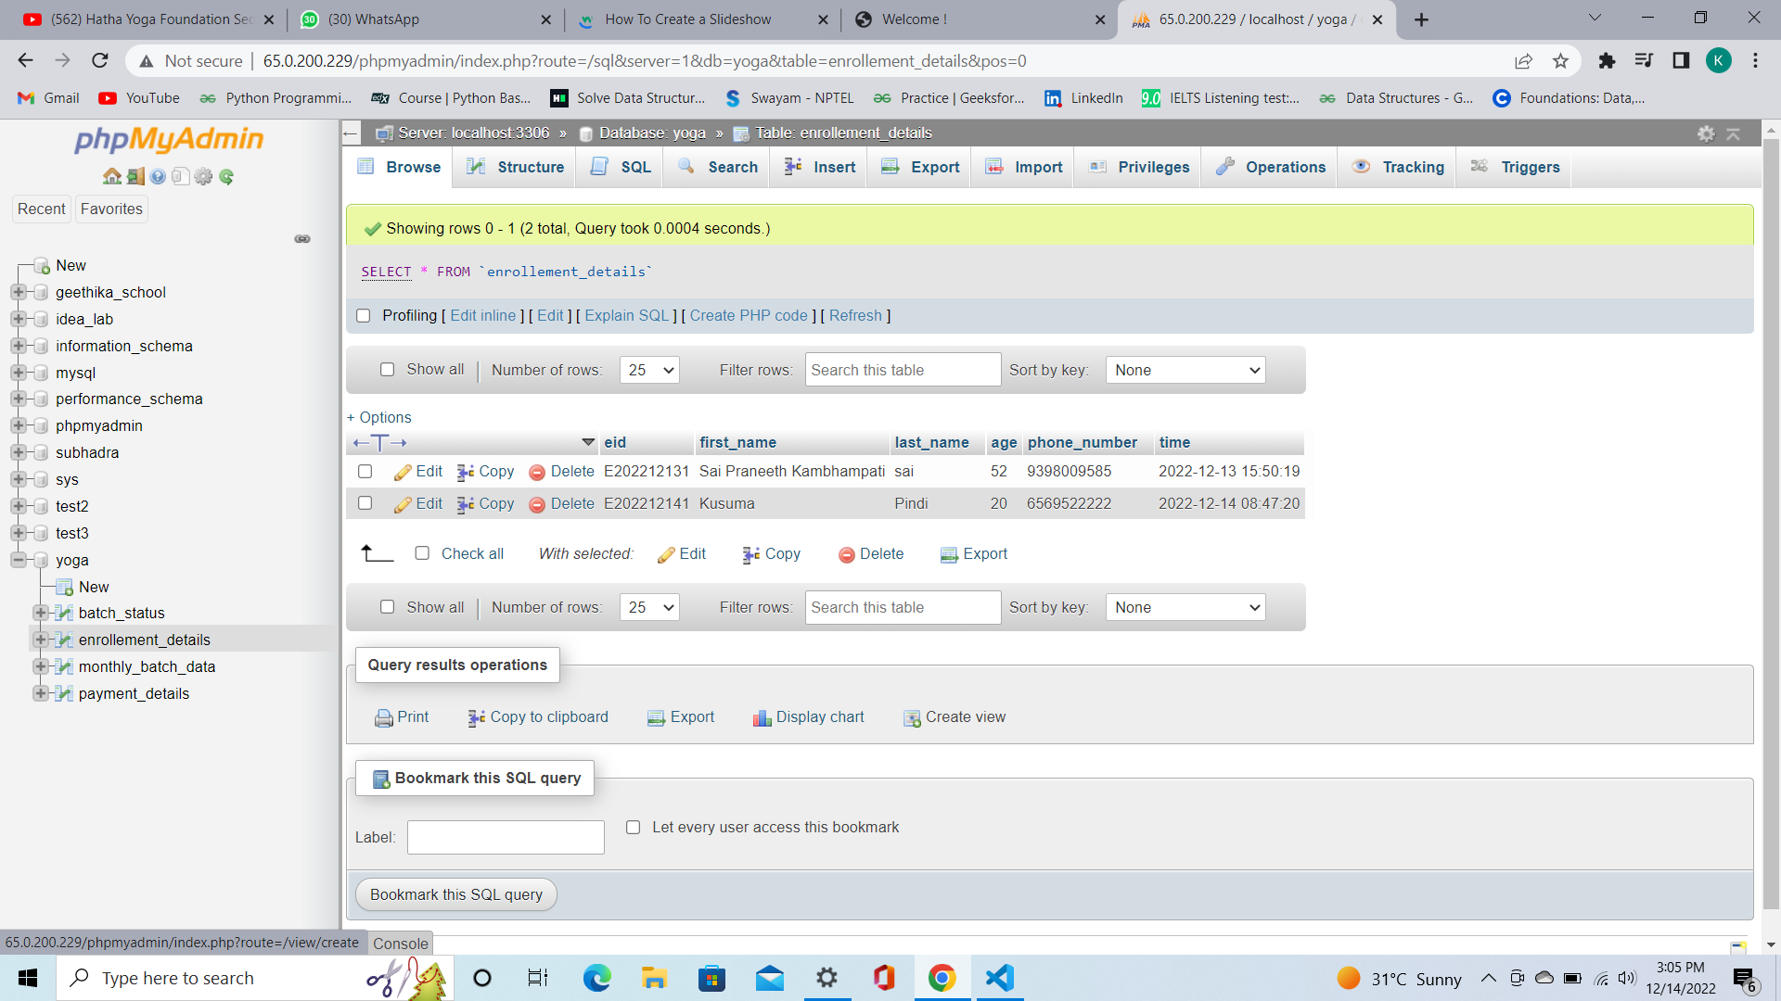

Enrollment_details table

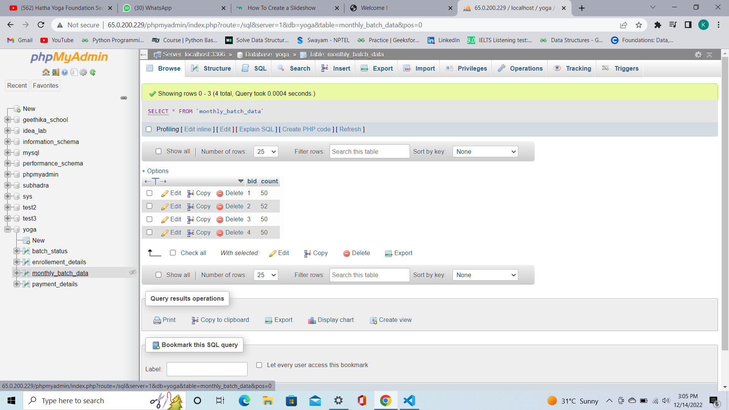

Monthly_batch_data table

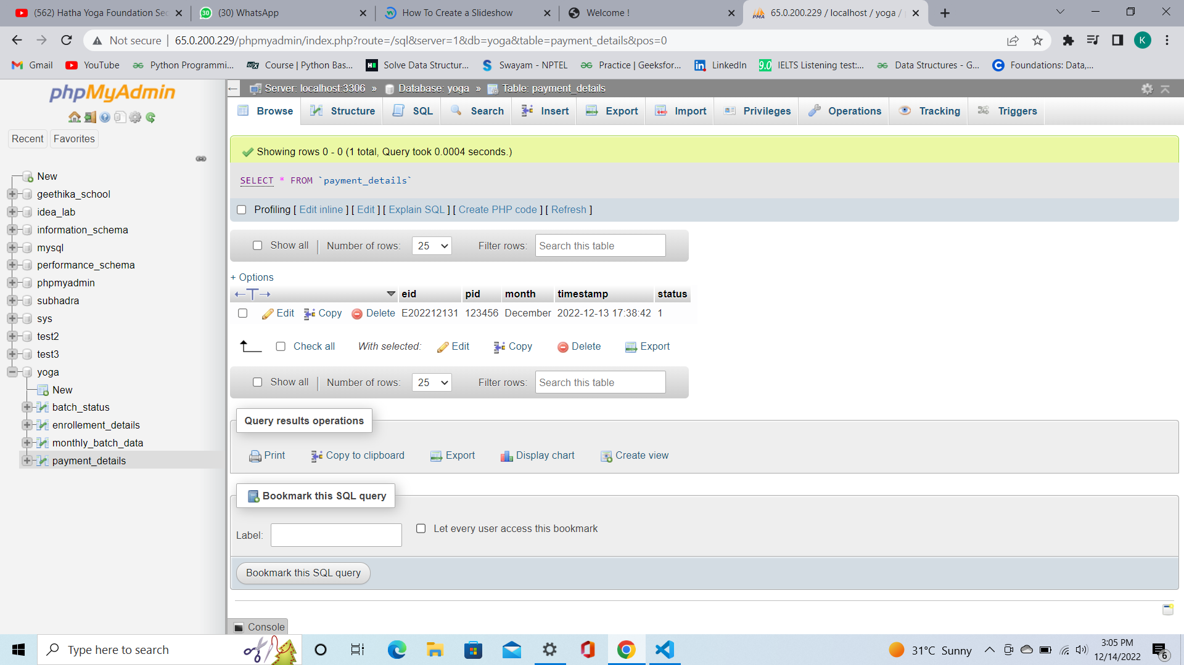

Payment_details table