Lab program 6

To create the folders

1.create a folder called java programs

2.in that create two folders which is the name of the packages ie CIE &SEE

3.now write all code save in their particular folder like students and internals in CIE and externals in SEE

4.And the last Main file in which u will import all packages save that java programs folder not in any subfolder

5.**To run the code -javac packagename/classname.java packagename/classname .java**

**javac CIE/Student.java CIE/Internals.java SEE/External.java Main.java**

**After compile run the main class**

**java Main**

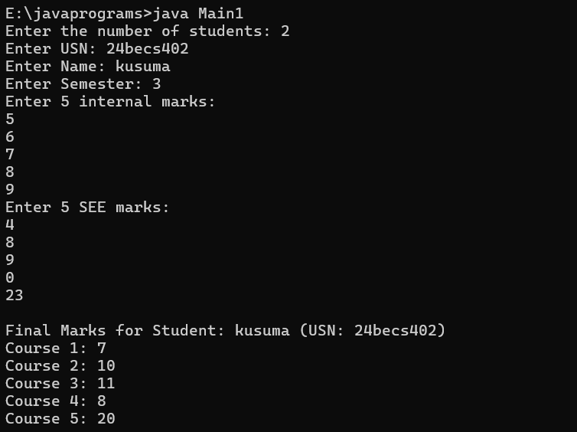

// CIE/Student.java

package CIE;

public class Student {

public String usn;

public String name;

public int sem;

public Student(String usn, String name, int sem) {

this.usn = usn;

this.name = name;

this.sem = sem;

}

}

// CIE/Internals.java

package CIE;

public class Internals {

public int[] internalMarks = new int[5];

public Internals(int[] marks) {

for (int i = 0; i < 5; i++) {

internalMarks[i] = marks[i];

}

}

}

// SEE/External.java

package SEE;

import CIE.Student;

public class External extends Student {

public int[] seeMarks = new int[5];

public External(String usn, String name, int sem, int[] marks) {

super(usn, name, sem);

for (int i = 0; i < 5; i++) {

seeMarks[i] = marks[i];

}

}

}

// Main.java

import CIE.*;

import SEE.External;

import java.util.Scanner;

public class Main {

public static void main(String[] args) {

Scanner sc = new Scanner(System.in);

System.out.print("Enter the number of students: ");

int n = sc.nextInt();

for (int i = 0; i < n; i++) {

sc.nextLine();

System.out.print("Enter USN: ");

String usn = sc.nextLine();

System.out.print("Enter Name: ");

String name = sc.nextLine();

System.out.print("Enter Semester: ");

int sem = sc.nextInt();

int[] internalMarks = new int[5];

System.out.println("Enter 5 internal marks:");

for (int j = 0; j < 5; j++) {

internalMarks[j] = sc.nextInt();

}

sc.nextLine();

int[] seeMarks = new int[5];

System.out.println("Enter 5 SEE marks:");

for (int j = 0; j < 5; j++) {

seeMarks[j] = sc.nextInt();

}

sc.nextLine();

Internals internal = new Internals(internalMarks);

External external = new External(usn, name, sem, seeMarks);

System.out.println("\nFinal Marks for Student: " + name + " (USN: " + usn + ")");

for (int j = 0; j < 5; j++) {

int finalMark = internal.internalMarks[j] + (seeMarks[j] / 2);

System.out.println("Course " + (j + 1) + ": " + finalMark);

}

System.out.println();

}

sc.close();

}

}

**Student and Family package**

**Output:**

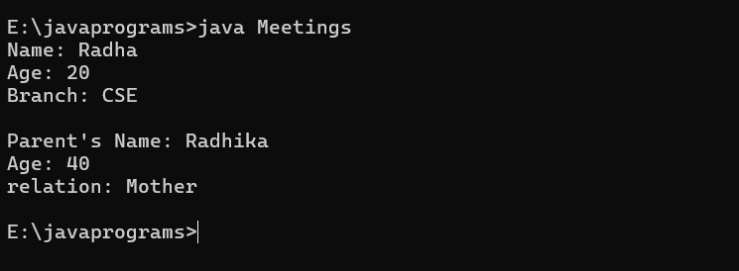

package Student;

public class Student1{

public String name;

public int age;

public String branch ;

public Student1(String name,int age, String branch){

this.name=name;

this.age=age;

this.branch=branch;

}

public void DisplayS(){

System.out.println("Name: "+name);

System.out.println("Age: "+age);

System.out.println("Branch: "+branch);

}

}

package Family;

public class Family1{

public String name;

public int age;

public String relation ;

public Family1(String name,int age, String relation){

this.name=name;

this.age=age;

this.relation=relation;

}

public void DisplayF(){

System.out.println("Parent's Name: "+name);

System.out.println("Age: "+age);

System.out.println("relation: "+relation);

}

}

import Student.Student1;

import Family.Family1;

public class Meeting{

public static void main (String[] args){

Student1 s =new Student1("Radha",20,"CSE");

s.DisplayS();

System.out.println();

Family1 f =new Family1("Radhika",40,"Mother");

f.DisplayF();

}

}

**Question series**

**JavaProject/**

**├── com/**

**│ └── example/**

**│ ├── greetings/**

**│ │ └── Greeter.java**

**│ └── app/**

**│ └── MainApp.java**

**javac com/example/greetings/Greeter.java com/example/app/MainApp.java**

**java com.example.app.MainApp**