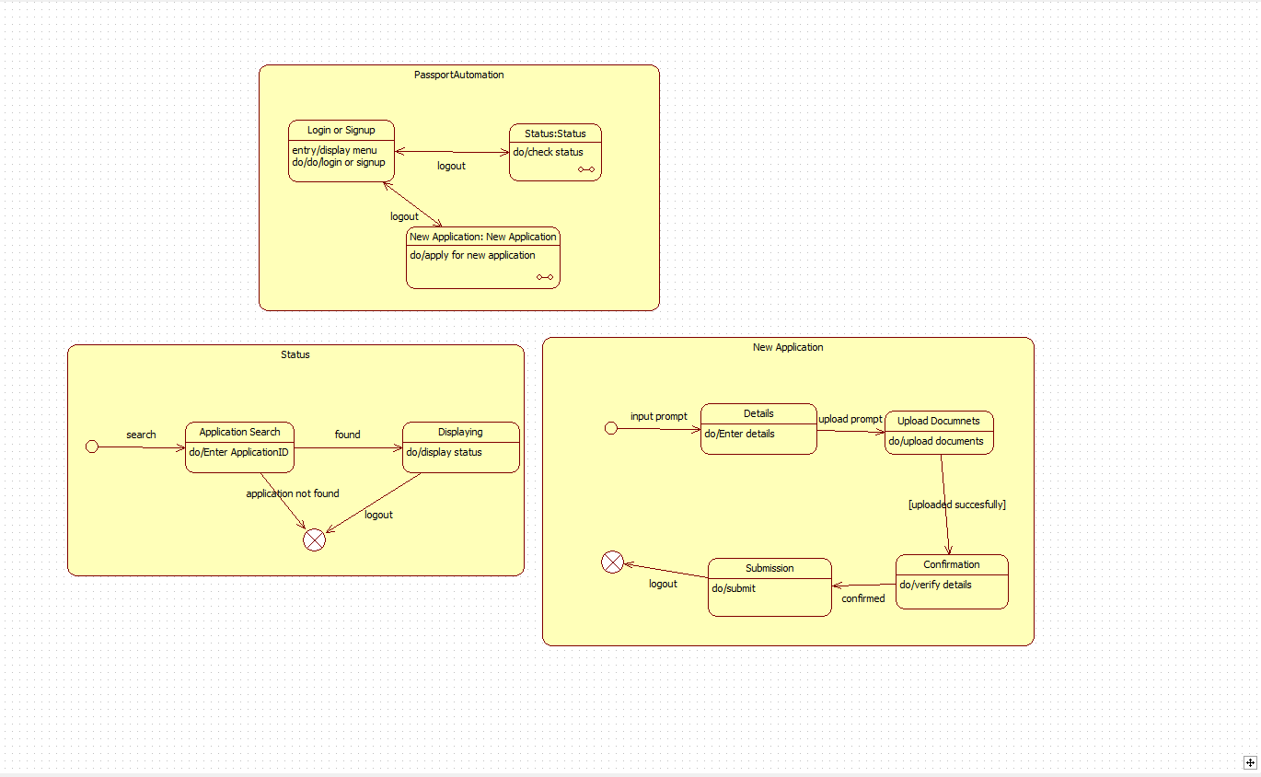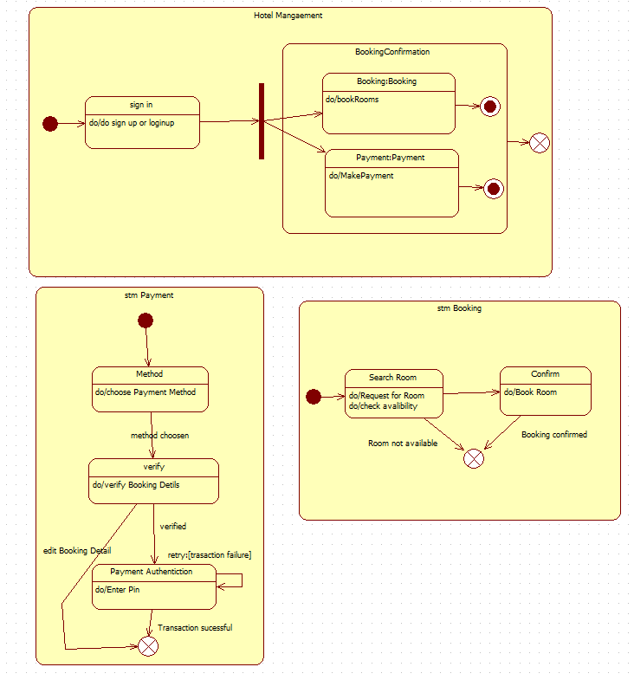
1.PASSPORT AUTOMATION STATE DIAGRAM
2.HOTEL MANAGEMNT SYSTEM

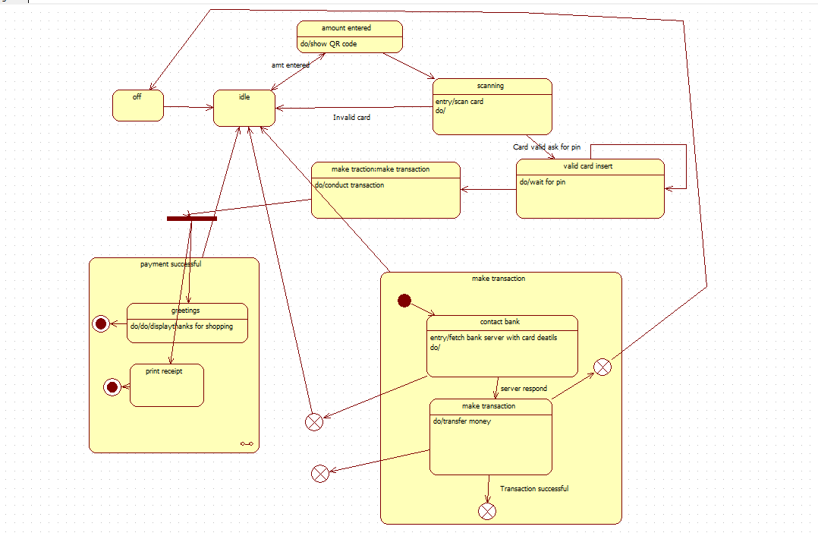
3.CREDIT CARD PROCESSING

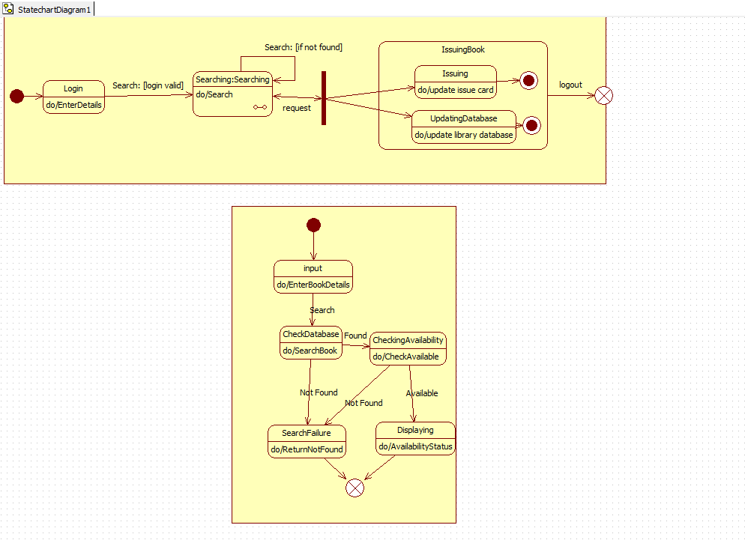
4.LIBRARY MANAGEMENT SYSTEM

