WEEK 1 TASK
DATA CLEANING AND PRELIMINARY ANALYSIS WITH R
Dataset: Titanic Passenger Dataset
Tool: Google Colab – R
Task: Data Cleaning, Preprocessing and Preliminary Analysis
Name: Kusuma Sri Parise
Introduction:
This project focuses on data cleaning, preprocessing and preliminary exploratory analysis using R. The Titanic passenger dataset was selected because it contains numerical and categorical variables, missing values and potential outliers. The analysis includes data inspection, missing-value treatment, duplicate detection, outlier detection and treatment, normalization, categorical encoding, descriptive statistics, visualization and correlation analysis.
Dataset Overview:
The Titanic dataset was obtained from the publicly available Kaggle Titanic dataset. The dataset contains information about 891 passengers and 12 variables. The dataset includes passenger information such as survival status, passenger class, name, gender, age, family members, fare, cabin and port of embarkation.
Variable | Type | Description
PassengerId | Numerical | Unique passenger ID
Survived | Binary | Survival status
Pclass | Categorical/Ordinal | Passenger class
Name | Categorical | Passenger name
Sex | Categorical | Passenger gender
Age | Numerical | Passenger age
SibSp | Numerical | Siblings/spouses aboard
Parch | Numerical | Parents/children aboard
Ticket | Categorical | Ticket number
Fare | Numerical | Passenger fare
Cabin | Categorical | Cabin information
Embarked | Categorical | Port of embarkation

Dataset Import:
data <- read.csv("/content/train.csv")
head(data)
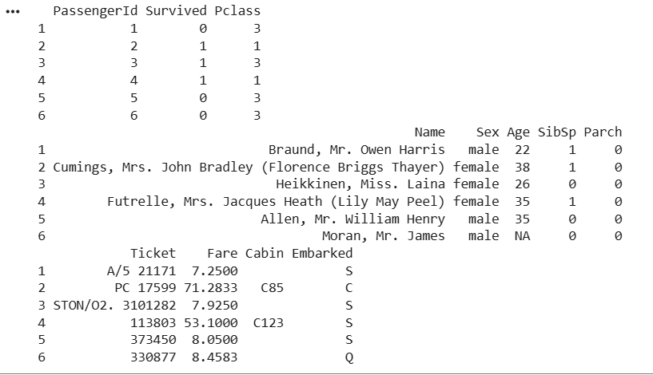
Initial Data Inspection:
str(data)
summary(data)
dim(data)
names(data)
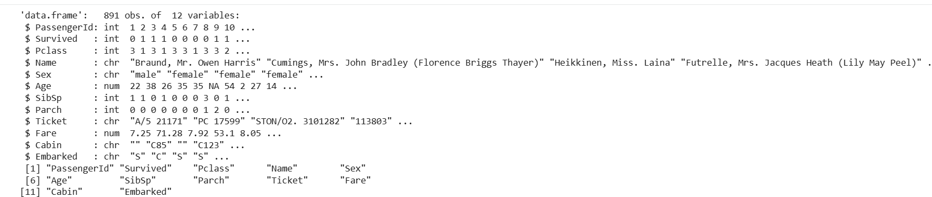
The dataset contains 891 observations and 12 variables. The str() function was used to understand the structure and data types, while summary() provided descriptive statistics. The dataset contains both numerical and categorical variables.
Missing Value Analysis:
missing_values <- colSums(is.na(data))
print(missing_values)
total_missing <- sum(is.na(data))
print(total_missing)
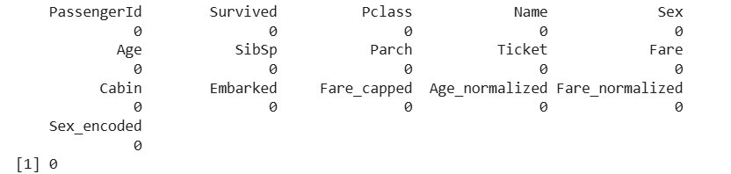
The missing-value analysis identified 177 missing values in the Age variable. No other variables contained NA values.
Missing Value Treatment:
median_age <- median(data$Age, na.rm = TRUE)
data$Age[is.na(data$Age)] <- median_age
colSums(is.na(data))
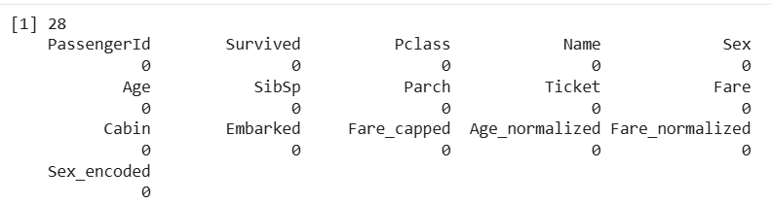
The missing Age values were replaced using median imputation. The calculated median age was 28 years. After imputation, the dataset was checked again and no NA values remained.
Duplicate Analysis:
duplicate_count <- sum(duplicated(data))
print(duplicate_count)
0 duplicates
Duplicate records were checked using the duplicated() function. The result was zero, indicating that the dataset did not contain duplicate records. Therefore, no rows were removed.
Outlier Detection:
A boxplot was created to visually identify potential outliers in the Fare variable. The plot shows several observations above the upper whisker, indicating the presence of potential outliers.
boxplot(
data$Fare,
main = "Fare Distribution and Outliers",
ylab = "Fare",
xlab = "Passenger Fare")
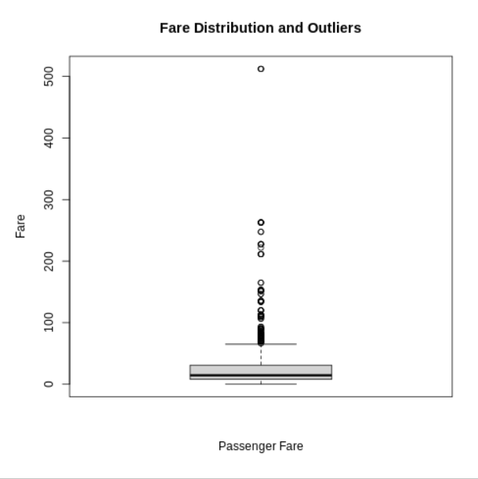
Figure: Fare Distribution and Potential Outliers
Q1 <- quantile(data$Fare, 0.25, na.rm = TRUE)
Q3 <- quantile(data$Fare, 0.75, na.rm = TRUE)
IQR_value <- IQR(data$Fare, na.rm = TRUE)
lower_limit <- Q1 - 1.5 * IQR_value
upper_limit <- Q3 + 1.5 * IQR_value
print(Q1)
print(Q3)
print(IQR_value)
print(lower_limit)
print(upper_limit)
Measure | Result
Q1 | 7.9104
Q3 | 31.0000
IQR | 23.0896
Lower Limit | -26.7240
Upper Limit | 65.6344
Number of Outliers | 116

Interpretation
Using the IQR method, the lower boundary was calculated as -26.7240 and the upper boundary as 65.6344. Since Fare values above 65.6344 were considered potential outliers, 116 observations were identified as outliers. These observations were retained and treated using the capping method in the next stage.
Outlier Treatment:
data$Fare_capped <- data$Fare
data$Fare_capped[data$Fare_capped > upper_limit] <- upper_limit
data$Fare_capped[data$Fare_capped < lower_limit] <- lower_limit
boxplot(
data$Fare_capped,
main = "Fare After Outlier Treatment",
ylab = "Fare",
xlab = "Passenger Fare"
)
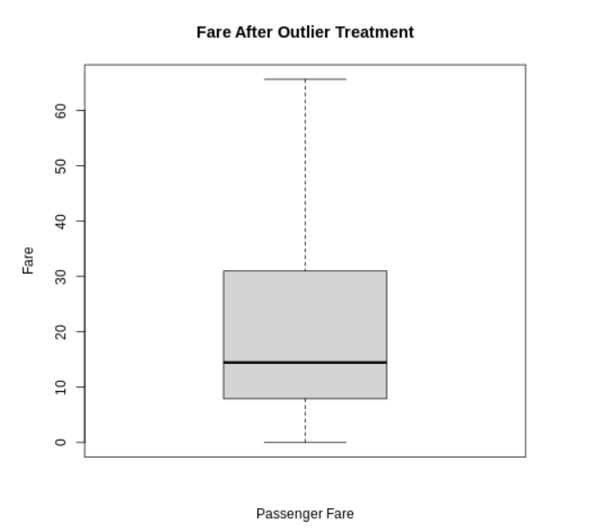
Normalization:
min_max <- function(x) {
(x - min(x, na.rm = TRUE)) /
(max(x, na.rm = TRUE) - min(x, na.rm = TRUE))
}
data$Age_normalized <- min_max(data$Age)
data$Fare_normalized <- min_max(data$Fare_capped)
summary(data$Age_normalized)
summary(data$Fare_normalized)
Min-Max normalization was applied to Age and the cleaned Fare variable. The transformed variables have values ranging from 0 to 1, making them suitable for analysis where variables need to be placed on a common scale.
Categorical Encoding:
Sex encoding
data$Sex_encoded <- ifelse(
data$Sex == "male",1,0)
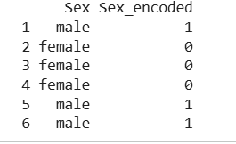
The Sex variable was binary encoded, with male represented as 1 and female represented as 0.
Embarked encoding
embarked_encoded <- model.matrix(
~ Embarked - 1,
data = data)
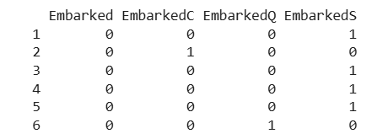
The Embarked variable was converted into separate binary variables using one-hot encoding. The resulting variables represent the three embarkation ports: C, Q and S.
Descriptive Statistics:
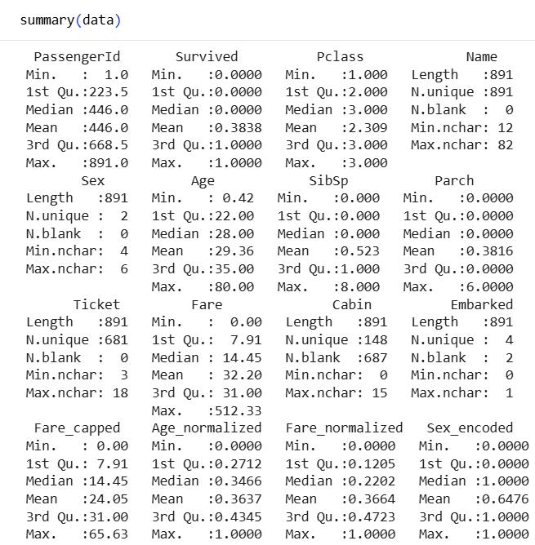
Variable | Mean | Median | Minimum | Maximum
Age | 29.36 | 28 | 0.42 | 80
SibSp | 0.52 | 0 | 0 | 8
Parch | 0.38 | 0 | 0 | 6
Fare | 32.20 | 14.45 | 0 | 512.33
Fare Capped | 24.05 | 14.45 | 0 | 65.63
The average passenger age was 29.36 years, while the median age was 28 years. The original Fare variable had a mean of 32.20 and a maximum of 512.33. After outlier treatment, the mean Fare decreased to 24.05 and the maximum became 65.63.
Exploratory Data Analysis:
Age Distribution
hist(
data$Age,
main = "Age Distribution of Passengers",
xlab = "Age",
ylab = "Frequency",
col = "lightblue",
border = "black"
)
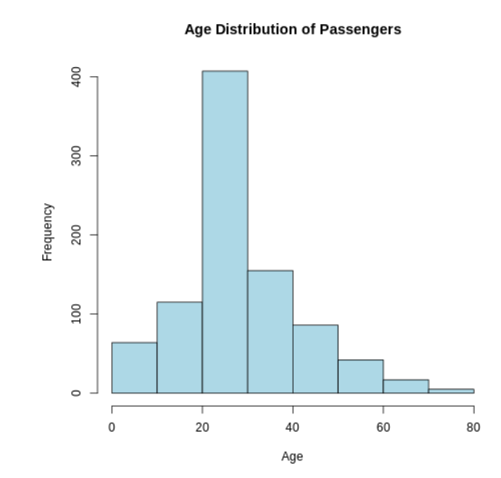
The histogram shows that most passengers were concentrated between approximately 20 and 40 years of age. The 20–30 age group had the highest frequency, while older age groups contained fewer passengers.
Survival by Gender
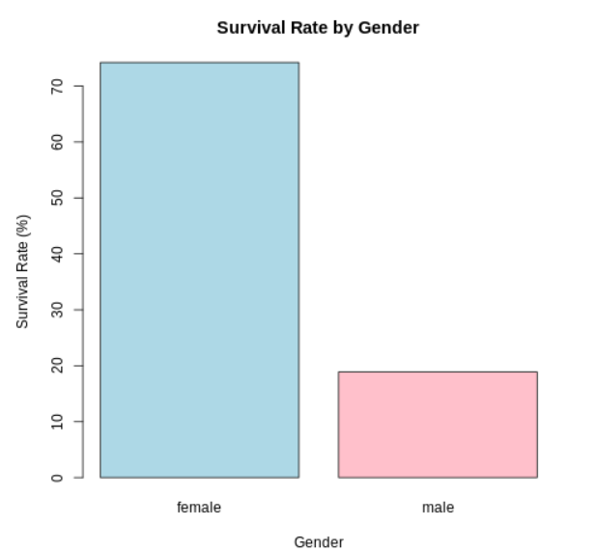
The analysis shows a substantial difference in survival rates between genders. Approximately 74% of female passengers survived, compared with approximately 19% of male passengers. This indicates a strong association between gender and survival in the dataset.
14.3 Survival by Passenger Class
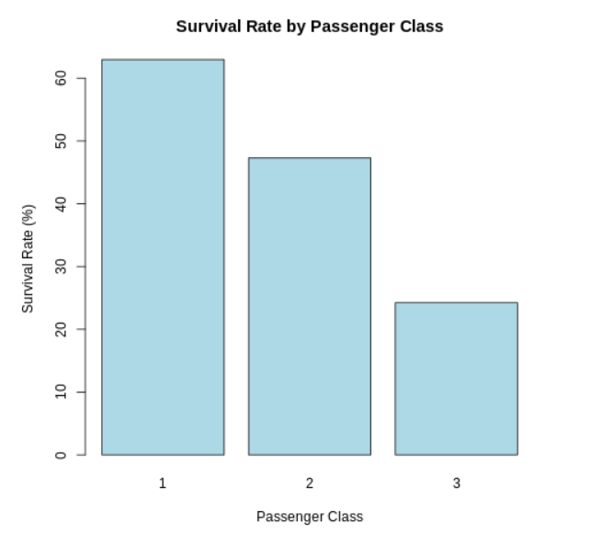
The analysis shows that survival rates differed across passenger classes. First Class passengers had the highest survival rate, followed by Second Class, while Third Class passengers had the lowest survival rate. This indicates an association between passenger class and survival in the Titanic dataset.
Correlation Analysis:
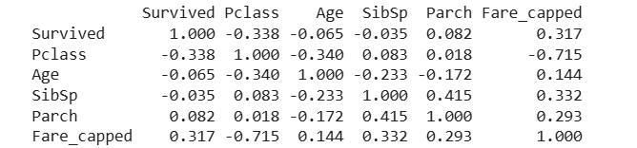
The correlation analysis shows that Pclass has a moderate negative correlation with survival (-0.338), while Fare has a moderate positive correlation (0.317). Age, SibSp and Parch show relatively weak linear correlations with survival. Correlation indicates association and does not establish causation.
Initial Insights:
- The dataset contained 891 passenger records and 12 variables.
- 177 missing Age values were identified and replaced using median imputation.
- The median Age used for imputation was 28 years.
- No duplicate records were identified.
- 116 potential Fare outliers were detected using the IQR method.
- Fare outliers were treated using capping at the upper limit of 65.6344.
- Age and Fare were normalized using Min-Max normalization.
- Sex was binary encoded and Embarked was one-hot encoded.
- The overall survival rate was 38.38%.
- Female passengers had a substantially higher survival rate than male passengers.
- Pclass and Fare showed stronger correlations with survival than Age, SibSp and Parch.
Conclusion:
This analysis demonstrated a complete data cleaning and preliminary exploratory analysis workflow using R in Google Colab. The Titanic dataset was inspected, cleaned and transformed by handling missing values, checking duplicates, detecting and treating outliers, normalizing numerical variables and encoding categorical variables. Descriptive statistics, visualizations and correlation analysis were then performed to identify initial patterns in the data. The cleaned dataset can be used for further statistical analysis or predictive modelling.
Complete R Code:
data <- read.csv("/content/train.csv")
head(data)
str(data)
summary(data)
dim(data)
names(data)
missing_values <- colSums(is.na(data))
median_age <- median(data$Age, na.rm = TRUE)
data$Age[is.na(data$Age)] <- median_age
duplicate_count <- sum(duplicated(data))
Q1 <- quantile(data$Fare, 0.25, na.rm = TRUE)
Q3 <- quantile(data$Fare, 0.75, na.rm = TRUE)
IQR_value <- IQR(data$Fare, na.rm = TRUE)
lower_limit <- Q1 - 1.5 * IQR_value
upper_limit <- Q3 + 1.5 * IQR_value
outliers <- data$Fare[
data$Fare < lower_limit |
data$Fare > upper_limit]
data$Fare_capped <- data$Fare
data$Fare_capped[data$Fare_capped > upper_limit] <- upper_limit
min_max <- function(x) {
(x - min(x, na.rm = TRUE)) /
(max(x, na.rm = TRUE) - min(x, na.rm = TRUE))
}
data$Age_normalized <- min_max(data$Age)
data$Fare_normalized <- min_max(data$Fare_capped)

data$Sex_encoded <- ifelse(data$Sex == "male", 1, 0)
embarked_encoded <- model.matrix(
~ Embarked - 1,
data = data)
numeric_data <- data[, c(
"Survived",
"Pclass",
"Age",
"SibSp",
"Parch",
"Fare_capped")]
cor_matrix <- cor(
numeric_data,
use = "complete.obs")
heatmap(
cor_matrix,
main = "Correlation Matrix",
symm = TRUE)

