**Index**

|  |  |  |
| --- | --- | --- |
| **Sr. No.** | **Contents** | **Page No.** |
| **1** | **Annexure I– Micro Project Proposal** | 2-3 |
| 1.Aims/Benefits of the Micro-Project | 2 |
| 2. Course Outcome Addressed | 2 |
| 3.Proposed Methodology | 2 |
| 4. Action Plan | 2-3 |
| 5. Resources Required | 3 |
| 6. Name of student with roll no | 3 |
| **2** | **Annexure II – Micro Project Report** | **4-8** |
| 1.Rationale | 4 |
| 2.Aims/Benefits of the Micro-Project | 4 |
| 3.Course Outcome Achieve | 4 |
| 4. Literature Review | 4-5 |
| 5.Actual Methodology Followed | 5-8 |
| 6.Actual Resources Used | 8 |
| 7. Applications of this Micro-Project | 9 |

**Annexure I**

**Micro Project Proposal**

**Global Warming**

**1. Aims/Benefits of the Micro-Project:**

Natural calamities have increased due to uncontrollable increase in pollution which has has led to Global warming. The AQI (Air Quality Index) has also worsened during the years.

**2. Course Outcome Addressed:**

1. Develop public awareness about the environment.

2. Apply techniques to reduce environmental pollution.

**3. Proposed Methodology:**

Global Warming is an important social and economic problem and an essential factor in assessing ecosystem health and function. Global warming is one of the naturally occurring problems all over globe. It will affect all landforms. Global warming may also happen through forces associated with industrial activities such as smoke, water pollution, which is rich in organic matter, high fertility and soil life, is relocated elsewhere "on-site" where it builds up over time or is carried "off-site" where it fills in drainage channels. Global warming reduces cropland productivity. Global warming contributes to the pollution of adjacent watercourses, wetlands and lakes.

**4. Action Plan**:

|  |  |  |  |  |
| --- | --- | --- | --- | --- |
| **Sr.**  **No.** | **Details of Activity** | **Planned**  **Start date** | **Planned**  **Finish date** | **Name of Responsible Team Members** |
| 1 | Search the topic | 05-09-2022 | 09-09-2022 | Khedkar Sanket Shivaji |
| 2 | Search the information | 10-9-2022 | 12-09-2022 |
| 3 | Find the meaning of Global warming | 16-09-2022 | 19-09-2022 |
| 4 | Find the different causes of pollution | 23-09-2022 | 24-09-2022 |
| 5 | Disadvantages and precaution of Global warming | 30-09-2022 | 10-10-2022 |
| 6 | Collecting the different images of pollution | 08-10-2022 | 3-12-2022 |
| 7 | Making Index and Certificate of project | 02-12-2022 | 02-12-2022 |
| 8 | Finalizing Project with its report | 10-12-2022 | 10-12-2022 |

**5. Resources Required:**

|  |  |  |  |  |
| --- | --- | --- | --- | --- |
| **Sr.No.** | **Name of resource / material** | **Specification** | **Quantity** | **Remarks** |
| 1 | Computer | WINDOWS 7, 2GB RAM, 160GB HDD | 1 |  |
| 2 | Operating System | WINDOWS 7 | 1 |  |
| 3 | Browser | Chrome | 1 |  |

**6. Names of Team Member with Roll No.:**

|  |  |  |  |
| --- | --- | --- | --- |
| **Sr. No.** | **Enrollment No.** | **Name of Team Member** | **Roll No.** |
| 1 | 2010950092 | Khedkar Sanket Shivaji | 17 |

**Mrs. Dharashive A.S.**

**Name and Signature of the Teacher**

**Annexure – II**

**Micro-Project Report**

**Global Warming**

**1. Rationale:**

The world today is facing the biggest challenge of survival. Degradation of the ecosystem, depletion of natural resources, increasing levels of pollution pose a major threat to the survival of mankind. The need of the hour, therefore, is to concentrate on the area of environmental aspects, which shall provide an insight into various environment related issues, Environmental studies are an interdisciplinary academic field that integrates physical, chemical and biological sciences. with the study of the environment. It provides an integrated, quantitative, and interdisciplinary approach to the study of the environmental system & gives an insight into solutions of environmental problems.

**2. Aims/Benefits of the Micro-Project:**

Natural calamities have increased due to uncontrollable increase in pollution which has has led to Global warming. The AQI (Air Quality Index) has also worsened during the years.

**3. Course Outcomes Achieved:**

1. Develop public awareness about the environment.

2. Apply techniques to reduce environmental pollution.

**4. Literature Review:**

The term “global warming” refers to the increase in the average temperature of global surface air and oceans since about 1950, and to continuing increases in those temperatures.

Greenhouse gases, being lighter than air, naturally rise up the outer limits of the earth’s atmosphere and then settle there, creating an impenetrable barrier that traps heat from being able to escape into space and warming the temperature.

Another term for “global warming” is “climate change”. The Intergovern­mental Panel on Climate Change (IPCC) concludes that greenhouse gases are responsible for most of the observed temperature increase since the middle of the twentieth century, and that natural phenomena such as solar variation and volcanoes probably had a small warming effect from pre-industrial times.

Climate change is any substantial change in Earth’s climate that lasts for an extended period of time. Global warming refers to climate change that causes an increase in the average temperature of the lower atmosphere. Global warming can have many different causes, but it is most commonly associated with human interference, specifically the release of excessive amounts of greenhouse gases.

Gases, such as carbon dioxide (CO2), methane (CH4), water vapour, and fluorinated gases, act like a greenhouse gas around the earth. This means that they allow the heat to come from the Sun into the atmosphere, but do not allow the heat to escape back into space. The more the greenhouse gases, the larger the percentage of heat that is trapped inside the earth’s atmosphere.

**5 Actual Methodology Followed:**

**5.1. Origin**

Global warming is the process, which started long and long ago. In order to understand when global warming began, we should look back for many and many years ago — in the times much earlier before human’s devised international treaties and even much earlier before we learned to burn first fossil fuel, which was wood. It was about the second half of the 20th century, when the global warming had become a talk of the town. In year 1997, the problem of global warming, or to be more exact the problem of human contribution into this natural phenomenon, was addressed officially, when the world’s largest industrialized countries agreed to reduce greenhouse gases emissions as the effort to stop the rapid progression of the global warming.

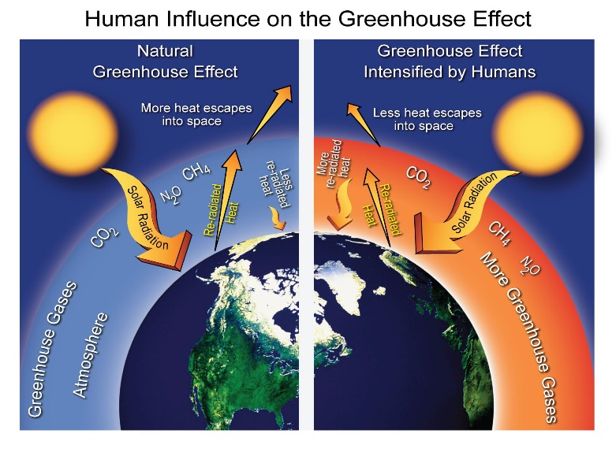

**5.2 Causes:**

Over the past century, our planet has slowly been warming up. Since the beginning of the 20th century, the average temperature around the world has gradually risen by one degree fahrenheit. Though this minimal warming might not seem so significant, but the over-all impact will most certainly prove to the devastating if this continual warming process is not somehow ebated.

So, the global warming may cause by both naturally and anthragogenically.

The issue of global warming is most often blamed on human beings’ ecologically irresponsible practices and technologies. In fact, global warming is quite a complex phenomena brought about not only by us but also by nature itself.

To the surprise of many environmentalists, in fact, mankind and technology actually aren’t the only significant causes of global warming. There are actually a wide variety of natural causes, ranging from volcanic eruptions, solar radiation and natural thawing of the Earths **“permafrost”** and glaciers.

In other words, the planet’s temperature, just like most other things in life and natural science, simply tends to fluctuate through natural, rhythmic, **“ebbs and flows”** and highs and lows that are caused and by sources within the planet itself, as well as the vacillating environment of the solar system and universe. Several “man-made” causes also play a significant role in global warming trend.

### 5.2.1 Man-made Causes of Global Warming

#### Deforestation

Plants are the main source of oxygen. They take in carbon dioxide and release oxygen thereby maintaining environmental balance. Forests are being depleted for many domestic and commercial purposes. This has led to an environmental imbalance, thereby giving rise to global warming.

#### Use of Vehicles

The use of vehicles, even for a very short distance results in various gaseous emissions. Vehicles burn fossil fuels which emit a large amount of carbon dioxide and other toxins into the atmosphere resulting in a temperature increase.

#### Chlorofluorocarbon

With the excessive use of air conditioners and refrigerators, humans have been adding CFCs into the environment which affects the atmospheric ozone layer. The ozone layer protects the earth surface from the harmful ultraviolet rays emitted by the sun. The CFCs have led to [ozone layer depletion](https://byjus.com/biology/ozone-layer-depletion/) making way for the ultraviolet rays, thereby increasing the temperature of the earth.

#### Industrial Development

With the advent of industrialization, the temperature of the earth has been increasing rapidly. The harmful emissions from the factories add to the increasing temperature of the earth.

In 2013, the Intergovernmental Panel for Climate Change reported that the increase in the global temperature between 1880 and 2012 has been 0.9 degrees Celsius. The increase is 1.1 degrees Celsius when compared to the pre-industrial mean temperature.

#### Agriculture

Various farming activities produce carbon dioxide and methane gas. These add to the greenhouse gases in the atmosphere and increase the temperature of the earth.

#### Overpopulation

An increase in population means more people breathing. This leads to an increase in the level of carbon dioxide, the primary gas causing global warming, in the atmosphere

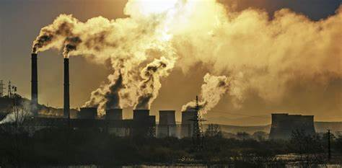

**c. Effects:** The effects of global warming are strongest at the poles. Ice all over the world melting. This includes the ice of mountain glaciers, Arctic sea ice and ice sheets covering West Antarctica and Greenland. The melting ice increases the sea level and this causes flooding of low-lying areas. When snow and ice melts, their ability to reflect sunlight lost this accelerate the global warming even further.

Since 1900 global glacier surface area has decreased by half and glacial retreat is occurring on every continent. The effects include landslides, glacial lake overflow and flash floods as regular, seasonal patterns of snowfall and some melting are destroyed.

Less glacier melt-water in summer means the drying up of rivers and streams which are needed for drinking water, irrigation and many other processes. Just imagine the effects from an accelerated melting of Himalayan glaciers. The Ganges and other major rivers are the lifeblood for the huge populations of India, China and other parts of Asia.

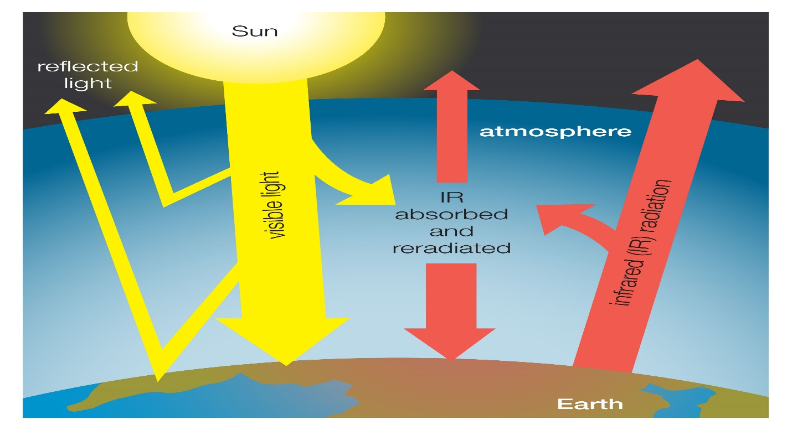

### Rise in Temperature

Global warming has led to an incredible increase in earth’s temperature. Since 1880, the earth’s temperature has increased by ~1 degrees. This has resulted in an increase in the melting of glaciers, which have led to an increase in the sea level. This could have devastating effects on coastal regions.

### Threats to the Ecosystem

Global warming has affected the coral reefs that can lead to the loss of plant and animal lives. Increase in global temperatures has made the fragility of coral reefs even worse.

### Climate Change

Global warming has led to a change in climatic conditions. There are droughts at some places and floods at some. This climatic imbalance is the result of global warming.

### Spread of Diseases

Global warming leads to a change in the patterns of heat and humidity. This has led to the movement of mosquitoes that carry and spread diseases.

### High Mortality Rates

Due to an increase in floods, tsunamis and other natural calamities, the average death toll usually increases. Also, such events can bring about the spread of diseases that can hamper human life.

### Loss of Natural Habitat

A global shift in the climate leads to the loss of habitats of several plants and animals. In this case, the animals need to migrate from their natural habitat and many of them even become extinct. This is yet another major impact of global warming on [biodiversity](https://byjus.com/biology/biodiversity/).

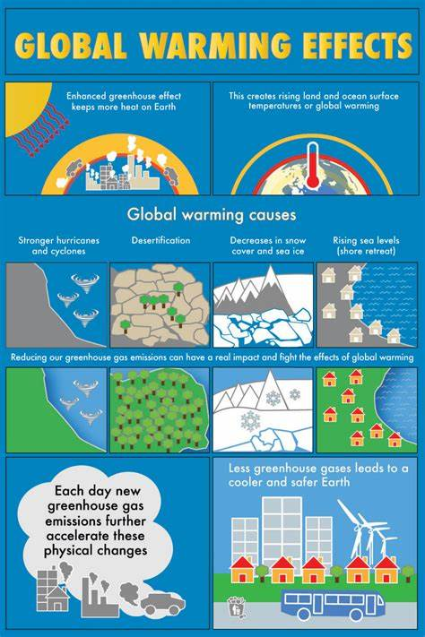

**d. Global Warming and Polar Bears:**

Polar bears are adapted to freezing environments and they can survive at temperatures as low as -46°C. This is why they thrive in Antarctica where snow, sea ice, and glacial ice cover most areas year round. At warmer climates, polar bears overheat and die.

This is why global warming poses a great threat to the world’s population of polar bears. Already, the increase in global temperature has caused a significant reduction in sea ice. Although Arctic temperatures are still well within the tolerable range for polar bears, the thinning and melting of ice due to global warming has already caused a significant number of polar bear drowning’s.

The change in Arctic climate has also caused polar bears to face starvation due to food shortages since they are losing about three weeks for hunting on solid ice and feeding on their prey. Polar bears now weigh at least 15% less than they did just 30 years ago.

For a typical adult male, which would amount to about 150 pounds less in weight, 60% of the 20,000-25,000 polar bears will die off within the next 50 years.

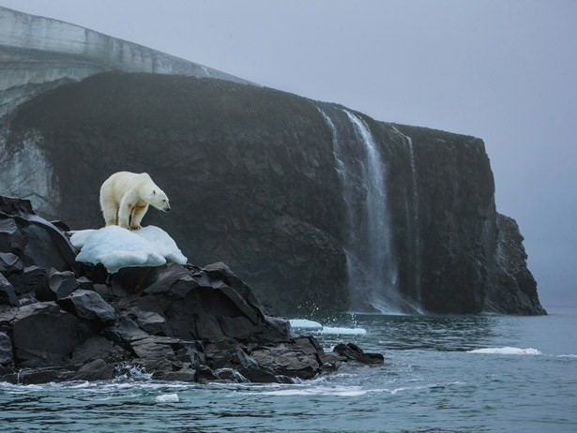

**e. Prevention**

A key step towards preventing global warming is to conserve energy. The vast majority of energy that we consume is produced from the burning of fossil fuels such as coal, oil, and gas. During this process, greenhouse gases are released into the atmosphere – gases that contribute to the artificial warming of our planet. By conserving energy, we will reduce the levels of fossil fuels that we burn, thus reducing the level of greenhouse gases released into the atmosphere.

Small changes will have a great impact and will help us to fight against global warming. For instance, if we use LED bulbs instead of light bulbs and CFLs, we can contribute to the cause. We can spread awareness regarding the emission of different global warming gasses from factory chimneys and domestic appliances. These glasses should be treated before they are released into the atmosphere. We can also pledge to use eco-friendly products that show immense responsibility towards our planet’s crises.

We can also stop deforestation and do our part by planting more trees. We need to restrict the use of fossil fuels and seek alternative renewable sources of energy. Our lifestyle should become eco-friendlier and more responsible for Mother Earth. Now is the time to act and make everyone aware. Start small but make it big by including everyone you know to protect our planet. We live in a big harmonious ecosystem. Disturbing its balance with manmade disasters like global warming will not leave a chance to survive if not checked. It is time to act accordingly and do every bit on our part to stop this catastrophe.

Some key steps are:

* Where possible, we can switch to renewable sources of energy (such as solar and wind energy) to power our homes and buildings, thus emitting far less heat-trapping gases into the atmosphere.
* Where feasible, we can drive electric vehicles instead of those that burn fossil fuels; or we can use mass transit instead of driving our own cars.
* Where affordable, we can conserve energy by better insulating our homes and buildings, and by replacing old, failing appliances with more energy-efficient models.
* Where practicable, we can counterbalance our annual carbon dioxide emissions by investing in commercial services that draw down an equal amount of carbon out of the atmosphere, such as through planting trees or [carbon capture and storage](https://19january2017snapshot.epa.gov/climatechange/carbon-dioxide-capture-and-sequestration-overview_.html) techniques.
* Where practical, we can support more local businesses that use and promote sustainable, climate-smart practices such as those listed above.
* We can consider placing an upper limit on the amount of carbon dioxide we will allow ourselves to emit into the atmosphere within a given timeframe.

**6. Actual Resources Used:**

|  |  |  |  |  |
| --- | --- | --- | --- | --- |
| **Sr.**  **No.** | **Name of resource / material** | **Specification** | **Quantity** | **Remarks** |
| 1 | Computer | WINDOWS 7,2GB RAM, 160GB HDD | 1 |  |
| 2 | Operating System | WINDOWS 7 | 1 |  |
| 3 | Browser | Chrome | 1 |  |

**7. Skill developed / Learning out of this Micro-Project:**

Soil erosion remains a key challenge for agriculture in several countries. Proper management of this valuable resource is vital to sustain long-term agricultural productivity. Soil conservation practices are tooling the farmer can use to prevent soil degradation and build organic matter. These practices include: crop rotation, reduced tillage, mulching, cover cropping and cross-slope farming.

**9. Applications of this Micro-Project:**

The study highlighted a potential underestimation of the *R* factor and recommended revisiting the regression equations used to compute pollution index , presently, generalized to the country, based on a climate zone approach, and also considering the climate predictions for rainfall under different scenarios.

*********