**RESUME**

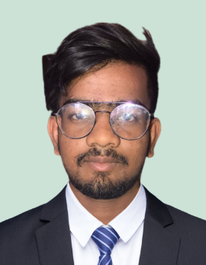**Aditya Kumar**

**Present Address :-**

Lal imly Patna city

**Post :** Begumpur

**State :** Bihar **Distt :-** Patna

**Mobile no:** 7488103944

**Email: -** [**adityakishor74@gmail.com**](mailto:adityakishor74@gmail.com)

To achieve a challenging position in the industry and to use my technical communication and interpersonal skills for the growth of organization.

**Educational Qualification:-**

|  |  |  |  |
| --- | --- | --- | --- |
| **Qualification** | **Board** | **Year of passing** | **Percentage** |
| **10th** | **BIHAR BOARD** | **2020** | **64.8** |
| **Diploma In Mechanical Engineering** | | | |
| **1st year** | **MSBTE** | **2021** | **82.99** |
| **2nd year** | **MSBTE** | **2022** | **78.725** |
| **3rd year** | **MSBTE** | **2023** | **82.41** |

**Internship:** - Mahindra Kiran automobile Pvt. Ltd.

**Computer Skill: -** Catia v5, Basic computer knowledge.

|  |
| --- |
| **SOFT SKILLS:**  ➢ Problem solving abilities.  ➢ Collaborating and working well together with others.  ➢ Excellent communication skills.  ➢ Enthusiastic, disciplined and dedicated.  ➢ Willing to acquire knowledge and learn new skills.  **LANGUAGE:**  ➢ ENGLISH - Fully Proficient  ➢ HINDI - Fully Proficient  ➢ MARATHI – Medium Proficient |

|  |
| --- |
| **VOLUNTEER EXPERIENCE:**  ➢ Appointed as Technical Coordinator from the  college for helping the students in learning new activities.  ➢ Organised various activities in college.  **STRENGTH:**  ➢ Quick at learning new things.  ➢ Ability to understand the responsibility and work according  **INTERESTS:**  ➢ Playing Badminton, Cricket |

**Declaration :**

I do hereby declare that the particulars of information and facts stated above are true and completed the best of my knowledge and belief.

Yours Faithfully,

## Mr. Aditya Kumar