**CS – 529 Assignment 2**

**Kutay Taşcı**

**22101359**

**Overview**

In this assignment we are going to construct one-mode networks from a given two-mode graph. The given two-mode graph consists of people and events as nodes, on the other hand participation of people in events are presented as links. This two-mode graph can be represented as *people X event* or *event X people* matrices. We are going to construct one-mode graphs with using this dataset.

I used Gephi to construct and visualize graphs, for transforming 2-mode graph to 1-mode I used a Python script. Visualizations and adjacency matrices can be found in the documents and in this report.

In the first step of this assignment, we will construct one-mode graphs from given data. We will give the visualization and adjacency matrices of one-mode graphs. Then in the second and third exercises, we are going to answer the questions given in the assignment paper about these graphs. These one-mode networks are *People-by-People* and *Event-by-Event networks.*

**Exercise 1**

In this exercise we are going to use the given 2-mode network, which consists of 18 different people and 14 different social events. In this exercise we are going to extract *people-by-people* and *event-by-event* networks from this 2-mode network. We are going to project this 2-mode network into 1-mode network with using matrix multiplication. You can see the given 2-mode network bellow:

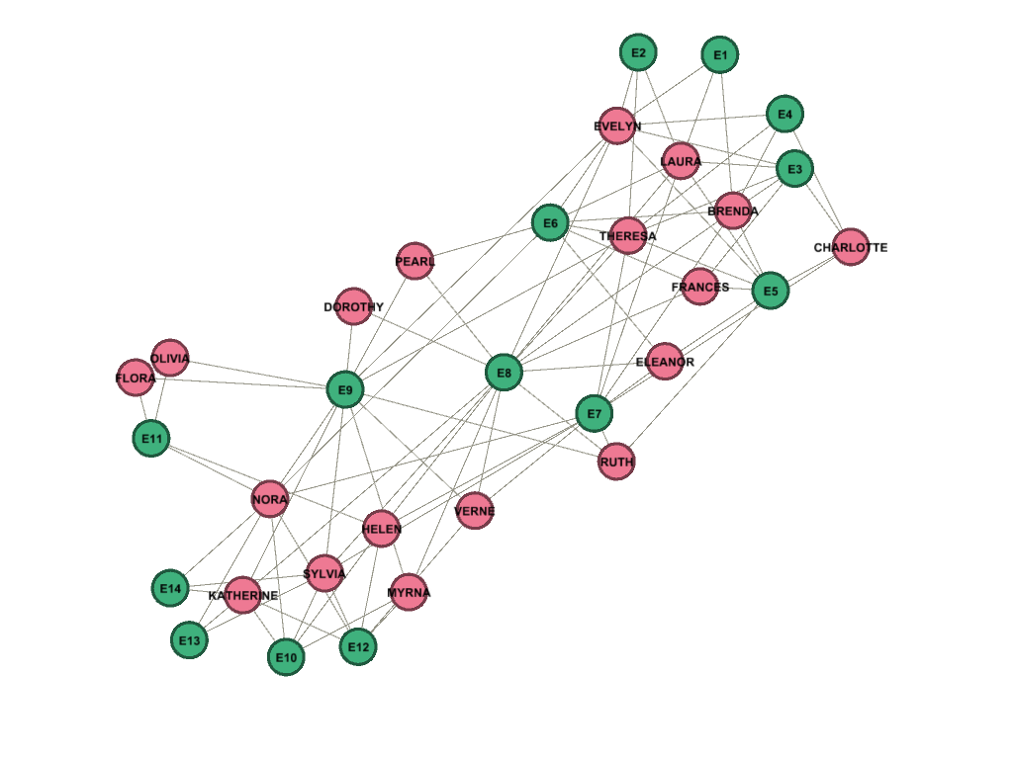

**Method**

In exercise-1 we are going to extract *people-by-people* network from the given 2-mode network. We do this projection with using matrix multiplication. I developed a python script for this task. Which read the data files and generates *event-by-people* matrices, also transpose of *event-by-people* matrix is *people-by-event* matrix. We can project matrices with this matrix multiplication:

***Event-by-People X People-by-Event = Event-by-Event***

**Part-1**

In this part we obtained *people-by-people* network with the method, I explained in above. Know we are going to give visualizations and adjacency matrices. You can also find these in the submission files.

***Visualization of People-by-People Network***

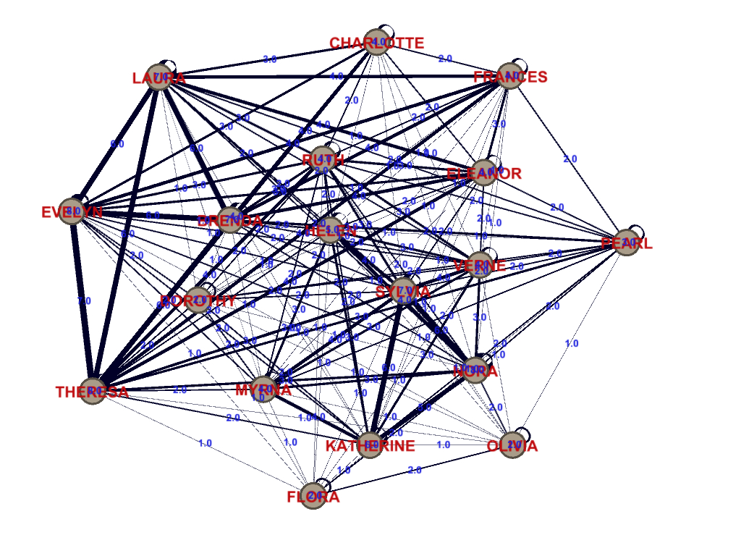

***Adjacency Matrix of People-by-People Network***



**Part-2**

In this part we obtained *event-by-event* network with the method, I explained in above. Know we are going to give visualizations and adjacency matrices. You can also find these in the submission files.

***Visualization of Event-by-Event Network***

***Adjacency Matrix of Event-by-Event Network***



**Exercise 2**

In this exercise we are going to answer the given questions for *People-by-People network.*

**What does the people x people network indicate? In other words, explain under what circumstances there is a link between two people.**

This network is the projection of the given 2-mode network into 1-mode network. When projected into 1-mode, a link means there is a common event node between given two people. A link means given nodes/people have attended the same event before.

For example, there is a link between Evelyn and Laura. This means they have attended the same event before.

**What do the edge weights indicate in the people x people network?**

Edge weights in this network gives the information for given two nodes number of events attended by two of them. For example, Evelyn and Laura has an edge weight of 6. This means they have attended the same events 6 times before.

**What do the values on the loops indicate?**

Self-loops are a side product of the matrix multiplication. It gives the information of a node’s participation to the events with itself. Which means number of the events attended by given node. For example, Evelyn has a self-loop of weight 8, this means Evelyn has attended 8 different events.

**Exercise 3**

In this exercise we are going to answer the given questions for *Event-by-Event network.*

**What does the event x event network indicate? In other words, explain under what circumstances there is a link between two events.**

This network is the projection of the given 2-mode network into 1-mode network. When projected into 1-mode, a link means there is a common people between the given events. A link means there are common people which attended both events.

For example, there is a link between the E1 and E2, which means there are people who attended both of the events in common.

**What do the edge weights indicate in the event x event network?**

Edge weights in this network gives the information of how many people in common attended both events. For example, the weight of the link between E1 and E2 is 2, which means that two people attended both E1 and E2.

**What do the values on the loops indicate?**

Self-loops are a side product of the matrix multiplication. It gives the information of the number people who attended the given event. Which means the number of the people who attended this specific event. For example, E1 has an self-loop with weight 3, this means 3 people has attended the E1.