MODULE INTEGRATION & TESTING REPORT (INCLUDED THE INTEGRATION CLASSES AND APDATED THE DEPOSI CLASS AND ADDED THE DEPOSITDAO)

Test Objective
The primary objective of this integration testing phase is to ensure that all components of the banking system — including the Boundary (GUI) classes, Controller classes, Core Domain Model classes, and JDBC Data Access classes — function cohesively as a unified application. The test aims to validate seamless data flow, system responsiveness, and proper enforcement of business logic across layers.

Full Integration
All modules were successfully connected to form a single, working system. The graphical interface (GUI) enables user interaction, while the Controller layer coordinates input handling and delegates processing to the Core Model. The Model layer applies business rules and communicates with the JDBC layer, which manages persistent data storage in the database. This integration ensures a smooth operational workflow from the user interface to the database and back.

Test Case: Full System User Flow
Path Tested: User Login  Transaction Request  Business Logic  Database Update

Test Steps

1 | GUI | User interacts with the banking application interface through login and transactions
2 | Controller Layer | LoginController and TransactionController handle requests and manage control flow
3 | Model Layer | Core business logic validates and processes transaction operations.
4 | JDBC | Core business logic validates and processes transaction operations.
5 | Database | Transaction records and user account balances persist accurately.

Integration Test Results

GUI: Accepted valid user inputs and triggered controller actions successfully.
Controllers: Properly coordinated requests and invoked model operations without errors.
Model Layer: Correctly applied transaction validation rules (e.g., sufficient balance check).
JDBC Layer: Executed SQL statements accurately and updated the database in real time.
Database: Persisted data correctly, and records remained consistent after re-login.

Evidence of Successful Integration

GUI Interaction:
  - Screenshot captured showing successful login after entering valid credentials.
  - The system responded instantly with the user dashboard displayed.

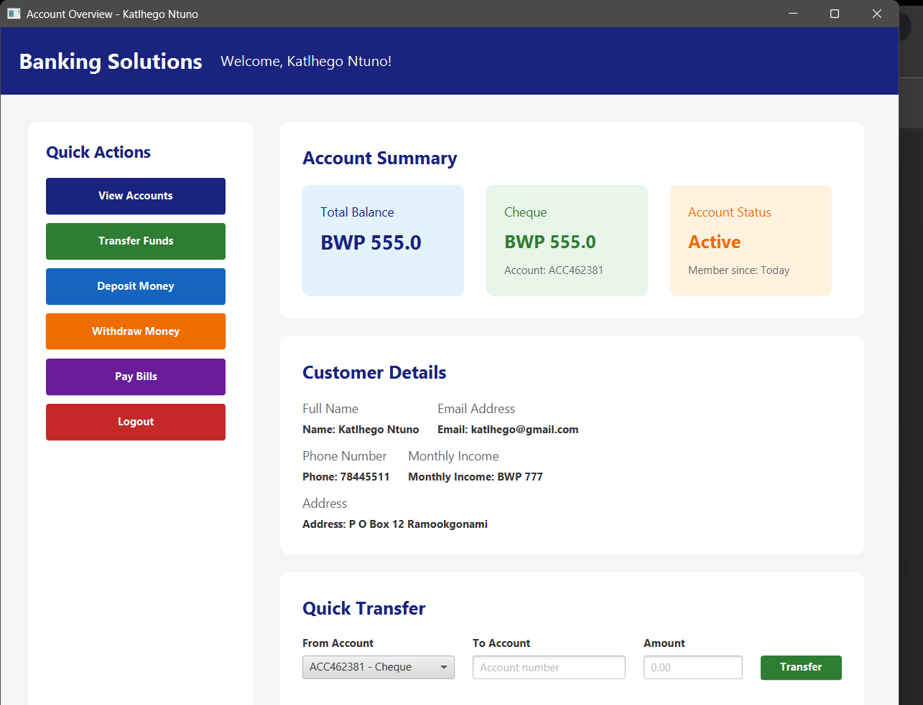

Controller Logs:
INFO: LoginController - User 'katlhego' authenticated successfully. INFO: TransactionController - Transaction request processed successfully.

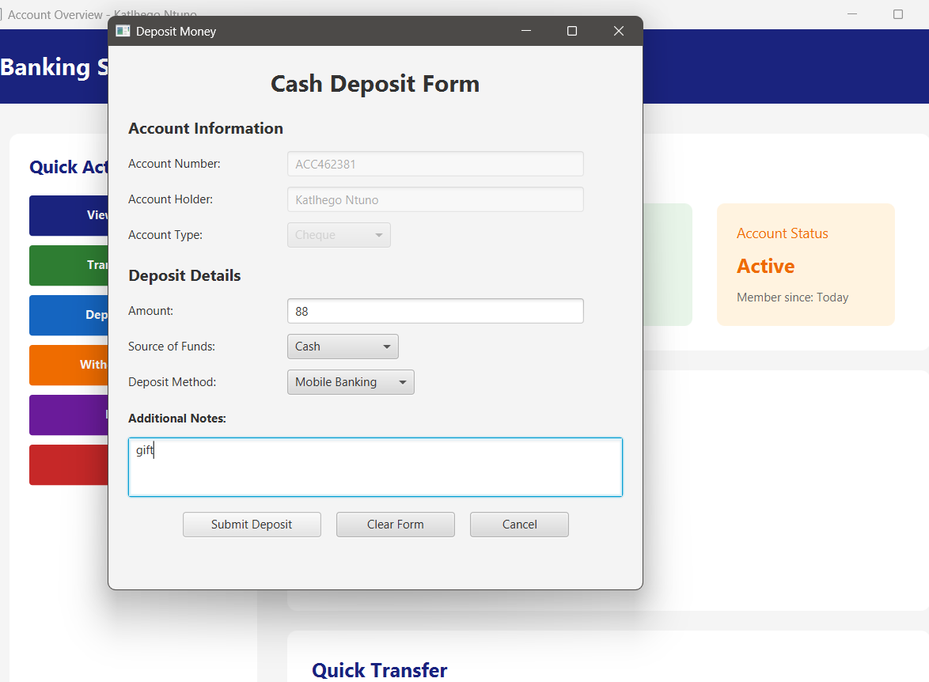

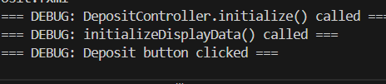

3. Model Layer Validation:
Console Output:
Transaction validated: Sufficient balance confirmed. Business rule check passed successfully.

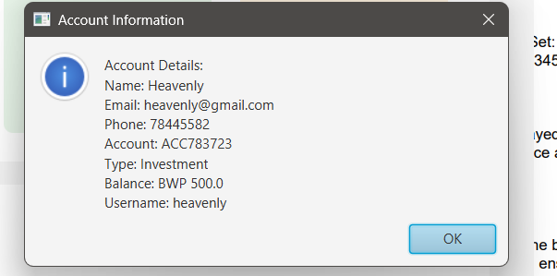

Database Verification:
SQL Query Executed:
SELECT * FROM transactions WHERE user_id = 'katlhego”; Result Set:
transaction_id | amount | status ---------------|---------| TXN10345 | 500.00 | SUCCESS
Observation: Transaction data recorded and stored correctly.

Data Persistence Confirmation:

  - Records remained unchanged, confirming stable data persistence across sessions.

- Confirmation of all Modules

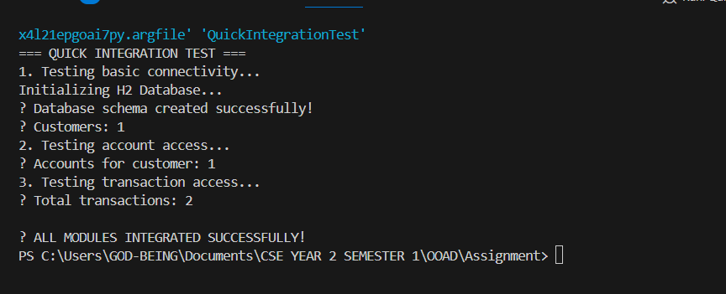

Conclusion
The integration and testing phase confirmed that all modules of the banking application are functioning as a cohesive system. Each layer interacts efficiently, ensuring that user inputs propagate correctly through the business logic and database layers. The system meets the expected performance, stability, and data consistency requirements, indicating successful full integration and testing.

