FORGESHELL
LINUX PROCESS MONITORING AND CONTROL SYSTEM
PROJECT ABSTRACT AND DOCUMENTATION
Operating Systems and Systems Programming
Implementation Language: C (C11)
Operating System: Ubuntu Linux 24.04
Interface: Command-Line Interface (CLI)
TEAM 01
Alekhya – 2520030209
Devika – 2520030329
Tanmayee – 2520030339

ABSTRACT
ForgeShell is a C-based, menu-driven Linux application designed to simplify process monitoring and management. In a Linux operating system, multiple processes execute simultaneously, making it important to identify active processes, understand their execution states, monitor resource consumption, and manage their execution when required.
The system provides a centralized command-line interface through which users can list running processes, search for processes using their Process ID (PID) or name, inspect detailed process information, monitor CPU and memory usage, and control selected processes.
The application uses the Linux /proc virtual filesystem to retrieve process-related information such as PID, Parent Process ID (PPID), process state, virtual memory size, resident memory, user ID, thread count, and CPU time. Process-control operations are implemented using the kill() system call and POSIX signals, including SIGTERM, SIGKILL, SIGSTOP, and SIGCONT.
ForgeShell also provides live process monitoring with automatic updates every two seconds. It estimates CPU utilization by comparing consecutive process CPU-time and total system CPU-time readings. Input validation, error handling, confirmation prompts, and safety checks are incorporated to reduce accidental process-control operations. The project demonstrates practical Operating Systems and Linux system-programming concepts, including process management, process states, memory monitoring, signals, system calls, and filesystem interaction.

1. INTRODUCTION
An operating system manages multiple processes during system execution. Each running application or program is represented by a process that consumes resources such as CPU time and memory. Linux provides system interfaces and commands for managing these processes. ForgeShell brings common process operations together in one terminal-based application. It reads process information from the /proc virtual filesystem and uses POSIX signals for process control.

2. PROBLEM STATEMENT
A Linux system may execute numerous processes simultaneously. Identifying active processes, understanding their execution states, viewing parent-child relationships, and observing resource consumption can require several separate commands or interfaces. Users may also need to search for a process, inspect its details, monitor it, or control its execution. ForgeShell addresses this by providing these operations through a single command-line interface.

3. OBJECTIVES
- Display currently running Linux processes.
- Identify processes using their PID or process name.
- Retrieve process details such as PID, PPID, state, and memory usage.
- Display UID, thread count, and accumulated CPU time when available.
- Monitor a selected process and estimate CPU utilization.
- Control processes using Linux signals.
- Provide input validation, error handling, and basic safety checks.
- Demonstrate Linux system-programming concepts through practical implementation.

4. PROPOSED SYSTEM
ForgeShell is a menu-driven process-management utility. The user selects an operation, supplies the required input, and receives the result in the terminal. The application reads information from /proc for listing, searching, inspection, and monitoring. It uses the kill() system call with POSIX signals for process-control operations. It is a user-space utility and does not modify the Linux kernel.

5. SYSTEM REQUIREMENTS

5.1 Hardware Requirements
- Computer or laptop
- Minimum 4 GB RAM recommended
- Sufficient storage for Ubuntu and development tools
- Keyboard and display

5.2 Software Requirements
Component | Requirement
Operating System | Ubuntu Linux 24.04
Programming Language | C (C11)
Compiler | GCC
Interface | Linux terminal / CLI
Linux interfaces | /proc filesystem and POSIX signals

6. TECHNOLOGIES AND LINUX INTERFACES
Technology / Interface | Purpose
C11 | Application implementation
GCC | Compiles the C source code
/proc | Provides process and system information
opendir() / readdir() | Opens and scans directory entries
fopen() / fgets() | Reads process information files
kill() | Sends a signal to a process
POSIX signals | Requests process termination, stop, or continuation
select() / termios | Supports terminal input and monitoring interaction

6.1 Important Linux Files
- /proc/<PID>/stat – process state, parent PID, and CPU-time counters.
- /proc/<PID>/status – process name, memory information, UID, and thread count.
- /proc/stat – total system CPU-time counters.

7. SYSTEM MODULES

7.1 Process Listing Module
Scans the /proc directory, identifies numeric directory names as process IDs, reads process information, and displays PID, PPID, state, and process name.

7.2 Process Searching Module
Accepts a numeric PID or process-name text. Numeric input is treated as a PID lookup; text input supports case-insensitive partial-name matching. Matching processes are displayed.

7.3 Process Inspection Module
Displays available details such as process name, PID, PPID, state, VmSize, VmRSS, UID, thread count, and accumulated CPU time.

7.4 Process Control Module
Uses kill() to send SIGTERM, SIGKILL, SIGSTOP, or SIGCONT to a selected process. Safety checks and confirmation prompts help reduce accidental operations.

7.5 Live Process Monitoring Module
Monitors a selected process and refreshes information every two seconds. It displays process state, resident memory, and estimated CPU utilization. The user can stop monitoring using Q or Ctrl+C.

8. PROCESS-CONTROL SIGNALS
Signal | Purpose
SIGTERM | Requests graceful process termination.
SIGKILL | Forcefully terminates a process; it cannot be caught or ignored.
SIGSTOP | Stops process execution.
SIGCONT | Continues a stopped process.

A successful signal operation indicates that the signal was delivered or accepted by the kernel; it does not, by itself, prove that a SIGTERM target has already exited.

9. CPU UTILIZATION CALCULATION
ForgeShell estimates CPU utilization by comparing consecutive readings of process CPU time from /proc/<PID>/stat and total system CPU time from /proc/stat.
Process CPU Time = User CPU Time + System CPU Time
CPU Usage (%) = (Process CPU-time difference / Total system CPU-time difference) × Number of Online CPUs × 100
The first monitoring display may not have a percentage because two samples are needed. The displayed percentage is normalized so that 100% represents one fully utilized CPU core.

10. SYSTEM WORKFLOW
- The user launches ForgeShell.
- The main menu is displayed.
- The user selects an operation.
- The application accepts and validates the required input.
- The application reads information from /proc or sends a process-control signal.
- The result is displayed in the terminal.
- The user returns to the menu or exits the application.

11. INPUT VALIDATION AND ERROR HANDLING
- Rejects empty search input.
- Validates PID input and rejects invalid numeric values.
- Handles processes that disappear during directory scanning.
- Reports permission-related and process-not-found errors.
- Handles unavailable process information.
- Requires confirmation for termination operations.
- Protects PID 1 and ForgeShell's own PID from control operations.
- Restores terminal settings when monitoring ends.

12. COMPILATION AND EXECUTION
Open the project directory:
cd ForgeShell
Compile the source file:
gcc -Wall -Wextra -Wpedantic -std=c11 main.c -o shellforge
Run the application:
./shellforge
The menu options shown by the application are:
1. List Running Processes
2. Search Process
3. Inspect Process
4. Control Process
5. Monitor Process
6. Exit

13. TESTING AND OBSERVED RESULTS
The following results are based on the terminal screenshots supplied for this documentation. Only the tests visible in those screenshots are marked as passed.
Test ID | Test / Input | Observed result | Status
TC01 | Launch application; choose 6 | Main menu appeared and exit message was displayed. | Pass
TC02 | Choose 1 – List processes | Process table displayed PID, PPID, state, and name; 28 processes were listed in that captured run. | Pass
TC03 | Choose 2; enter PID 210 | One matching process, rsyslogd, was displayed. | Pass
TC04 | Choose 3; enter PID 114 | Details for snapfuse were displayed, including memory, UID, threads, and CPU time. | Pass
TC05 | Choose 5; enter PID 3925 | Application reported that the process did not exist. | Pass – error handling

13.1 Additional Tests to Perform
Test ID | Suggested procedure | Expected behavior
TC06 | Search for a known process name such as bash. | Matching process names are displayed.
TC07 | Use a temporary sleep process to test SIGSTOP, SIGCONT, and SIGTERM. | Process stops, resumes, and receives termination request.
TC08 | Monitor a temporary sleep process. | Information refreshes every two seconds; Q or Ctrl+C stops monitoring.
TC09 | Enter invalid PID input such as 0 or non-numeric text. | Input is rejected with an error.
TC10 | Attempt to control PID 1. | The protected operation is refused.

Important: Tests TC06–TC10 are suggested validation steps and were not demonstrated in the screenshots supplied. Use only a temporary test process for signal testing, not important system processes.

14. SCREENSHOTS AND OUTPUT
The following screenshots show the captured terminal execution of ForgeShell.
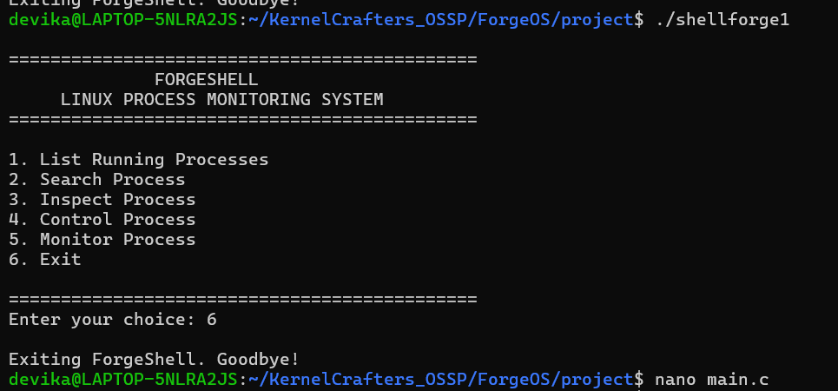
Figure 1. ForgeShell main menu and exit output.
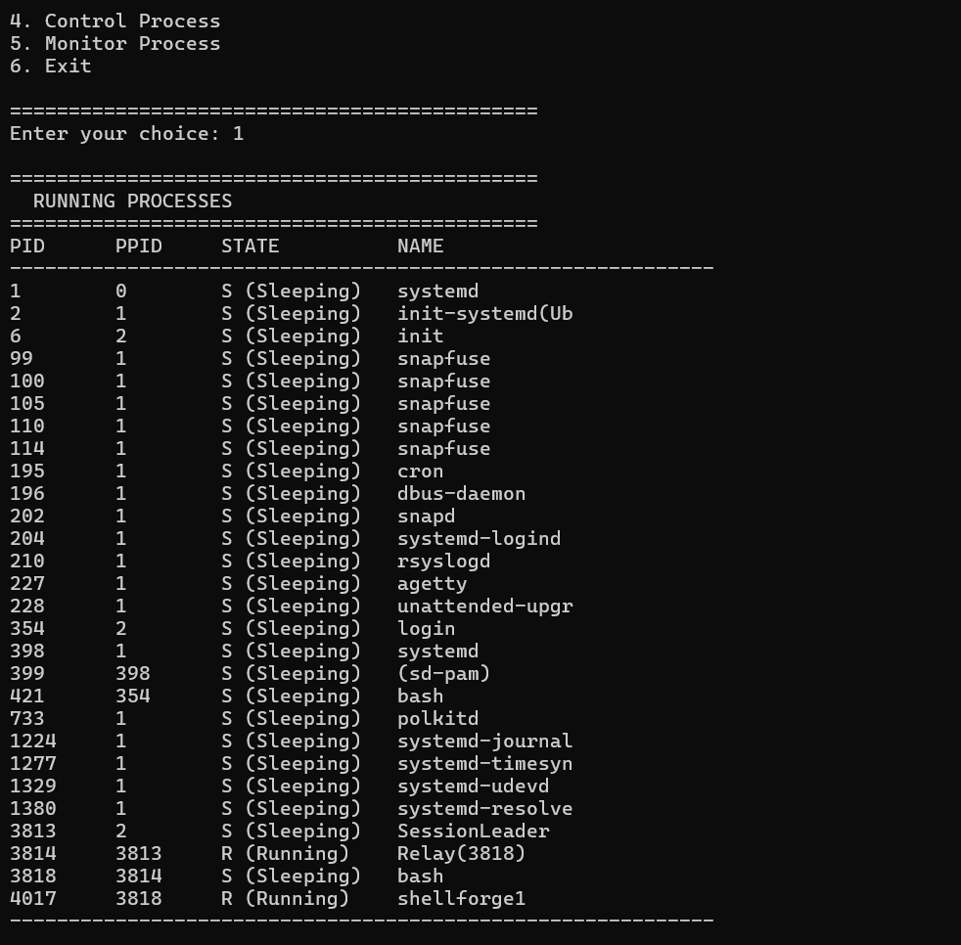
Figure 2. List Running Processes output; 28 processes listed in this run.
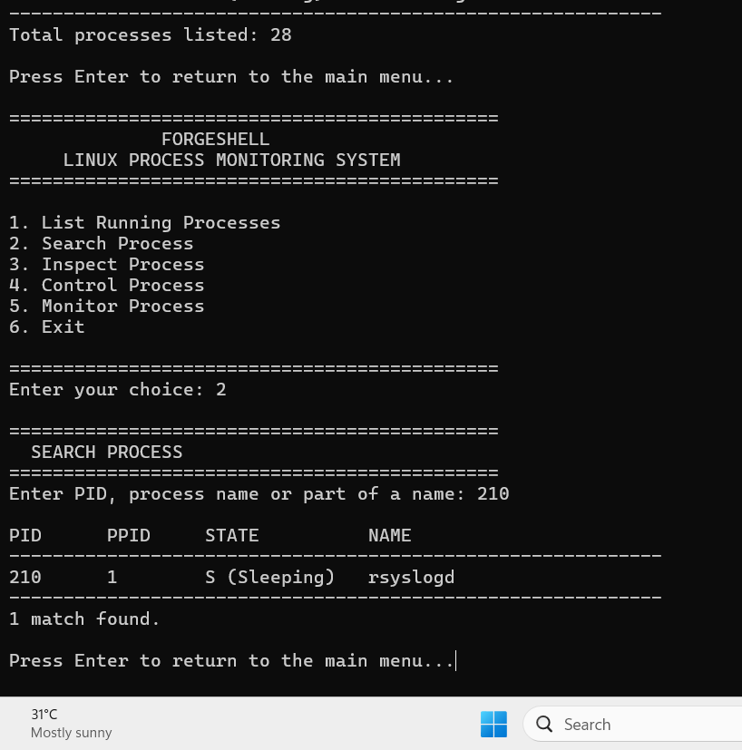
Figure 3. Search Process output for PID 210 (rsyslogd).
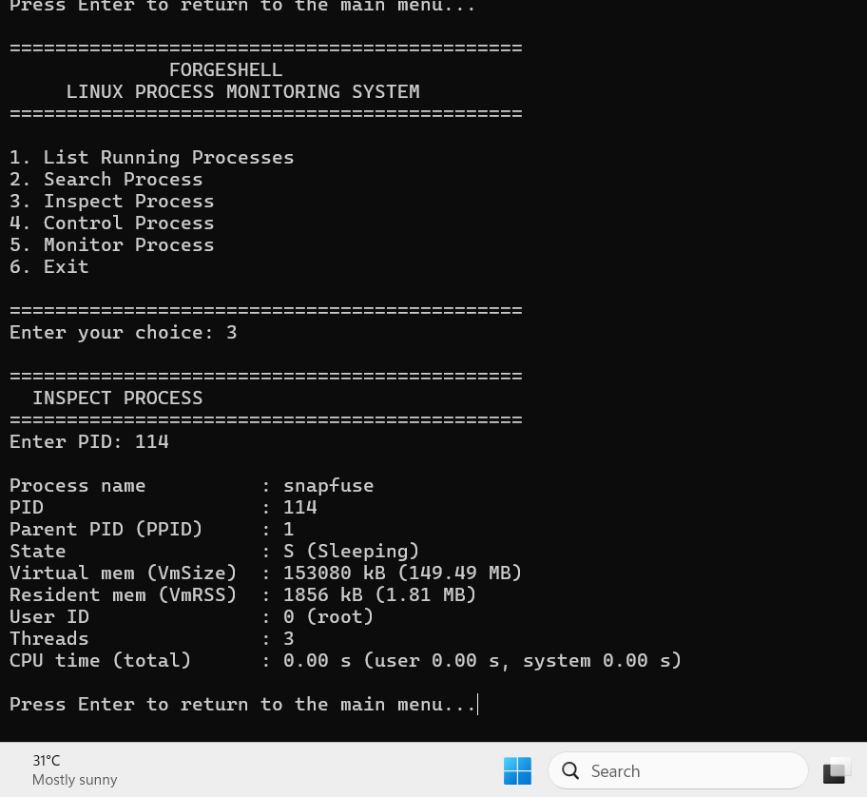
Figure 4. Inspect Process output for PID 114 (snapfuse).
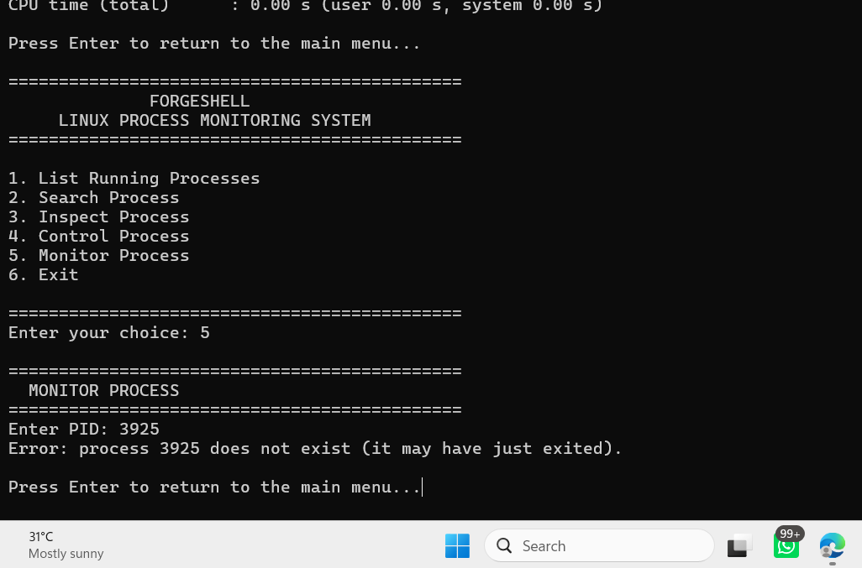
Figure 5. Monitor option reporting that PID 3925 does not exist.

15. ADVANTAGES
- Combines several process-management operations in one application.
- Uses Linux system interfaces directly.
- Displays detailed process information.
- Supports periodic monitoring.
- Includes process-control safeguards and error handling.
- Provides a lightweight command-line interface.

16. LIMITATIONS
- Designed for Linux systems and Linux /proc interfaces.
- Some process information may be unavailable due to permissions or process termination.
- Process-control operations depend on the user's permissions.
- CPU usage is an estimate based on periodic samples.
- The application provides a terminal interface rather than a graphical interface.

17. FUTURE ENHANCEMENTS
- Develop a graphical user interface.
- Add process sorting and filtering.
- Add process-priority management using Linux scheduling interfaces.
- Provide historical CPU and memory usage graphs.
- Export process information into CSV or text reports.
- Allow configurable monitoring intervals.

18. CONCLUSION
ForgeShell demonstrates a Linux process monitoring and control utility implemented using the C programming language. It combines process listing, searching, inspection, live monitoring, and process control in one command-line interface. By using the /proc virtual filesystem and POSIX signals, the project demonstrates practical concepts such as process identification, process states, memory information, CPU-time calculations, system calls, signal handling, and Linux filesystem interaction.

19. REFERENCES
- Linux manual page: proc(5).
- Linux manual page: kill(2).
- Linux manual page: signal(7).
- Linux manual pages: opendir(3) and readdir(3).
- Linux manual page: termios(3).
- GNU GCC documentation.

