Лабораторная работа №6
Тема: Разработка и интеграция модулей проекта
(командная работа)

Цель: разработать и интегрировать модуль базы данных проекта в Microsoft SQL Server, создать эффективную схему данных, обеспечивающую целостность и удобство хранения информации, а также подготовить основу для дальнейшей реализации бизнес-логики и взаимодействия с приложением с учетом командной работы.

Ход работы
Откройте Excel-файл «Издательство.xlsx».
Убедитесь, что данные в Excel-файле корректны и все таблицы готовы для импорта. Каждый лист в Excel-файле представляет отдельную таблицу.
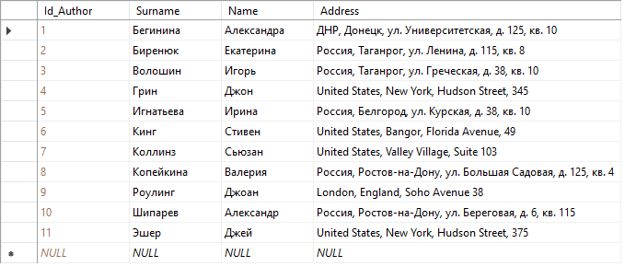
Рис. 1. Authors
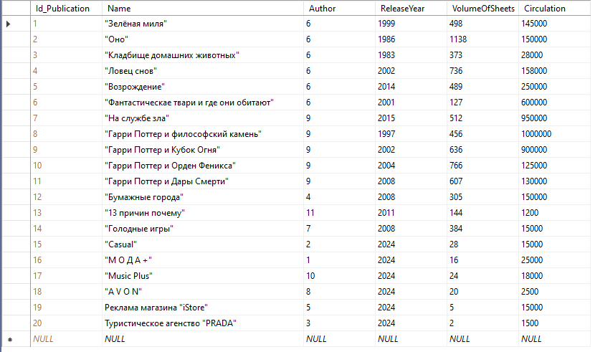
Рис. 2. Publications
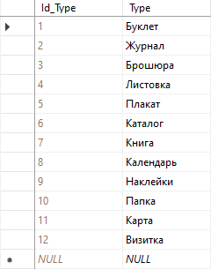
Рис. 3. TypesOfProducts
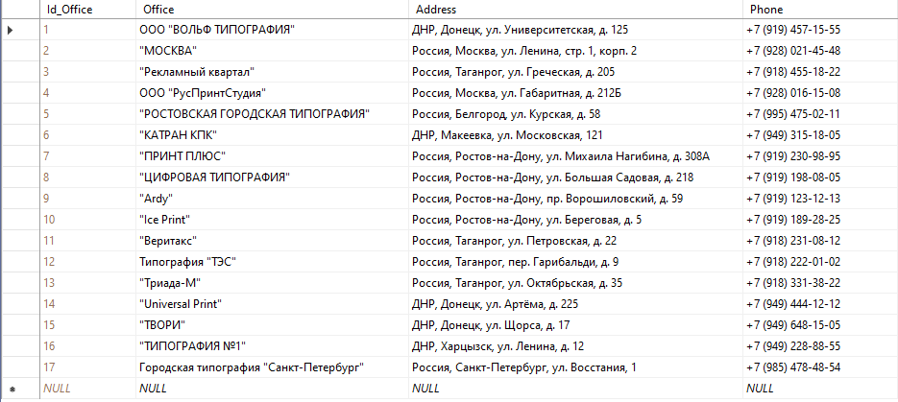
Рис. 4. Offices
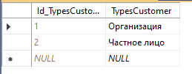
Рис. 5. TypesCustomers
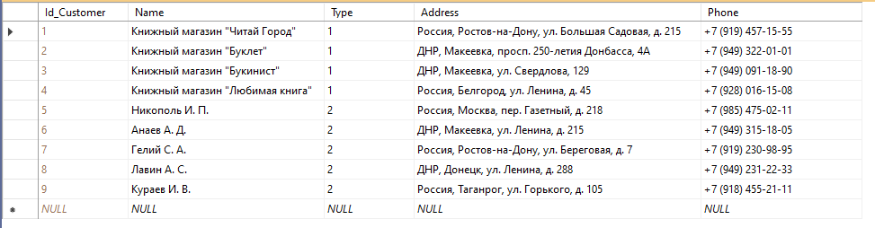
Рис. 6. Customers
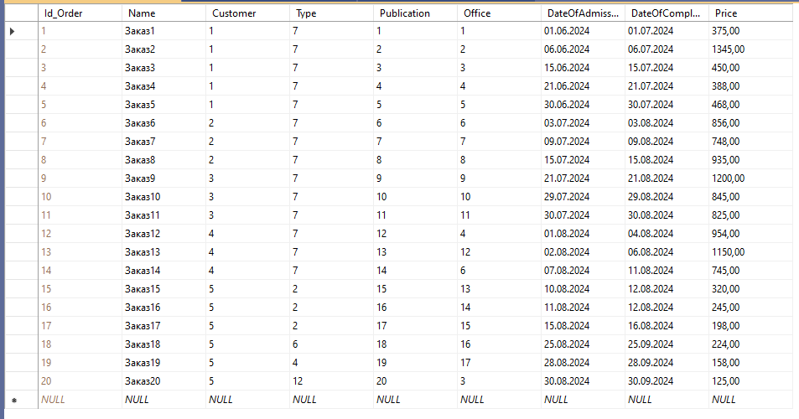
Рис. 7. Orders
Диаграмма:
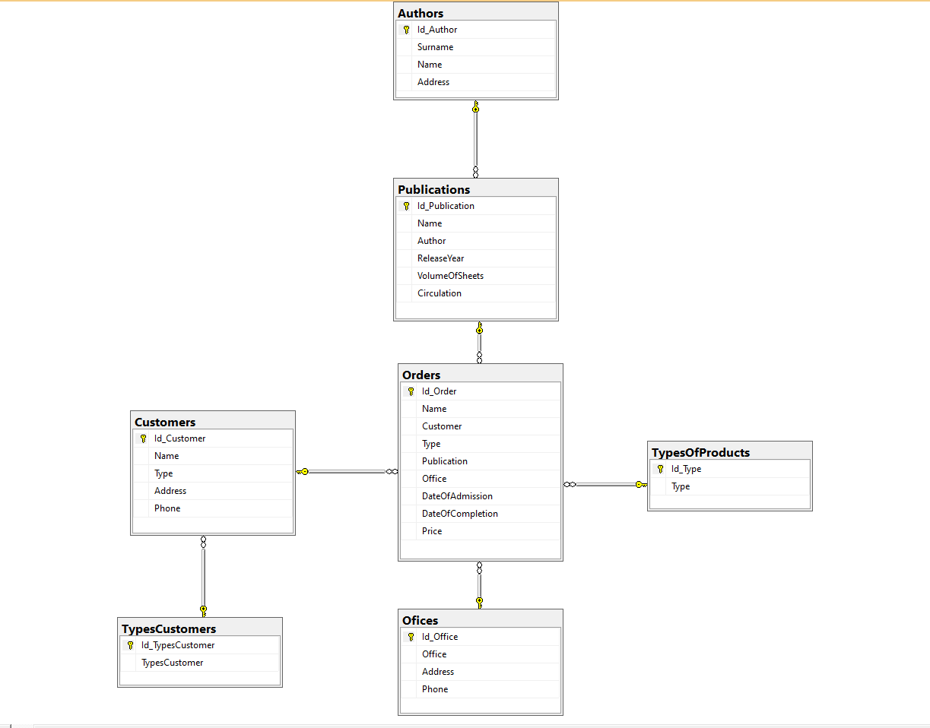
Рис. 8. Диаграмма
Скрипт:
USE [master]
GO
/****** Object: Database [Publishing] Script Date: 16.12.2025 9:17:04 ******/
CREATE DATABASE [Publishing]
CONTAINMENT = NONE
ON PRIMARY
( NAME = N'Publishing', FILENAME = N'D:\Database\Publishing.mdf' , SIZE = 8192KB , MAXSIZE = UNLIMITED, FILEGROWTH = 65536KB )
LOG ON
( NAME = N'Publishing_log', FILENAME = N'D:\Database\Publishing_log.ldf' , SIZE = 8192KB , MAXSIZE = 2048GB , FILEGROWTH = 65536KB )
WITH CATALOG_COLLATION = DATABASE_DEFAULT, LEDGER = OFF
GO
ALTER DATABASE [Publishing] SET COMPATIBILITY_LEVEL = 160
GO
IF (1 = FULLTEXTSERVICEPROPERTY('IsFullTextInstalled'))
begin
EXEC [Publishing].[dbo].[sp_fulltext_database] @action = 'enable'
end
GO
ALTER DATABASE [Publishing] SET ANSI_NULL_DEFAULT OFF
GO
ALTER DATABASE [Publishing] SET ANSI_NULLS OFF
GO
ALTER DATABASE [Publishing] SET ANSI_PADDING OFF
GO
ALTER DATABASE [Publishing] SET ANSI_WARNINGS OFF
GO
ALTER DATABASE [Publishing] SET ARITHABORT OFF
GO
ALTER DATABASE [Publishing] SET AUTO_CLOSE OFF
GO
ALTER DATABASE [Publishing] SET AUTO_SHRINK OFF
GO
ALTER DATABASE [Publishing] SET AUTO_UPDATE_STATISTICS ON
GO
ALTER DATABASE [Publishing] SET CURSOR_CLOSE_ON_COMMIT OFF
GO
ALTER DATABASE [Publishing] SET CURSOR_DEFAULT GLOBAL
GO
ALTER DATABASE [Publishing] SET CONCAT_NULL_YIELDS_NULL OFF
GO
ALTER DATABASE [Publishing] SET NUMERIC_ROUNDABORT OFF
GO
ALTER DATABASE [Publishing] SET QUOTED_IDENTIFIER OFF
GO
ALTER DATABASE [Publishing] SET RECURSIVE_TRIGGERS OFF
GO
ALTER DATABASE [Publishing] SET DISABLE_BROKER
GO
ALTER DATABASE [Publishing] SET AUTO_UPDATE_STATISTICS_ASYNC OFF
GO
ALTER DATABASE [Publishing] SET DATE_CORRELATION_OPTIMIZATION OFF
GO
ALTER DATABASE [Publishing] SET TRUSTWORTHY OFF
GO
ALTER DATABASE [Publishing] SET ALLOW_SNAPSHOT_ISOLATION OFF
GO
ALTER DATABASE [Publishing] SET PARAMETERIZATION SIMPLE
GO
ALTER DATABASE [Publishing] SET READ_COMMITTED_SNAPSHOT OFF
GO
ALTER DATABASE [Publishing] SET HONOR_BROKER_PRIORITY OFF
GO
ALTER DATABASE [Publishing] SET RECOVERY SIMPLE
GO
ALTER DATABASE [Publishing] SET MULTI_USER
GO
ALTER DATABASE [Publishing] SET PAGE_VERIFY CHECKSUM
GO
ALTER DATABASE [Publishing] SET DB_CHAINING OFF
GO
ALTER DATABASE [Publishing] SET FILESTREAM( NON_TRANSACTED_ACCESS = OFF )
GO
ALTER DATABASE [Publishing] SET TARGET_RECOVERY_TIME = 60 SECONDS
GO
ALTER DATABASE [Publishing] SET DELAYED_DURABILITY = DISABLED
GO
ALTER DATABASE [Publishing] SET ACCELERATED_DATABASE_RECOVERY = OFF
GO
ALTER DATABASE [Publishing] SET QUERY_STORE = ON
GO
ALTER DATABASE [Publishing] SET QUERY_STORE (OPERATION_MODE = READ_WRITE, CLEANUP_POLICY = (STALE_QUERY_THRESHOLD_DAYS = 30), DATA_FLUSH_INTERVAL_SECONDS = 900, INTERVAL_LENGTH_MINUTES = 60, MAX_STORAGE_SIZE_MB = 1000, QUERY_CAPTURE_MODE = AUTO, SIZE_BASED_CLEANUP_MODE = AUTO, MAX_PLANS_PER_QUERY = 200, WAIT_STATS_CAPTURE_MODE = ON)
GO
USE [Publishing]
GO
/****** Object: Table [dbo].[Authors] Script Date: 16.12.2025 9:17:04 ******/
SET ANSI_NULLS ON
GO
SET QUOTED_IDENTIFIER ON
GO
CREATE TABLE [dbo].[Authors](
[Id_Author] [int] IDENTITY(1,1) NOT NULL,
[Surname] [varchar](50) NULL,
[Name] [varchar](50) NULL,
[Address] [varchar](100) NULL,
PRIMARY KEY CLUSTERED
(
[Id_Author] ASC
)WITH (PAD_INDEX = OFF, STATISTICS_NORECOMPUTE = OFF, IGNORE_DUP_KEY = OFF, ALLOW_ROW_LOCKS = ON, ALLOW_PAGE_LOCKS = ON, OPTIMIZE_FOR_SEQUENTIAL_KEY = OFF) ON [PRIMARY]
) ON [PRIMARY]
GO
/****** Object: Table [dbo].[Customers] Script Date: 16.12.2025 9:17:04 ******/
SET ANSI_NULLS ON
GO
SET QUOTED_IDENTIFIER ON
GO
CREATE TABLE [dbo].[Customers](
[Id_Customer] [int] IDENTITY(1,1) NOT NULL,
[Name] [varchar](50) NULL,
[Type] [int] NULL,
[Address] [varchar](100) NULL,
[Phone] [varchar](50) NULL,
PRIMARY KEY CLUSTERED
(
[Id_Customer] ASC
)WITH (PAD_INDEX = OFF, STATISTICS_NORECOMPUTE = OFF, IGNORE_DUP_KEY = OFF, ALLOW_ROW_LOCKS = ON, ALLOW_PAGE_LOCKS = ON, OPTIMIZE_FOR_SEQUENTIAL_KEY = OFF) ON [PRIMARY]
) ON [PRIMARY]
GO
/****** Object: Table [dbo].[Ofices] Script Date: 16.12.2025 9:17:04 ******/
SET ANSI_NULLS ON
GO
SET QUOTED_IDENTIFIER ON
GO
CREATE TABLE [dbo].[Ofices](
[Id_Office] [int] IDENTITY(1,1) NOT NULL,
[Office] [varchar](50) NULL,
[Address] [varchar](100) NULL,
[Phone] [varchar](50) NULL,
PRIMARY KEY CLUSTERED
(
[Id_Office] ASC
)WITH (PAD_INDEX = OFF, STATISTICS_NORECOMPUTE = OFF, IGNORE_DUP_KEY = OFF, ALLOW_ROW_LOCKS = ON, ALLOW_PAGE_LOCKS = ON, OPTIMIZE_FOR_SEQUENTIAL_KEY = OFF) ON [PRIMARY]
) ON [PRIMARY]
GO
/****** Object: Table [dbo].[Orders] Script Date: 16.12.2025 9:17:04 ******/
SET ANSI_NULLS ON
GO
SET QUOTED_IDENTIFIER ON
GO
CREATE TABLE [dbo].[Orders](
[Id_Order] [int] IDENTITY(1,1) NOT NULL,
[Name] [varchar](50) NULL,
[Customer] [int] NULL,
[Type] [int] NULL,
[Publication] [int] NULL,
[Office] [int] NULL,
[DateOfAdmission] [varchar](50) NULL,
[DateOfCompletion] [varchar](50) NULL,
[Price] [varchar](50) NULL,
PRIMARY KEY CLUSTERED
(
[Id_Order] ASC
)WITH (PAD_INDEX = OFF, STATISTICS_NORECOMPUTE = OFF, IGNORE_DUP_KEY = OFF, ALLOW_ROW_LOCKS = ON, ALLOW_PAGE_LOCKS = ON, OPTIMIZE_FOR_SEQUENTIAL_KEY = OFF) ON [PRIMARY]
) ON [PRIMARY]
GO
/****** Object: Table [dbo].[Publications] Script Date: 16.12.2025 9:17:04 ******/
SET ANSI_NULLS ON
GO
SET QUOTED_IDENTIFIER ON
GO
CREATE TABLE [dbo].[Publications](
[Id_Publication] [int] IDENTITY(1,1) NOT NULL,
[Name] [varchar](50) NULL,
[Author] [int] NULL,
[ReleaseYear] [varchar](50) NULL,
[VolumeOfSheets] [varchar](50) NULL,
[Circulation] [varchar](50) NULL,
PRIMARY KEY CLUSTERED
(
[Id_Publication] ASC
)WITH (PAD_INDEX = OFF, STATISTICS_NORECOMPUTE = OFF, IGNORE_DUP_KEY = OFF, ALLOW_ROW_LOCKS = ON, ALLOW_PAGE_LOCKS = ON, OPTIMIZE_FOR_SEQUENTIAL_KEY = OFF) ON [PRIMARY]
) ON [PRIMARY]
GO
/****** Object: Table [dbo].[TypesCustomers] Script Date: 16.12.2025 9:17:04 ******/
SET ANSI_NULLS ON
GO
SET QUOTED_IDENTIFIER ON
GO
CREATE TABLE [dbo].[TypesCustomers](
[Id_TypesCustomer] [int] IDENTITY(1,1) NOT NULL,
[TypesCustomer] [varchar](50) NULL,
PRIMARY KEY CLUSTERED
(
[Id_TypesCustomer] ASC
)WITH (PAD_INDEX = OFF, STATISTICS_NORECOMPUTE = OFF, IGNORE_DUP_KEY = OFF, ALLOW_ROW_LOCKS = ON, ALLOW_PAGE_LOCKS = ON, OPTIMIZE_FOR_SEQUENTIAL_KEY = OFF) ON [PRIMARY]
) ON [PRIMARY]
GO
/****** Object: Table [dbo].[TypesOfProducts] Script Date: 16.12.2025 9:17:04 ******/
SET ANSI_NULLS ON
GO
SET QUOTED_IDENTIFIER ON
GO
CREATE TABLE [dbo].[TypesOfProducts](
[Id_Type] [int] IDENTITY(1,1) NOT NULL,
[Type] [varchar](50) NULL,
PRIMARY KEY CLUSTERED
(
[Id_Type] ASC
)WITH (PAD_INDEX = OFF, STATISTICS_NORECOMPUTE = OFF, IGNORE_DUP_KEY = OFF, ALLOW_ROW_LOCKS = ON, ALLOW_PAGE_LOCKS = ON, OPTIMIZE_FOR_SEQUENTIAL_KEY = OFF) ON [PRIMARY]
) ON [PRIMARY]
GO
ALTER TABLE [dbo].[Customers] WITH CHECK ADD CONSTRAINT [FK_Customers_TypesCustomers] FOREIGN KEY([Type])
REFERENCES [dbo].[TypesCustomers] ([Id_TypesCustomer])
GO
ALTER TABLE [dbo].[Customers] CHECK CONSTRAINT [FK_Customers_TypesCustomers]
GO
ALTER TABLE [dbo].[Orders] WITH CHECK ADD CONSTRAINT [FK_Orders_Customers] FOREIGN KEY([Customer])
REFERENCES [dbo].[Customers] ([Id_Customer])
GO
ALTER TABLE [dbo].[Orders] CHECK CONSTRAINT [FK_Orders_Customers]
GO
ALTER TABLE [dbo].[Orders] WITH CHECK ADD CONSTRAINT [FK_Orders_Ofices] FOREIGN KEY([Office])
REFERENCES [dbo].[Ofices] ([Id_Office])
GO
ALTER TABLE [dbo].[Orders] CHECK CONSTRAINT [FK_Orders_Ofices]
GO
ALTER TABLE [dbo].[Orders] WITH CHECK ADD CONSTRAINT [FK_Orders_Publications] FOREIGN KEY([Publication])
REFERENCES [dbo].[Publications] ([Id_Publication])
GO
ALTER TABLE [dbo].[Orders] CHECK CONSTRAINT [FK_Orders_Publications]
GO
ALTER TABLE [dbo].[Orders] WITH CHECK ADD CONSTRAINT [FK_Orders_TypesOfProducts] FOREIGN KEY([Type])
REFERENCES [dbo].[TypesOfProducts] ([Id_Type])
GO
ALTER TABLE [dbo].[Orders] CHECK CONSTRAINT [FK_Orders_TypesOfProducts]
GO
ALTER TABLE [dbo].[Publications] WITH CHECK ADD CONSTRAINT [FK_Publications_Authors] FOREIGN KEY([Author])
REFERENCES [dbo].[Authors] ([Id_Author])
GO
ALTER TABLE [dbo].[Publications] CHECK CONSTRAINT [FK_Publications_Authors]
GO
USE [master]
GO
ALTER DATABASE [Publishing] SET READ_WRITE
GO

