**Topics: Normal distribution, Functions of Random Variables**

1. The time required for servicing transmissions is normally distributed with *μ* = 45 minutes and *σ* = 8 minutes. The service manager plans to have work begin on the transmission of a customer’s car 10 minutes after the car is dropped off and the customer is told that the car will be ready within 1 hour from drop-off. What is the probability that the service manager cannot meet his commitment?
2. 0.3875
3. 0.2676
4. 0.5
5. 0.6987

Answer : option B  
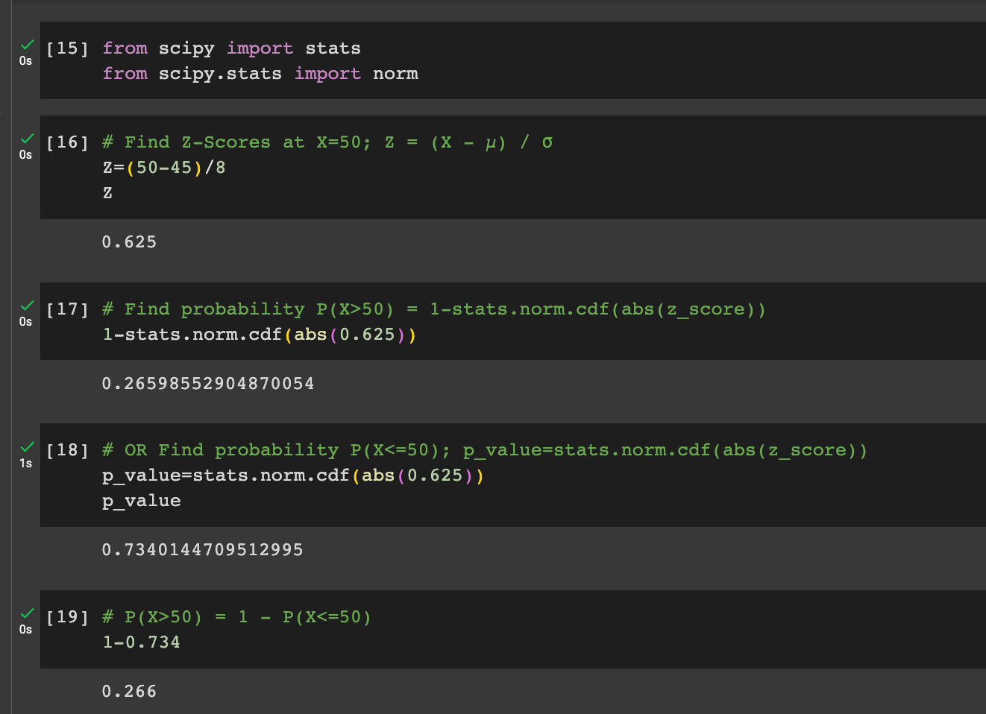

1. The current age (in years) of 400 clerical employees at an insurance claims processing center is normally distributed with mean *μ* = 38 and Standard deviation *σ* =6. For each statement below, please specify True/False. If false, briefly explain why.
2. More employees at the processing center are older than 44 than between 38 and 44.
3. A training program for employees under the age of 30 at the center would be expected to attract about 36 employees.

*Answer: A. p(38<X<44)== 0.3413447460685429 “more employes at the processing center are older than 44 than between 38 and 44” is true*

*B.N\*P(X<30)== 36.484487890347154 “training program employees under the age of 30 at the center would be expected to attract about 36 employee” is true*



1. If *X1* ~ *N*(μ, σ2) and *X*2 ~ *N*(μ, σ2) are *iid* normal random variables, then what is the difference between 2 *X*1 and *X*1 + *X*2? Discuss both their distributions and parameters.

**Answer:** The difference between IMG_256 and IMG_257 is IMG_258.

**Step-by-step explanation:** According to the **Central Limit Theorem**, any **large sum** of **independent**, **identically distributed(iid)** random variables is approximately **Normal**.

The **Normal distribution** is defined by two parameters, the **mean**, IMG_259, and the **variance**, IMG_260 and written as IMG_261.

Given IMG_262  are two independent identically distributed random variables.

From the properties of **normal random variables**,

if IMG_263 and IMG_264 are two independent identically distributed random variables then

* the **sum** of normal random variables is given by

IMG_265,

* and the **difference** of normal random variables is given by

IMG_266

* When  IMG_267, the **product** of X is given by

IMG_268

* When  IMG_269, the **linear combination** of X and Y is given by

IMG_270

Given to find, IMG_271

Thus, following the property of multiplication, we get

IMG_272

and following the property of addition,

IMG_273

And the difference between the two is given by

IMG_274

The mean of IMG_275 and IMG_276 is same but the var(IMG_277) of  IMG_278 is 2 times more than the variance of IMG_279.

The difference between the two says that the two given variables are **identically** and **independently** distributed.

1. Let X ~ N(100, 202). Find two values, *a* and *b*, symmetric about the mean, such that the probability of the random variable taking a value between them is 0.99.
2. 90.5, 105.9
3. 80.2, 119.8
4. 22, 78
5. 48.5, 151.5
6. 90.1, 109.9

Answer: Option D 48.48,151.5

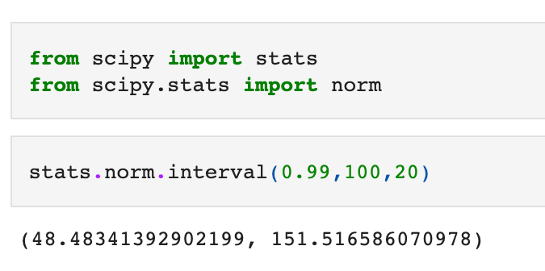

1. Consider a company that has two different divisions. The annual profits from the two divisions are independent and have distributions Profit1 ~ N(5, 32) and Profit2 ~ N(7, 42) respectively. Both the profits are in $ Million. Answer the following questions about the total profit of the company in Rupees. Assume that $1 = Rs. 45
2. Specify a Rupee range (centered on the mean) such that it contains 95% probability for the annual profit of the company.
3. Specify the 5th percentile of profit (in Rupees) for the company
4. Which of the two divisions has a larger probability of making a loss in a given year?

Answer: File: Assignment-2-Set2-Q5 .ipynb