**CREDIT CARD FRAUD DETECTION USING PYTHON & MECHINE LEARNING:**

**About dataset:**

Credit card fraud detection datasets are typically used for developing and testing machine learning models. One of the most popular datasets for this purpose is the "Credit Card Fraud Detection" dataset

This dataset usually contains anonymized credit card transaction data, with a class label indicating whether each transaction is fraudulent or not. The data typically includes features such as transaction amount, time, and various other transaction details. The goal is to build a model that can accurately classify transactions as either legitimate or fraudulent.

The "Credit Card Fraud Detection" dataset is a widely used dataset in the field of machine learning and fraud detection. This dataset contains credit card transaction data, and it's often used to develop and evaluate fraud detection models.

Here are some key details about this dataset are given below:

**Number of Instances:** The dataset typically contains a few hundred thousand credit card transactions.

**Features:** It includes various features, but the most common ones are time, amount, and a large number of anonymized features derived from the transaction data. These features are often the result of dimensionality reduction techniques like Principal Component Analysis (PCA).

**Target Variable:** The dataset has a binary classification target variable, where 1 indicates a fraudulent transaction, and 0 indicates a legitimate one.

**Class Imbalance**: It's important to note that this dataset is highly imbalanced, with a very low percentage of fraudulent transactions compared to legitimate ones. This makes it challenging to build effective fraud detection models.

**Anonymized Data:** Due to privacy and security concerns, most of the features are anonymized, so you won't be able to interpret the actual transaction details from the dataset.

**Usage:** Data scientists and machine learning practitioners often use this dataset to train and test models for credit card fraud detection. Common techniques include various machine learning algorithms, anomaly detection methods, and deep learning models.

**BUILDING THE PROJECT BY LOAD THE DATA SET:**

Building a credit card fraud detection project involves several steps, and loading the dataset is one of the initial tasks. Here are the general steps to get you started

**Choose a Dataset:** You need a dataset of credit card transactions, with instances of fraud and non-fraud transactions. Datasets like the Credit Card Fraud Detection dataset on Kaggle can be a good choice.

**Select a Programming Language and Libraries:** Common choices are Python and libraries like pandas, scikit-learn, and TensorFlow for machine learning.

**Load the Dataset**: You can use pandas to load your dataset. Here's a basic example in Python.

**Example code in python:**

import pandas as pd

# Load the dataset

dataset = pd. read csv('credit_card_data.csv')

**Data Preprocessing:** This step involves handling missing values, scaling features, and possibly encoding categorical variables.

**Exploratory Data Analysis (EDA):** Understand the dataset's characteristics through visualization and summary statistics. This will help you identify patterns and potential features for your model.

**Split the Data**: Divide the dataset into training and testing sets to evaluate your model's performance.

**Build a Fraud Detection Model:** Utilize machine learning or deep learning techniques to create a model that can predict fraud. Common algorithms include Logistic Regression, Random Forest, or Neural Networks.

**Train and Evaluate the Model:** Train your model on the training data and evaluate its performance on the testing data using appropriate metrics like precision, recall, F1-score, and AUC-ROC.

**Tune Hyperparameters:** Optimize your model's hyperparameters to improve its performance.

**Deployment:** If you plan to deploy this model for real-world use, you will need to create an application or service that integrates the model for real-time fraud detection.

**PREPROCESSING THE DATASET:**

Preprocessing the dataset is a crucial step in building a credit card fraud detection model. Here are some common preprocessing tasks you should consider,

**Handling Missing Values:**

Check for missing values in your dataset and decide on an appropriate strategy. You can either remove rows with missing values, impute missing values, or use techniques like mean, median, or mode imputation.

**Feature Scaling:**

Scaling features is important, especially if you're using algorithms that are sensitive to feature magnitudes. Common methods include standardization (scaling to have a mean of 0 and a standard deviation of 1) or min-max scaling (scaling to a specific range).

**Encoding Categorical Variables:**

If your dataset contains categorical variables, you'll need to encode them into numerical values. Common techniques include one-hot encoding or label encoding.

**Dealing with Imbalanced Data:**

In credit card fraud detection, you often have imbalanced data with a lot more non-fraudulent transactions than fraudulent ones. You may need to balance the dataset through techniques like oversampling (creating more fraud examples) or undersampling (reducing non-fraud examples).

**Feature Engineering:**

Consider creating new features or modifying existing ones that might be more informative for fraud detection. For example, you can calculate time-based features, transaction frequency, or amounts relative to the account balance.

**Outlier Detection:**

Identify and handle outliers in your dataset, as they can significantly affect the performance of your model. Techniques like the IQR (Interquartile Range) method or Z-score can help with outlier detection.

**Split the Data**:

As mentioned earlier, split your dataset into training and testing sets for model evaluation. A common split is something like 70% for training and 30% for testing.

**Data Normalization:**

For some algorithms, data normalization (e.g., transforming features to have a specific distribution) might be benefits.

**EXAMPLE FOR DATA PREPROCESSING**:

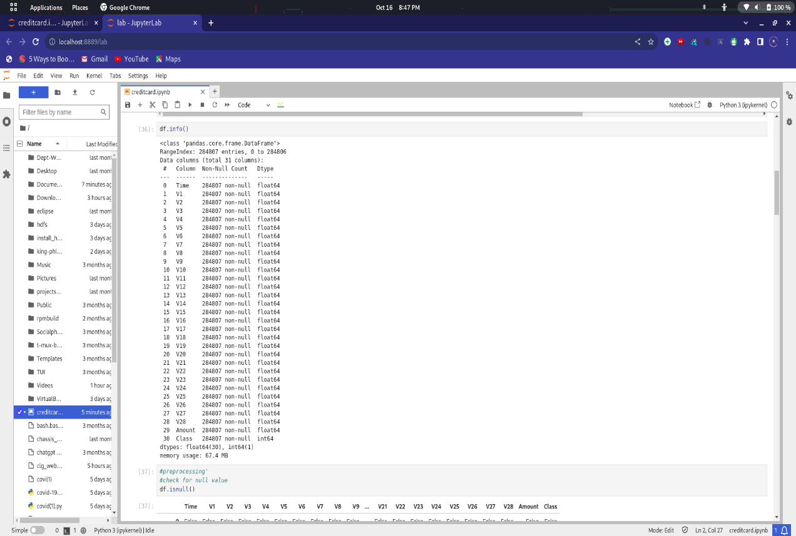

**ABOUT THE DATASET:**

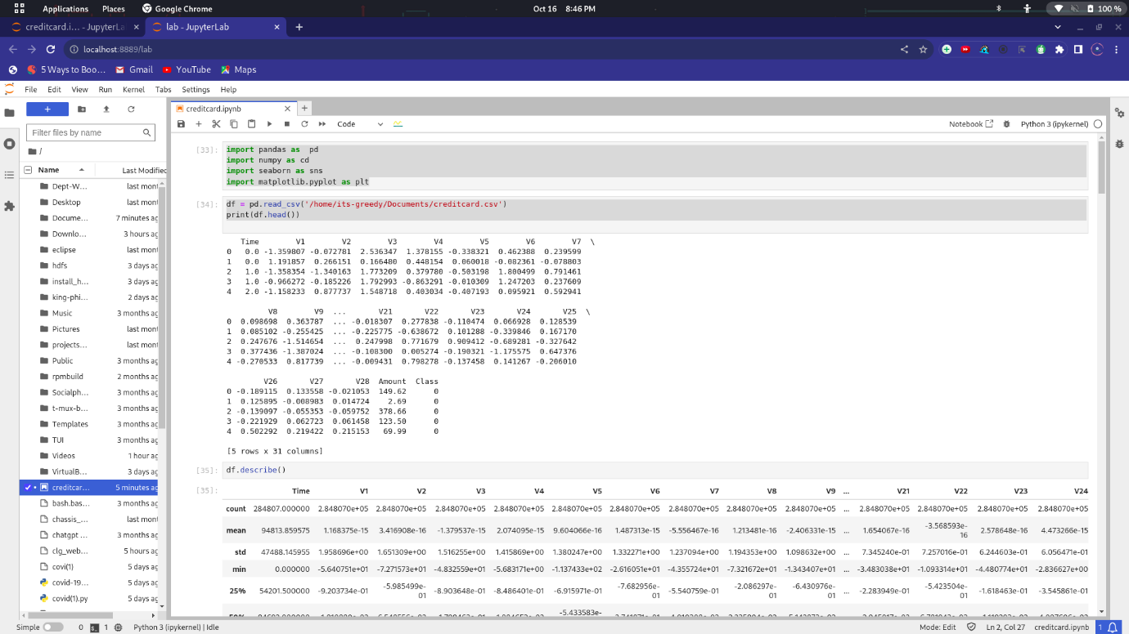

**ANALYSIS WHICH PERFORMED:**

