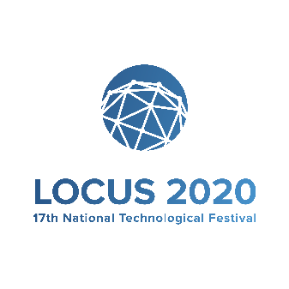**PROJECT PROPOSAL**

**PROJECT** **TITLE**: Medico

**PROJECT** **MEMBERS**: Erosha Poudel (075BCT035); Laxman Kunwar (075BCT46)

Kriti Nyoupane (075BCT043); Kushal Shrestha (075BCT045);

**INSTITUTION**: Pulchowk Campus

1. **PROBLEM STATEMENT**: Patients find it hard to **find Doctors**, appointments, correct suggestions and health services in time.

2. **OBJECTIVES OF YOUR PROJECT**: Initially, we intended to create a system for patients to find Doctors in a map and **set-up meeting** with them but after some research we decided to add features like inputting symptoms and an algorithm to suggest diseases according to them. Also **blood donation**, **hospital** and **ambulance** **locating** services.

3. **UTILIZED TECHNOLOGY** : We are making an app for realizing our idea. We are going to use the following programs:

1. Android Studio
2. Visual Studio Code
3. Flutter (Plugin)
4. Dart (Plugin)
5. Firebase

4. **OBTAINED OUTPUT/RESULTS**: We are have managed to set up our system and make a service for locating and contacting doctors, nurses, ambulances and the like.

5. **LIMITATION ANALYSIS**: The limitations of the project are only the amount of resources we have for collecting data on doctors and health services and so we can overcome them as we get more and more resources

6. **REFERENCES**: Most of the references were taken for our backend (like login systems and the like) and we derived the idea to set up doctors with patients from the very popular *Pathau* app.