**catboost all – standard settings (1000 iterations, 0.1 learning rate)**

Confusion Matrix:

[[20141 184]

[ 1388 3116]]

Classification report:

precision recall f1-score support

NORMAL 0.94 0.99 0.96 20325

TOXIC 0.94 0.69 0.80 4504

accuracy 0.94 24829

macro avg 0.94 0.84 0.88 24829

weighted avg 0.94 0.94 0.93 24829

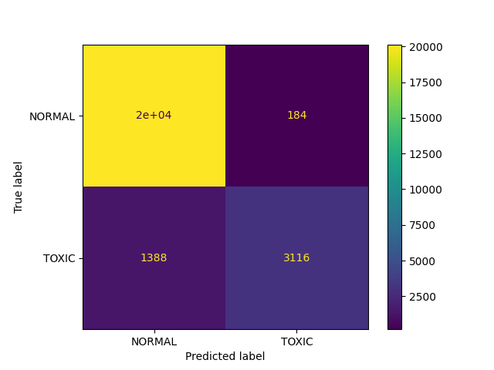

**catboost all – 2000 iterations 0.2 learning rate**

Confusion Matrix:

[[20078 247]

[ 1329 3175]]

Classification report:

precision recall f1-score support

NORMAL 0.94 0.99 0.96 20325

TOXIC 0.93 0.70 0.80 4504

accuracy 0.94 24829

macro avg 0.93 0.85 0.88 24829

weighted avg 0.94 0.94 0.93 24829

**rfm all**

Confusion Matrix:

[[19941 384]

[ 1284 3220]]

Classification report:

precision recall f1-score support

NORMAL 0.94 0.98 0.96 20325

TOXIC 0.89 0.71 0.79 4504

accuracy 0.93 24829

macro avg 0.92 0.85 0.88 24829

weighted avg 0.93 0.93 0.93 24829

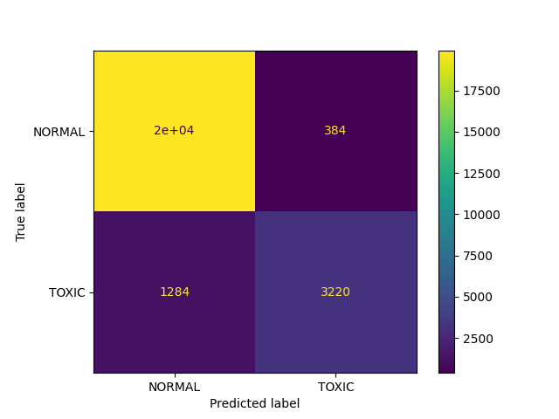

**logreg all**

Confusion Matrix:

[[20129 196]

[ 1410 3094]]

Classification report:

precision recall f1-score support

NORMAL 0.93 0.99 0.96 20325

TOXIC 0.94 0.69 0.79 4504

accuracy 0.94 24829

macro avg 0.94 0.84 0.88 24829

weighted avg 0.94 0.94 0.93 24829

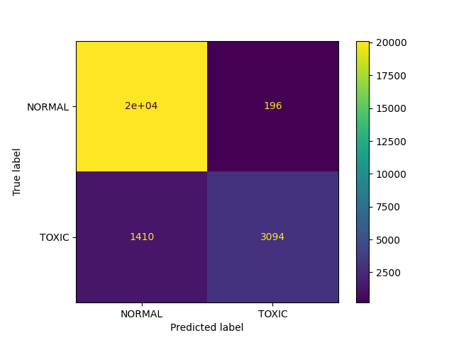

**dtree all**

Confusion Matrix:

[[19535 790]

[ 1340 3164]]

Classification report:

precision recall f1-score support

NORMAL 0.94 0.96 0.95 20325

TOXIC 0.80 0.70 0.75 4504

accuracy 0.91 24829

macro avg 0.87 0.83 0.85 24829

weighted avg 0.91 0.91 0.91 24829

