**dtree all**

Confusion Matrix:

[[9062 524]

[2977 1849]]

Classification report:

precision recall f1-score support

NORMAL 0.75 0.95 0.84 9586

TOXIC 0.78 0.38 0.51 4826

accuracy 0.76 14412

macro avg 0.77 0.66 0.68 14412

weighted avg 0.76 0.76 0.73 14412

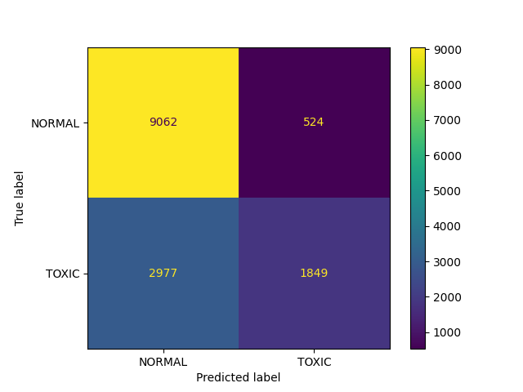

**logreg all**

Confusion Matrix:

[[9460 126]

[3386 1440]]

Classification report:

precision recall f1-score support

NORMAL 0.74 0.99 0.84 9586

TOXIC 0.92 0.30 0.45 4826

accuracy 0.76 14412

macro avg 0.83 0.64 0.65 14412

weighted avg 0.80 0.76 0.71 14412

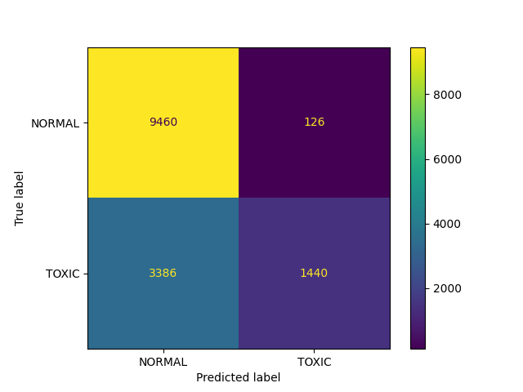

**rfm all**

Confusion Matrix:

[[9246 340]

[3014 1812]]

Classification report:

precision recall f1-score support

NORMAL 0.75 0.96 0.85 9586

TOXIC 0.84 0.38 0.52 4826

accuracy 0.77 14412

macro avg 0.80 0.67 0.68 14412

weighted avg 0.78 0.77 0.74 14412

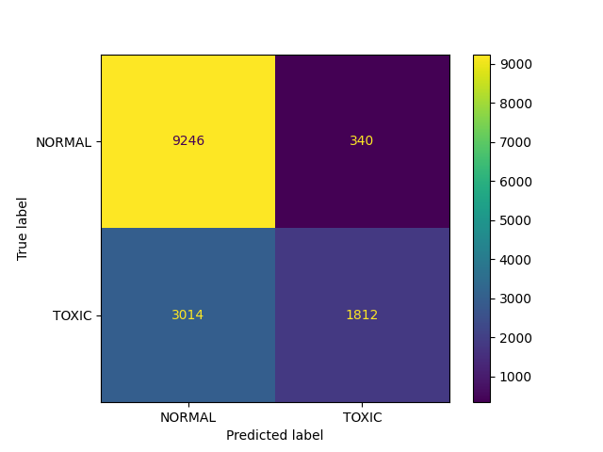

**catboost all**

Confusion Matrix:

[[9386 200]

[3337 1489]]

Classification report:

precision recall f1-score support

NORMAL 0.74 0.98 0.84 9586

TOXIC 0.88 0.31 0.46 4826

accuracy 0.75 14412

macro avg 0.81 0.64 0.65 14412

weighted avg 0.79 0.75 0.71 14412

