**Logreg with selected features**

Confusion Matrix:

[[11257 9068]

[ 2093 2411]]

Classification report:

precision recall f1-score support

NORMAL 0.84 0.55 0.67 20325

TOXIC 0.21 0.54 0.30 4504

accuracy 0.55 24829

macro avg 0.53 0.54 0.49 24829

weighted avg 0.73 0.55 0.60 24829

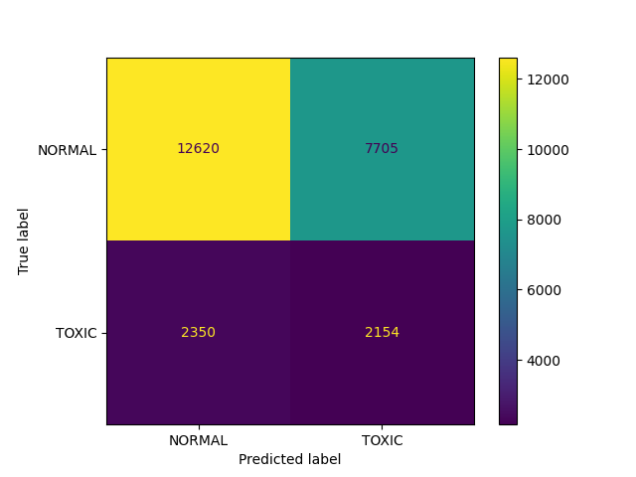

**RFM with selected features**

Confusion Matrix:

[[10408 9917]

[ 1945 2559]]

Classification report:

precision recall f1-score support

NORMAL 0.84 0.51 0.64 20325

TOXIC 0.21 0.57 0.30 4504

accuracy 0.52 24829

macro avg 0.52 0.54 0.47 24829

weighted avg 0.73 0.52 0.58 24829

