BÁO CÁO THỰC HÀNH LAP 1  
LẬP TRÌNH HƯỚNG ĐỐI TƯỢNG

# The Very First Java Programs

## *2.2.1* Write, compile the first Java application:

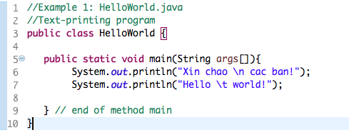

*Kết quả*

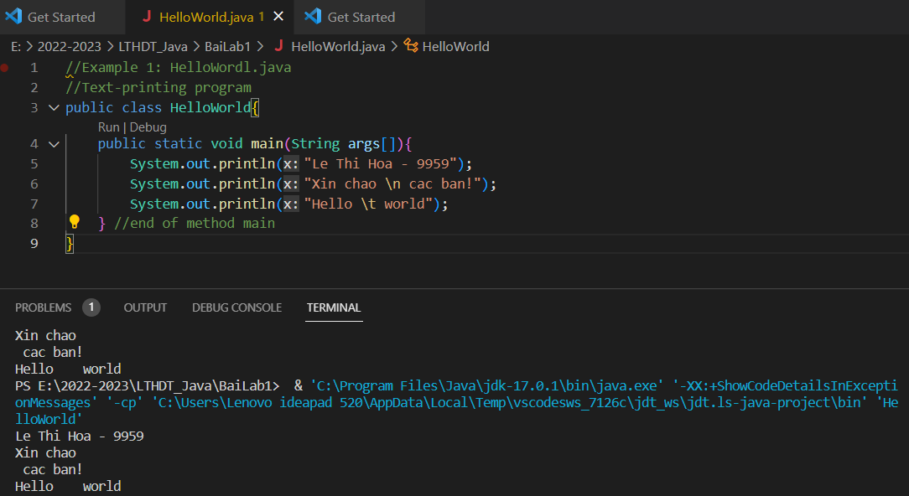

## 2.2.2 Write, compile the first dialog Java program

### Screen Shot 2019-02-12 at 12

### 

## 2.2.3 Write, compile the first input dialog Java application

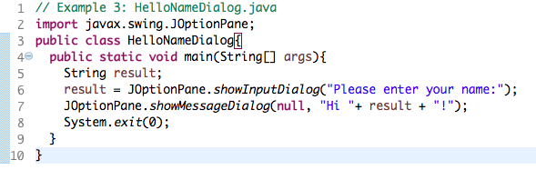

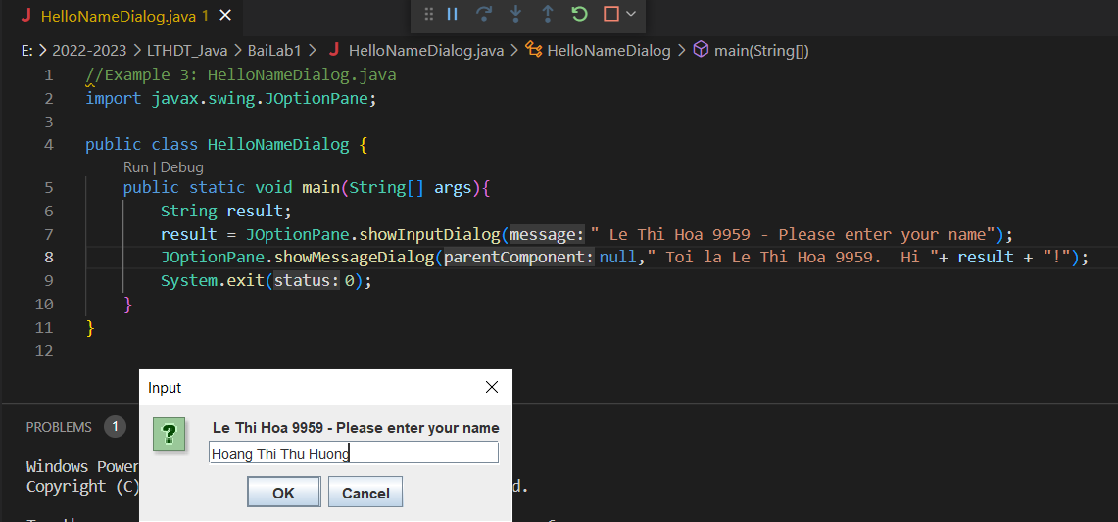

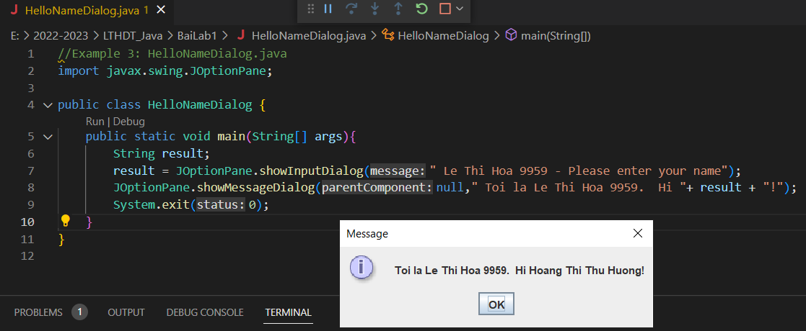

## 2.2.4 Write, compile, and run the following example:

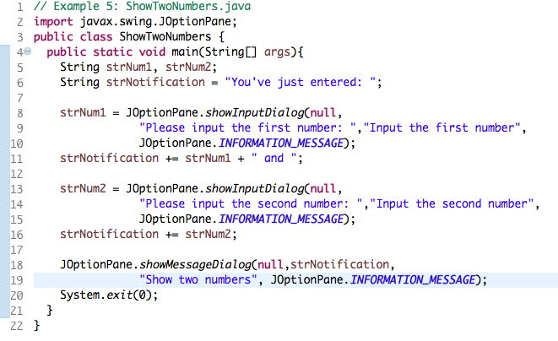

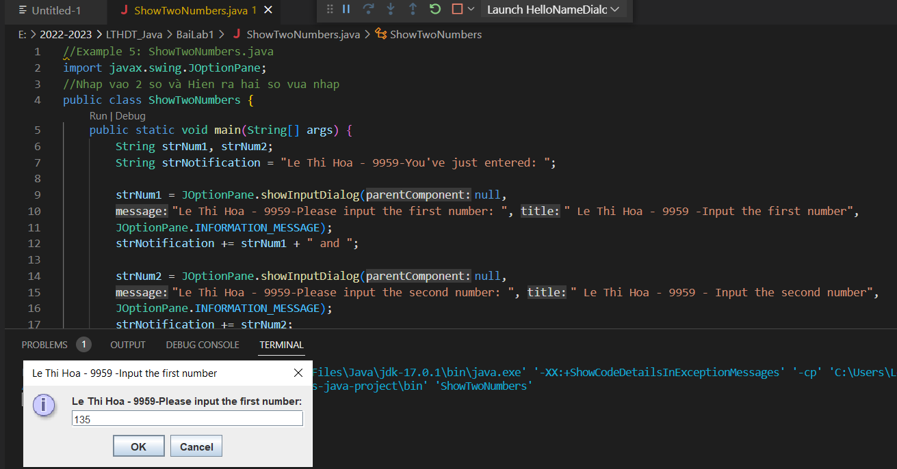

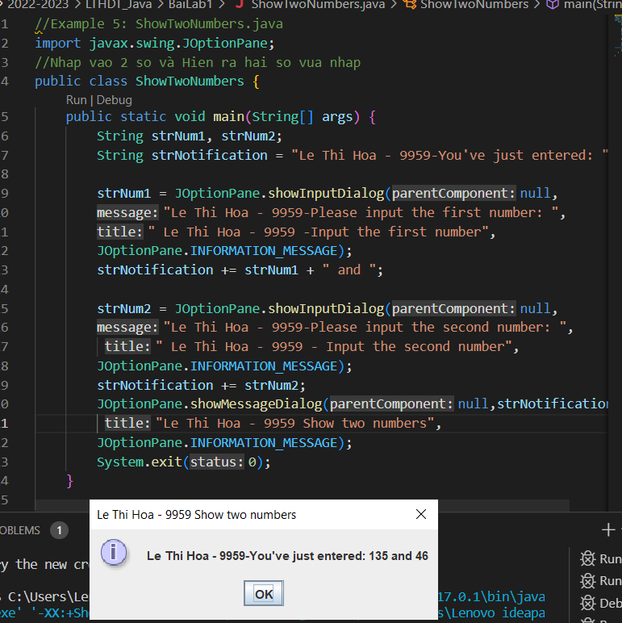

## 2.2.5 Write a program to calculate sum, difference, product, and quotient of 2 double numbers which are entered by users.

**Notes**

* To convert from String to double, you can use

**double num1 = Double.parseDouble(strNum1)**

* Check the divisor of the division