**BÁO CÁO THỰC HÀNH LAB 4**

**LẬP TRÌNH HƯỚNG ĐỐI TƯỢNG**

Table of Contents

**I.** **Class Diagram** 4

**II.** **Class** 4

**1.** **Book** 5

**2.** **Compact Disc** 6

**3.** **DigtialVideoDisc** 8

**4.** **Disc** 10

**5.** **Media** 11

**6.** **MediaComparatorByCostTitle** 13

**7.** **MediaComparatorByTitleCost** 13

**8.** **Track** 13

**9.** **Cart** 14

**10.** **Store** 16

**11.** **Aims** 17

**III.** **Demo chương trình** 30

**1.** **Track** 30

**2.** **Authors of Books** 31

**IV.** **Demo Aims** 32

**1.** **View Store** 34

*a)* *See a media’s details* 34

*b)* *Add a media to cart* 36

*c)* *Play a media* 37

*d)* *See current cart* 38

**2.** **Update Store** 39

*a)* *Add a media* 40

*b)* *Remove a media* 41

**3.** **See current cart** 42

*a)* *Filter medias in cart* 42

*b)* *Sort medias in cart* 43

*c)* *Remove media from cart* 44

*d)* *Play a media* 44

*e)* *Place order* 45

Mục lục ảnh

Hình 1. Class Diagram 4

Hình 2. Book Part 1 5

Hình 3. Book Part 2 6

Hình 4. CompactDisc Part 1 7

Hình 5. CompactDisc Part 2 8

Hình 6. CompactDisc Part 3 8

Hình 7. DVD Part 1 9

Hình 8. DVD Part 2 10

Hình 9. Disc 11

Hình 10. Media Part 1 12

Hình 11. Media Part 2 13

Hình 12. MediaComparatorByCostTitle 13

Hình 13. MediaComparatorByTitleCost 13

Hình 14. Track 14

Hình 15. Cart Part 1 15

Hình 16. Cart Part 2 16

Hình 17. Cart Part 3 16

Hình 18. Store Part 1 17

Hình 19. Store Part 2 17

Hình 20. Aims Part 1 18

Hình 21. Aims Part 2 19

Hình 22. Aims Part 3 20

Hình 23. Aims Part 4 21

Hình 24. Aims Part 5 22

Hình 25. Aims Part 6 23

Hình 26. Aims Part 7 24

Hình 27. Aims Part 8 25

Hình 28. Aims Part 9 26

Hình 29. Aims Part 10 27

Hình 30. Aims Part 11 28

Hình 31. Aims Part 12 29

Hình 32. Aims Part 13 29

Hình 33. Demo Track 30

Hình 34. Kết quả add track và getLength 30

Hình 35. Kết quả remove track 3 31

Hình 36. Demo Authors 31

Hình 37. Kết quả addAuthors 32

Hình 38. Kết quả removeAuthors 32

Hình 39. Demo Aims 33

Hình 40. Menu chính 34

Hình 41. View Store Menu 34

Hình 42. 1_1 Không thành công 35

Hình 43. 1_1 thành công 35

Hình 44. 1_1_1 Add to cart 35

Hình 45. 1_1_2 Play not work (book) 36

Hình 46. 1_1_2 Play Media 36

Hình 47. 1_2 Add media to cart 37

Hình 48. 1_2 Media not exist 37

Hình 49. 1_3 Play media 37

Hình 50. 1_3 Play media not work because of Book 38

Hình 51. 1_3 Media not exist 38

Hình 52. 1_4 See cart 39

Hình 53. Update Menu 39

Hình 54. Add a media Menu 40

Hình 55. 2_1_1 Add book 40

Hình 56. 2_1_1 Kết quả 40

Hình 57. 2_1_2 Add CD 40

Hình 58. 2_1_2 Kết quả 41

Hình 59. 2_1_3 Add DVD 41

Hình 60. 2_1_3 Kết quả 41

Hình 61. 2_2 Media not exist 41

Hình 62. 2_2 Remove media 41

Hình 63. 2_2 Kết quả 42

Hình 64. See current cart Menu 42

Hình 65. Filter Menu 42

Hình 66. 3 - Giỏ hàng hiện tại 42

Hình 67. 3_1_1 ID not exist 43

Hình 68. 3_1_1 Filter by ID 43

Hình 69. 3_1_2 Title not exist 43

Hình 70. 3_1_2 Filter by Title 43

Hình 71. 3 - Sort Menu 43

Hình 72. 3_2_1 Sort by Cost 43

Hình 73. 3_2_2 Sort by Title 44

Hình 74. 3_3 Media not exist 44

Hình 75. 3_3 Remove Media from cart 44

Hình 76. 3_3 Kết quả 44

Hình 77. 3_4 Not play because of book 44

Hình 78. 3_4 Play media in cart 45

Hình 79. 3_5 Place order 45

Hình 80. Current Cart empty 45

1. **Class Diagram**

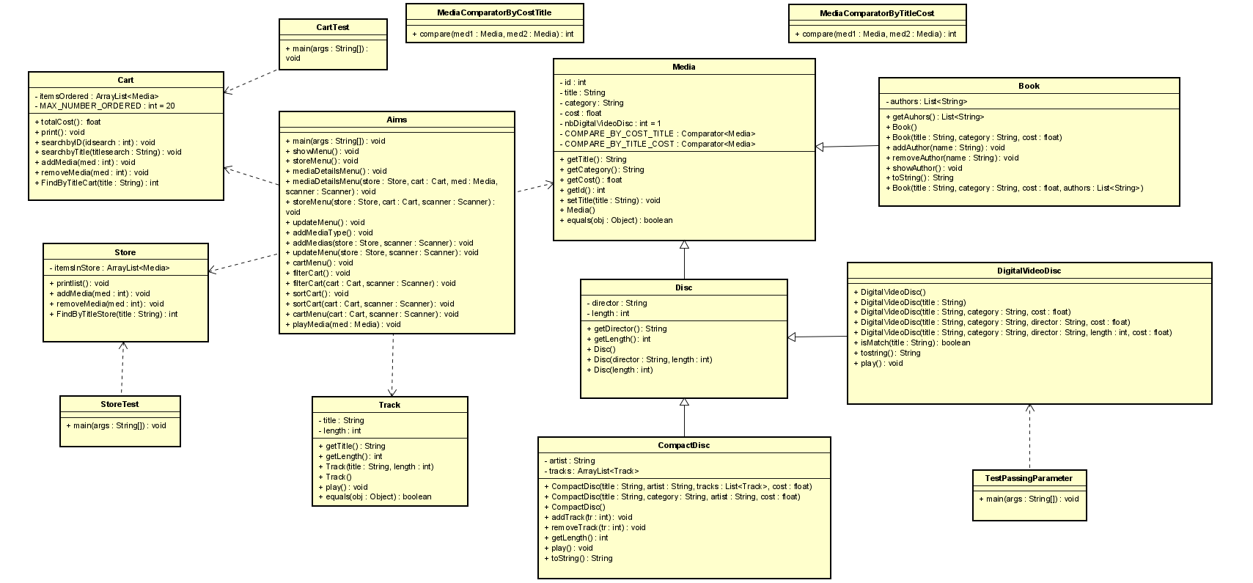

Hình 1. Class Diagram

1. **Class**
2. **Book**

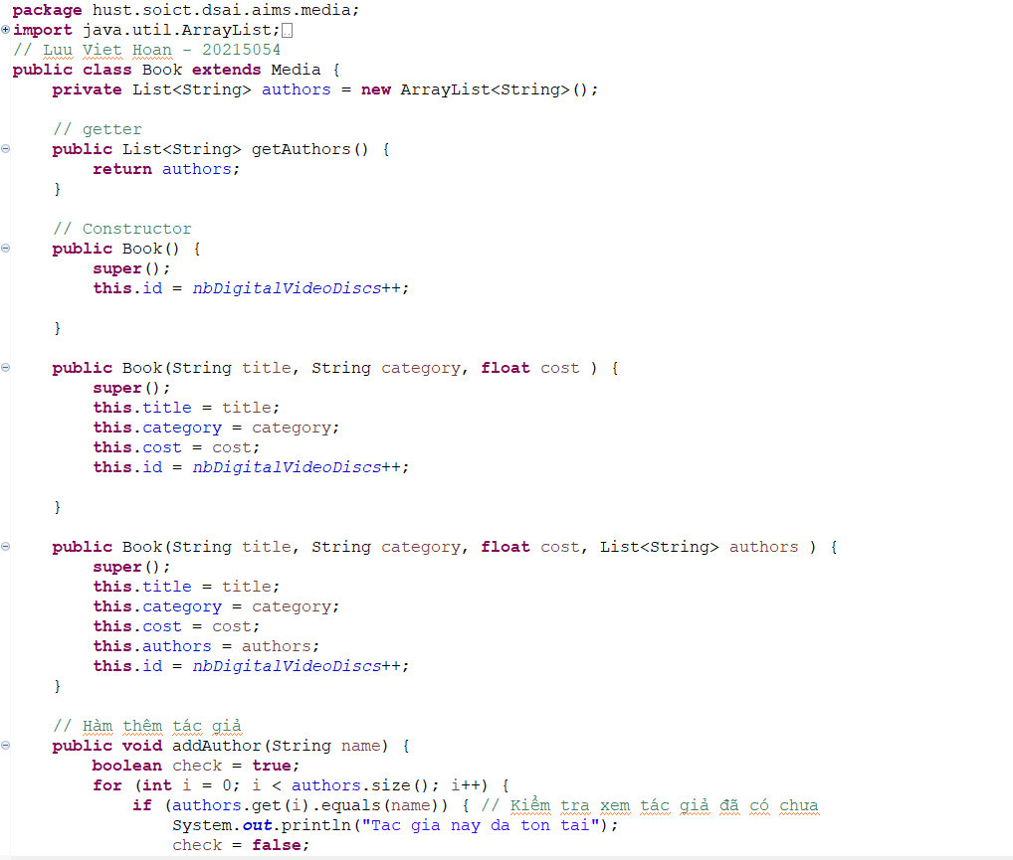

Hình 2. Book Part 1

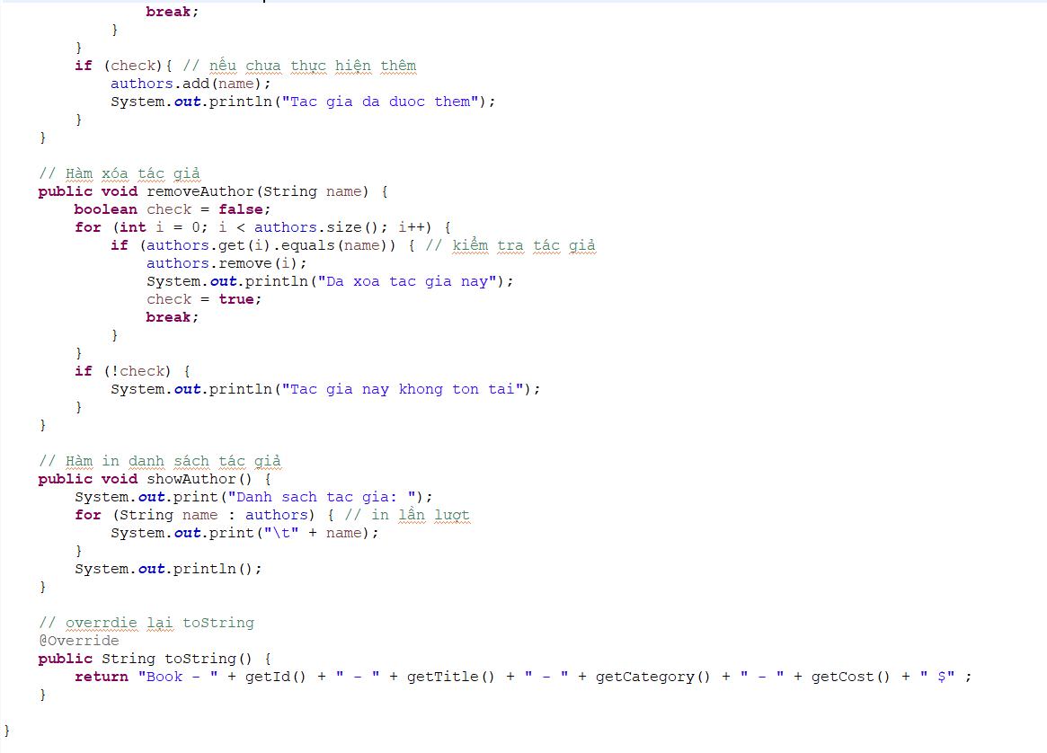

Hình 3. Book Part 2

1. **Compact Disc**

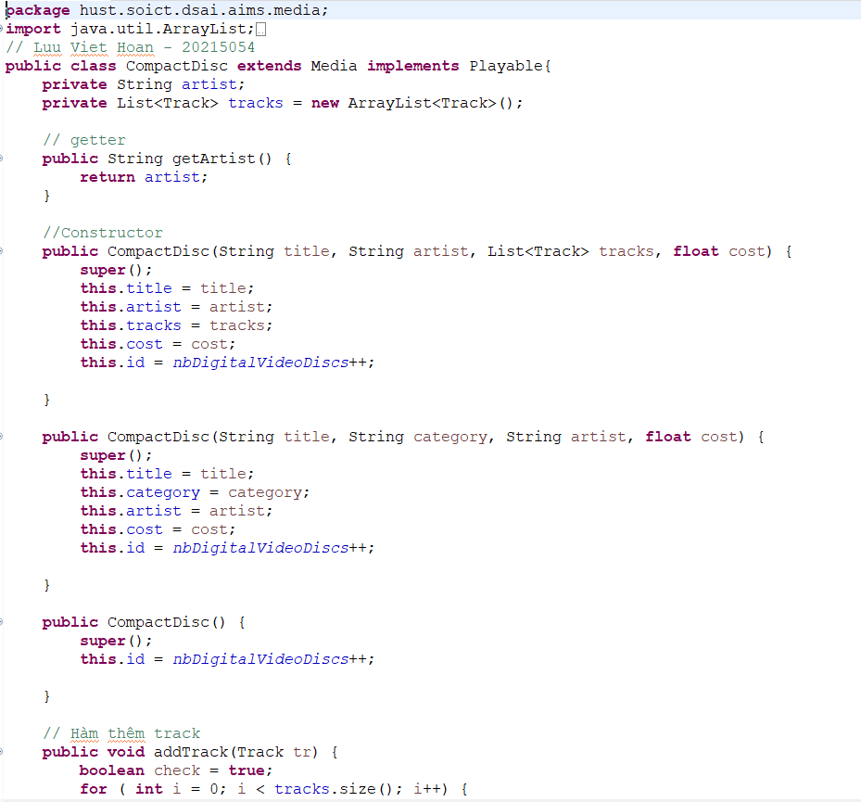

Hình 4. CompactDisc Part 1

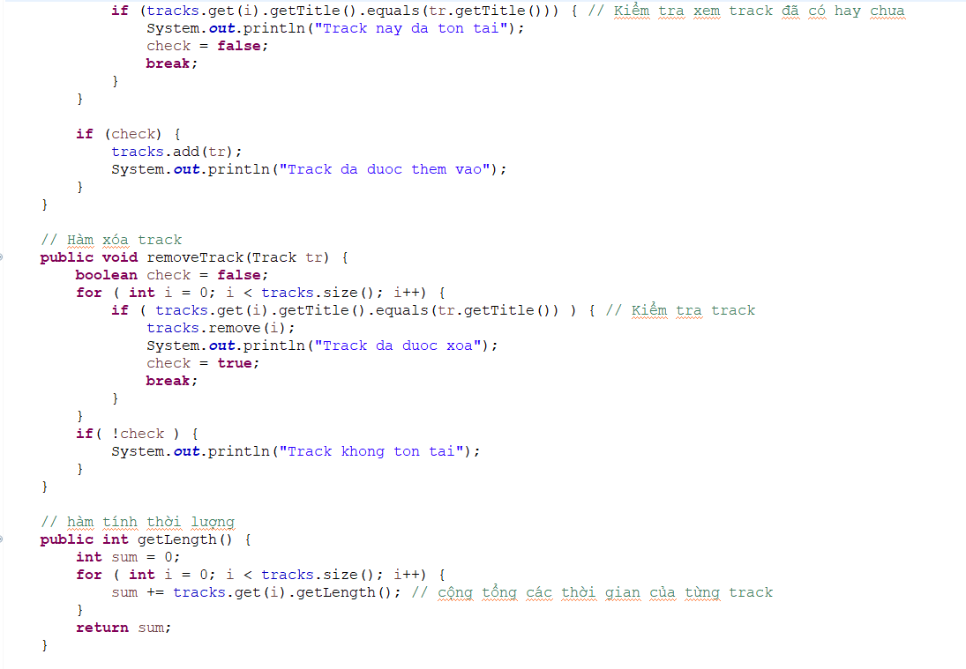

Hình 5. CompactDisc Part 2

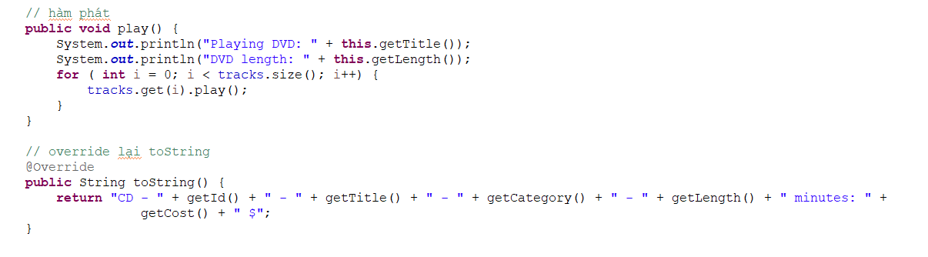

Hình 6. CompactDisc Part 3

1. **DigtialVideoDisc**

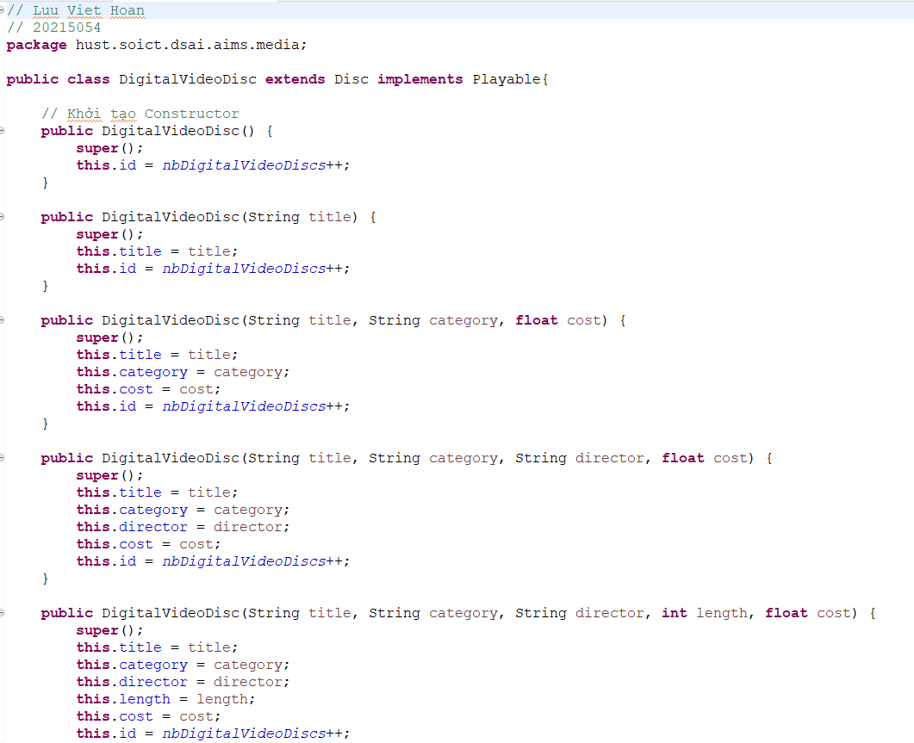

Hình 7. DVD Part 1

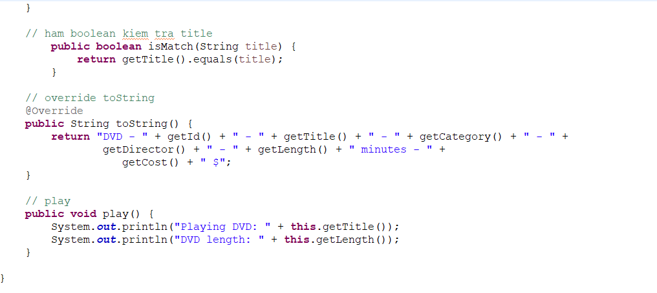

Hình 8. DVD Part 2

1. **Disc**

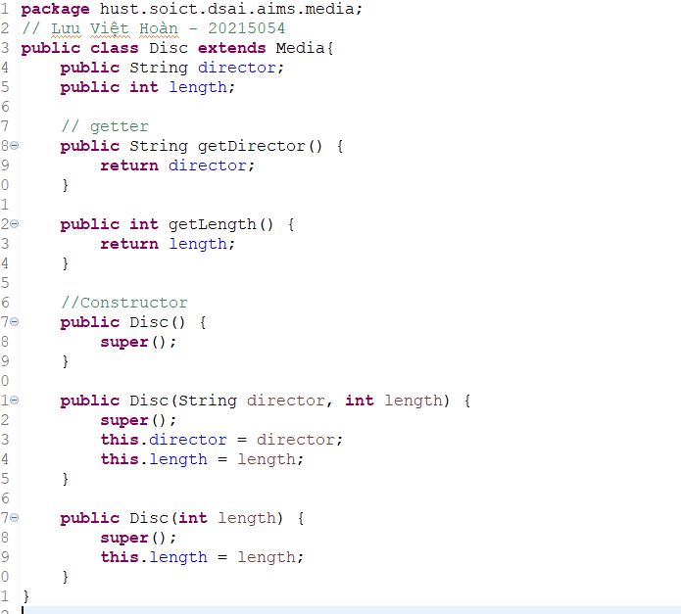

Hình 9. Disc

1. **Media**

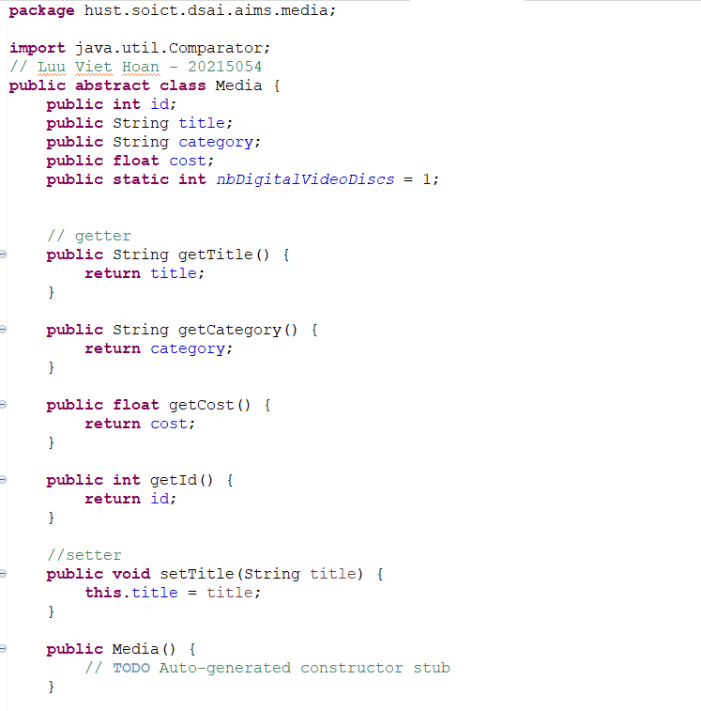

Hình 10. Media Part 1

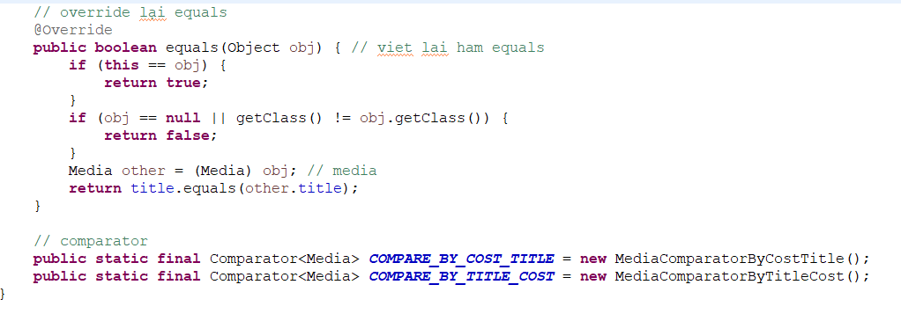

Hình 11. Media Part 2

1. **MediaComparatorByCostTitle**

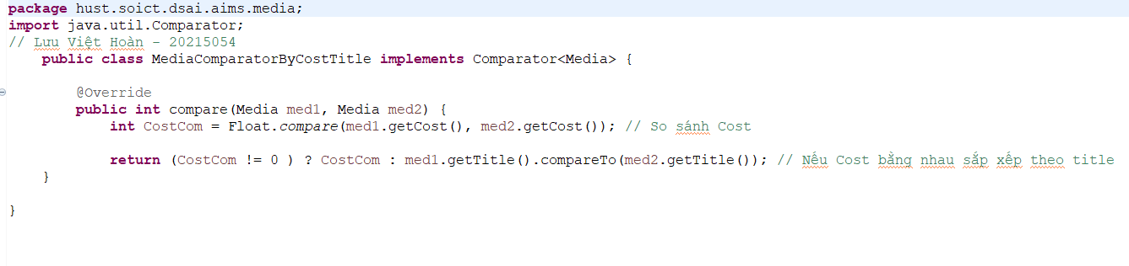

Hình 12. MediaComparatorByCostTitle

1. **MediaComparatorByTitleCost**

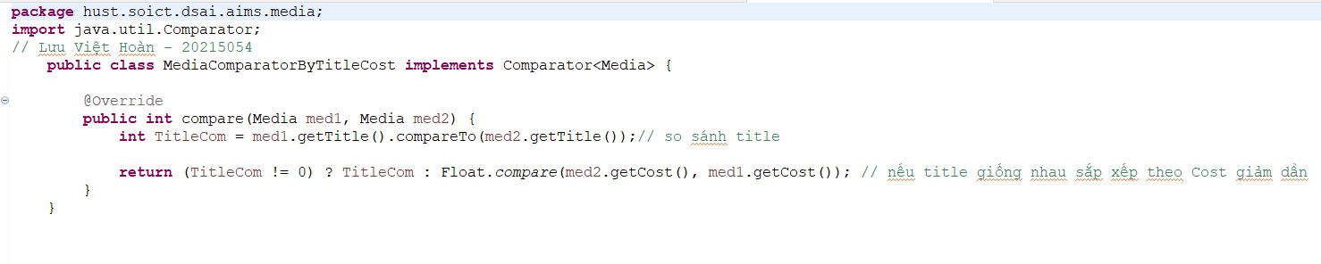

Hình 13. MediaComparatorByTitleCost

1. **Track**

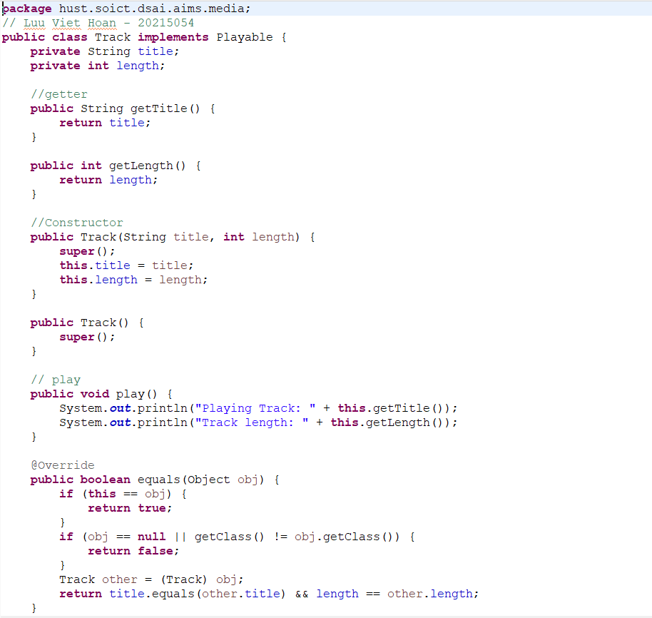

Hình 14. Track

1. **Cart**

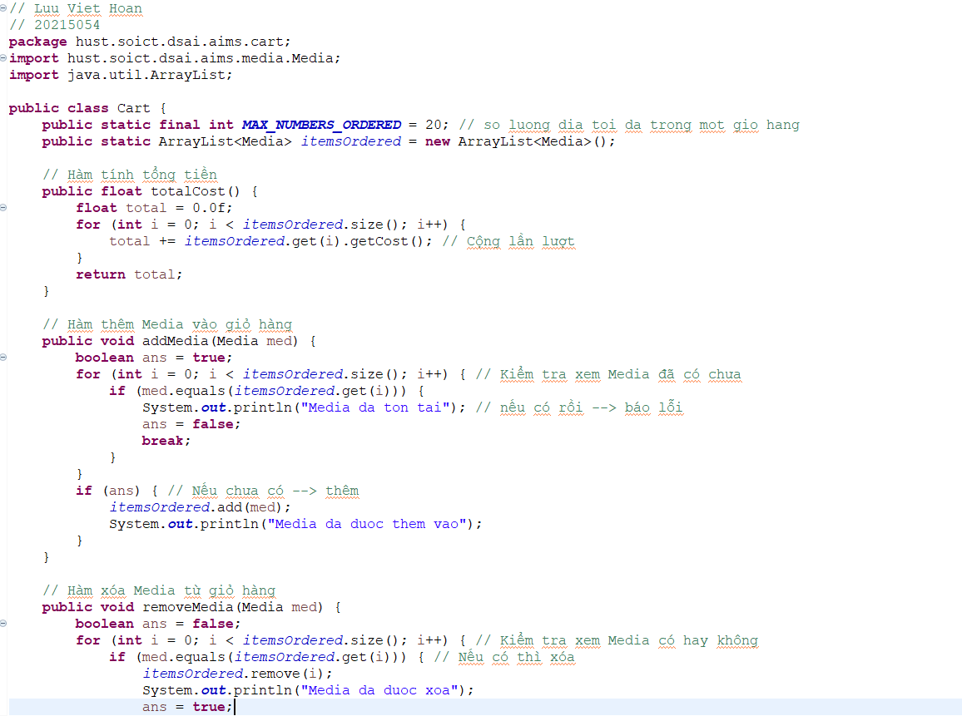

Hình 15. Cart Part 1

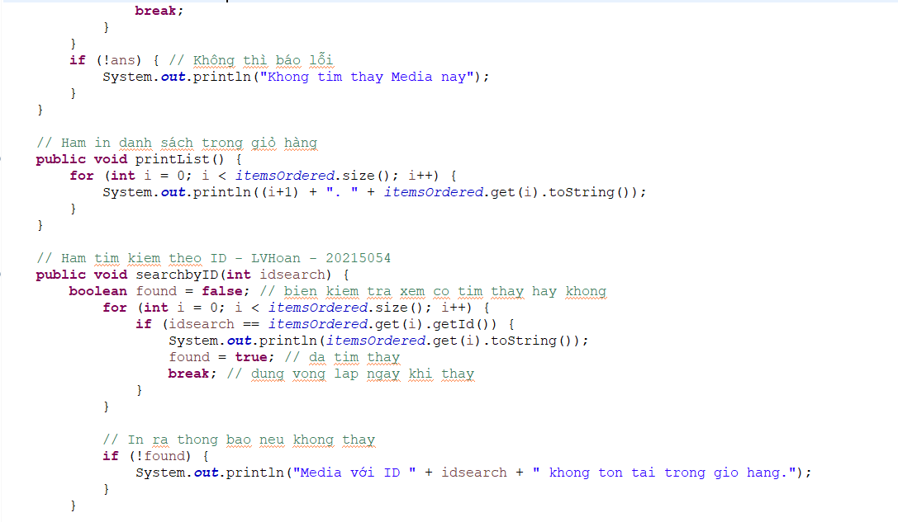

Hình 16. Cart Part 2

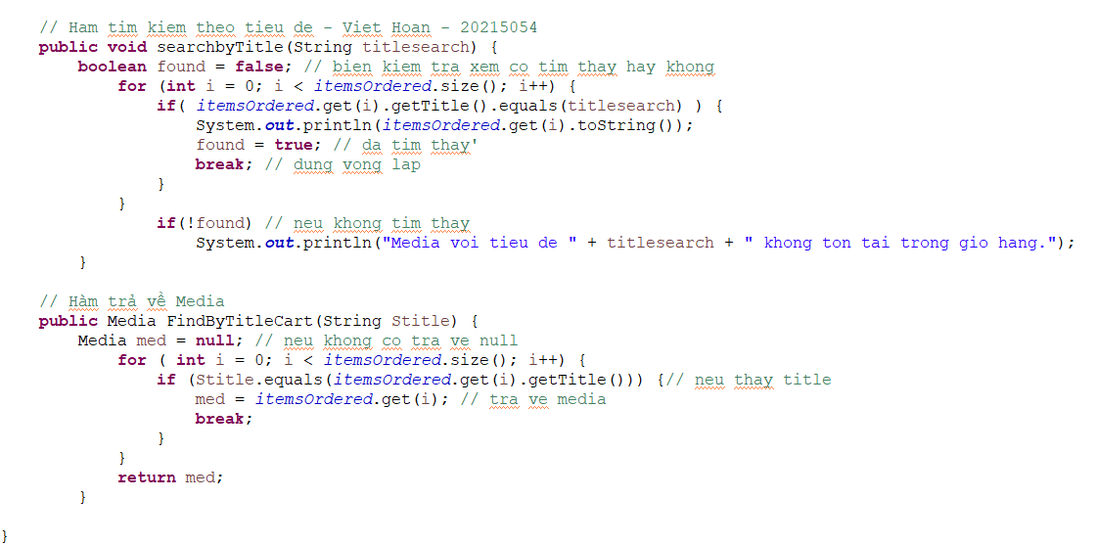

Hình 17. Cart Part 3

1. **Store**

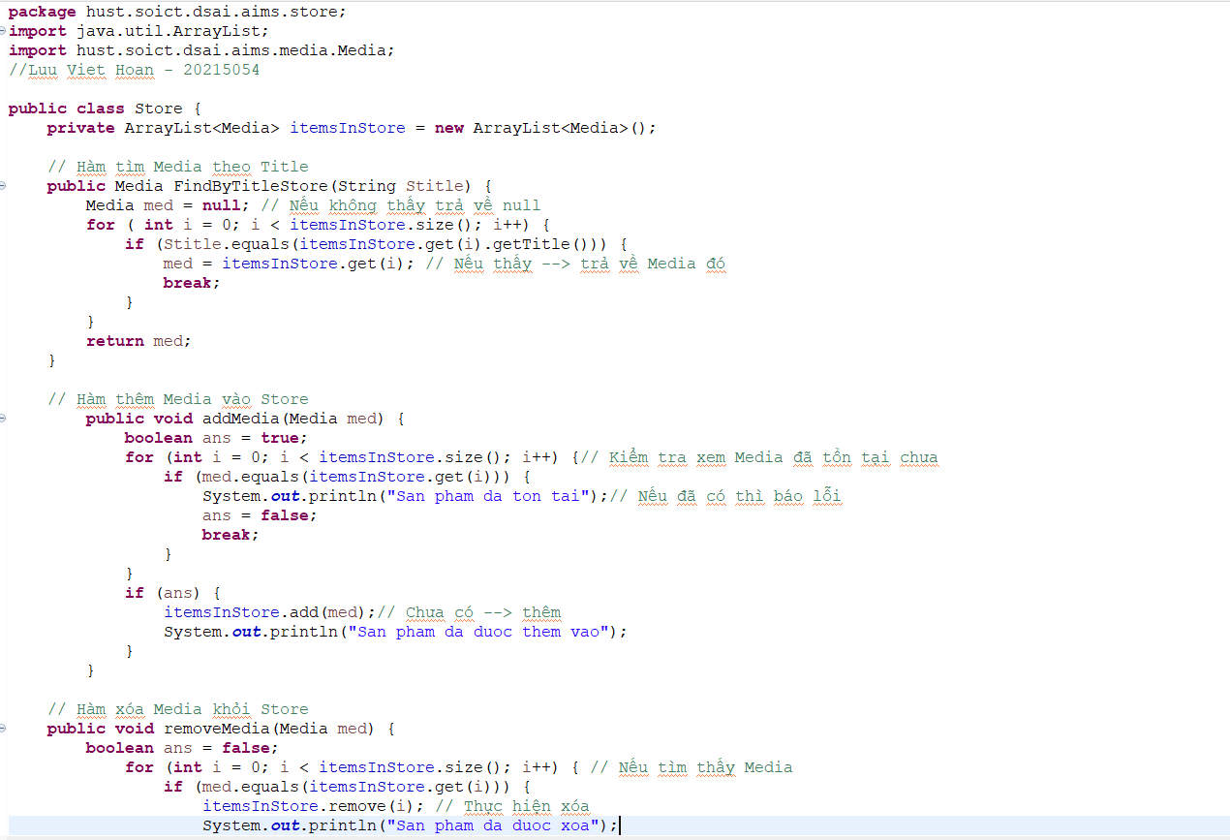

Hình 18. Store Part 1

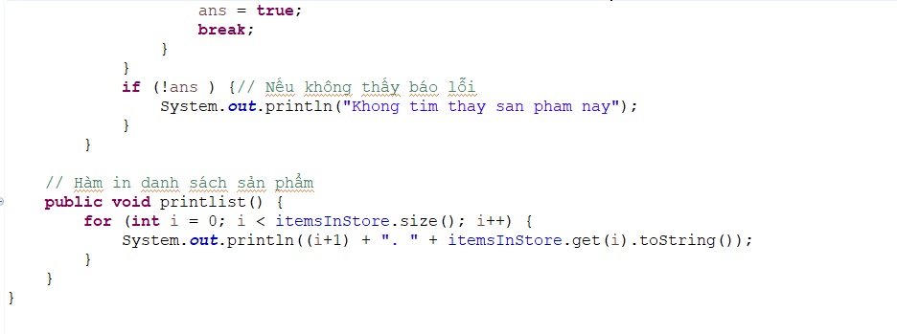

Hình 19. Store Part 2

1. **Aims**

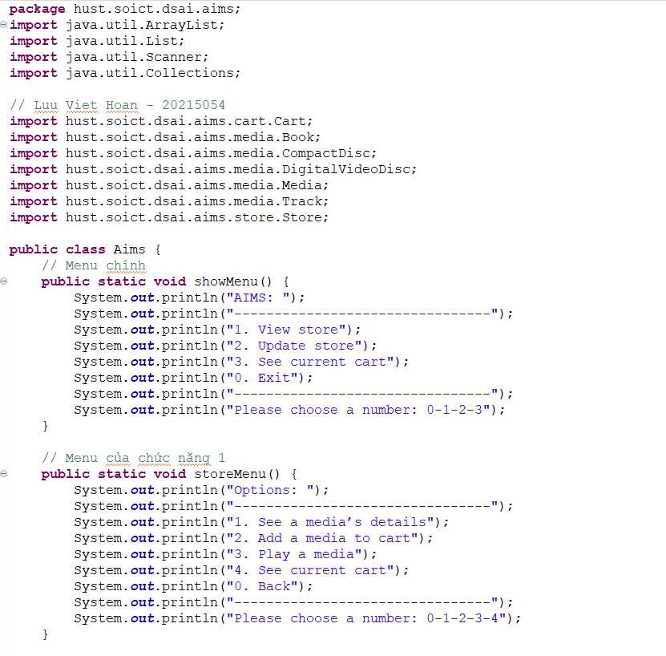

Hình 20. Aims Part 1

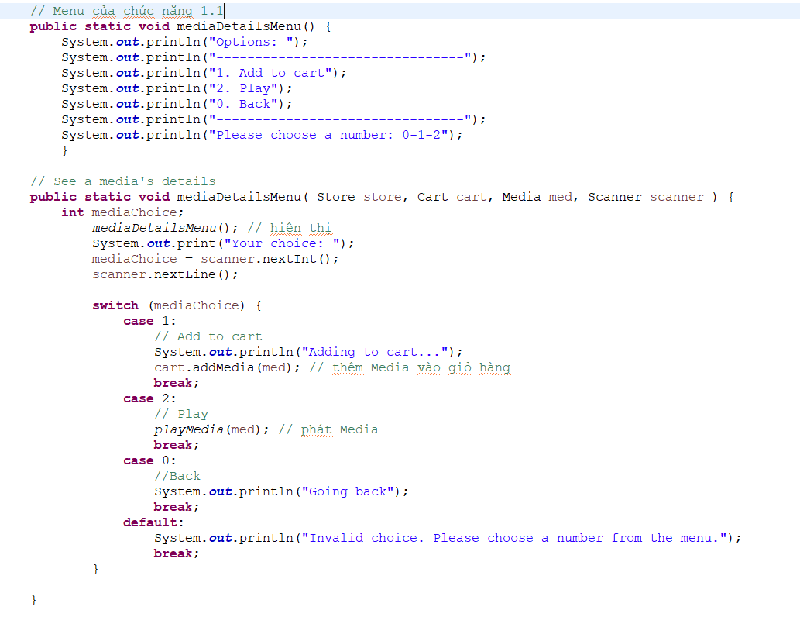

Hình 21. Aims Part 2

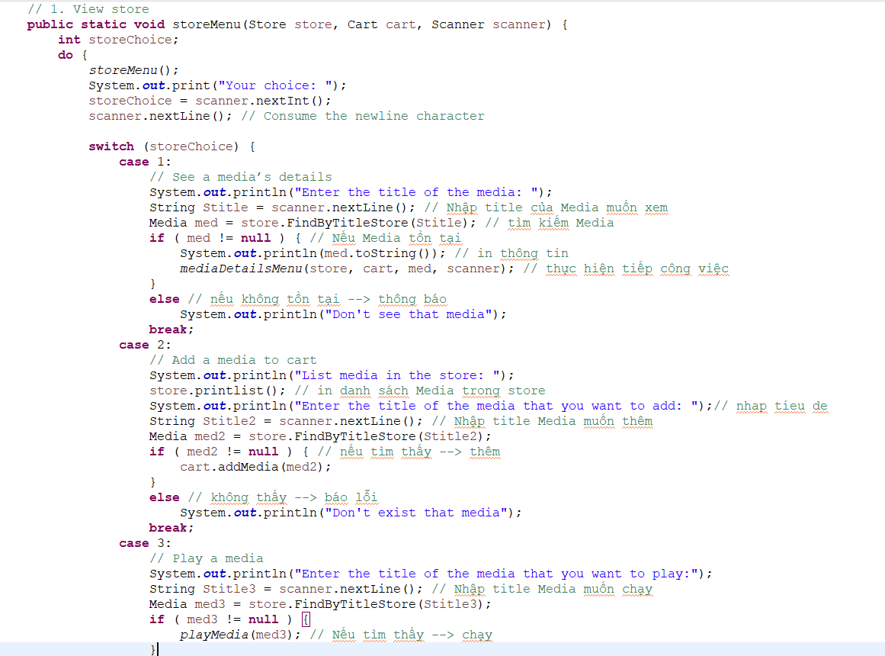

Hình 22. Aims Part 3

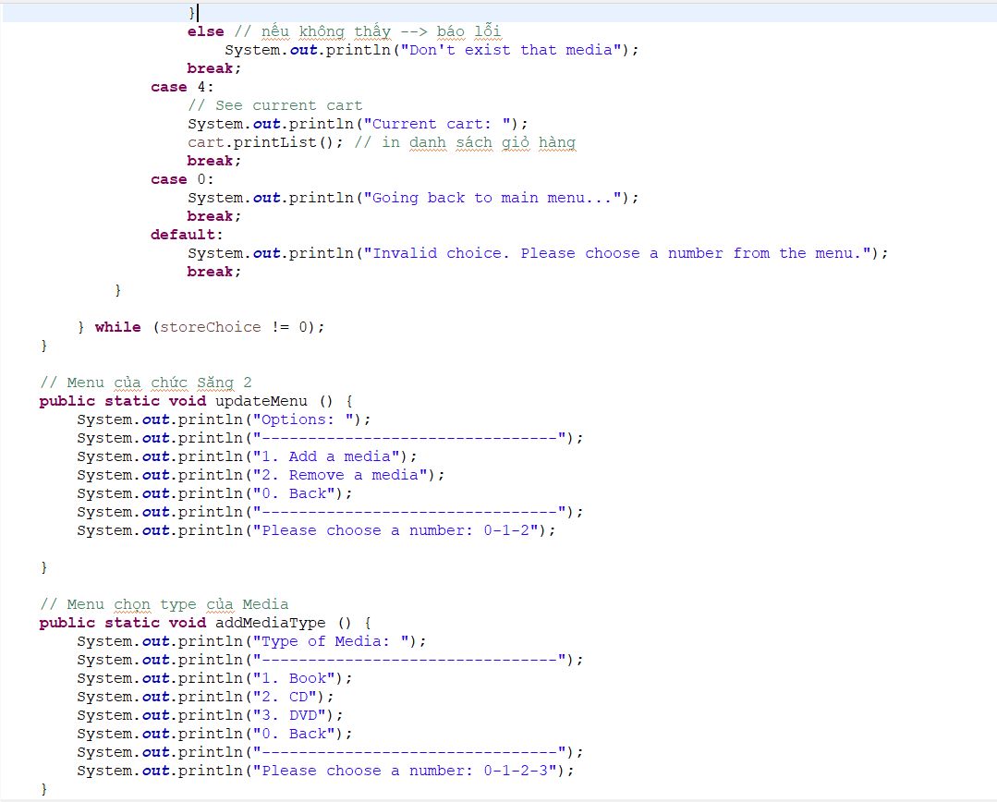

Hình 23. Aims Part 4

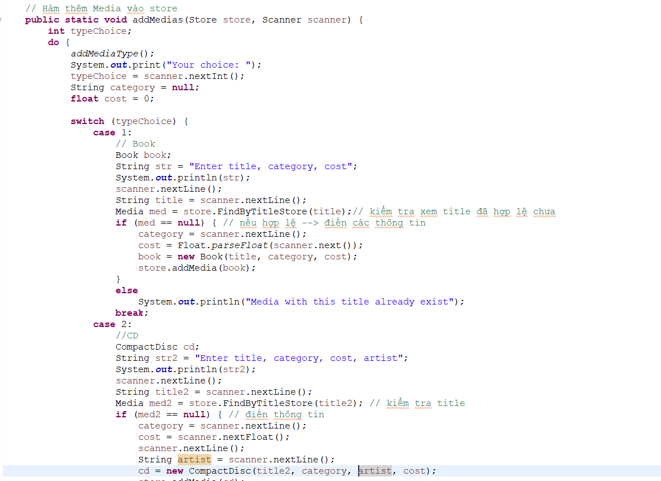

Hình 24. Aims Part 5

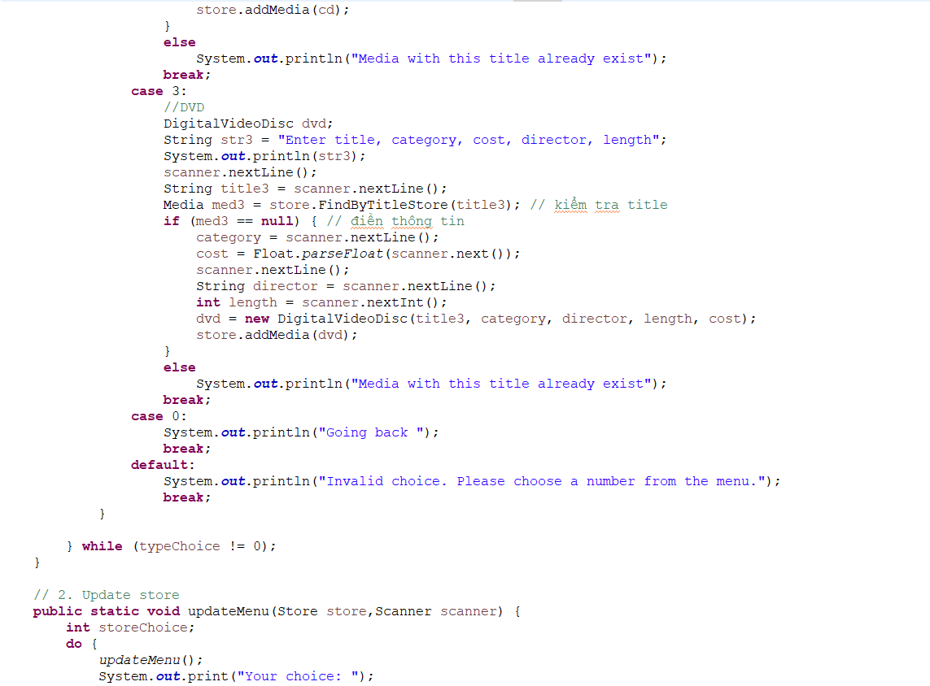

Hình 25. Aims Part 6

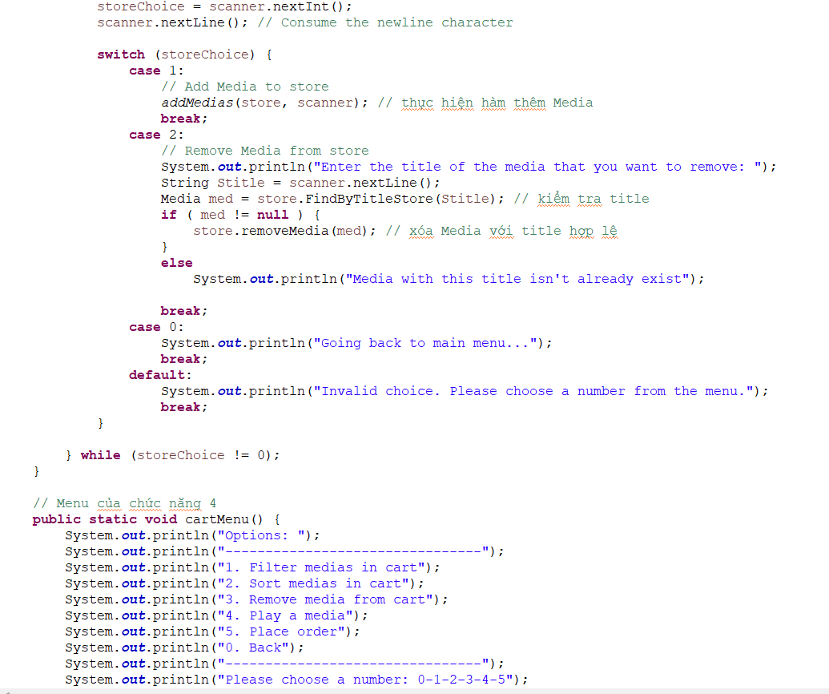

Hình 26. Aims Part 7

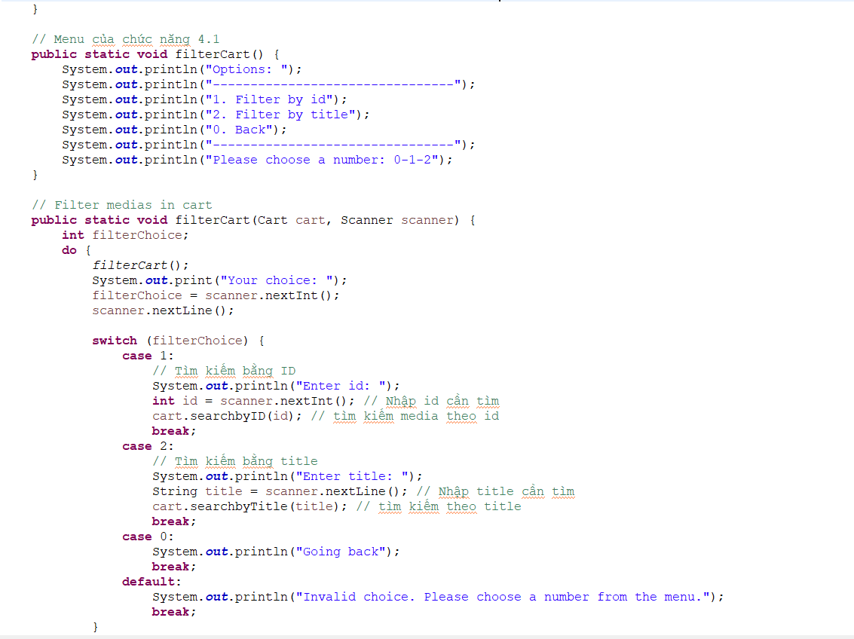

Hình 27. Aims Part 8

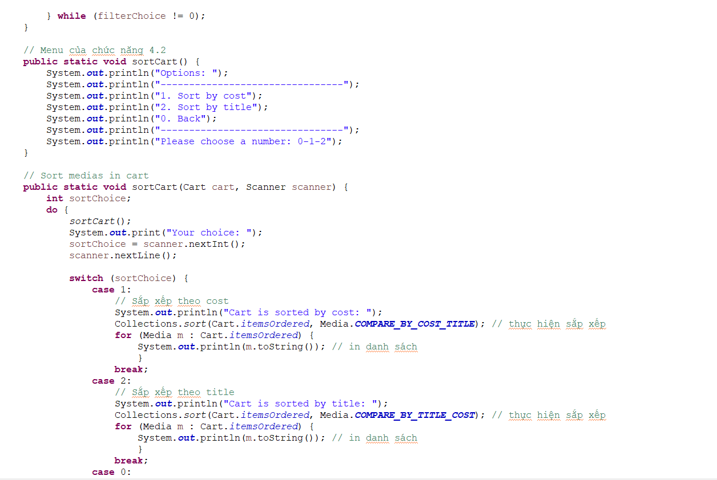

Hình 28. Aims Part 9

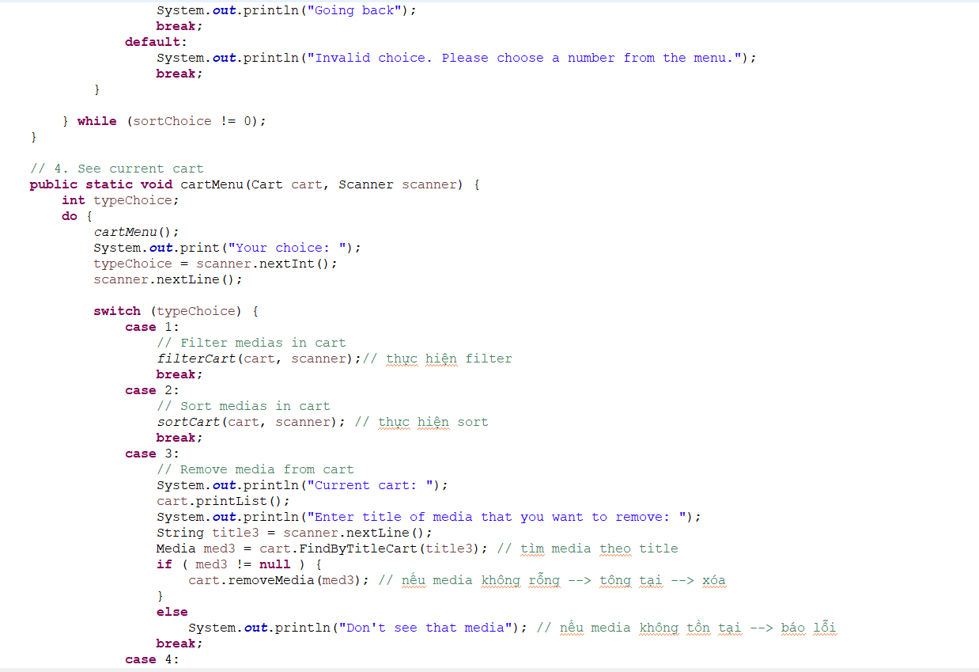

Hình 29. Aims Part 10

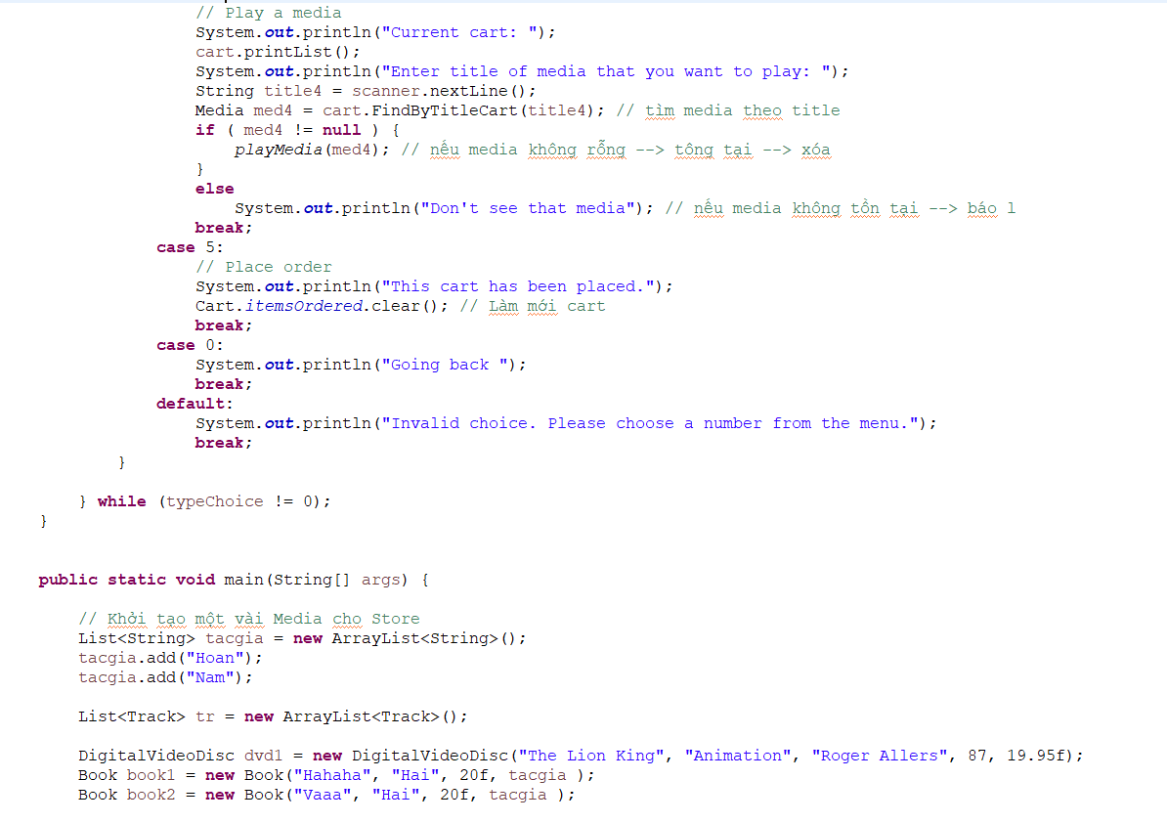

Hình 30. Aims Part 11

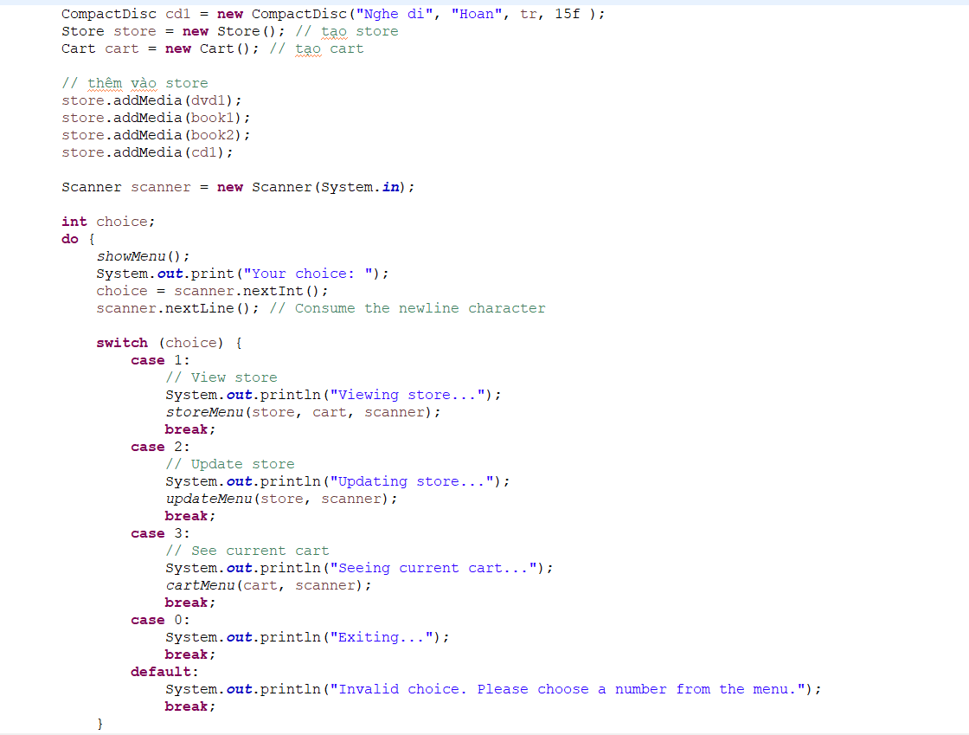

Hình 31. Aims Part 12

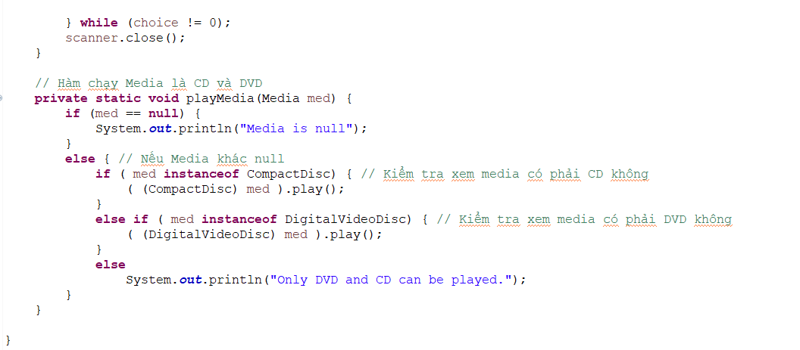

Hình 32. Aims Part 13

1. **Demo chương trình**
2. **Track**

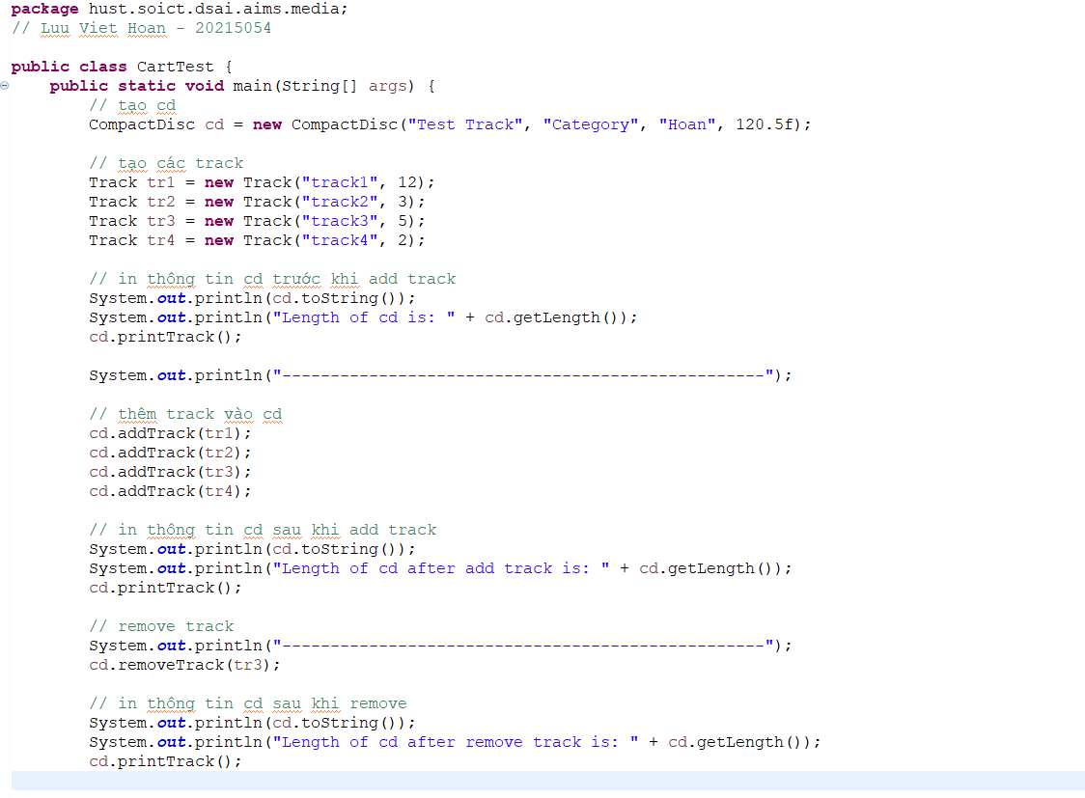

Hình 33. Demo Track

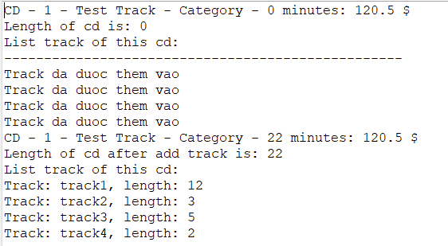

Hình 34. Kết quả add track và getLength

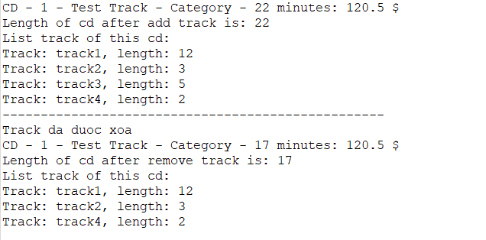

Hình 35. Kết quả remove track 3

1. **Authors of Books**

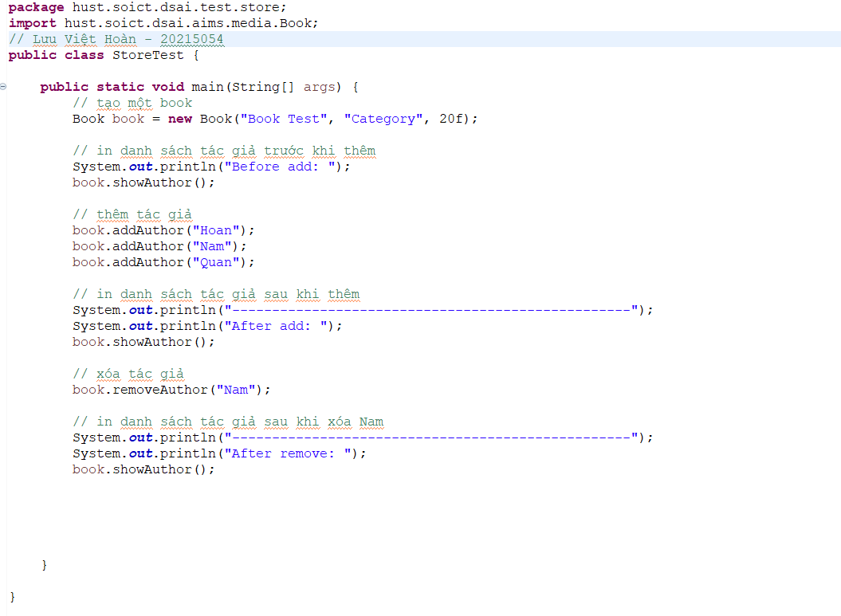

Hình 36. Demo Authors

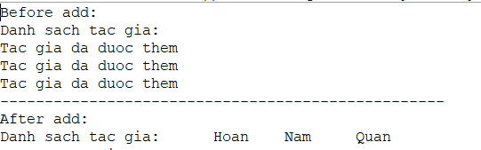

Hình 37. Kết quả addAuthors

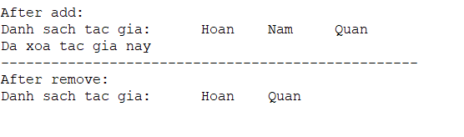

Hình 38. Kết quả removeAuthors

1. **Demo Aims**

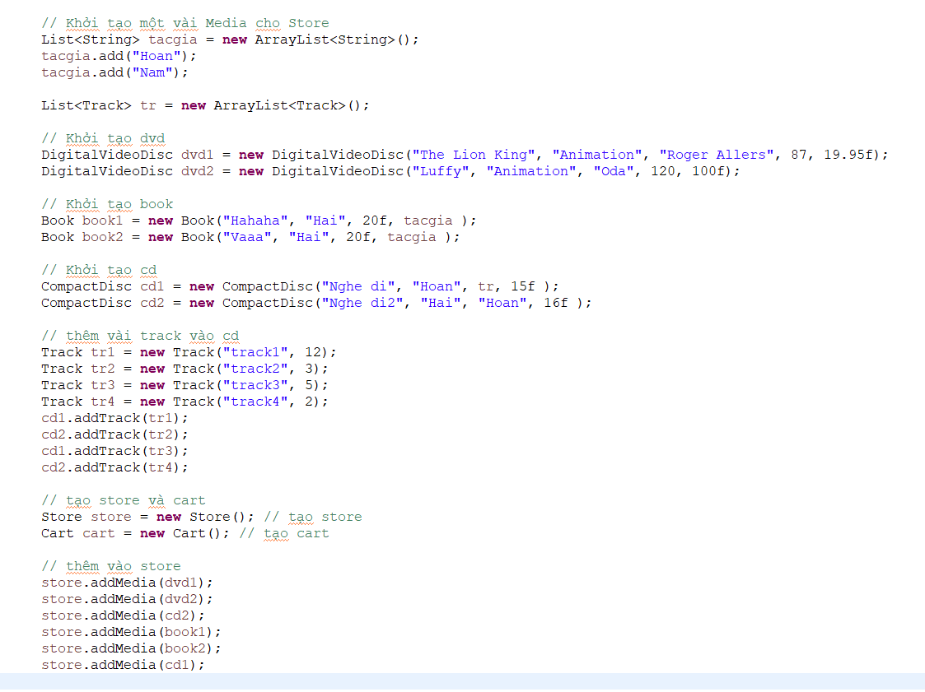

Hình 39. Demo Aims

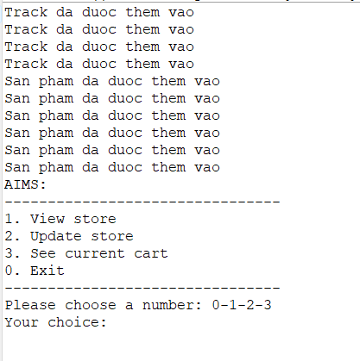

Hình 40. Menu chính

1. **View Store**

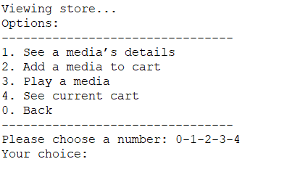

Hình 41. View Store Menu

1. *See a media’s details*

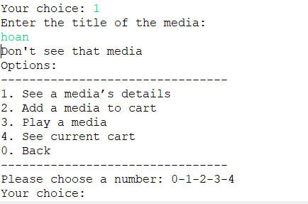

Hình 42. 1_1 Không thành công

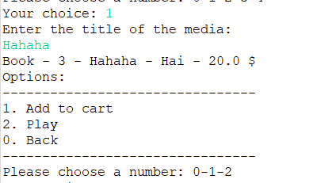

Hình 43. 1_1 thành công

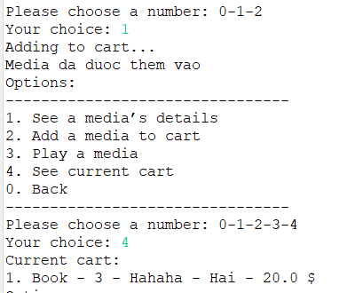

Hình 44. 1_1_1 Add to cart

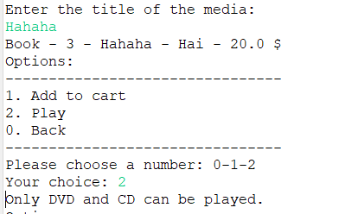

Hình 45. 1_1_2 Play not work (book)

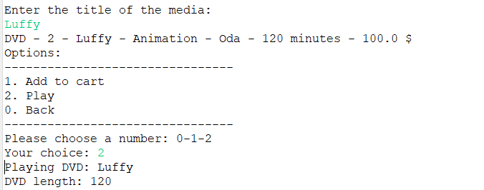

Hình 46. 1_1_2 Play Media

1. *Add a media to cart*

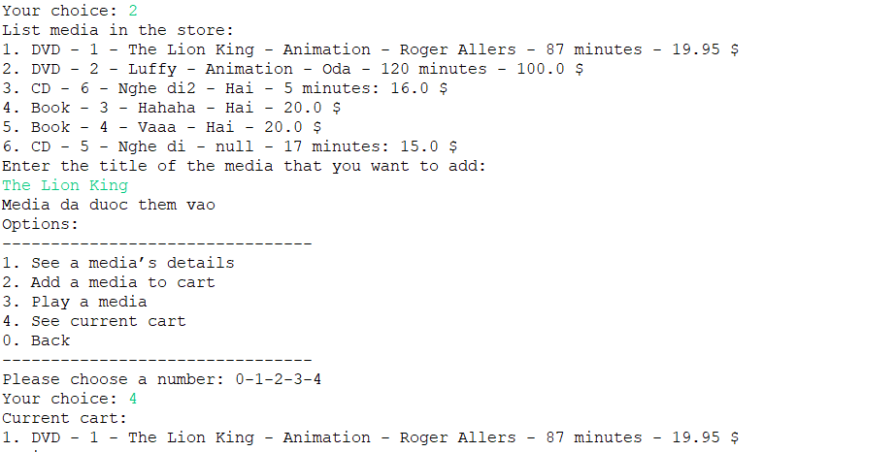

Hình 47. 1_2 Add media to cart

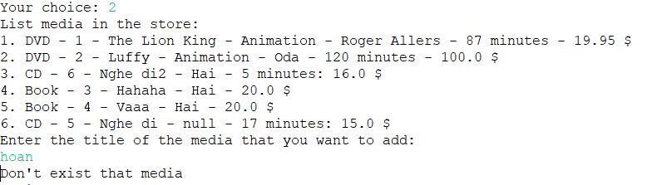

Hình 48. 1_2 Media not exist

1. *Play a media*

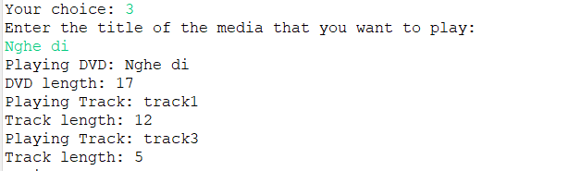

Hình 49. 1_3 Play media

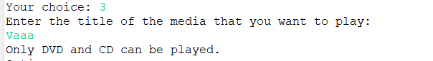

Hình 50. 1_3 Play media not work because of Book

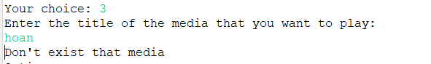

Hình 51. 1_3 Media not exist

1. *See current cart*

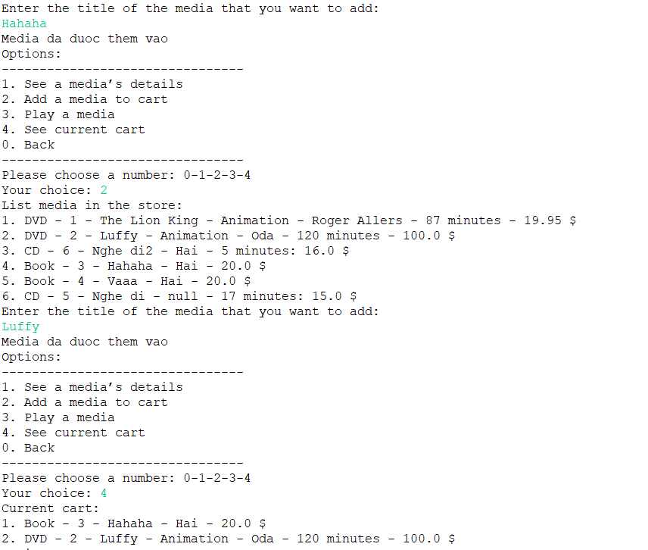

Hình 52. 1_4 See cart

1. **Update Store**

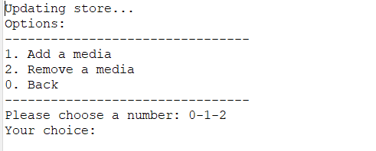

Hình 53. Update Menu

1. *Add a media*

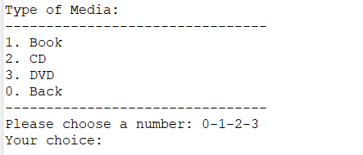

Hình 54. Add a media Menu

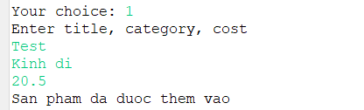

Hình 55. 2_1_1 Add book

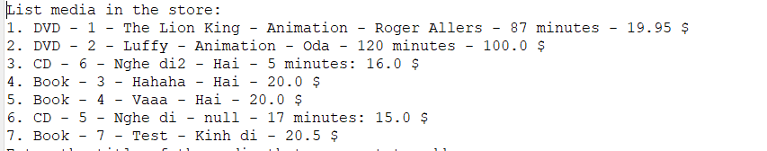

Hình 56. 2_1_1 Kết quả

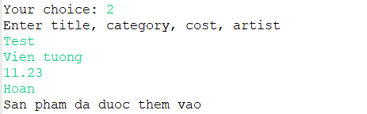

Hình 57. 2_1_2 Add CD

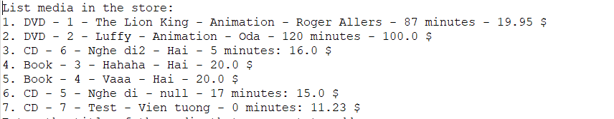

Hình 58. 2_1_2 Kết quả

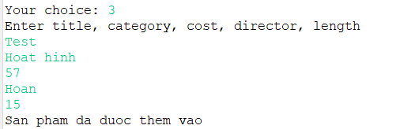

Hình 59. 2_1_3 Add DVD

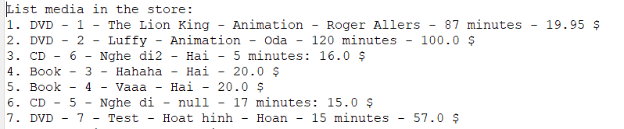

Hình 60. 2_1_3 Kết quả

1. *Remove a media*

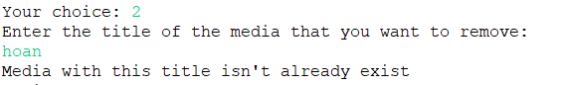

Hình 61. 2_2 Media not exist

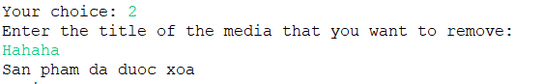

Hình 62. 2_2 Remove media

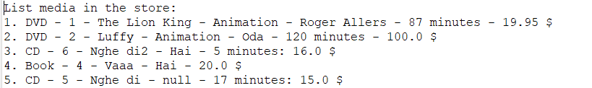

Hình 63. 2_2 Kết quả

1. **See current cart**

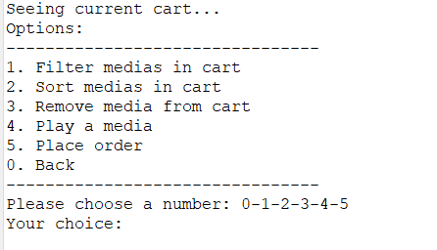

Hình 64. See current cart Menu

1. *Filter medias in cart*

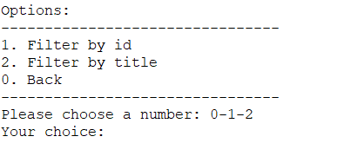

Hình 65. Filter Menu

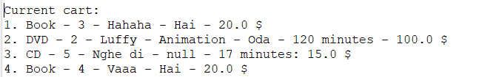

Hình 66. 3 - Giỏ hàng hiện tại

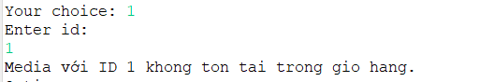

Hình 67. 3_1_1 ID not exist

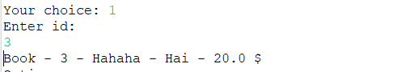

Hình 68. 3_1_1 Filter by ID

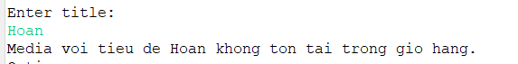

Hình 69. 3_1_2 Title not exist



Hình 70. 3_1_2 Filter by Title

1. *Sort medias in cart*

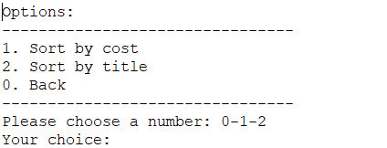

Hình 71. 3 - Sort Menu

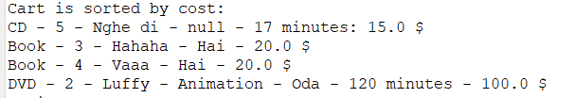

Hình 72. 3_2_1 Sort by Cost

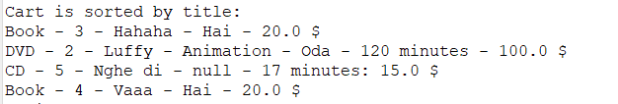

Hình 73. 3_2_2 Sort by Title

1. *Remove media from cart*



Hình 74. 3_3 Media not exist

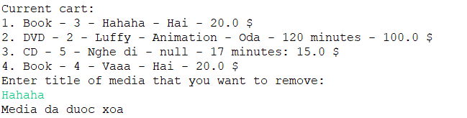

Hình 75. 3_3 Remove Media from cart

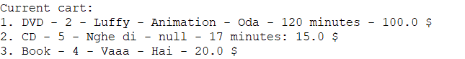

Hình 76. 3_3 Kết quả

1. *Play a media*

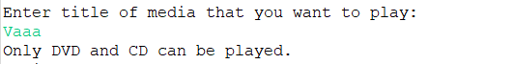

Hình 77. 3_4 Not play because of book

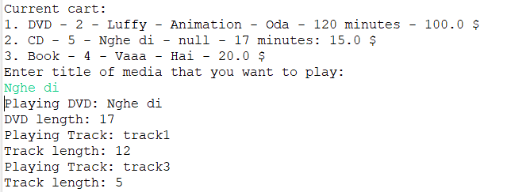

Hình 78. 3_4 Play media in cart

1. *Place order*



Hình 79. 3_5 Place order

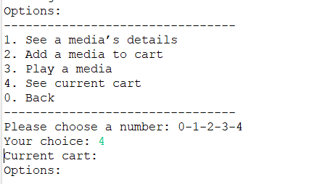

Hình 80. Current Cart empty