**BÁO CÁO THỰC HÀNH LAB 5**

**LẬP TRÌNH HƯỚNG ĐỐI TƯỢNG**

Table of Contents

**I.** **Swing components** 2

**1.** AWTAccumulator 2

2. SwingAccumulator 3

**II.** **Organizing Swing components with Layout Managers** 5

**III.** **Create a graphical user interface for AIMS with Swing** 10

1. StoreScreen 10

2. MediaStore 13

3. Kết quả 15

**IV.** **JavaFX API** 17

1. Create the FXML file 17

2. Create the controller class 18

3. Create the application 19

4. Practice exercise 21

**V.** **Setting up the View Cart Screen with ScreenBuilder** 23

**VI.** **Integrating JavaFX into Swing application – the JFXPanel class** 24

**VII.** **View the items in cart – JavaFX’s data-driven UI** 25

**VIII.** **Updating buttons based on selected item in TableView – ChangeListener** 27

**IX.** **Deleting a media** 28

**X.** **Filter items in cart – FilteredList** 29

**XI.** **Complete the Aims GUI application** 29

**XII.** **Exception** 32

**Mục lục ảnh**

Hình 1. AWTAccumulator 3

Hình 2. AWT_Demo 4

Hình 3. SwingAccumulator 5

Hình 4. SwingAccumulator_Demo 6

Hình 5. NumberGrid part 1 7

Hình 6. NumberGrid part 2 8

Hình 7. NumberGrid demo 9

Hình 8. NumberGrid demo DEL 10

Hình 9. NumberGrid demo C 11

Hình 10. StoreScreen part 1 12

Hình 11. StoreScreen part 2 13

Hình 12. StoreScreen part 3 14

Hình 13. MediaStore part 1 15

Hình 14. MediaStore part 2 16

Hình 15. Kết quả 1 16

Hình 16. Kết quả 2 17

Hình 17. Kết quả add to cart 17

Hình 18. Kết quả play 18

Hình 19. Preview 19

Hình 20. PainterController 20

Hình 21. Painter 21

Hình 22. Kết quả Painter 22

Hình 23. Painter code 23

Hình 24. Kết quả UpdatedPainter 24

Hình 25. Cart_Setup 25

Hình 26. CartScreen 26

Hình 27. CartScreenController 27

Hình 28. Demo_View_Cart 28

Hình 29. Demo update button 28

Hình 30. Before_DeleteMedia 29

Hình 31. After_DeleteMedia 29

Hình 32. Filter_by_Title 30

Hình 33. Filter_by_Id 30

Figure 1. Add_Book 30

Figure 2. Add Book Kết quả 31

Figure 3. Add CD 31

Figure 4. Add CD Kết quả 32

Figure 5. Add DVD 32

Figure 6. Add DVD Kết quả 33

Figure 7. DVD Play 34

Figure 8. CD play part 1 35

Figure 9. CD play part 2 35

Figure 10. ExceptionDialog 36

1. **Swing components**
2. AWTAccumulator

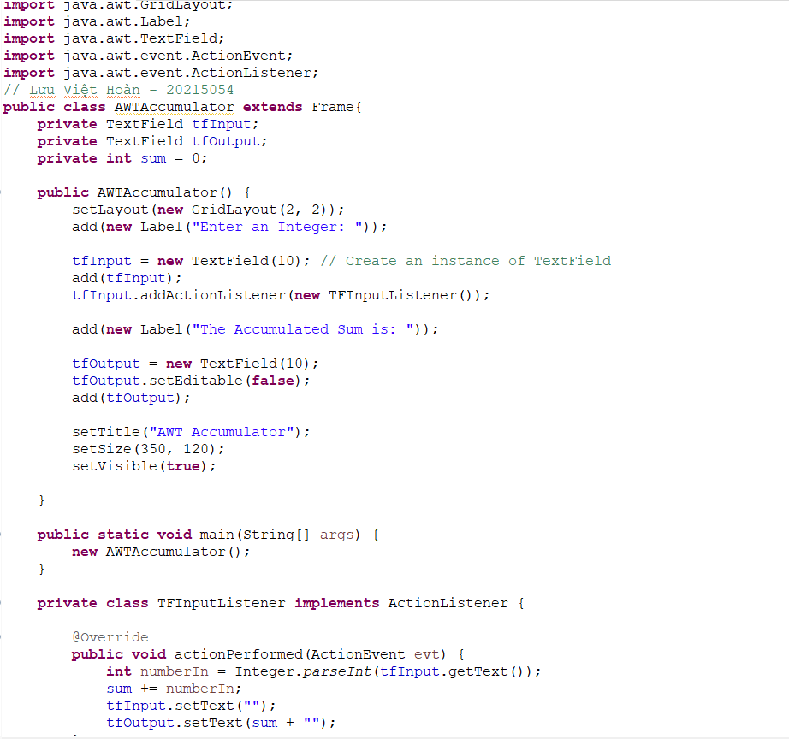

Hình 1. AWTAccumulator

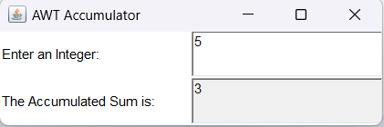 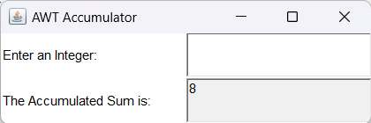

Hình 2. AWT_Demo

1. SwingAccumulator

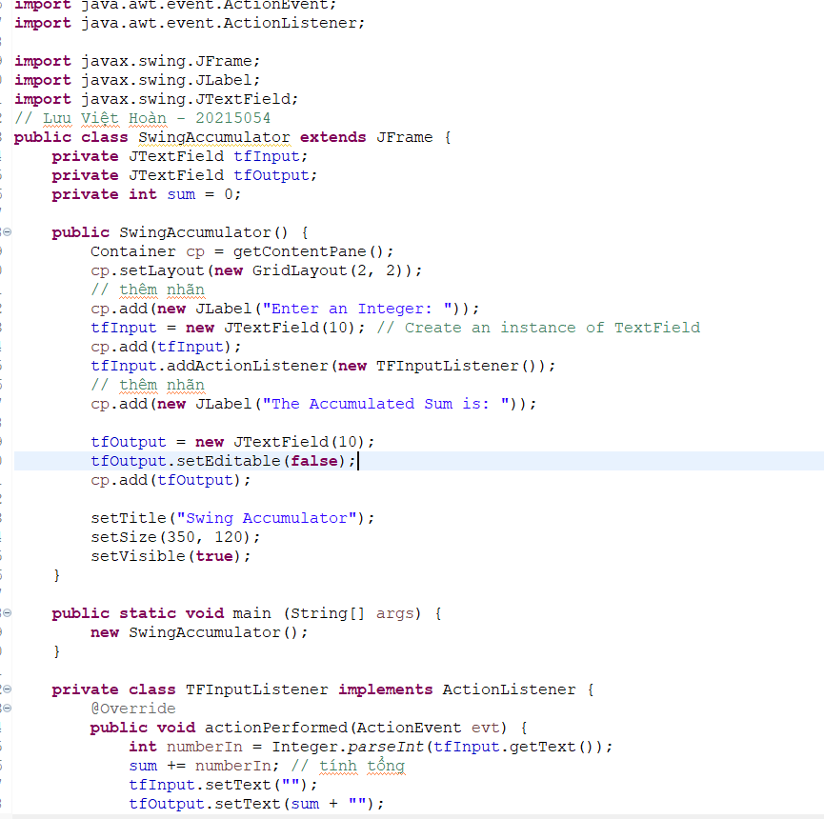

Hình 3. SwingAccumulator

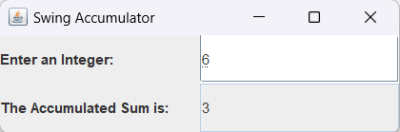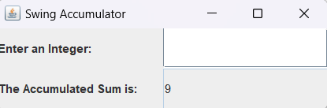

Hình 4. SwingAccumulator_Demo

1. **Organizing Swing components with Layout Managers**

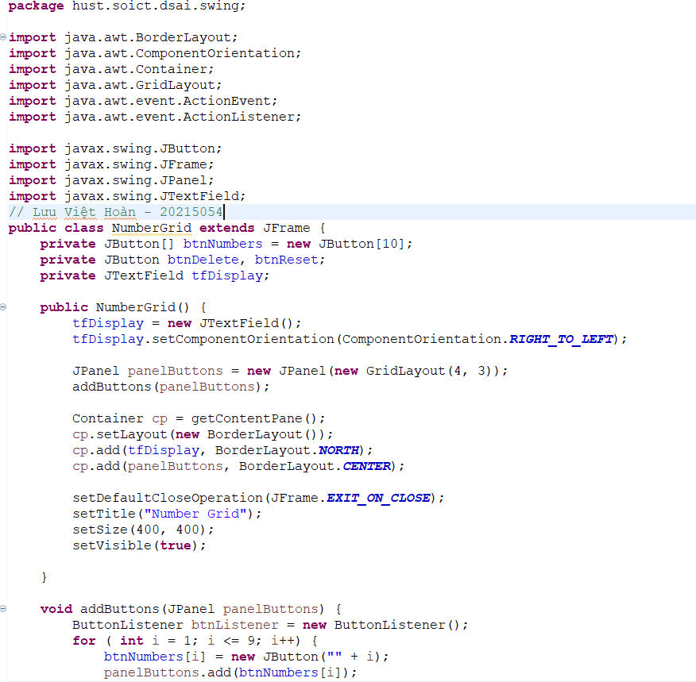

Hình 5. NumberGrid part 1

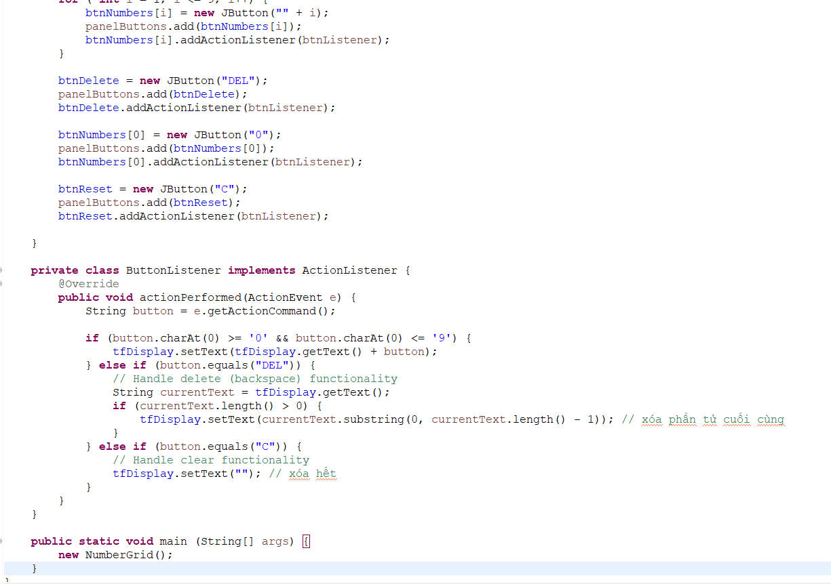

Hình 6. NumberGrid part 2

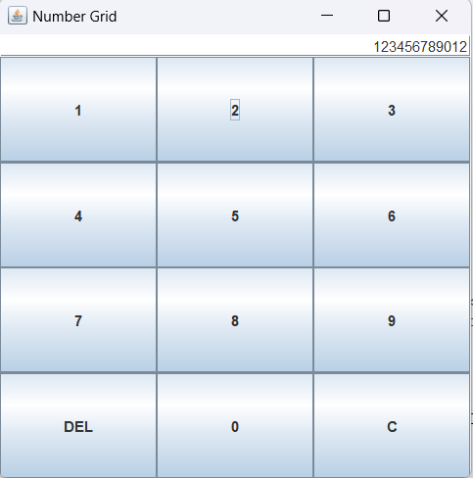

Hình 7. NumberGrid demo

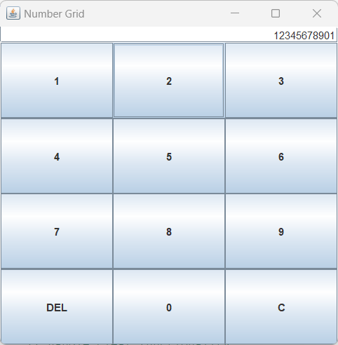

Hình 8. NumberGrid demo DEL

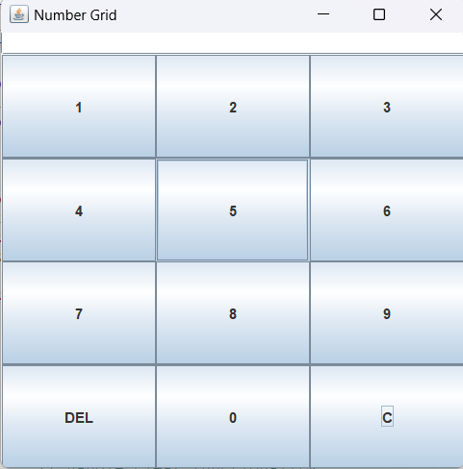

Hình 9. NumberGrid demo C

1. **Create a graphical user interface for AIMS with Swing**
2. StoreScreen

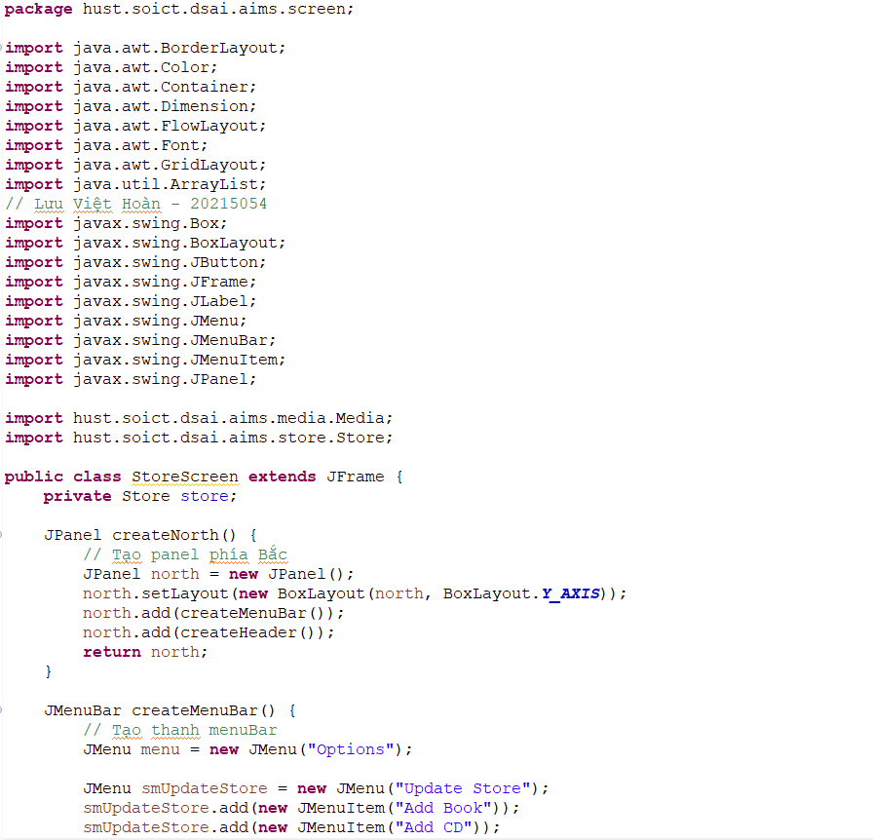

Hình 10. StoreScreen part 1

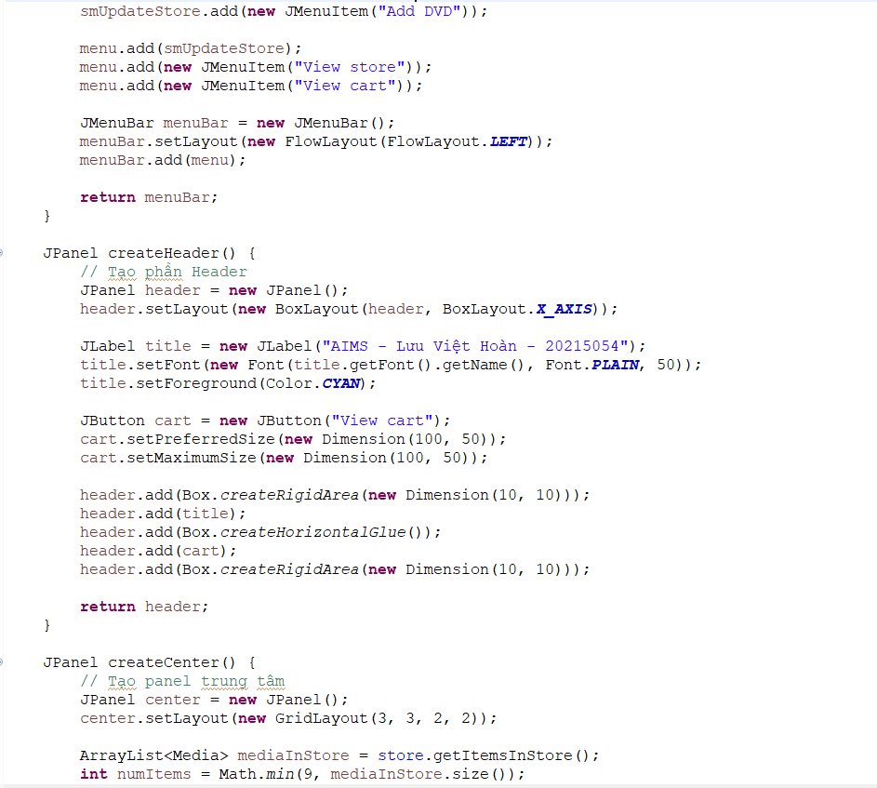

Hình 11. StoreScreen part 2

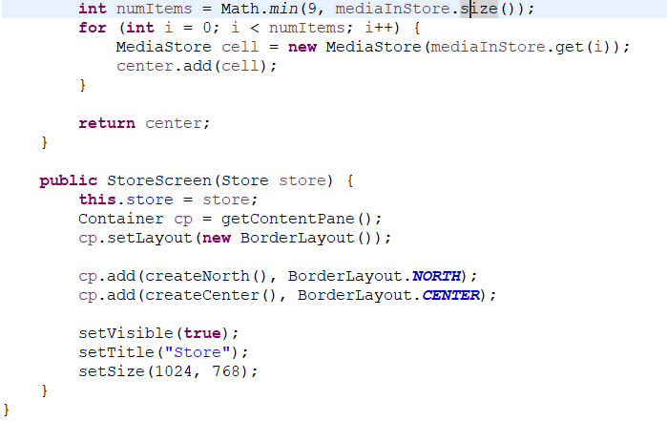

Hình 12. StoreScreen part 3

1. MediaStore

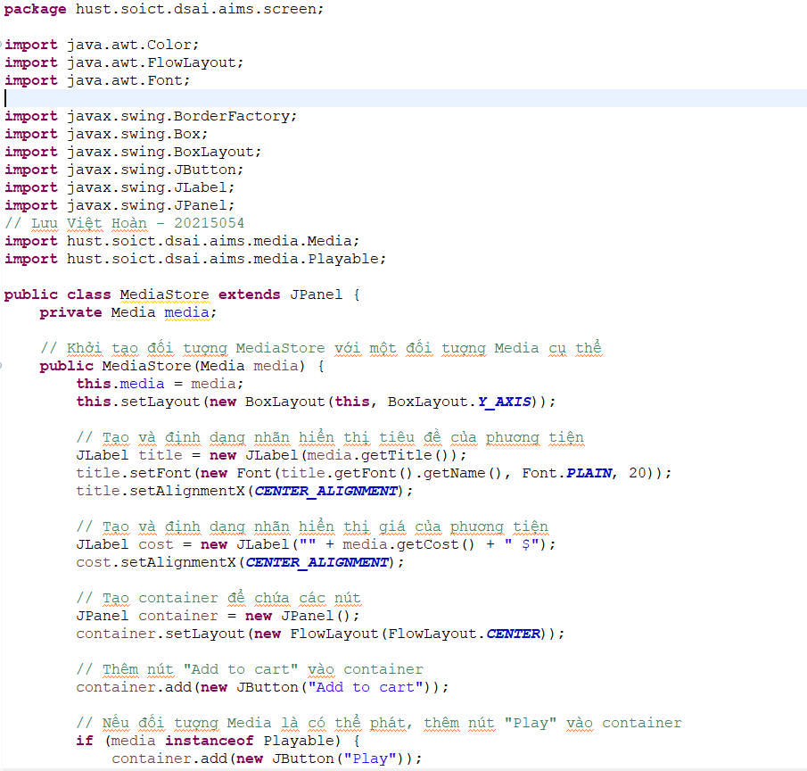

Hình 13. MediaStore part 1

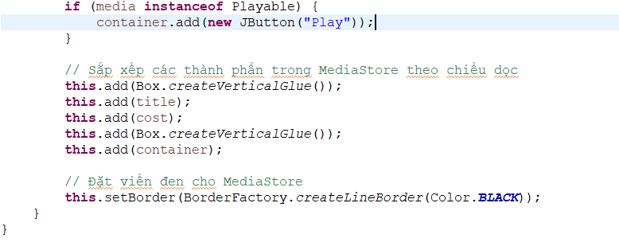

Hình 14. MediaStore part 2

1. Kết quả

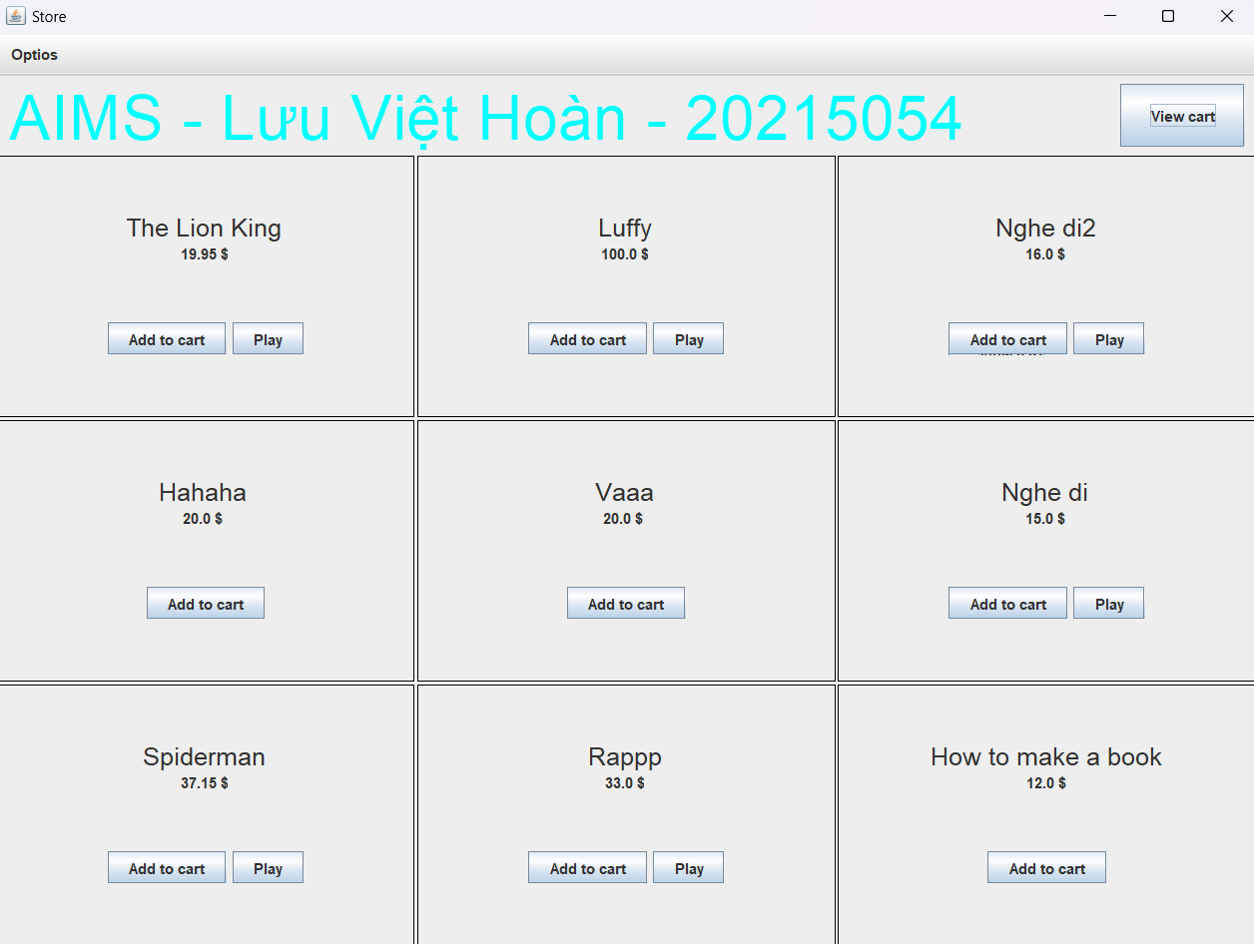

Hình 15. Kết quả 1

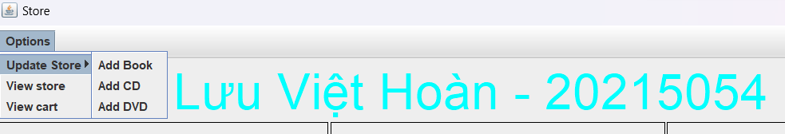

Hình 16. Kết quả 2

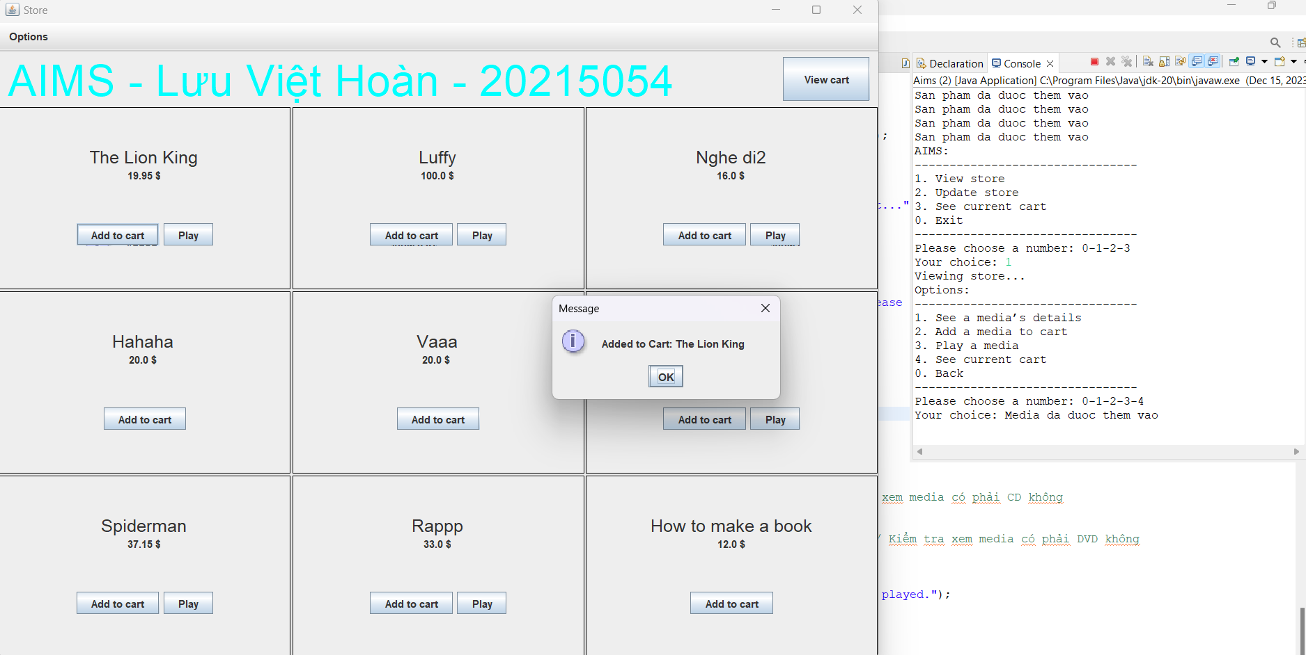

Hình 17. Kết quả add to cart

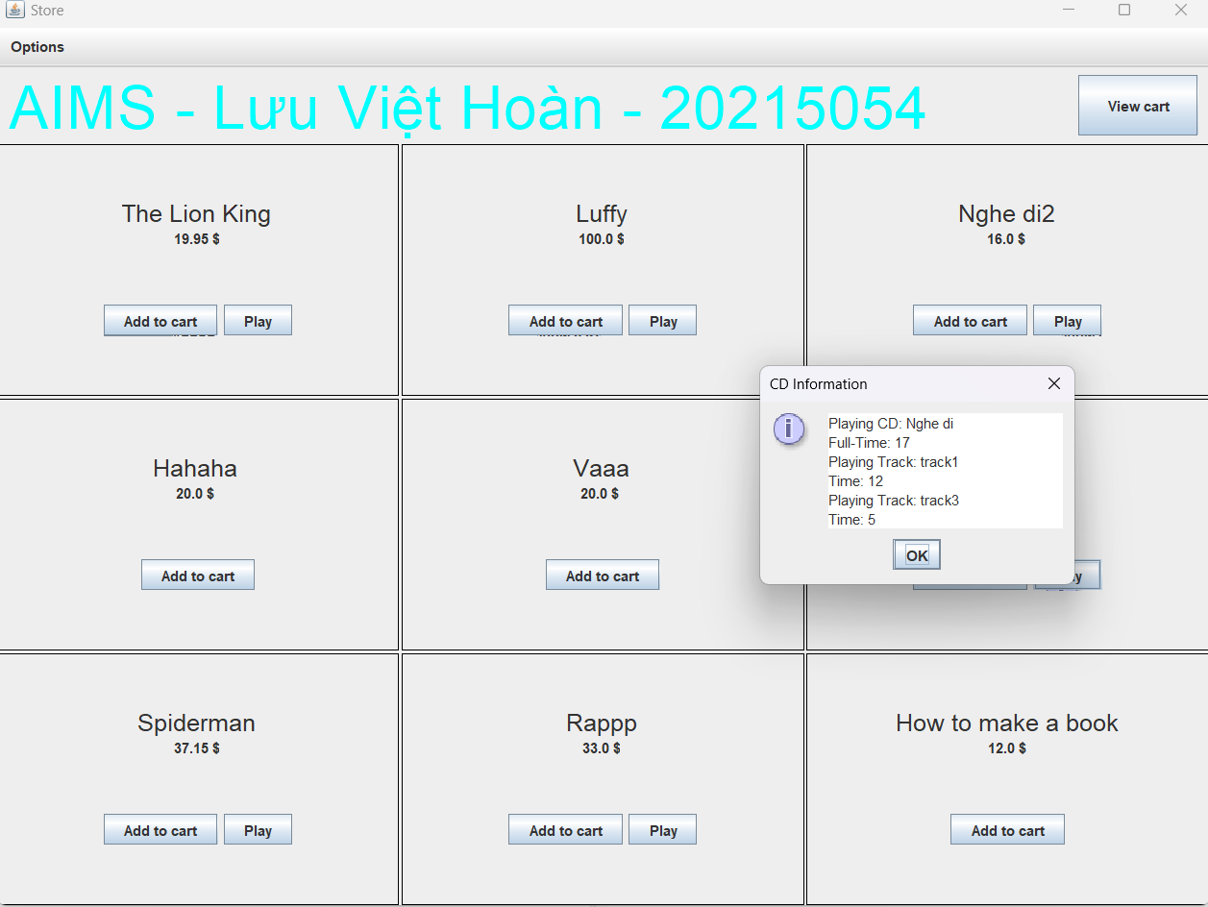

Hình 18. Kết quả play

1. **JavaFX API**
2. Create the FXML file

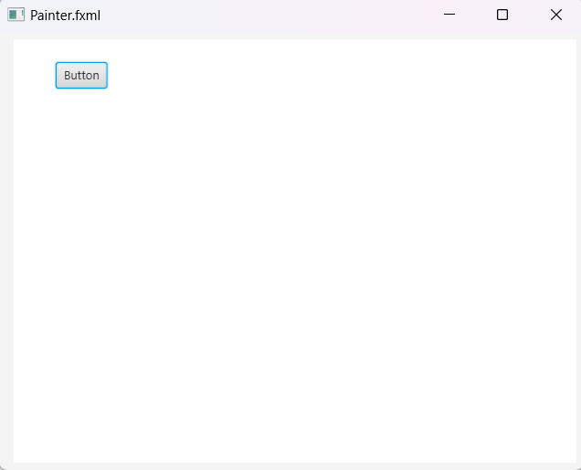

Hình 19. Preview

1. Create the controller class

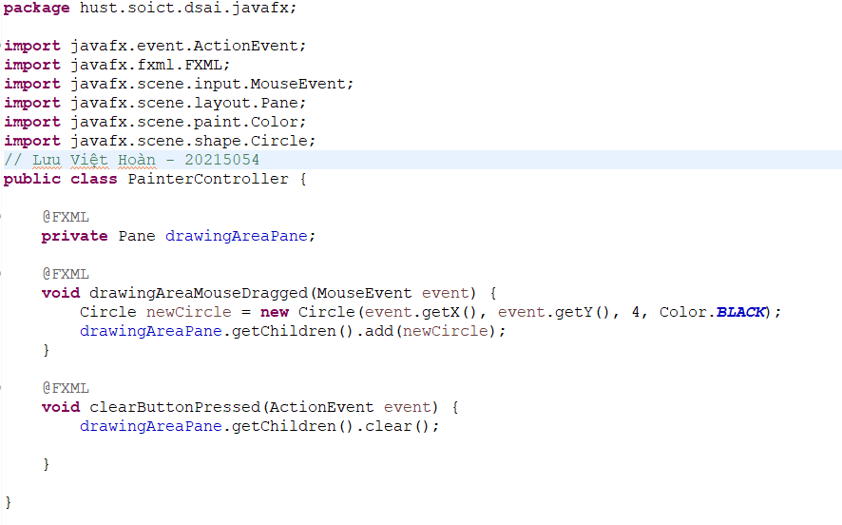

Hình 20. PainterController

1. Create the application

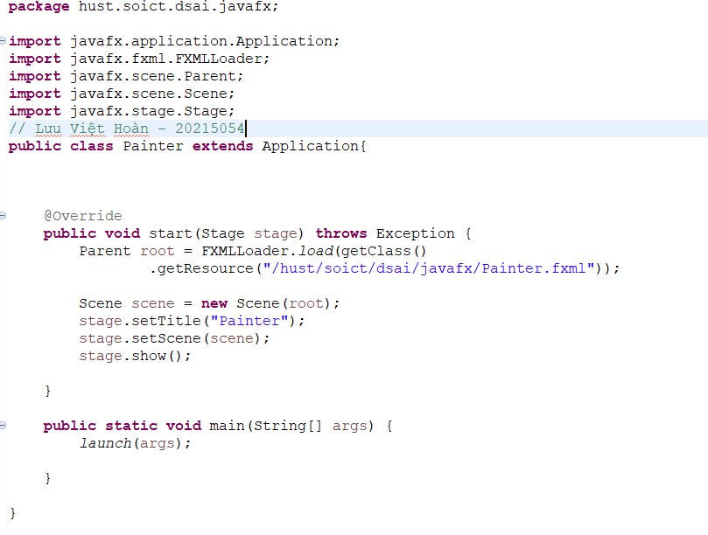

Hình 21. Painter

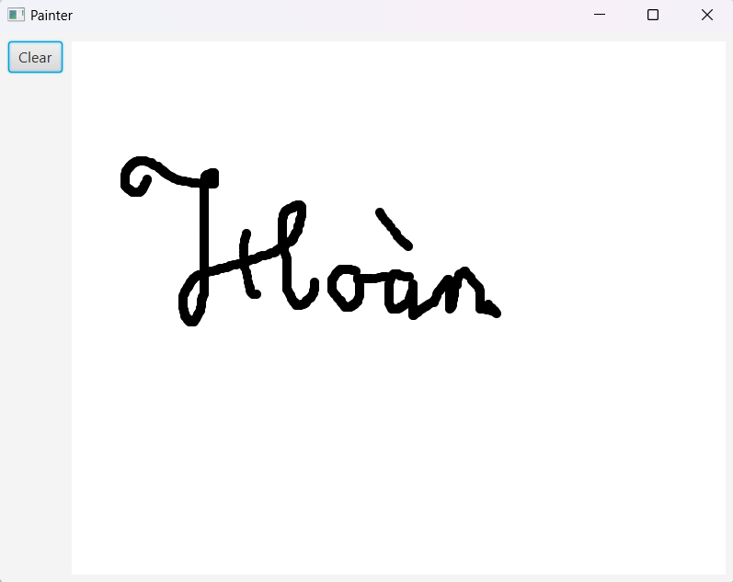

Hình 22. Kết quả Painter

1. Practice exercise

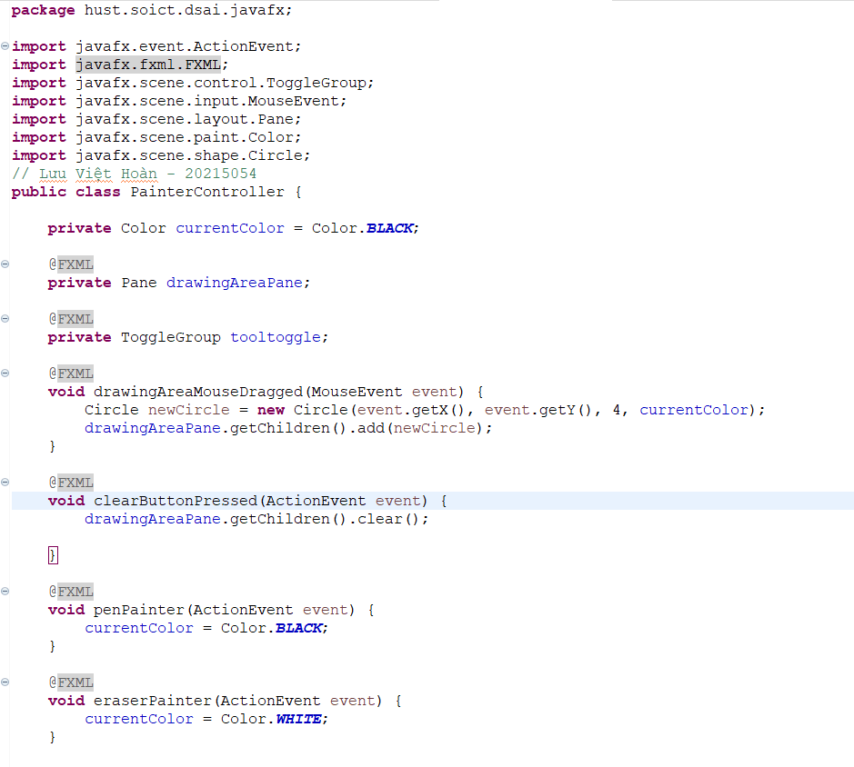

Hình 23. Painter code

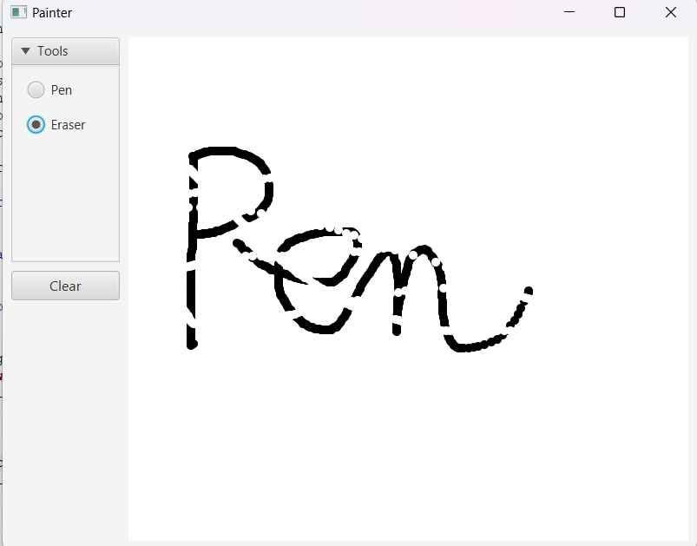

Hình 24. Kết quả UpdatedPainter

1. **Setting up the View Cart Screen with ScreenBuilder**

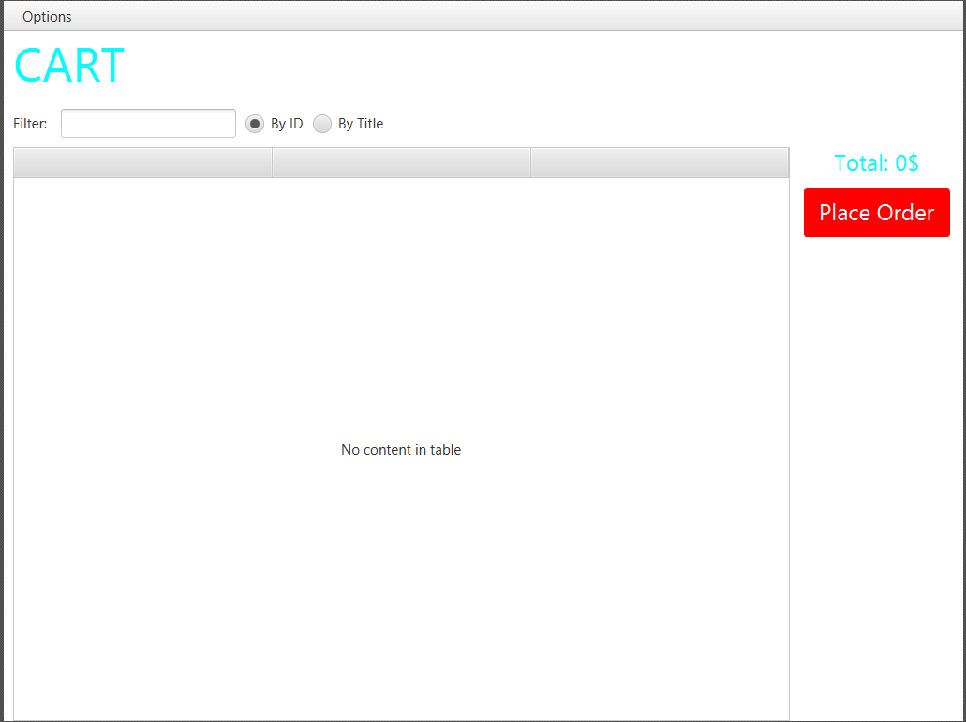

Hình 25. Cart_Setup

1. **Integrating JavaFX into Swing application – the JFXPanel class**

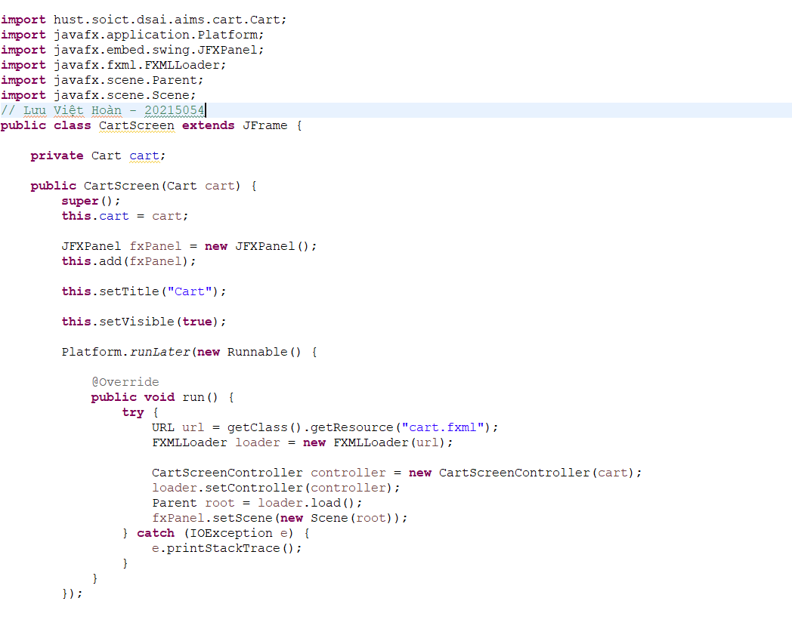

Hình 26. CartScreen

1. **View the items in cart – JavaFX’s data-driven UI**

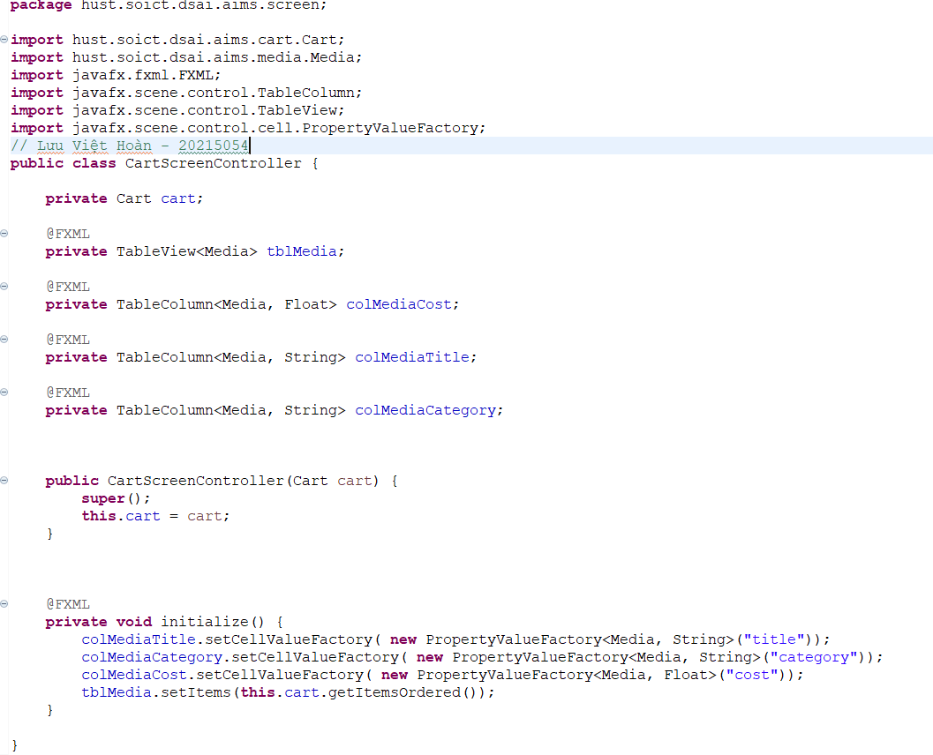

Hình 27. CartScreenController

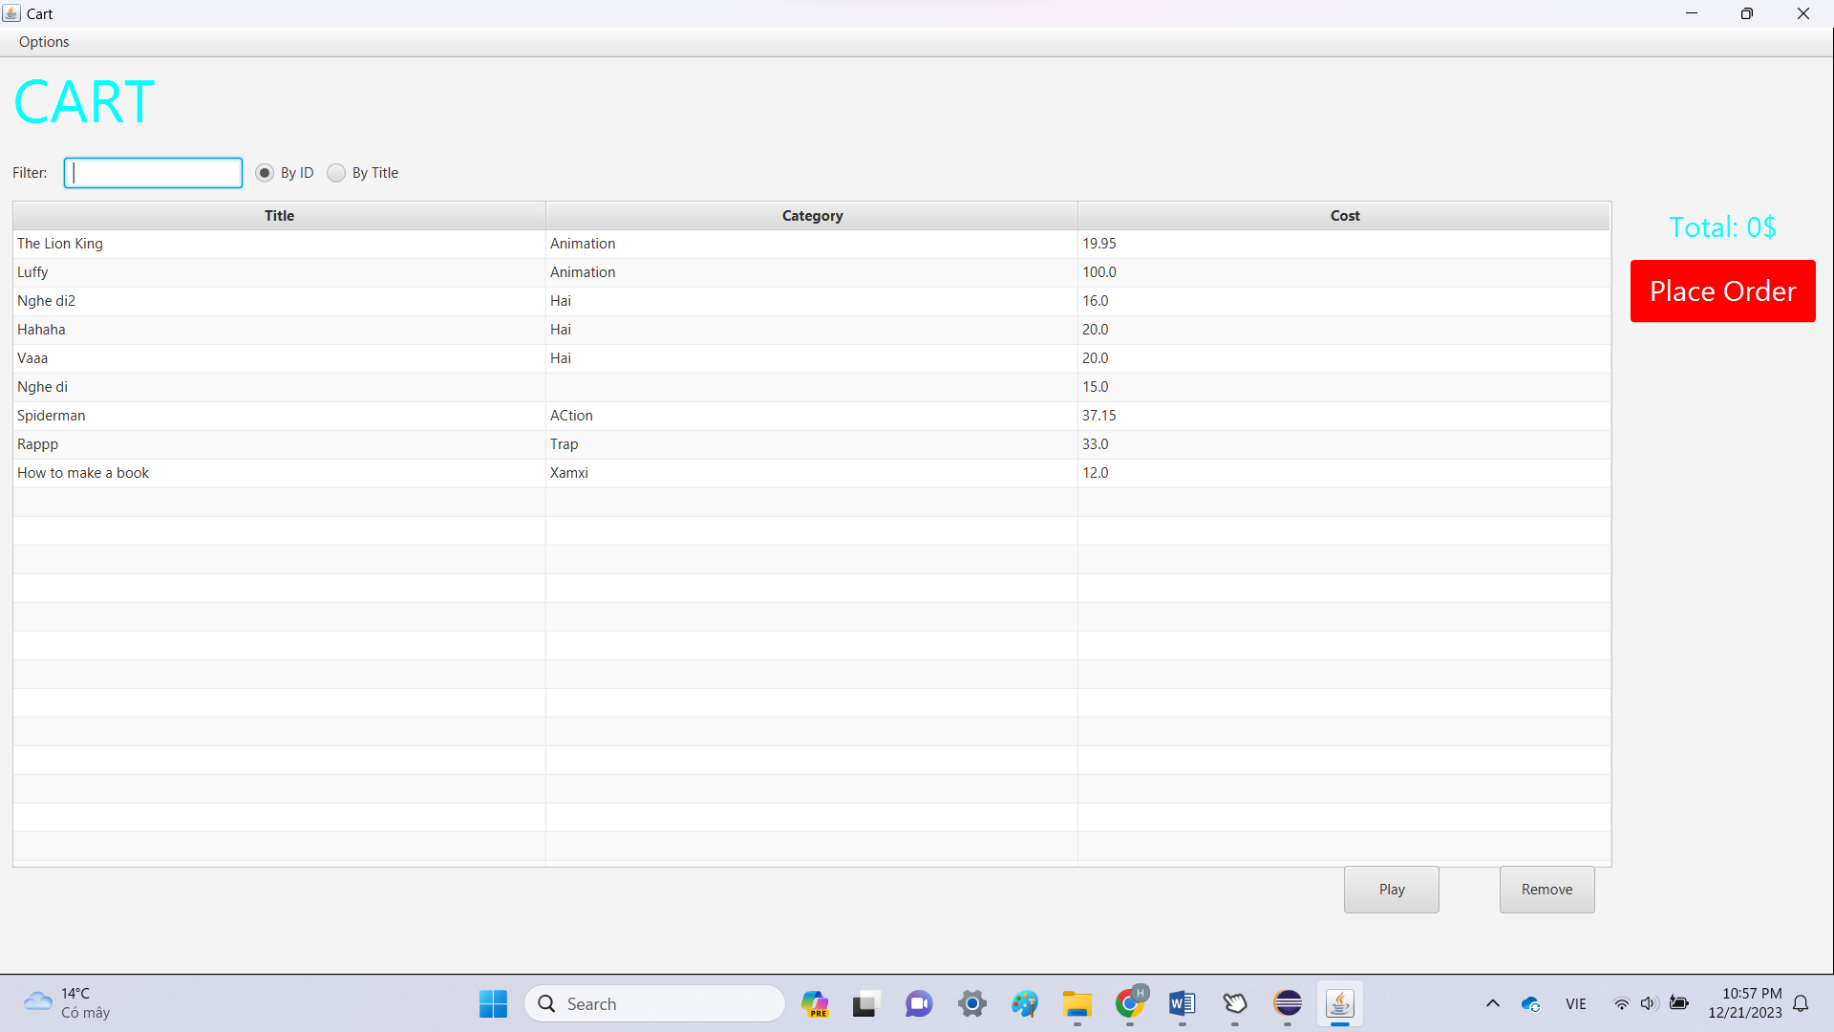

Hình 28. Demo_View_Cart

1. **Updating buttons based on selected item in TableView – ChangeListener**

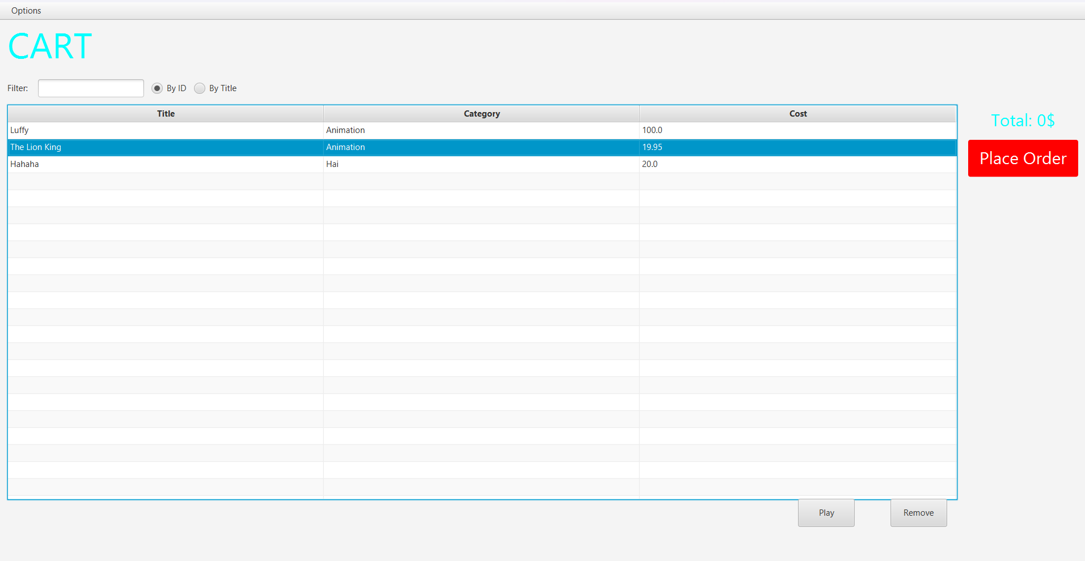

Hình 29. Demo update button

1. **Deleting a media**

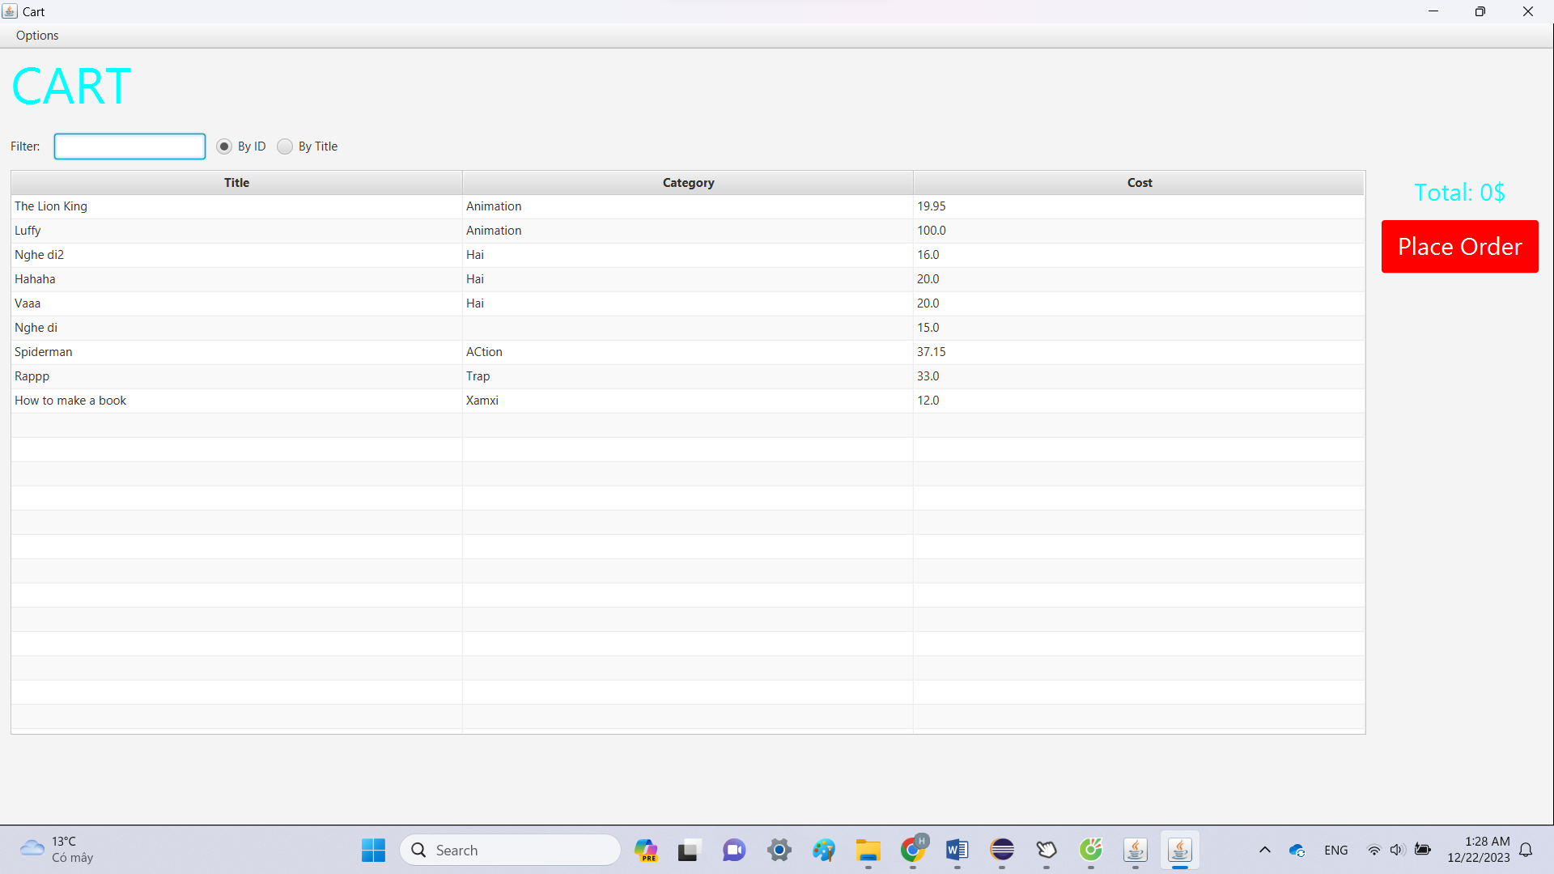

Hình 30. Before_DeleteMedia

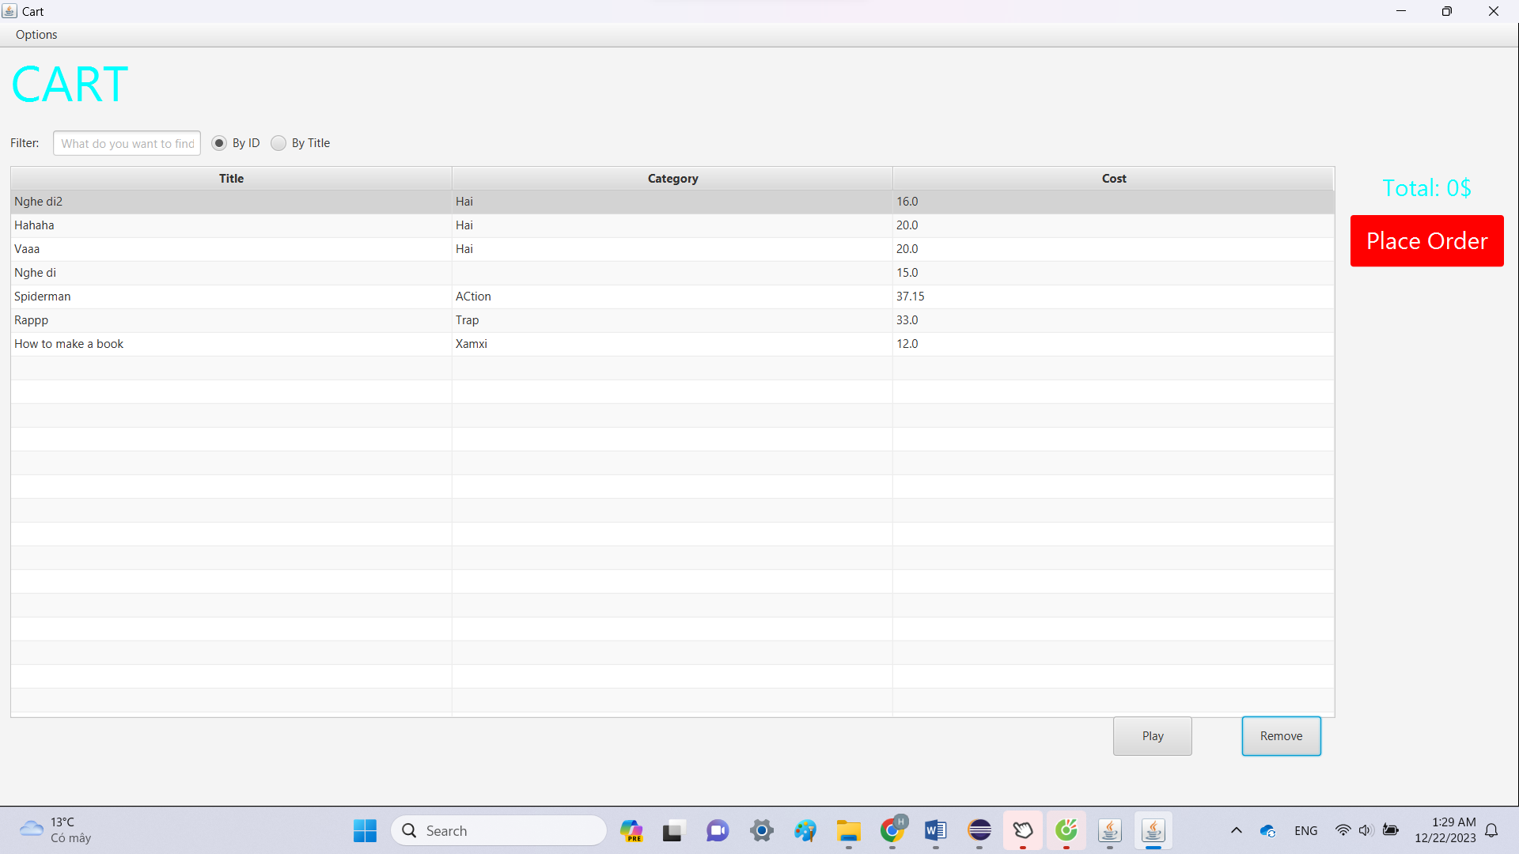

Hình 31. After_DeleteMedia

1. **Filter items in cart – FilteredList**

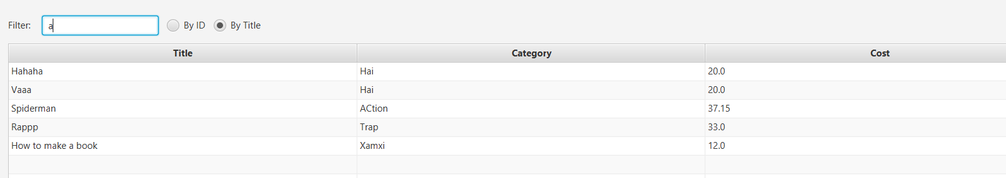

Hình 32. Filter_by_Title



Hình 33. Filter_by_Id

1. **Complete the Aims GUI application**

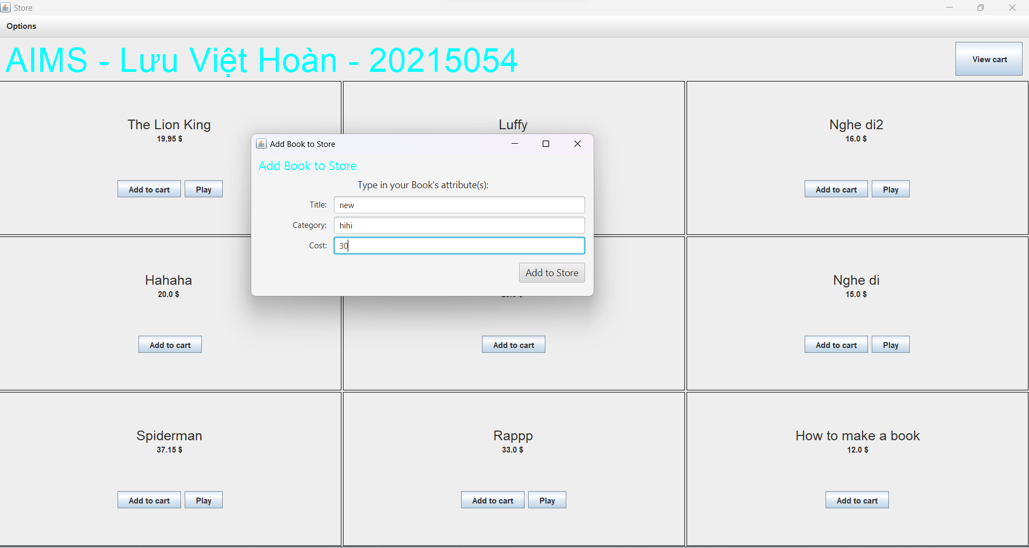

Figure 1. Add_Book

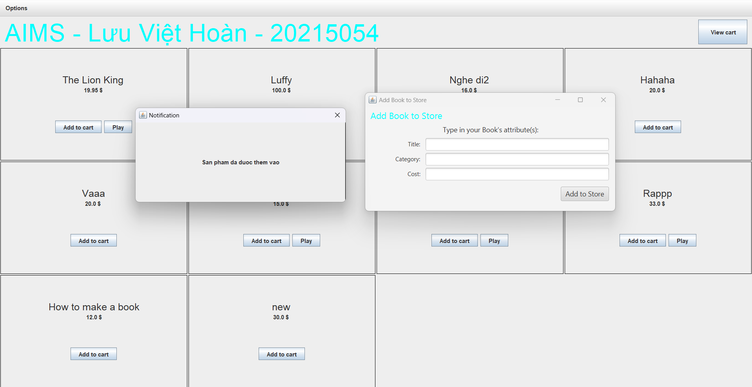

Figure 2. Add Book Kết quả

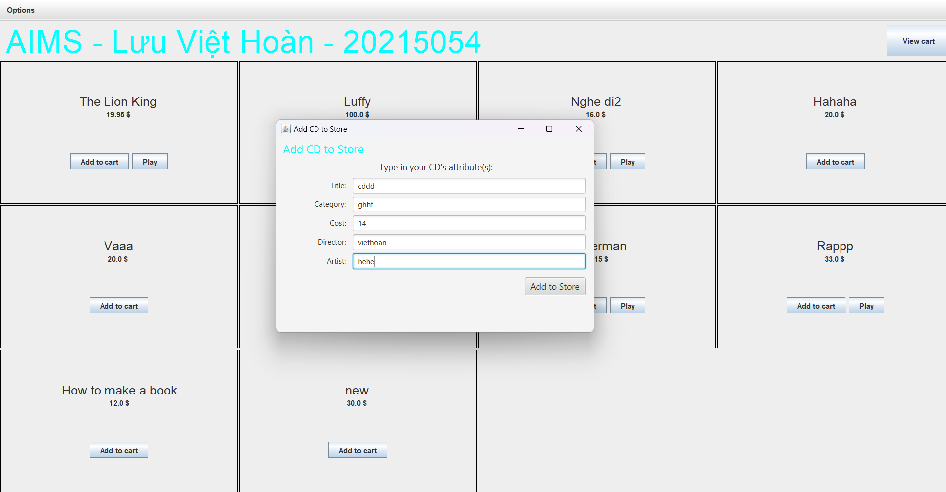

Figure 3. Add CD

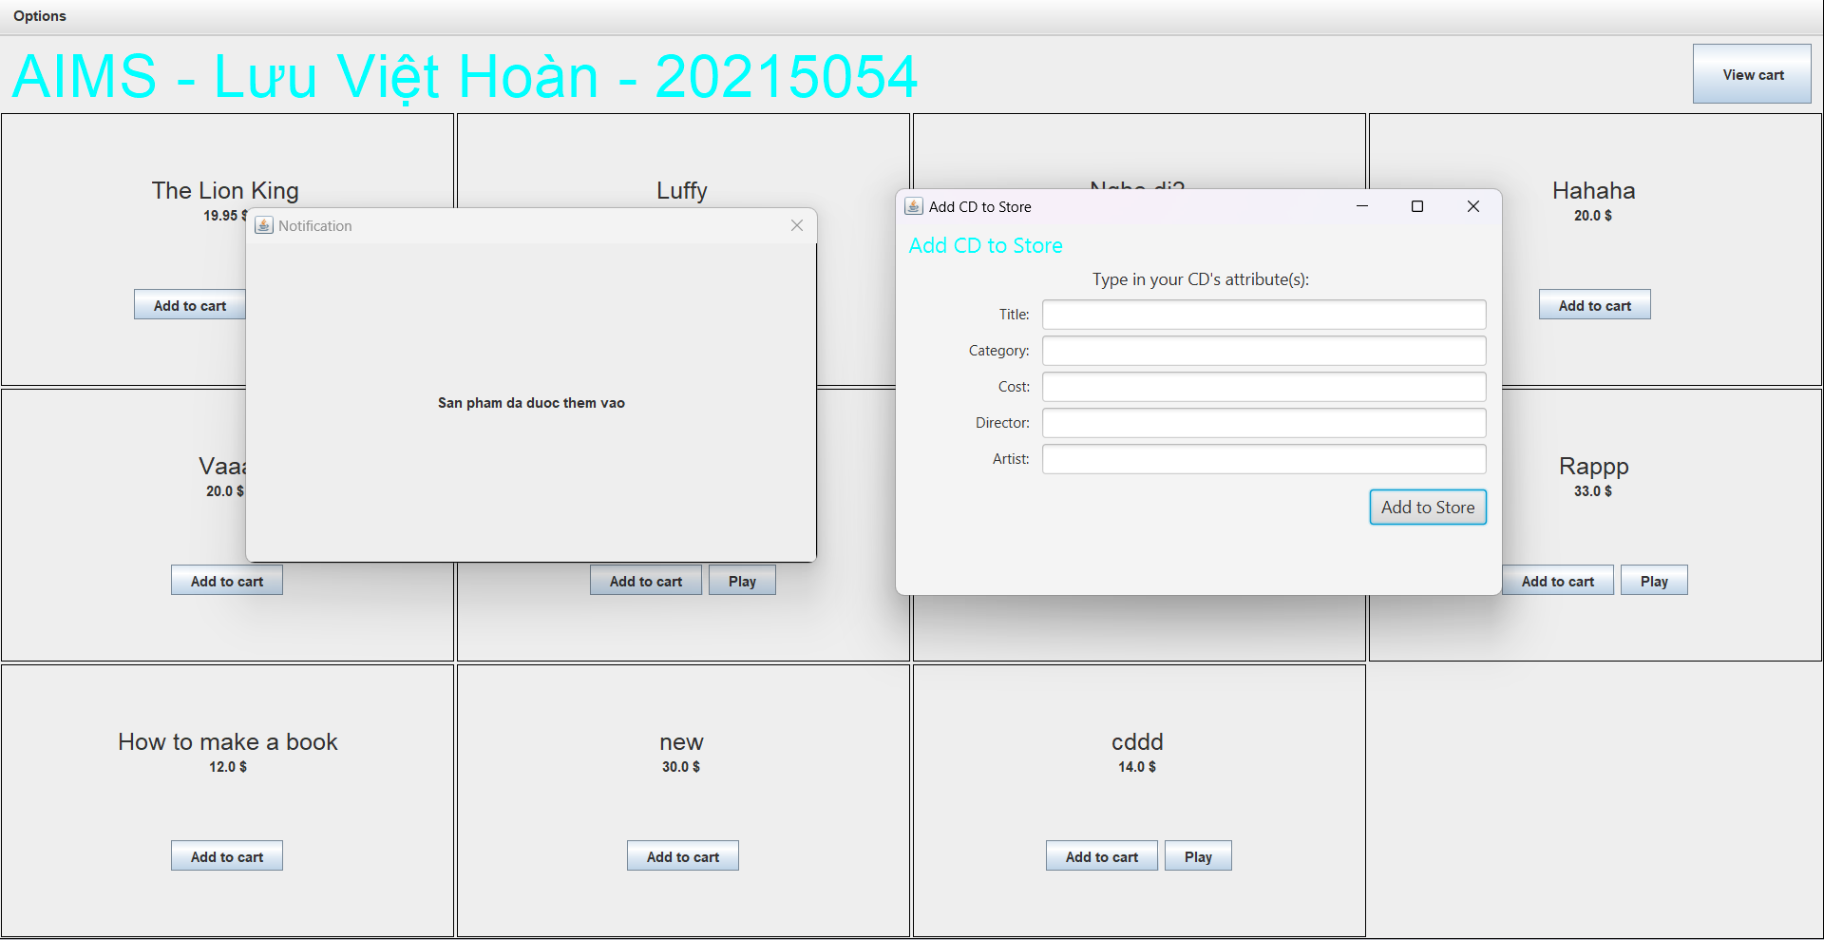

Figure 4. Add CD Kết quả

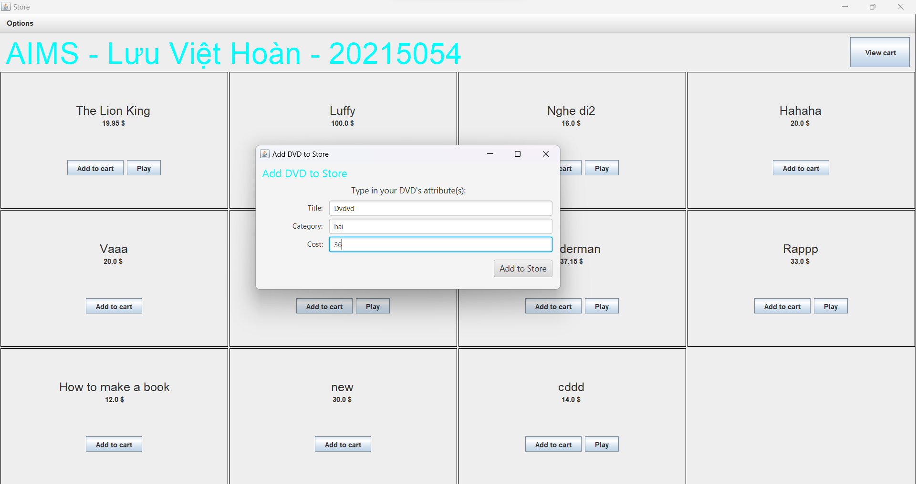

Figure 5. Add DVD

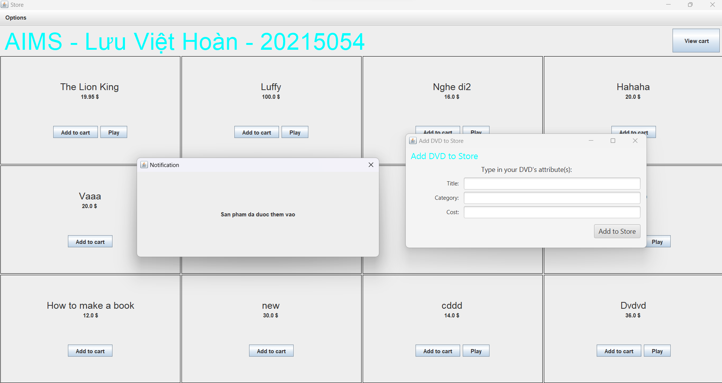

Figure 6. Add DVD Kết quả

1. **Exception**

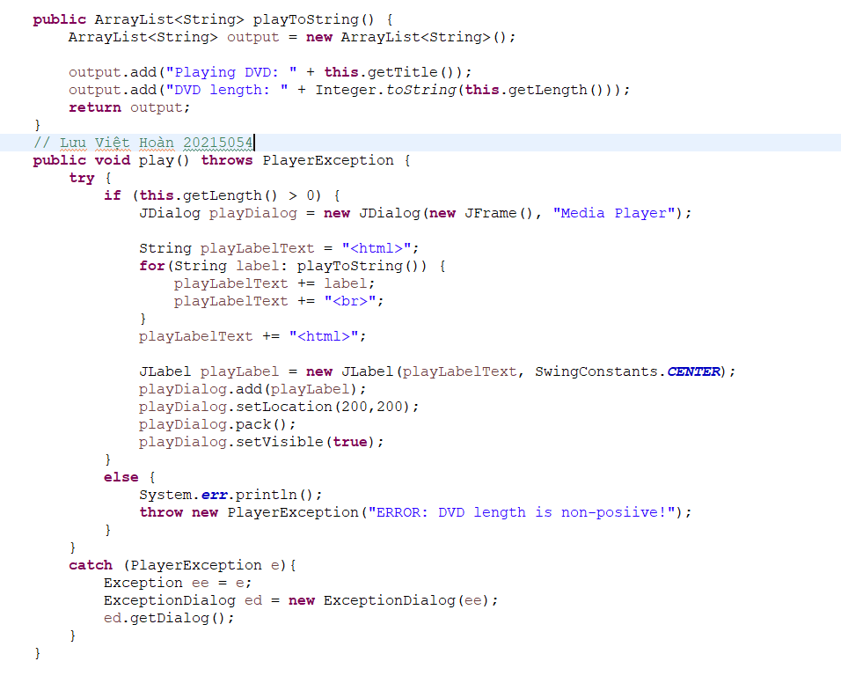

Figure 7. DVD Play

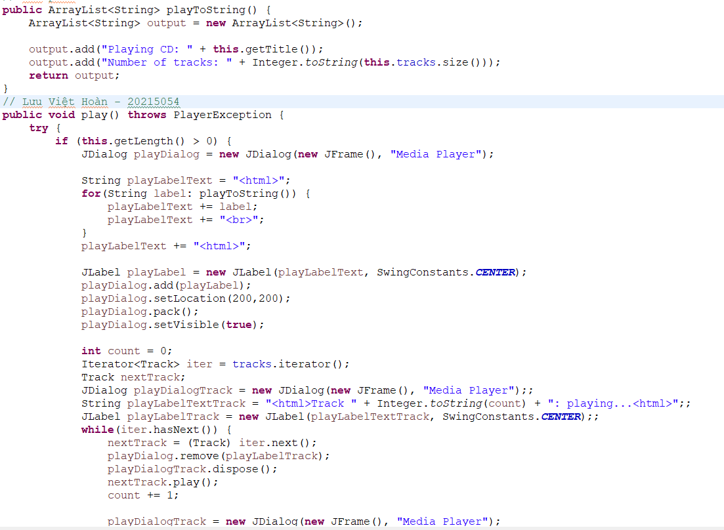

Figure 8. CD play part 1

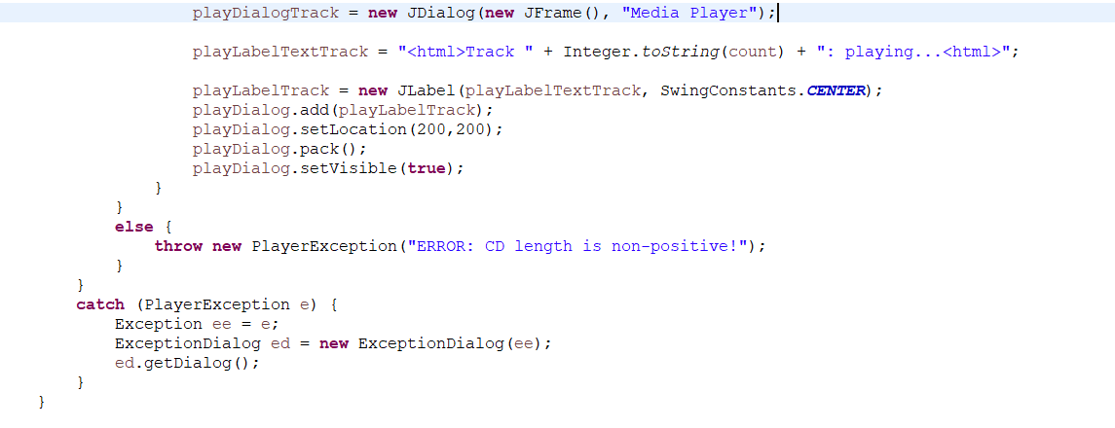

Figure 9. CD play part 2

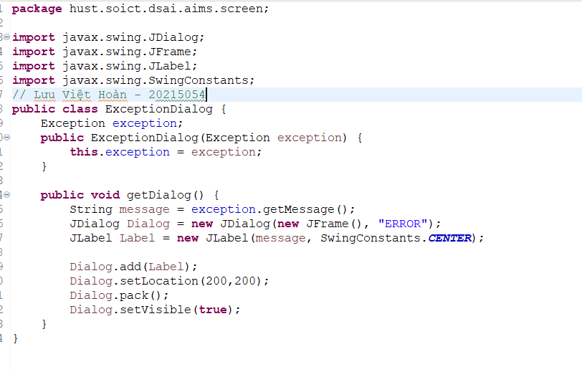

Figure 10. ExceptionDialog