ĐẠI HỌC BÁCH KHOA HÀ NỘI

**TRƯỜNG CÔNG NGHỆ THÔNG TIN VÀ TRUYỀN THÔNG**

**________________________________**

**BÁO CÁO**

**Phát triển phần mềm theo chuẩn kĩ năng ITSS**

**Bài tập về nhà tuần 1**

|  |  |
| --- | --- |
| Họ và tên: | **Hà Đình Nam** |
| MSSV: | **20215095** |
| Giảng viên hướng dẫn: | **TS. Trịnh Tuấn Đạt** |

***Hà Nội, 2/2024***

Create an account in github  
• Create a private repository in github, join with all members in  
your group  
• Naming your project name (check the previous lesson)  
• Create a sub-directory (Homework01)

• Each member in the group does the following tasks  
• HelloWorld.java: Ask a user to enter his/her name, then display hello to  
that name

• Implement MVCTutorial example

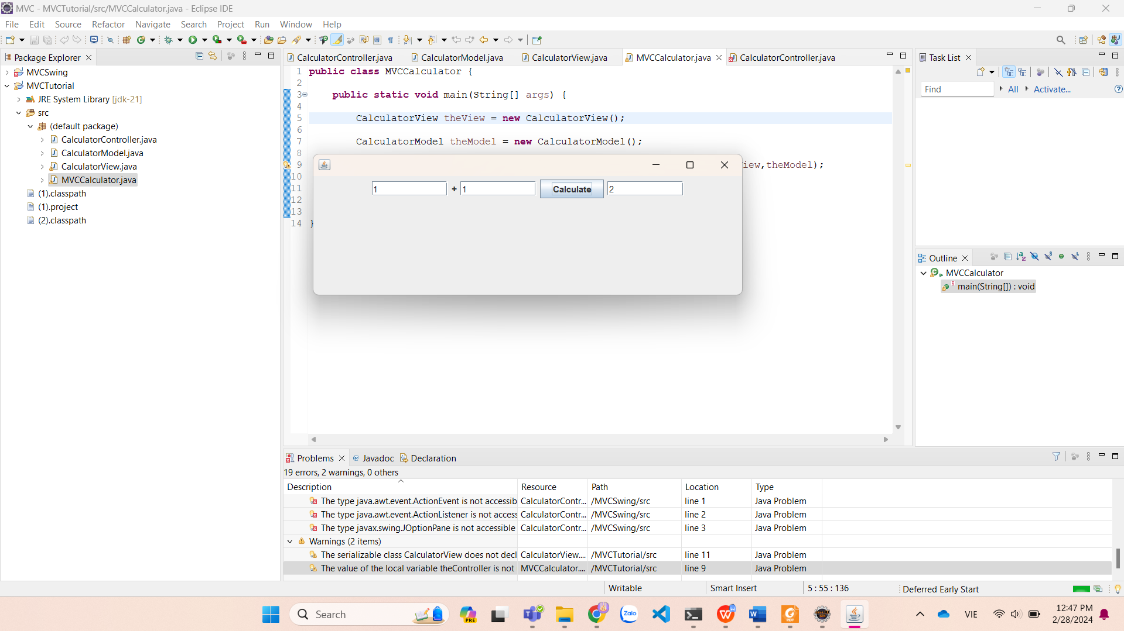  
• Implement Calculator, using MVC model with 2 version: Swing and JavaFX

Dùng Swing:

Dùng JavaFX:

• Each member must perform all of these GIT actions:  
• add file, remove file, modify, commit, push, pull, merge (resolve  
conflict), create branch, merge branch

  
• take a screenshot to prove that you have done all actions

Add and commit:

• Each member create his/her own report for homework 01.