Software Tools

These are tools I have used. Keep in mind, that once you enroll with the school you can qualify for academic pricing on many software tools which is usually full featured at substantially reduced cost. They usually want a school email address to confirm you are valid. Let me just mention, You don’t need all of these. Pick and choose what you think works for you to make research and writing more efficient. I just happen to like these tools.

Bibliography Reference Manager
- JabRef
  - Cost: Free
  - Description: JabRef is an open source bibliography reference manager. The native file format used by JabRef is BibTeX, the standard LaTeX bibliography format. JabRef is a desktop application and runs on the Java VM (version 8), and works equally well on Windows, Linux, and Mac OS X. BibTeX is an application and a bibliography file format.
  - WebSite: http://www.jabref.org/
  - Comments: This program is great for tracking and categorizing all of your resources like pdf’s, word documents, photos, websites both on your local computer and on the internet. It’s best to set up an organized library folder on the computer for all of your research. It also makes searching and find your resources much easier. This program takes a little time to understand as there is a learning curve with it, however, once you understand how it works, its very easy to keep up with the references. It does take a little discipline to enter the information consistently, such as key words, comments and discriptions. When you search for the item you are looking for it will open up the item so you don’t have to look for it on the computer.

Online Citation Help
- Purdue OWL: MLA formatting and Style Guide.
  - Cost: Free
- Website: https://owl.english.purdue.edu/owl/resource/747/01/
  - Cite this for me
  - Cost: Free
  - Website: http://www.citethisforme.com/mla8

- Perella : https://www.perrla.com/
  - This is one that I have not used, however my brother has used it for his Masters. He likes it very much. I may test it out later once we get more in-depth with writing.

Screen Capture
- Snagit
  - Cost: $29.92 / this one will give an academic discount.
  - Description: Screen and video capture.
  - Website: http://shop.techsmith.com/store/techsm/en_US/cat/categoryID.67158100
  - Comments: I have used this software extensively for many things. The power of this tool is to quickly capture research information and save it to a power point for later retrieval or to get complex document information and transcribe it to my reference tracking program. It’s a good idea to screen capture the front page of a research pdf for easy recall of what the research paper was about in conjunction with your notes and comments. Typically, as I build my Bibliography References, I will screen capture the resources and put them in a PowerPoint with notes. These notes get stored with my research paper for later retrieval as needed. Windows does have a free screen capture program that works just fine, but I like Snagit for the many features. I have visual recall much better than I have word recall, I can remember what a PDF looked like and know what I’m looking for much quicker. You could even add the shots to Jabref as a quick look with keywords for search ability.

PDF Editor:
Ok, I think having a PDF editor is invaluable. I use my constantly to highlight, take notes, and make them up. Anytime I find research papers in pdf, I will mark them up to make things easy to find and reuse. The 2 programs I have are: Adobe Acrobat XI Pro and Nitro Pro. Some will let you convert the PDF to word or excel, combine PDFs, and mod them. There are cheaper programs that will do the basics. Some will let you have free trials. My recommendation is shop around a little first and find what works for you. Sometimes PDFs are locked. Unlocking a PDF is easy online and little Google research with tell you how. I don’t redistribute other’s work, so I really don’t see and issue with unlocking a PDF to take notes.
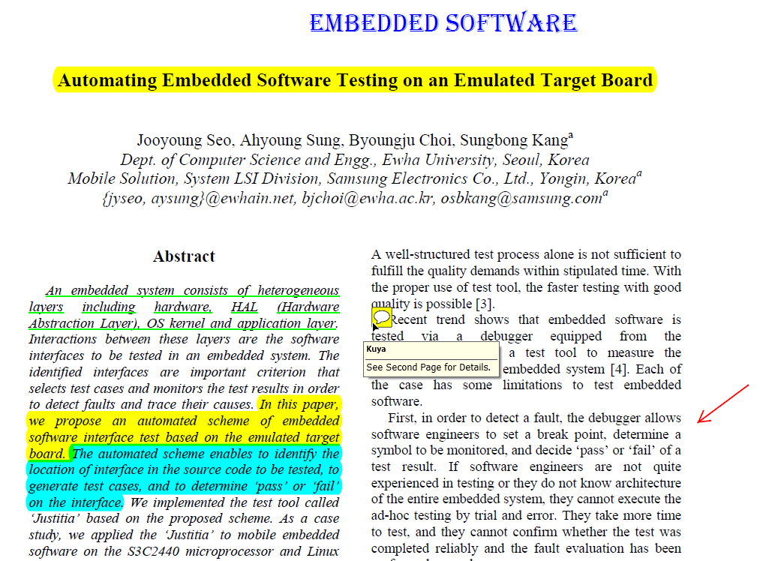
Edited with a PDF editor, screen capture with Snag-it.

Document Comparison
- Beyond Compare
  - Cost: standard = $30, Pro is $60. Can be installed on unlimited computer but only for the person who purchased the license. 30 day free trial.
  - Description: Compares the differences between files and folders.
  - Website: https://www.scootersoftware.com/index.php
  - Comments: Ok, the real power with this program is that it will compare word documents among many other file types including photos, text and excel workbooks. You will be writing and modifying your research documents many times. After a while they all begin to look alike. This program will highlight the differences between the 2 documents. I purchased the pro because I use some of the advanced features, but standard is all that is needed to do Microsoft word and excel comparisons.
  - This is what a document compare looks like. It highlights the change, and turns the text one side red so you can see what is different between the 2 documents.
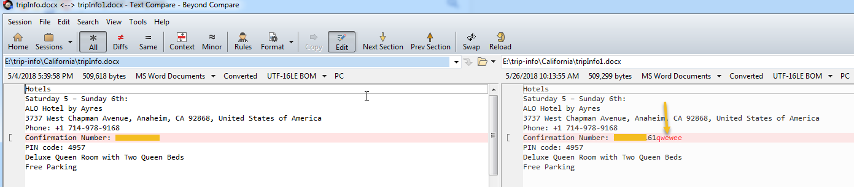

Document Repository and Version Control
When writing research papers, it is very common for people to create multiple copies of a paper as edits are made as well as saving the files in different locations on your computer. This is not efficient and causes problems in both finding the correct document and using the correct edited version. There is a much easier way to manage papers. I highly recommend an SVN repository. I can hold demo session on how to do this later. I have also been working on a how to document.
TortioseSVN: You can create a document repository on your computer. The power of this is to version your documents. There are also some free SVN repositories online that will allow you to synchronize your documents and have a working directory on your computer and a safe backup on line.
GitHub: is an online repository. Due to the public nature of this, I’d be careful about what you put up on GitHub. It is great for sharing.
Google Drive: is another good place to store documents online for easy access, but it does not version your documents. You can share your drive with others for collaboration.

Flash Cards
- Anki
  - Cost: Free
  - Description: Anki is a program which makes remembering things easy. Because it's a lot more efficient than traditional study methods, you can either greatly decrease your time spent studying, or greatly increase the amount you learn. Anyone who needs to remember things in their daily life can benefit from Anki. Since it is content-agnostic and supports images, audio, videos and scientific markup (via LaTeX), the possibilities are endless. The study cards remember what is easy or hard and adjusts the study material each day to reflect what needs to be reviewed.
  - Website: https://apps.ankiweb.net/
  - Comments: May not need this program for the degree but it will be useful for remembering Deaconate things. I use it to study many of the IT certifications I go after. You can find just about anything and its just as easy to create your own stack. Works really nice. This is a little study deck I have been making for all of the items we need to remember. I’ll make it available on GitHub once I’ve completed it.
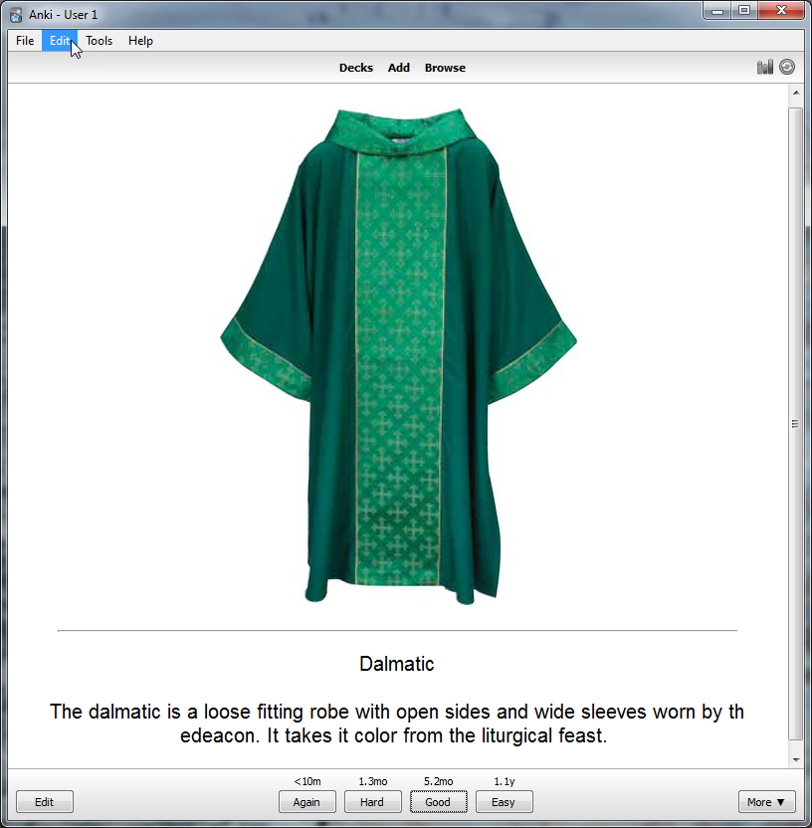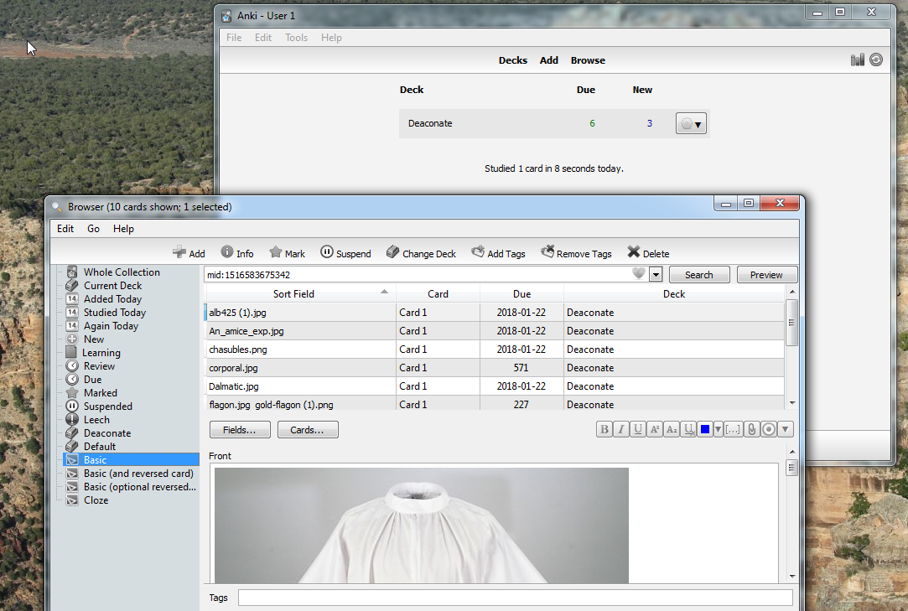
- OneNote: If you happen to have Microsoft OneNote installed with your Microsoft Office, this is good note book for recording and organizing your notes. I personally would not go buy it just for these classes.

