**Technological Institute of the Philippines**

**Quezon City**

Bachelor of Science in Computer Engineering

A Project Proposal Submitted to the Department of Computer Engineering in Partial Fulfilment of the Requirements for the Degree

**DMD Oragon**

By

Dalmacio, Aaron Christopher V.

Diaz, Adrian Gabriel T.

Matienzo, John Edward Sam T.

**Submitted To**

Engr. Royce Chua

October 09, 2019

**TABLE OF CONTENTS**

1. **CHAPTER 1 ……………………………………………………………………………**
2. **Project Background …………………………………………………………….**
3. **Statement of the Problem ………………………………………………………**
4. **Objectives …………………………………………………………………………**
5. **General Objectives …………………………………………………………..**
6. **Specific Objectives …………………………………………………………..**
7. **CHAPTER 2 ……………………………………………………………………………**
8. **Flowchart …………………………………………………………………………..**
9. **Algorithm …………………………………………………………………………..**
10. **Database Diagram ………………………………………………………………..**
11. **CHAPTER 3: Final Design …………...………………………………………………**
12. **Compressed Codes ……………………………………………………………….**
13. **CHAPTER 4: ………….…………………………………………………………………**
14. **Conclusion ………………………………………………………………………….**
15. **References ………………………………………………………………………….**
16. **Curriculum Vitae …………………………………………………………………..**

**CHAPTER 1 – PROJECT BACKGROUND**

**Project Background:**

Oragon is a clothing line business within Taytay City, Rizal owned by Rylin Mina and her co workers . Rylin Mina is doing full time management of their business . With the help of her staff, they manage the clothing line business by manual computing of all the stocks of the garments withing their inventory , computing of all expenses and incomes, and manual tabulations of the orders, deliveries, and receipt in their logbook. Since all of her duties are more done using manual, some of the tasks done are having errors. For example, their manual tabulations in their logbooks are lacking some data since they were not able to list the garments that were ordered. Due to that problem, their inventory are not updated and this will cause a lot of errors. As of now, they are still doing manual tabulation for their operation , however she and her staffs are working accurately as they can especially with their logbook and inventory in order to prevent unnecessary errors. With the help of a program / software , it would ease their operation and would lessen the time needed in doing records.

In addressing the problem , the programmers have interviewed the client on what would be her recommended design of the system and its database and all of the other comments that she requires.The programmers have designed and created a software with its database which would be very helpful for their clothing line business.

**Statement of the Problem:**

The problem is that Oragon still uses manual tabulation for their operation. Due to the manual tabulations in their transactions and inventory , errors in inputing data and values are prone to their system operations.

**Objectives:**

* **General Objective:**
* The objective of this project is to develop an automated program that will record all of the transaction, records and inventory.
* **Specific Objective:**
* The objective of this program is to create a system that is able to create , read , update and delete the products in the program itself and in its database.
* To be able to create a program that would display the specific type of garment the user wants to see.
* An objective of this project is to create a system that is able to record the orders of the customers.
* The last objective is to be able to track all of the deliveries of their products.

**CHAPTER 2 : Project Design**

**Flowchart:**

**Algorithm:**

**Database Design :**

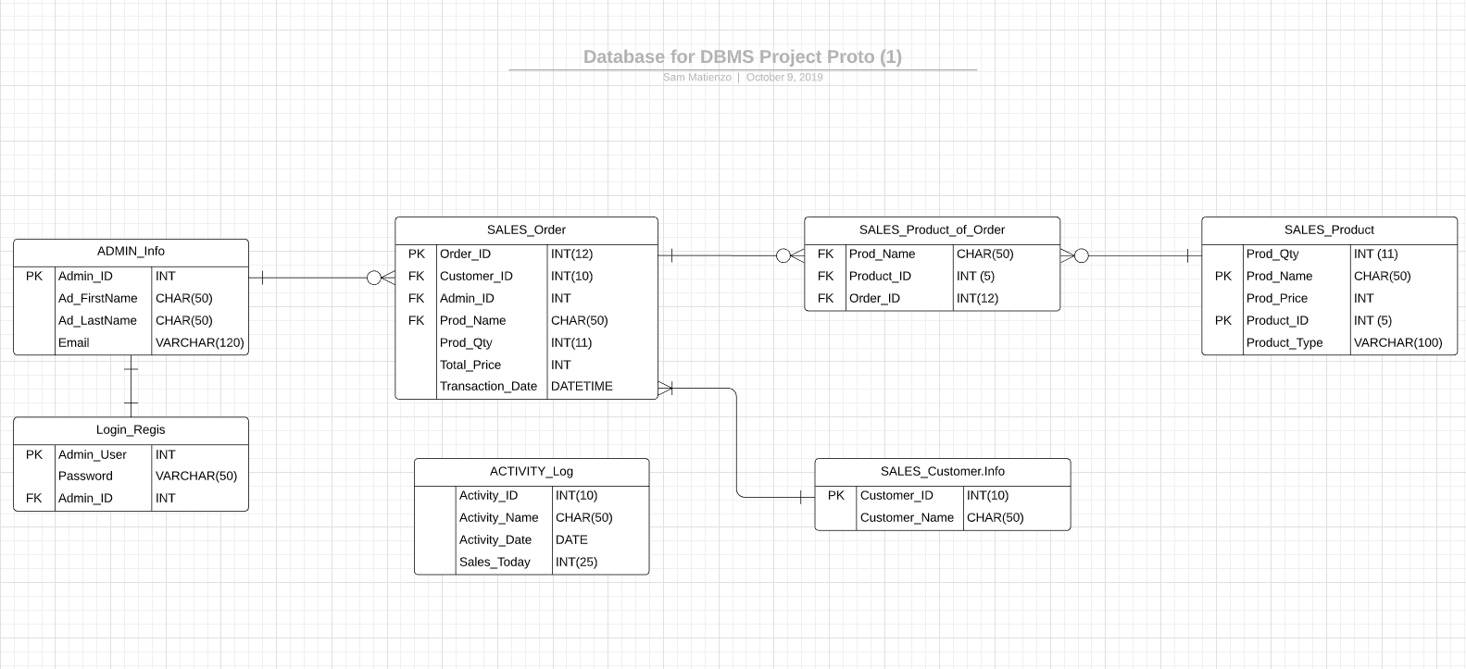

**Chapter 3: Final Design**

**Compressed Codes:**

**CHAPTER 4**

**Conclusions:**

In conclusion to this project , the programmers are able to create a software that will enable the client to access and log their stocks in an inventory system automatically. Another thing is that the programmers are successful in creating a software that will enhance the client to record the clients’ informations and deliveries automatically. The programmers have done it for the client in order to lessen their time consumption by having an automated inventory and delivery software rather than manually listing and recording their data. Lastly, is that they are successful in accurately following the wish lists and demands of the client regarding of the designs and other small components of the software that they created.