# Exercise: Position & Grid

## Simple Site Layout

Create a Web page, holding like the following:

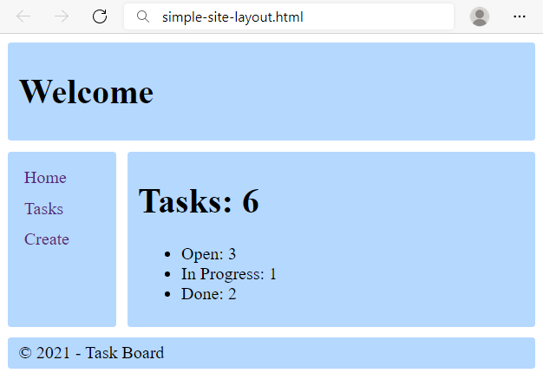

Use the texts from the filesite-texts.txt.

Create two files: simple-site-layout.html and styles.css.

Change the document title to "**Simple Site Layout**"

**Requirements**

<body> that contains: header, aside, main, footer all with:

* border-radius: **3px**;
* background: **rgb(181, 216, 255)**;
* padding: **5px 10px**;

The elements into the body:

* <header> with
  + <h1> text that is displayed as inline block and is vertically aligned in the middle;
* <aside>tag that contains:
  + <ul> tag for unordered list
    - list-style-type: **none**;
    - margin: **0px**;
    - padding: **5px**;
    - <li> tag for list item
      * <a> tag for hyperlink
        + display: block;
        + padding: 5px 0px;
        + color: rgb(86, 40, 129);
        + text-decoration: none;
* <main>tag that contain:
  + <h1> text title for the tasks
  + <ul> tag with:
    - <li> for the tasks with their status
* <footer>tag that contain:
  + <div> with copyright sign and text

### CSS Grid

In the styles.css:

* Make the body grid container by displaying the grid.
* Define two grid columns and their size. 100px for the first column and auto for the second.
* Define the grid areas: header, main, aside, footer.
* Reference the grid areas: "header header", "aside main", "footer footer".
* Set gap: 10px.

### Hints

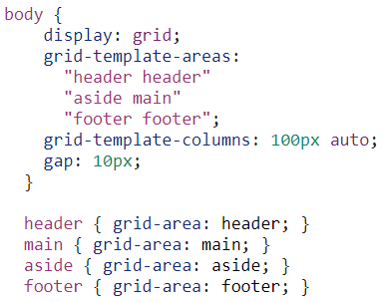

## Position Playground

Create a web page like the following:

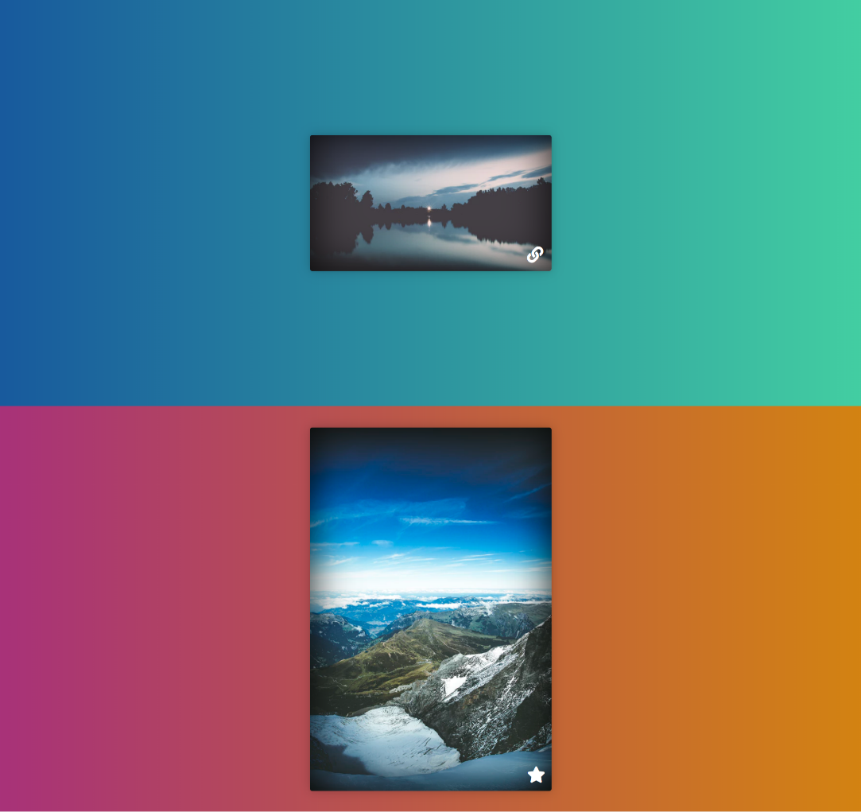

* Change the document title to "**Positioning Playground**"
* Import [Font Awesome](https://fontawesome.com/) into your **CSS** file

**Requirements**

* Add two container units **(**divs**)** with class viewport inside the body
  + Inside each one add section with class card *(*section.card*)*
    - Change the display property to block
    - Try to center the section with position property absolute

## Center Position and Transform

Create a web page like the following:

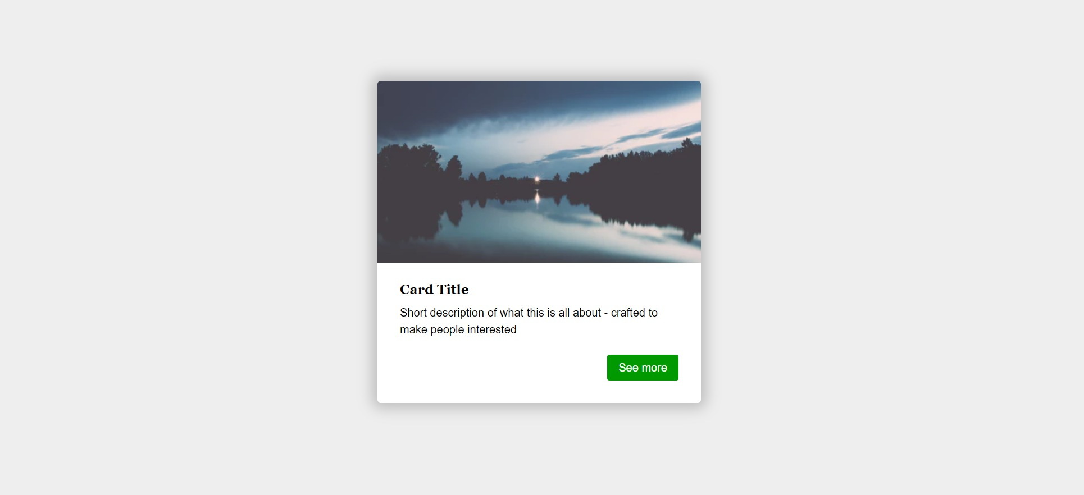

* Change the document title to "**Center Position and Transform**"

**Requirements**

* **Section** tag must have **class="card"**
* Create section with two divs
  + First div contains image
  + Second div contains**: <h3>**, **<p>** and **a** tags
* Use rgb(238, 238, 238) for body background
* Use rgb(255, 255, 255) for card background
* Use rgb(0, 153, 0) for card button background
* Use font Georgia, serif with size 1em/1.2 for the headings
* Set the image position property to absolute

## Navigation

Create a web page like the following:

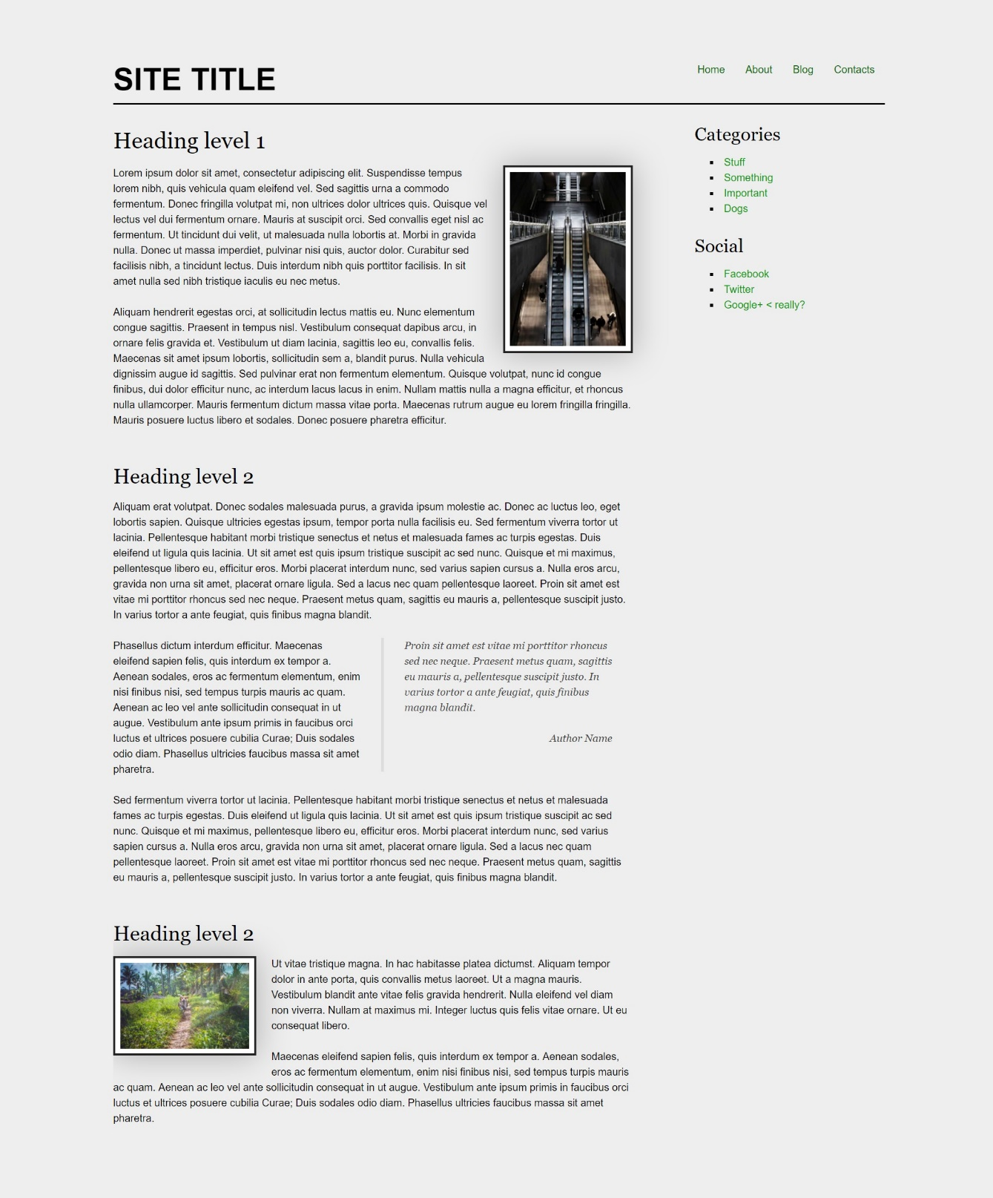

* Change the document title to "**Navigation**"

**Requirements**

* Create a header with a p for as title
  + Inside the header add a nav with a ul and 4 li elements
* Create a main, which contains an article with a header and h1 heading
  + Add a section inside the article
* Create an aside element with two sections inside
  + The sections should have a h3 heading and a navigation - nav with ul, li and a elements
* Use rgb(0, 102, 0) for the anchors
* Use rgb(238, 238, 238) for body background
* Use rgb(255, 255, 255) for image background and rgba(0, 0, 0, 0.25) for image box shadow
* Use font Georgia, serif for the blockquote
* Use font Georgia, serif with size 1em/1.2 for the headings

## New Offer

Create a web page like the following:

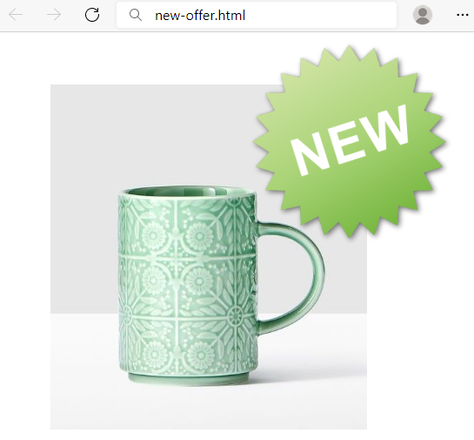

**Requirements**

HTML with <body> that contains <main> and two <img>.

<img> with new.png need class="new".

CSS:

* <main>:
  + Width: **700px**
  + Height: **500px**
  + Margins: **60px**
* img.new:
  + **Relative** position
  + Top coordinates: **-200px**
  + Right coordinates: **150px**

## Social Media Icons

Create a web page like the following:



* Change the document title to "**Social Media Icons**"
* Use FontAwesome to add social icons

**Requirements**

* All you need for your HTML are ul, li and a tags
* Change the ul display property to inline-block
* Remove list items default style
* Each a tag must have border-radius: 50%;
* Check the provided screenshots to see the hover effects

## Interior Design Studio

Create a webpage like the following:

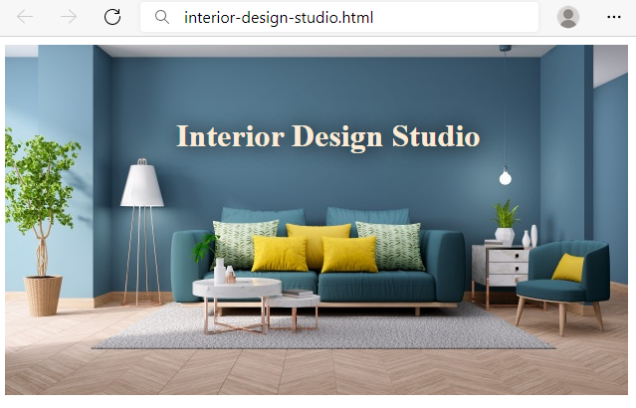

**Requirements**

HTML with <body> that contains <h1> and <img>.

CSS:

* <h1>
  + **Absolute** position
  + **Top** coordinates: **60px**
  + **Left** coordinates: **180px**
  + Text color: **antiquewhite**
  + text-shadow: 1px 1px 20px black;

## Jewellery Website

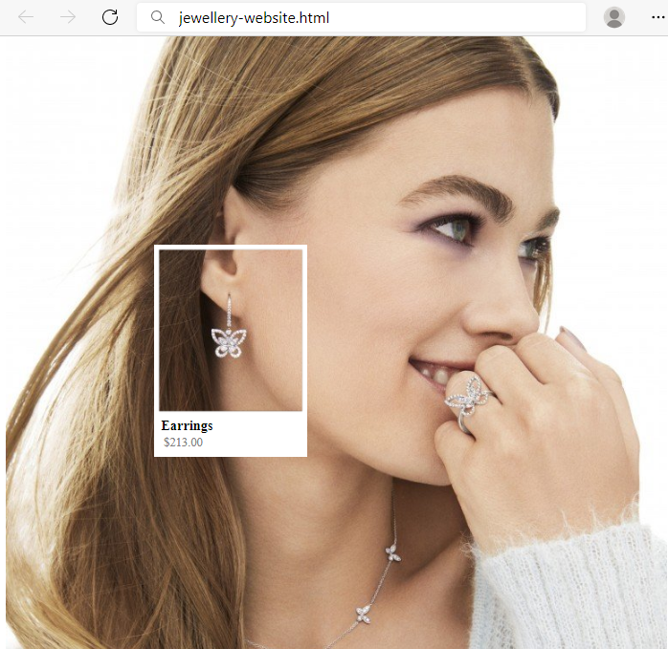

**Requirements**

You will be given a skeleton with **filled** **HTML** and an **empty** **CSS** file. Write the missing **CSS** following the guidelines in the task.

* <section>
  + Set the position to **absolute**
  + Use the **coordinates**: **250px** and **180px** to position the **frame** correctly
* <h3>
  + Font size: **16px**
  + Margin: **0px**
* <span>
  + Padding left: **3px**
  + Text color: **gray**
  + Font size: **14px**
* <div>
* Set the position to **relative**
* Use the **coordinates**: **50px** and **8px** to position the **text** correctly