**1. (3.5pts) Suppose that the following processes arrive for execution at the times indicated. Each process will run for the amount of time listed. In answering the questions, use non-preemptive scheduling, and base all decisions on the information you have at the time the decision must be made.**

|  |  |  |
| --- | --- | --- |
| Process | Arrival Time | Burst Time |
| P1 | 0.0 | 8 |
| P2 | 0.4 | 4 |
| P3 | 1.0 | 1 |

**a) What is the average turnaround time for these processes with the FCFS scheduling algorithm?**

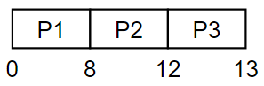

|  |  |  |  |  |
| --- | --- | --- | --- | --- |
| Process | Arrival Time | Burst Time | Turn-around time | Wait-time |
| P1 | 0.0 | 8 | 8 – 0 = 8 | 8 – 8 = 0 |
| P2 | 0.4 | 4 | 12 – 0.4 = 11.6 | 11.6 – 4 = 7.6 |
| P3 | 1.0 | 1 | 13 – 1 = 12 | 12 – 1 = 11 |

Average Turnaround time: $\frac{8+11.6+12}{3}=10.533$

**b) What is the average turnaround time for these processes with the SJF scheduling algorithm?**

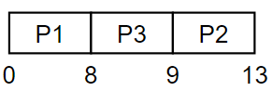

|  |  |  |  |  |
| --- | --- | --- | --- | --- |
| Process | Arrival Time | Burst Time | Turn-around time | Wait-time |
| P1 | 0.0 | 8 | 8 – 0 = 8 | 8 – 8 = 0 |
| P2 | 0.4 | 4 | 13 – 0.4 = 12.6 | 12.6 – 4 = 8.6 |
| P3 | 1.0 | 1 | 9 – 1 = 8 | 8 – 1 = 7 |

Average Turnaround time: $\frac{8+8+12.6}{3}=9.533$

**c) The SJF algorithm is supposed to improve performance, but notice that we chose to run process P1 at time 0 because we did not know that two shorter processes would arrive soon. Compute what the average turnaround time will be if the CPU is left idle for the first 1 unit and then SJF scheduling is used. Remember that processes P1 and P2 are waiting during this idle time, so their waiting time may increase. This algorithm could be called future-knowledge scheduling.**

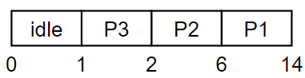

|  |  |  |  |  |
| --- | --- | --- | --- | --- |
| Process | Arrival Time | Burst Time | Turn-around time | Wait-time |
| P1 | 0.0 | 8 | 14 – 0 = 14 | 14 – 8 = 6 |
| P2 | 0.4 | 4 | 6 – 0.4 = 5.6 | 5.6 – 4 = 1.6 |
| P3 | 1.0 | 1 | 2 – 1 = 1 | 1 – 1 = 0 |

Average Turnaround time: $\frac{14+5.6+1}{3}=6.867$

**2. (3.5pts) Consider the following set of processes, with the length of the CPU burst given in milliseconds:**

|  |  |  |
| --- | --- | --- |
| **Process** | **Burst Time** | **Priority** |
| **P1** | **8** | **4** |
| **P2** | **6** | **1** |
| **P3** | **1** | **2** |
| **P4** | **9** | **2** |
| **P5** | **3** | **3** |

**The processes are assumed to have arrived in the order P1, P2, P3, P4, P5, all at time 0. Draw four Gantt charts that illustrate the execution of these processes using the following scheduling algorithms: FCFS, SJF, non-preemptive priority (a larger priority number implies a higher priority), and RR (quantum = 1). Calculate the average waiting time and turnaround time of each scheduling algorithm.**

**FCFS**

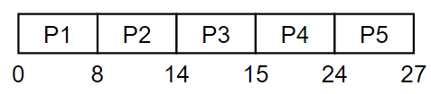

|  |  |  |  |  |
| --- | --- | --- | --- | --- |
| Process | Burst Time | Priority | Turn-around time | Wait time |
| P1 | 8 | 4 | 8 – 0 = 8 | 8 – 8 – 0 |
| P2 | 6 | 1 | 14 – 0 = 14 | 14 – 6 = 8 |
| P3 | 1 | 2 | 15 – 0 = 15 | 15 – 1 = 14 |
| P4 | 9 | 2 | 24 – 0 = 24 | 24 – 9 = 15 |
| P5 | 3 | 3 | 27 – 0 = 27 | 27 – 3 = 24 |

Average Turn-around time = $\frac{8+14+15+24+27}{5}=17.6$

Average Wait-time = $\frac{0+8+14+15+24}{5}=12.2$

**SJF**

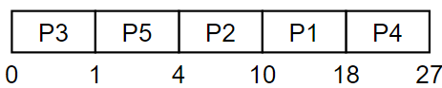

|  |  |  |  |  |
| --- | --- | --- | --- | --- |
| Process | Burst Time | Priority | Turn-around time | Wait time |
| P1 | 8 | 4 | 18 – 0 = 18 | 18 – 8 = 10 |
| P2 | 6 | 1 | 10 – 0 = 10 | 10 – 6 = 4 |
| P3 | 1 | 2 | 1 – 0 = 1 | 1 – 1 = 0 |
| P4 | 9 | 2 | 27 – 0 = 27 | 27 – 9 = 18 |
| P5 | 3 | 3 | 4 – 0 = 4 | 4 – 3 = 1 |

Average Turn-around time = $\frac{18+10+1+27+4}{5}=12$

Average Wait-time = $\frac{10+4+18+1}{5}=6.6$

**Non-preemtive priority**

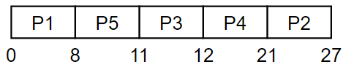

|  |  |  |  |  |
| --- | --- | --- | --- | --- |
| Process | Burst Time | Priority | Turn-around time | Wait time |
| P1 | 8 | 4 | 8 – 0 = 8 | 8 – 8 = 0 |
| P2 | 6 | 1 | 27 – 0 = 27 | 27 – 6 = 21 |
| P3 | 1 | 2 | 12 – 0 = 12 | 12 – 1 = 11 |
| P4 | 9 | 2 | 21 – 0 = 21 | 21 – 9 = 12 |
| P5 | 3 | 3 | 11 – 0 = 11 | 11 – 3 = 8 |

Average Turn-around time = $\frac{8+27+12+21+11}{5}=15.8$

Average Wait-time = $\frac{21+11+12+8}{5}=10.4$

**RR (timeslice = 1)**

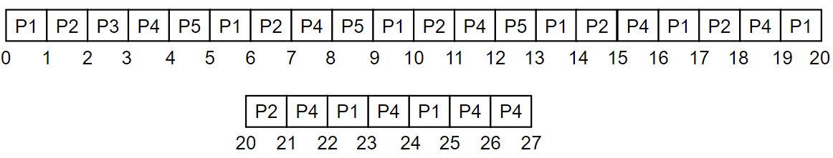

|  |  |  |  |  |
| --- | --- | --- | --- | --- |
| Process | Burst Time | Priority | Turn-around time | Wait time |
| P1 | 8 | 4 | 25 – 0 = 25 | 25 – 8 = 17 |
| P2 | 6 | 1 | 21 – 0 = 21 | 21 – 6 = 15 |
| P3 | 1 | 2 | 3 – 0 = 3 | 3 – 1 = 2 |
| P4 | 9 | 2 | 27 – 0 = 27 | 27 – 9 = 18 |
| P5 | 3 | 3 | 13 – 0 = 13 | 13 – 3 = 10 |

Average Turn-around time = $\frac{25+21+3+27+13}{5}=17.8$

Average Wait-time = $\frac{17+15+2+18+10}{5}=12.4$