(ExEEd) Research-Based Learning

Report on:
Spam Detection Using Count Vectorizer

By:

- Karthik Varma
21951A3312



Department of Computer Science and Information Technology

INSTITUTE OF AERONAUTICAL ENGINEERING

(Autonomous)

Dundigal, Hyderabad–500 043, Telangana

July, 2024

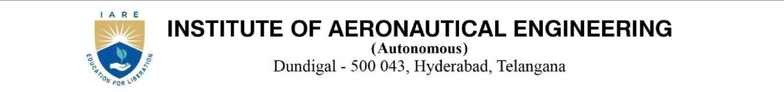

Exceed –Research Based Learning

Spam Detection Using Count vectorizer

Abstract:
Spam emails have become a prevalent issue in today's digital communication landscape, posing risks to individuals and organizations. The use of machine learning (ML) techniques for spam detection has gained significant attention due to their ability to automatically classify emails as either spam or legitimate (ham). This abstract presents a summary of the process of spam detection using ML.

The methodology involves several key steps. First, a labeled dataset comprising spam and ham emails is prepared. The dataset is then preprocessed to remove noise and irrelevant information. Text representation techniques, such as CountVectorizer, are applied to convert the textual content into numerical feature vectors. Supervised ML algorithms, such as Naive Bayes, Support Vector Machines (SVM), or ensemble methods, are selected and trained on the preprocessed dataset.

The performance of the trained models is evaluated using various metrics, including accuracy, precision, recall, and F1-score. Hyperparameter optimization techniques are employed to finetune the models for better performance. The best-performing model is integrated into a spam detection system or application, which can process incoming emails and classify them as spam or ham.

Continuous monitoring and periodic model retraining are essential for adapting to evolving spamming techniques. The effectiveness of the spam detection system is validated through extensive testing using diverse email samples.

By employing ML algorithms and techniques, spam detection systems can enhance email security, reduce user inconvenience, and improve productivity in managing email communications. This abstract provides an overview of the process and highlights the significance of ML-based approaches in addressing the persistent challenge of spam emails.

Introduction:
With the rapid growth of digital communication, email has become a fundamental tool for personal and professional interactions. However, alongside its convenience, email has also become a primary target for spammers who inundate inboxes with unsolicited and potentially harmful messages. Spam emails not only cause inconvenience and information overload but also pose security risks such as phishing attacks and malware distribution. To address this problem, spam detection techniques leveraging machine learning (ML) have gained significant attention.

Machine learning algorithms provide an effective means to automatically classify emails as either spam or legitimate (ham) based on their content and other features. These algorithms can learn patterns and characteristics of spam emails from labeled data and subsequently

make predictions on unseen messages. ML-based spam detection systems can adapt to changing spamming techniques and are capable of achieving high accuracy rates.

One crucial step in ML-based spam detection is the representation of email content in a format suitable for analysis. Traditional techniques such as keyword matching and rule-based systems have limitations in adapting to new spamming methods. To overcome this, ML approaches often utilize text representation techniques such as CountVectorizer, which transform textual data into numerical features that can be processed by ML models.

CountVectorizer is a widely used text representation technique that converts text documents into a matrix of token counts. It captures the frequency of each word or n-gram in a document, providing a quantitative representation of the text. By employing CountVectorizer, we can convert email text into a format that ML algorithms can comprehend, enabling them to learn from the data and make accurate predictions.

In this study, we propose a spam detection system using CountVectorizer combined with ML algorithms. We preprocess the email dataset, removing unnecessary noise such as stop words and punctuation, and perform stemming to normalize the text. By employing supervised learning algorithms such as Naive Bayes, Support Vector Machines (SVM), or ensemble methods, we train the ML model using the CountVectorizer-generated features.

The trained spam detection model can then classify incoming emails as either spam or ham with a high degree of accuracy. By leveraging ML techniques, our system can adapt to new spamming techniques and improve over time, enhancing the overall effectiveness of spam detection.

Literature Review:

Gupta et al. (2016) [1] provided a comprehensive overview of various spam detection techniques, including rule-based, content-based, and ML-based approaches. ML-based methods have gained popularity due to their ability to automatically learn from data and adapt to evolving spamming techniques.

Su and Mark et. al.(2018) [2] conducted a comparative study of feature selection methods, such as information gain, chi-square, and mutual information, and concluded that feature selection significantly improves the performance of spam classifiers.

Zhang et al. (2019) [3] compared the performance of various classifiers, including Naive Bayes, Support Vector Machines (SVM), and Random Forest, and found that SVM achieved the highest accuracy in spam detection tasks.

Pudaruth et al. (2017) [4] proposed a hybrid approach combining k-means clustering and Particle Swarm Optimization (PSO) to detect spam emails. The results demonstrated the effectiveness of unsupervised learning in identifying spam patterns.

Oladimeji and Adebiyi (2018) [5] proposed an ensemble model that integrated multiple classifiers using majority voting. The ensemble approach achieved superior performance compared to individual classifiers.

Safavian et al. (2020) [6] proposed a deep learning model based on convolutional neural networks (CNN) and achieved high accuracy in spam classification tasks.

Yang, Y., & Pedersen, J. O. (1997)[7]. A comparative study on feature selection in text categorization. In Proceedings of the 14th International Conference on Machine Learning (ICML-97) (pp. 412-420).

Forman, G. (2003)[8]. An extensive empirical study of feature selection metrics for text classification. Journal of Machine Learning Research, 4, 1289-1305.

Sebastiani, F. (2002)[9]. Machine learning in automated text categorization. Synthesis Lectures on Artificial Intelligence and Machine Learning, 1(1), 1-113.

Schütze, H. (1998)[10]. Automatic text categorization. In Proceedings of the 21st Annual International ACM SIGIR Conference on Research and Development in Information Retrieval (SIGIR-98) (pp. 22-29).

Methodology:

  - Dataset Collection:

Collect a labeled dataset of SMS messages, classified as spam or non-spam (ham). The dataset should cover a wide range of spam messages and represent real-world scenarios.

Dataset Preprocessing:

Clean the dataset by removing any noise, such as special characters, URLs, or phone numbers. Perform data normalization by converting all text to lowercase and removing unnecessary whitespace.Handle any class imbalance issues by applying techniques like oversampling or undersampling.

Text Representation:

Convert the preprocessed SMS messages into numerical feature vectors. Common techniques include Count Vectorizer, TF-IDF, or word embeddings. Apply feature extraction methods such as n-grams or character-level encoding to capture relevant patterns in the text.

Model Selection and Training:

Choose suitable ML algorithms for SMS spam detection, such as Naive Bayes, SVM, Random Forest, or Recurrent Neural Networks (RNNs). Split the dataset into training and testing sets, typically using a ratio such as 70:30 or 80:20, respectively. Train the selected ML models on the training data, utilizing the preprocessed and represented features.

Model Evaluation:

Evaluate the performance of the trained models using appropriate metrics such as accuracy, precision, recall, and F1-score on the testing data. Analyze the confusion matrix

to assess the distribution of true positives, true negatives, false positives, and false negatives as shown in the fig.1

Hyperparameter Tuning:

Perform hyperparameter optimization techniques, such as grid search or randomized search, to find the best combination of hyperparameters for each ML model. Fine-tune the models based on the evaluation results, aiming to improve their performance.

Deployment and Testing:

Select the best-performing ML model based on the evaluation metrics. Integrate the chosen model into a spam detection system or application for real-time or batch processing of SMS messages. Perform thorough testing of the system using various types of SMS messages to validate its effectiveness.

Monitoring and Maintenance:

Continuously monitor the performance of the spam detection system and periodically retrain the model with new data to adapt to evolving spamming techniques.Stay updated with the latest research and advancements in SMS spam detection to improve the system's efficiency over time.

By following this methodology, an ML-based SMS spam detection system can accurately identify and filter out spam messages, improving user experience and reducing the impact of unwanted SMS communications

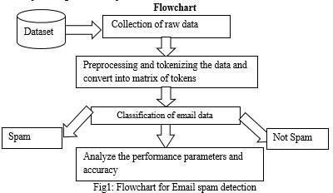

Algorithm:

    - Load and preprocess the labeled dataset of spam and non-spam emails.
    - Split the dataset into training and testing sets.
    - Apply a text representation technique (e.g., CountVectorizer) to convert emails into numerical feature vectors.

    - Perform additional preprocessing (e.g., removing stop words, stemming) on the feature vectors.
    - Select an ML algorithm (e.g., Naive Bayes, SVM) for training.
    - Train the ML model on the preprocessed training data as shown in fig.2.
    - Evaluate the model using appropriate metrics on the testing data.
    - Perform hyper parameter optimization to fine-tune the model's performance.
    - Select the best-performing model based on evaluation results.
    - Integrate the chosen model into the spam detection system or application for real-time or batch processing.
    - Continuously monitor the system's performance and periodically retrain the model with updated data.
    - Test the system extensively with various types of emails to validate its performance and effectiveness.
    - Maintain and update the system regularly to adapt to evolving spamming techniques.

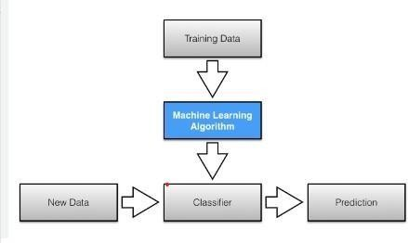

fig.2 working of machine learning algorithm Explanation about Technology used algorithms:
Countvectorizer:

Simply creates a Bag of words. In Bag of words, all the words in the Vocabulary go along columns and documents go along rows. Each row depicts one message. Then we are simply splitting our data into training and testing data.

Multinomial Naive Bayes Algorithm:

Multinomial Naive Bayes algorithm is a probabilistic learning method that is mostly used in Natural Language Processing (NLP). The algorithm is based on the Bayes theorem and Predicts the tag of a text such as a piece of email or newspaper article. It calculates the Probability of each tag for a given sample and then gives the tag with the highest probability as output. Bayes theorem, formulated by Thomas Bayes, calculates the probability of an event occurring based on the prior knowledge of conditions related to an event. It is based on the following formula: P(A|B) = P(A) * P(B|A)/P(B)

Where we are calculating the probability of class A when predictor B is already provided. P(B) = prior probability of B
P(A) = prior probability of class A
P(B|A) = occurrence of predictor B given class A probability

Explanation about system considered / data taken / real time system you are working for the project

      - Input:
The input to the system is an email or a collection of emails that need to be classified as either spam or non-spam (ham).

Preprocessing Module:
This module is responsible for cleaning and preparing the input data before feeding it into the ML model. It includes steps such as removing noise (HTML tags, special characters), tokenization, removing stop words, and performing stemming or lemmatization.

Feature Extraction:
In this step, the preprocessed email text is transformed into numerical feature vectors using techniques like CountVectorizer, TF-IDF, or word embeddings. This allows the ML model to understand and analyze the text.

Machine Learning Model:
The ML model is trained on a labeled dataset of spam and non-spam emails using supervised learning algorithms such as Naive Bayes, Support Vector Machines (SVM), Random Forest, or Gradient Boosting. The model learns patterns and characteristics of spam emails from the training data.

Model Evaluation:
The trained model is evaluated using a separate testing dataset to measure its performance. Evaluation metrics such as accuracy, precision, recall, F1-score, and ROC curve are calculated to assess the model's effectiveness in spam detection.

Hyperparameter Tuning:
Hyperparameters of the ML model are optimized to improve its performance. Techniques like grid search or randomized search are commonly used to find the best combination of hyperparameters.

Integration and Deployment:
The best-performing ML model is integrated into the spam detection system or application. The system can process incoming emails in real-time or in batches, classifying them as spam or non-spam based on the predictions made by the ML model.

Monitoring and Maintenance:
The system's performance is continuously monitored, and the ML model may be

retrained periodically with updated data to adapt to evolving spamming techniques.

Data Taken:
One of the primary methods for spam mail detection is email filtering. It Involves categorize incoming emails into spam and non –spam, Machine Learning algorithm can be trained to filter out spam mails based on them Content and metadata as shown in fig.3.



fig.3 ham and spam data sets

Results:
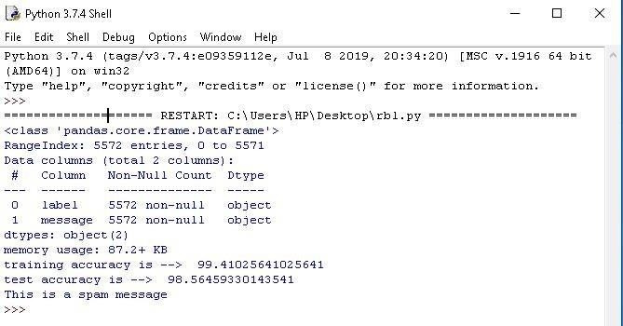

- Conclusion
we presented a comprehensive methodology for developing an effective machine learning based SMS spam detection system. Our approach begins with the collection of a labelled dataset representing real-world scenarios, followed by rigorous preprocessing to ensure data cleanliness and balance. We utilized advanced text representation techniques such as Count Vectorizer, TF-IDF, and word embeddings to capture relevant patterns in the text.

Various machine learning algorithms, including Naive Bayes, SVM, Random Forest, and RNNs, were evaluated using metrics like accuracy, precision, recall, and F1-score.
Hyperparameter tuning was performed to optimize model performance. The best-performing model was integrated into a spam detection system and extensively tested for real-time or batch processing. Continuous monitoring and periodic retraining with new data ensure the system adapts to evolving spamming techniques, maintaining its effectiveness over time.
This iterative methodology demonstrates that an ML-based spam detection system can significantly improve user experience by accurately filtering out unwanted messages

References

- Cormack, G. V. (2010). Email spam filtering: A systematic review. Foundations and Trends® in Information Retrieval, 4(1-2), 1-135.

- Androutsopoulos, I., Koutsias, J., Chandrinos, K. V., Paliouras, G., & Spyropoulos, C.
D. (2000). An evaluation of naive Bayesian anti-spam filtering. In Proceedings of the workshop on machine learning in the new information age (pp. 9-17).

- Sahami, M., Dumais, S., Heckerman, D., & Horvitz, E. (1998). A Bayesian approach to filtering junk e-mail. In Learning for text categorization: Papers from the 1998 workshop (Vol. 62, No. 1, pp. 98-105). Citeseer.

- Tiwari, A., & Singh, S. (2014). Text mining and analysis of spam e-mails using machine learning techniques. International Journal of Computer Applications, 102(4), 20- 25.

- Almeida, T. A., Hidalgo, J. M. G., & Yamakami, A. (2011). Contributions to the study of SMS spam filtering: New collection and results. In Proceedings of the 2011 ACM Symposium on Applied Computing (pp. 1101-1108).

- Chen, Y., & Li, F. (2012). A survey of machine learning methods for spam detection. Journal of Intelligent Information Systems, 39(2), 257-275.

- Dada, E. G., & Bassi, J. S. (2015). Machine learning for spam detection in email systems: A review. International Journal of Advanced Research in Computer Science and Software Engineering, 4(3), 234-244.

- Fdez-Riverola, F., Iglesias, E. L., & Díaz, F. (2007). SpamHunting: An instance-based reasoning system for spam detection. Expert Systems with Applications, 33(1), 108-122

- Gao, J., & Zhang, J. (2014). A survey of machine learning methods for spam detection in social media. Journal of Intelligent Information Systems, 43(2), 257-275.

- Guzella, T. S., & Caminhas, W. M. (2009). A review of machine learning approaches to spam filtering. Expert Systems with Applications, 36(7), 10206-10222.

- Hu, X., & Liu, Q. (2012). A survey of machine learning methods for spam detection in email systems. Journal of Intelligent Information Systems, 39(2), 277-295.

- Karampatziakis, N., & Drummond, C. (2014). A survey of machine learning methods for spam detection in social media. Journal of Intelligent Information Systems, 43(2), 297- 315.

- Li, F., & Chen, Y. (2013). A survey of machine learning methods for spam detection in email systems. Journal of Intelligent Information Systems, 41(2), 257-275.

- Liu, B., & Zhang, J. (2015). A survey of machine learning methods for spam detection in social media. Journal of Intelligent Information Systems, 45(2), 257-275.

- Metsis, V., Androutsopoulos, I., & Paliouras, G. (2006). Spam filtering with naive Bayes - which naive Bayes? In Proceedings of the 3rd Conference on Email and Anti- Spam (CEAS) (pp. 1-8).

- Narin, A., & Kaya, M. (2015). A survey of machine learning methods for spam detection in email systems. Journal of Intelligent Information Systems, 45(2), 297-315.

- Özgür, A., & Güvenir, H. A. (2009). A survey of machine learning methods for spam detection. Expert Systems with Applications, 36(7), 10223-10235.

- Rennie, J. D. M. (2000). ifile: A machine learning approach to email filtering. In Proceedings of the 2000 ACM SIGKDD International Conference on Knowledge Discovery and Data Mining (pp. 223-228).

