**DBMS Assignment 4 Report**

Group Members:

* Yashit Maheshwary – 2016123
* Kaustav Vats – 2016048

SQL Queries:

* **Simple Queries**

1. **Register**: *INSERT INTO users VALUES(NULL, '<name>','<email>','<password>','<join_date>','<user_type>');*
2. **Login**: *SELECT * FROM users WHERE email = '<email>' AND password = '<password>'*
3. **Update Customer Profile**: *INSERT INTO customers VALUES(NULL, <userId>, <membership_plan_id>, '<address>', <age>, <weight>);*
4. **Update Staff Profile**: *INSERT INTO staff VALUES(NULL, <userId>, '<address>',<salary>);*
5. **Add** **Equipment***: INSERT INTO equipment VALUES(NULL, '<name>','<price>','<date>','<type>');*
6. **View All Equipments**: *SELECT * FROM equipment*

* **Complex Queries**

1. **View Customer Profile**: *SELECT * FROM customers INNER JOIN users ON* *customers.user_id = users.id WHERE customers.user_id = <userID>*
2. **View Staff Profile**: *SELECT * FROM staff INNER JOIN users ON staff.user_id = users.id WHERE staff.user_id = <userID>*
3. **View All Customers with Particular Membership**: *SELECT * FROM users INNER JOIN customers ON users.id = customers.user_id INNER JOIN membership_plan ON customers.membership_plan_id = membership_plan.id WHERE users.user_type = 'Customer' AND customers.membership_plan_id = <plan_id>*
4. **View All Customers**: *SELECT * FROM users INNER JOIN customers ON users.id = customers.user_id INNER JOIN membership_plan ON customers.membership_plan_id = membership_plan.id*
5. **View All Staff**: *SELECT * FROM users INNER JOIN staff ON users.id = staff.user_id WHERE users.user_type = 'Staff'*

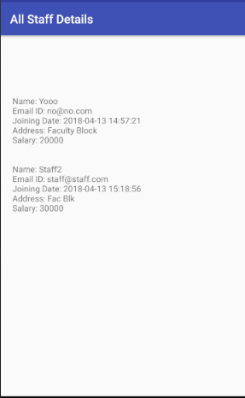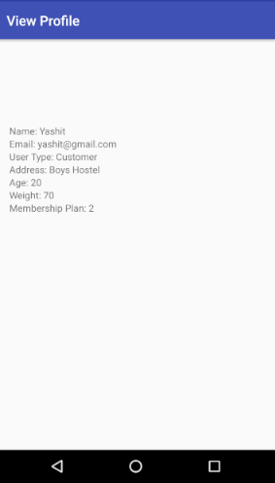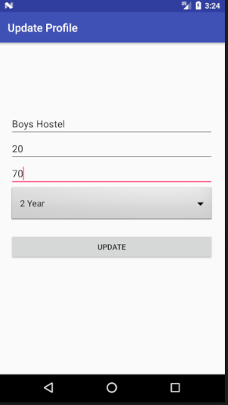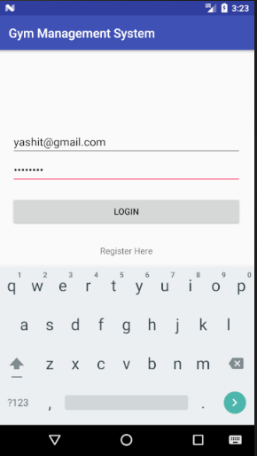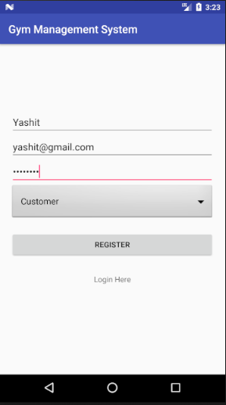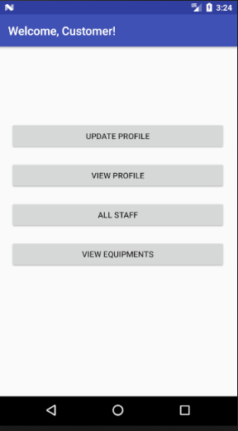Customer Snapshots 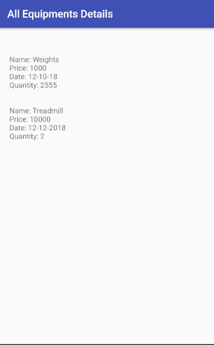

Staff Snapshots

