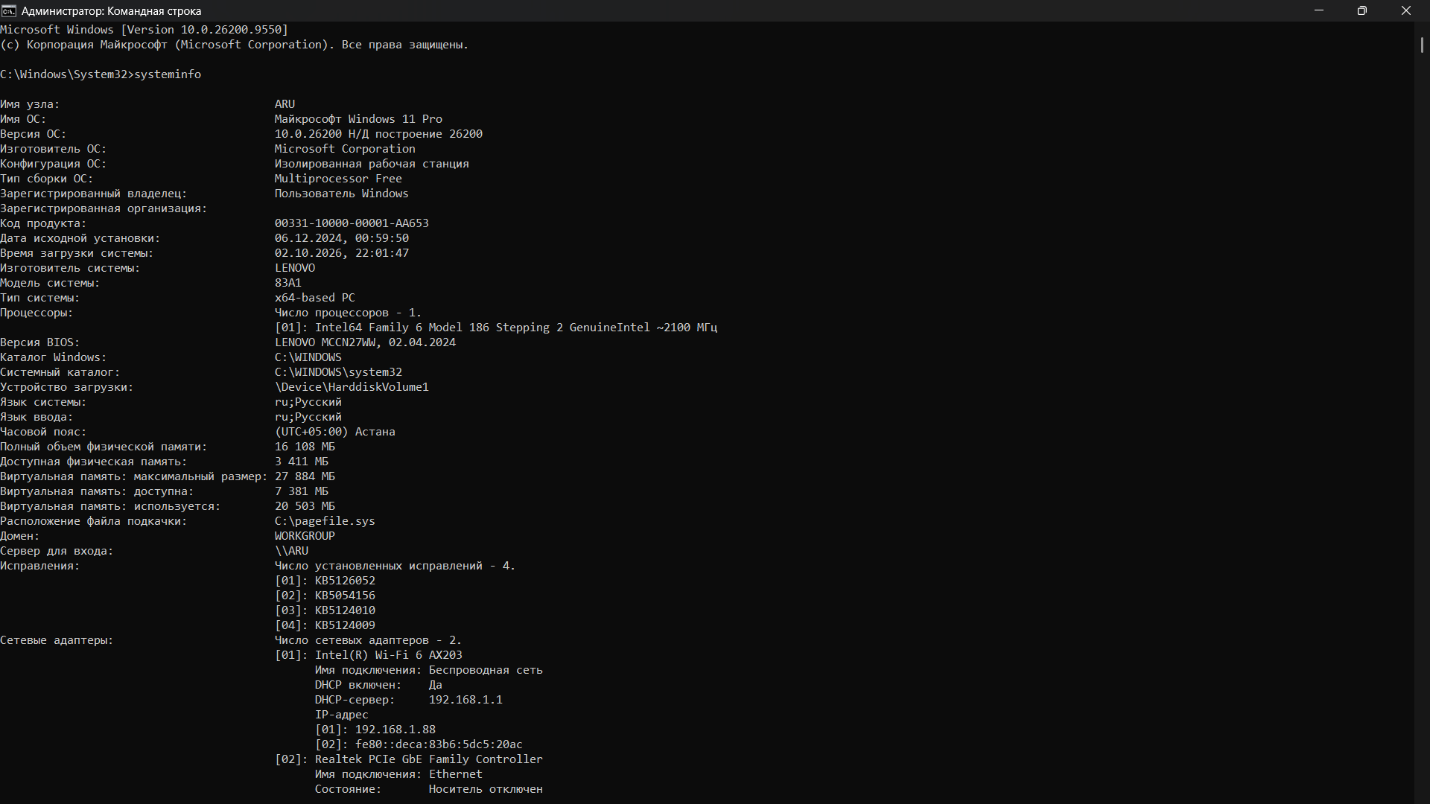
I opened cmd and entered “systeminfo” for display my configuration overall. I have 16108Mb in total on disk which have 3411 free mb.
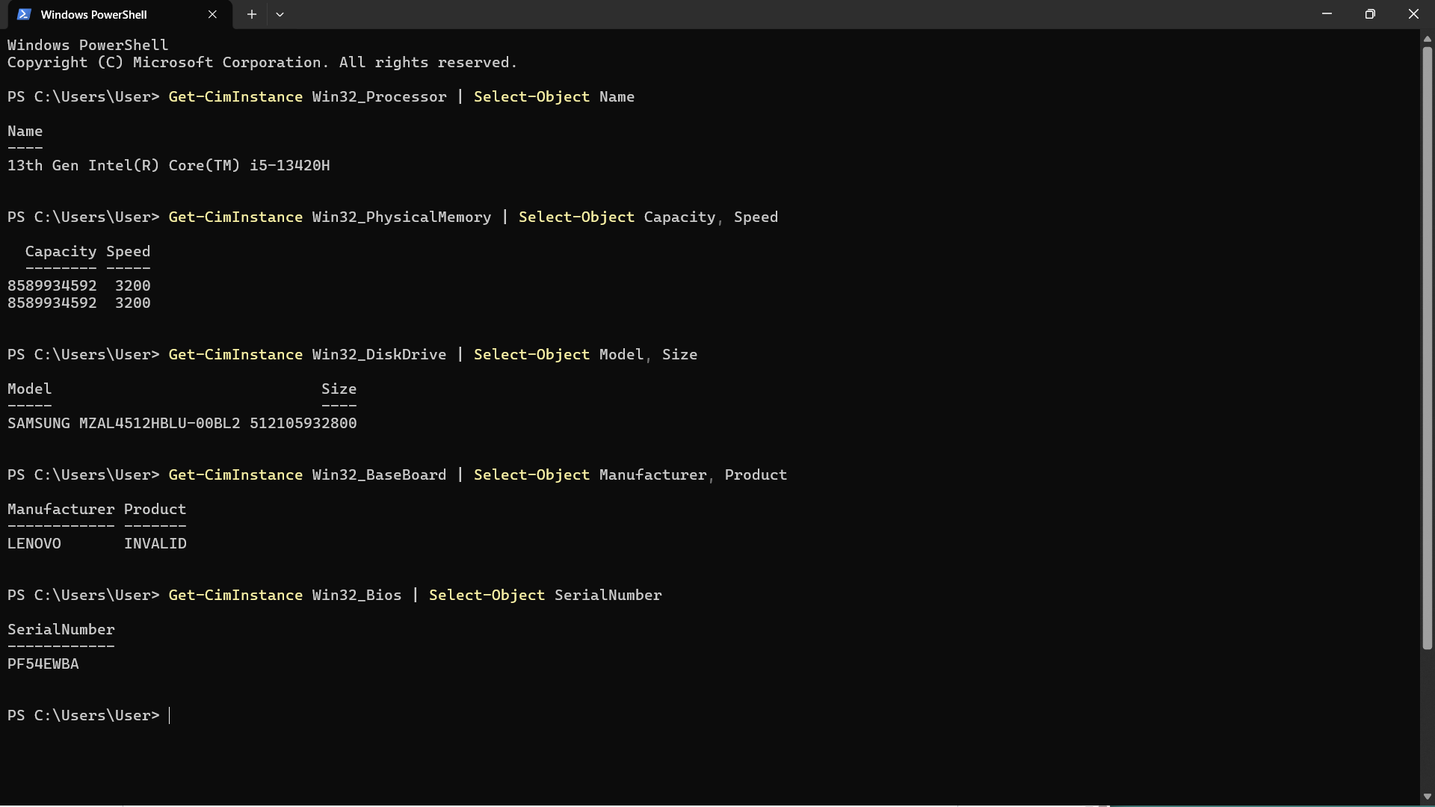
Then I opened PowerShell for more accurate stats.
1.Get-CimInstance Win32_Processor | Select-Object Name
For processor stats:13th Gen Intel(R) core(TM) i5-13420H
2. Get-CimInstance Win32_PhysicalMemory | Select-Object Capacity, Speed
Shows RAM size and speed
3. Get-CimInstance Win32_DiskDrive | Select-Object Model, Size
Storage Drives (SSD / HDD) info
4. Get-CimInstance Win32_BaseBoard | Select-Object Manufacturer, Product
Motherboard details
5. Get-CimInstance Win32_Bios | Select-Object SerialNumber
PC serial number

