WEDE5020
Kabelo Teffo (ST10477855)
Group 1
1st Proposal
Name: Rise & Root (Youth empowerment and sustainable farming)
The Rise & Root NGO is focused on empowering young people through sustainable agriculture and agribusiness training. The website of such an NGO would need to support recruiting the youth as well as fundraising from donors.
The general goals of the website are to bring on board unemployed youth to submit applications, inform communities about events, and share success stories that invite others to participate. The second critical goal is to invite donations and collaborations through impact promotion. The main performance metrics of the site are online applications received, donations given, reports downloaded, and referrals to agricultural resources.
Since Rise & Root does not currently have a website, there are no weaknesses to address. This project does create the chance to design a new and effective site that places emphasis on youth-friendly layout, clear information, and smartphone usability.
The site will contain the following major components: a home page, an about us page, program details, application form, an events calendar, news or blog page, a gallery for images and videos, a donation page, and a contact page.
The design will have a natural and light colour palette with green and brown tones for farming and growth. Design and typography will be simple with a readable sans-serif font for readability and hierarchy for headings and body text. Layout and design will focus on easy navigation with simple menus, gigantic buttons, and space to tell stories. The user experience must be simple, with easy navigation on both desktop and mobile.
Technically speaking, the site may be developed using HTML, CSS, and JavaScript, hosted on a shared server with a domain name such as riseandroot.org. There is also the option to use a simple CMS such as WordPress for minor updates.
The project timeline is three months. One month is for research and wireframes, the second month for design and development, and the final month for test and launch.
The budget breakdown is R35,000 covering domain registration, hosting, web development, design, training, and maintenance.
The site will facilitate Rise & Root's mission by connecting the youth with possibility, building donors' trust, and making their efforts known globally.

2nd Proposal
Name: South African National Blood Service (Life-saving donations and healthcare support)
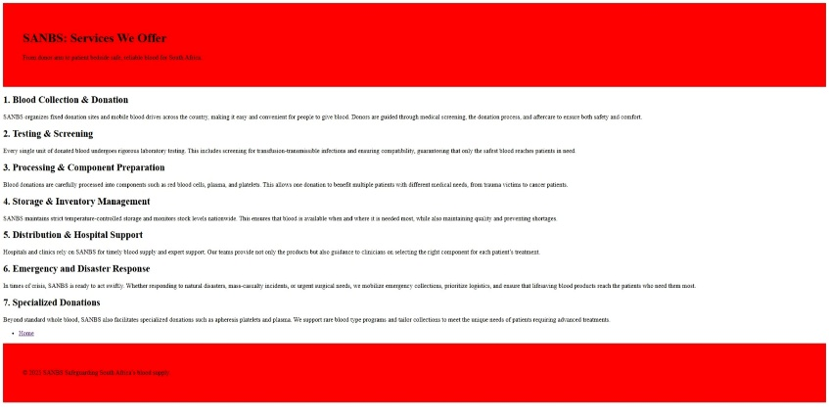
The South African National Blood Service (SANBS) is a nonprofit organization that plays a fundamental role in saving lives all over South Africa. It has the mandate of collecting, testing, and supplying safe blood and blood products in eight of the country's nine provinces, with the Western Cape covered by a separate blood service. SANBS collects more than one million units of blood every year, and it is feasible that one donation can save three lives since it can be fractionated into red blood cells, plasma, and platelets. They aspire to be the cornerstone of healthcare in South Africa, and their mission is to deliver dependable and quality blood products with efficiency and accountability.
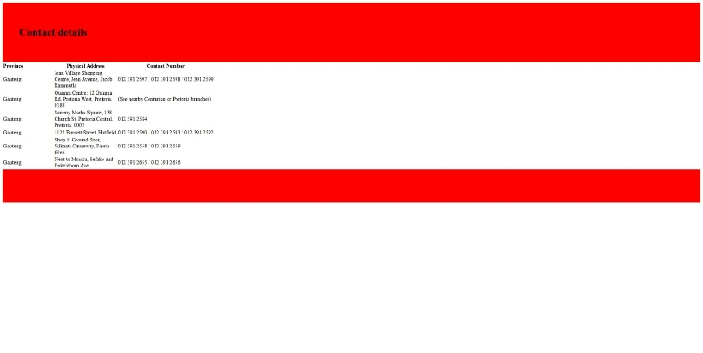
A SANBS new website would seek to assert its mission by making blood donation and access easier. One of the main goals would be to see more donors. This would be done through the offering of a convenient process for one to become a donor, book an appointment, and find donating centre’s closest to them. Another very essential goal would be raising awareness. Such campaigns as "We Are the Pulse" can be advertised on the website, along with live updates in terms of the amount of blood stock, so that people understand the urgency of donation. The website would also be used to build trust and transparency through sharing impact statistics, accreditations, and testimonials of how donations change lives.
The success of the site could be measured by some quantitative measures. These would include the numbers of new and repeat donors registering on the site, the number of appointments scheduled on the site, visits to the campaign page, and the interactions with educational materials. Greater donations and online donations would also reflect how successful the site had been in reaching out to individuals.
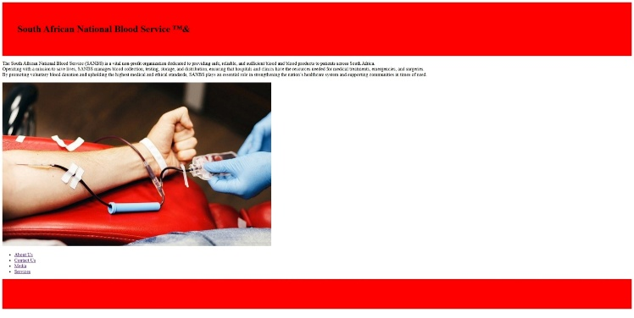
The site must be a clean, user-friendly design. Red and white are powerful colours and would convey health and urgency, and plain fonts would enable the text to be legible. The major features would include a homepage that shows the level of blood stock, a booking and registration system, and an interactive donor centre and mobile blood drive map. Campaign pages, donor stories, and news feeds would add to the community and trust vibe.
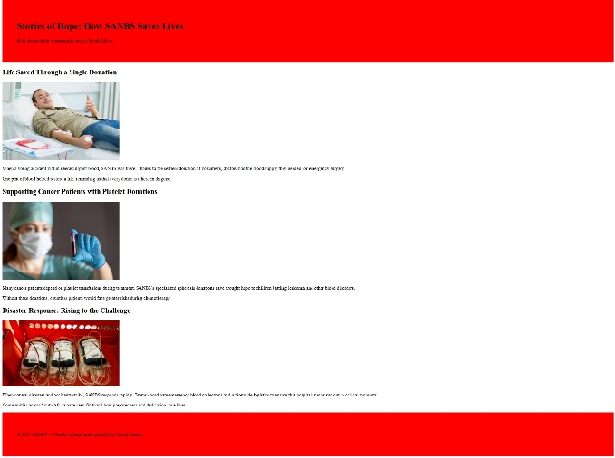
With secure hosting, encryption of donor data, and integration into internal SANBS systems, the site would be technically sound and secure. The project would last approximately four months and cost approximately R60,000 in design, development, integration, and upkeep.
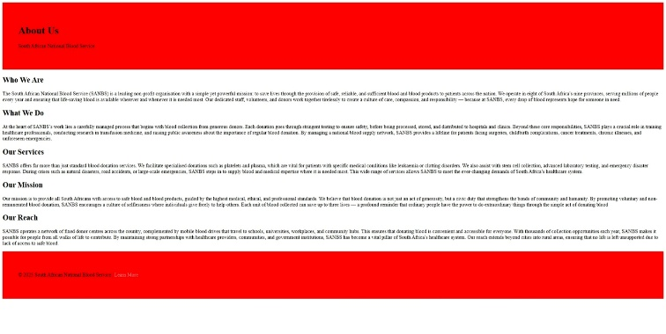
SANBS would be able to engage more people, raise awareness, and make life-saving blood easily accessible when South Africa needs it most with this website.

Wireframe
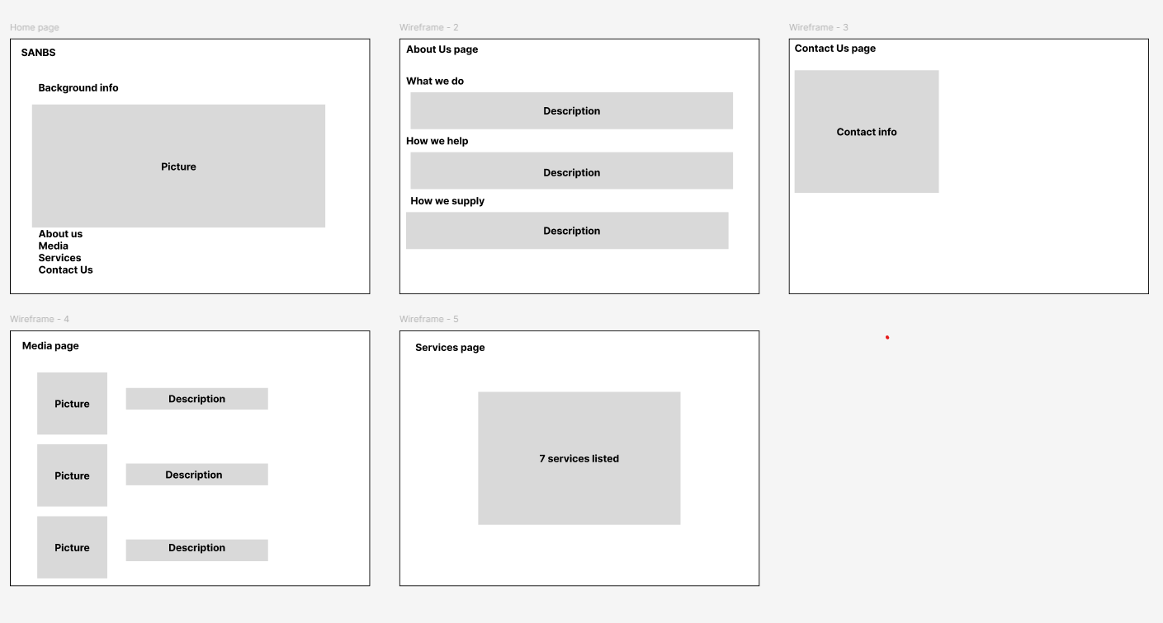

Sitemap
