**Biochemistry of ectomycorrhizal fungal necromass predicts decomposition across different vegetation communities and plant-mycorrhizal associations**

**Authors**: Katilyn V. Beidler1*, Erin Andrews2, Chris W. Fernandez2, Ryan M. Mushinski3, Richard P. Phillips1, Craig See2 and Peter G. Kennedy2.

**Affiliations:**

1. Department of Biology, Indiana University, Bloomington IN USA
2. Department of Plant Biology, University Minnesota, Twin Cities, MN, USA
3. School of Public and Environmental Affairs, Indiana University, Bloomington, IN, USA

Background

Ectomycorrhizal (EcM) fungi form a continuum between soils and plants, connecting plant-assimilated C to the nutrients contained in soil organic matter (SOM) via their extensive hyphal mycelium; conservative estimates of EcM mycelial biomass range from 20-250 g m-2 with turnover times ranging from 9-48 days (Godbold *et al.* 2006; Allen and Kitajima 2014; Soudzilovskaia *et al.* 2015). Thus, the decomposition of EcM fungal necromass (i.e. recently dead biomass) is an important pathway by which carbon and nutrients enter the soil food web. Furthermore, fungal necromass is an attractive resource for microbial decomposers, as reflected in rapid rates of EcM necromass decay (Koide and Malcolm 2009; Fernandez and Koide 2014; Brabcová *et al.* 2016, 2018; Fernandez and Kennedy 2017). Decay rates of EcM necromass range from 6.76 to 15.6 g g−1 yr−1, which are considerably faster that rates of leaf litter decay ranging from 0.006 to 4.99 g g−1 yr−1 (Zhang *et al.* 2008; Brabcová *et al.* 2018). Compared with leaf litter, we know considerably less about the factors that regulate the decomposition of fungal necromass and if they differ from the controls on plant litter decay.

Decomposition rates are controlled by the following interrelated factors (1) the biochemical traits (litter quality) of the litter; (2) the community of decomposer organisms; (3) soil conditions, including, moisture, pH, and nitrogen (N) availability and (4) climate (Tenney and Waksman 1926; Berg and Mclaughrety 2008). Similar to leaf litter, rates of fungal necromass decay are thought to be primarily controlled by initial biochemistry at local to regional scales (Hurst and Wagner 1969; Cleveland *et al.* 2014; Fernandez *et al.* 2016). Biochemical traits of EcM necromass known to influence decay include N content and concentrations of the cell wall pigment melanin, which is protective in function and resistant to decay (Malcom and Koide 2009; Fernandez and Koide 2012, 2014; Brabcová *et al.* 2018; Leaners *et al.* 2018). Nutrient rich tissues high in N and low in melanin which are more attractive to decomposers can be considered “high-quality” tissues, whereas tissues that contain melanin and are low in N can be considered “low-quality.” It is unclear if there are separate guilds of microbial decomposers that target high vs low-quality fungal necromass and how these decomposer communities differ within and across ecosystems (Fernandez and Kennedy 2018; Brabcová *et al.* 2018).

It has been demonstrated that dominant plant-mycorrhizal symbioses can be used to predict litter decay, microbial processes and soil nutrient conditions, with arbuscular-(AM) and ectomycorrhizal-(EcM) fungal associations being the most geographically and taxonomically pervasive (Read and Perez-Mereno 2003; Phillips *et al.* 2013). Plant species that associate with AM fungi generate high-quality leaf litters which are quickly transformed by bacterial dominated microbial communities, leading to an abundance of inorganic nutrients; Whereas, plants that associate with EcM fungi generate low-quality leaf litters that are slowly processed by fungal dominated microbial communities leading to an abundance of organic nutrients (Corenlissen *et al.* 2001;Yin *et al.* 2014; Midgely *et al.* 2015; Cheeke *et al.* 2017; Lin *et al.* 2017; Keller and Phillips 2018). EcM dominated systems may promote specialized decomposer communities that are able to efficiently degrade low quality litters, due to the production of oxidative enzymes (Wallenstein *et al* 2009; Midgley *et al.* 2015). Additionally, it is thought that EcM fungi may participate directly in decomposition, competing with free-living saprotrophs for organic N or recycling nutrients from EcM necromass (i.e., the Gadgil Effect; Gadgil and Gadgil 1971; Orwin *et al.* 2011; Fernandez and Kennedy 2015; Fernandez and Kennedy 2018). We hypothesized that similar to plant litter, high-quality fungal necromass (non-melanized, high N) would decompose more rapidly than low-quality necromass (melanized, low N) and that the effects of necromass quality would depend on the mycorrhizal setting of the decay environment. In other words, low quality necromass would decompose more quickly when incubated in soils conditioned by EcM rather than AM dominated plant communities. Whereas, high quality fungal necromass (non-melanized, high N) would decompose more quickly when incubated in soils conditioned by AM rather than EcM dominated plant communities.

Methods

*Experimental Approach*

We investigated the effects of litter quality, decomposer community and soil conditions on the decay of EcM fungal necromass. Extracting hyphae from AM fungi in quantities large enough to perform mass remaining experiments is currently infeasible (Langley and Hungate 2003). As a result, we were only able to measure decomposition of EcM fungal necromass. We took advantage of the biogeochemical syndromes known to exist in AM and EcM dominated systems to establish different decay environments (i.e., differing mycorrhizal settings within vegetation communities).We decomposed EcM necromass in (1) prairie fields containing AM-associated grasses and patches of the EcM-associated forb, *Helianthemum bicknellii* (2) in an oak savannah containing EcM-associated trees and AM-associated grasses and (3) in AM and EcM associated temperate forest stands. To test the potential interactive effects of litter quality in these decay settings we utilized (1), *Mortirella elongata*,an EcM fungal species that produces necromass high in N and low in melanin and (2) *Meliniomyces bicolor* an EcM fungal species that produces melanized necromass low in N.

*Study Sites*

This work is a synthesis of three fungal decay studies in which fungal necromass was deployed under three different vegetation communities and in different mycorrhizal settings (AM associated or EcM associated vegetation). The research was conducted at the Cedar Creek Ecosystem Science Reserve (CCESR) in central Minnesota and Moores Creek Research Preserve (MCRP) in south-central Indiana. Cedar Creek is a 5,600 acre ecological field station that borders prairie and forest ecoregions with a mean annual temperature of 6.7°C and mean annual precipitation of 801 mm. Moores Creek is comprised of 261 acres of mixed deciduous hardwood forest (~ 80 years in age) with a mean annual temperature of 11.6°C and a mean annual precipitation of 1200 mm. Decomposition experiments were conducted within prairie and oak savanna sites at CCESR and in temperate forest stands at MCRP. Within sites, vegetation communities differed in their AM and EcM associated plant species (see Table 1). Plot locations within the different vegetation communities were chosen to test the effects of dominant plant mycorrhizal type on fungal decomposition.

Necromass was deployed in three separate prairie fields, each containing six plots (See Figure 1). In prairie plots, fungal litter was decomposed beneath patches of the EcM associated forb, *Helianthemum bicknellii* (hoary frostweed) and nearby patches of AM associated grass species (see Table 1). *H. bicknellii* a herbaceous perennial which grows in prairies and oak savannas in the Eastern and Midwestern United States; It is known to maintain patches of elevated EcM fungal abundance while growing in a matrix of AM-associated vegetation (Dickie *et al.* 2004a). Three plots were established in an oak-savanna, each plot contained EcM associated oak stands and adjacent AM associated grasslands. Temperate forest plots were established according to known mycorrhizal associations of dominant tree species. In all plots, trees from the dominant mycorrhizal type (AM or EcM) represented >85% of the basal area of the plot. Seven AM and seven EcM dominated forest plots were established, AM and EcM plots were paired according to geographic proximity. For more information on temperate forest plot design at MCRP refer to Midgley *et al.* (2016).

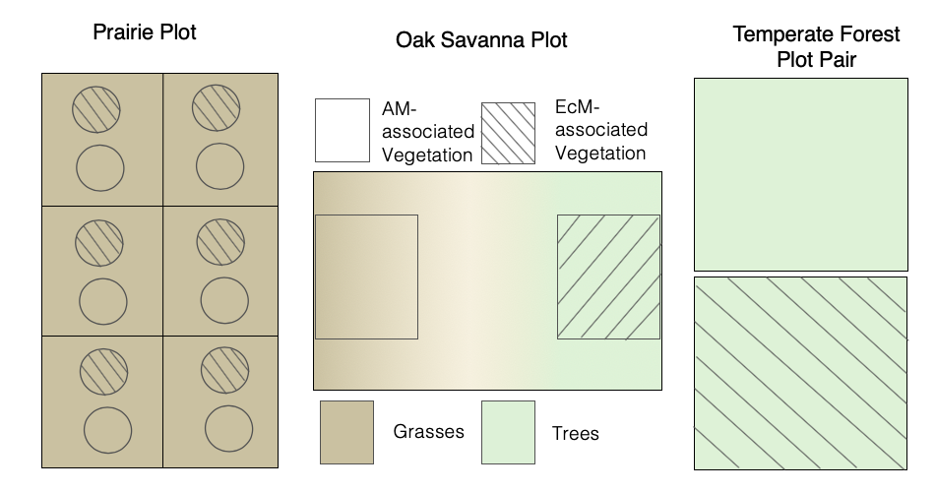

**Figure 2:** Visual representation of plot designs at each of the three sites. Hatched areas represent EcM dominated vegetation and open areas represent AM dominated vegetation. Green shading denotes areas containing mostly trees and tan shading denotes areas containing mostly grasses. Seven temperate forest plot pairs, three oak savanna plots and 18 prairie plots (6 per field) were utilized.

*Fungal Necromass Generation and Decomposition*

We selected two ectomycorrhizal fungal species, *Meliniomyces bicolor* and *Mortierella elongata*, known to differ in their C:N values and melanization. The melanized species, *Meliniomyces bicolor* (C:N = 13.7 ± 0.13) and the non-melanized species *Mortierella elongata* (C:N = 6.17 ± 0.38) represented a low and high quality fungal litter, respectively. For each species, fungal biomass was produced in liquid cultures by inoculating 50 mL of half-strength potato dextrose broth with 3mm diameter mycelial plugs. Following inoculation, cultures were transferred to an orbital shaker and left to shake at 80 rpm for at least 30 days or until growth stopped (growing times differed among fungal species as melanized species tended to grow more slowly).

To produce the fungal necromass, cultures were rinsed with distilled water and dried at 26°C for 24 hours. Dried fungal cultures (~25mg) were then placed into nylon mesh litter bags constructed from 53-micron mesh (Elko, Minneapolis, MN, USA) and heat-sealed. Separate litter bags were constructed for each fungal species. During deployment, litter bags were buried at organic-mineral soil interface (0-5cm depth). To determine mass loss due to transport and handling, an additional set of litter bags was carried into the field (n=3). Necromass recovery was greater than 98% and did not differ between fungal species, so masses were not corrected for loss due to field transport. Harvested litter bags were placed on ice and transported back to the lab for immediate processing. During processing, necromass was carefully removed from the litterbag and dried to a constant mass to determine mass remaining. Following mass measurements, a subset of remaining necromass was stored at -20oC for DNA analyses.

While the preparation and processing of necromass was standardized across the three sites, study durations and incubation times differed. At the prairie site,necromass was incubated for 11 and 34 days at the end of August of 2017 (n = 6 litter bags of each fungal species for each mycorrhizal association treatment for each sampling date). Necromass was incubated in the oak-savanna site for 14, 28, 42- and 56-day increments in July of 2017 (n = 3 litter bags of each fungal species for each mycorrhizal association treatment for each sampling date). At the forest site over 14, 31- and 92-days beginning in late July of 2017 (n = 7 litter bags of each fungal species for each mycorrhizal association treatment for each sampling date).

*Soil Measurements*

Soil moisture measurements were taken at the time litter bags were harvested. At the prairie and temperate forest sites, volumetric water data was collected as an average of 3 field measurements per plot using a soil moisture meter. At the oak-savanna site gravimetric soil moisture data was collected from the composite of two 5 × 10 cm soil cores per plot. Soil cores were also taken at the prairie and temperate forest sites on the final harvest date, three 5 × 10 cm soil cores at the prairie site and three 6.35 × 10 cm soil cores at the temperate forest site. To determine pH a sub-sample of air-dried soil was analyzed in a 0.01 M CaCl2 solution using a bench-top pH meter.

*On-going Identification of Bacterial and Fungal Decomposer Communities*

For a comparison of microbial decomposer communities for the different necromass and mycorrhizal types we performed molecular analyses at the oak savanna and temperate forest sites. Microbial genomic DNA was isolated from soil and necromass samples using DNeasy PowerSoil Extraction Kits (QIAGEN, Germantown, MD, USA). DNA extractions were done according to the manufacturer’s instructions with the addition of a bead-beating step prior to the start of the extraction to better homogenize necromass samples (Fernandez and Kennedy 2018). Positive and negative controls were included for both bacteria and fungi. Positive controls included mock communities from the Human Microbiome Project for bacteria and for fungi, the “SynMock” synthetic mock community developed by Palmer *et al.* (2017). We also extracted DNA from necromass that had not been incubated in litterbags. Negative controls included lysis tubes lacking substrate and PCR reactions with no DNA template added

Bacteria and fungi colonizing necromass samples and nearby soil were identified using high-throughput sequencing. For fungal identification we used the ITS2 primer pair designed by Taylor *et al.* (2016). For bacteria, we used 515F-806R primers to target the V4 region of the 16S rRNA gene. PCR reaction reagents and cycling conditions followed the Illumina MiSeq two-step PCR amplicon sequencing protocol. If initial PCRs were not successful, we performed dilutions or increased cycle numbers. Following amplification PCR products were visualized by gel electrophoresis and cleaned using the Charm Just-a-Plate Purifiation and Normalization Kit (Charm Biotech, San Diego, CA, USA). Successful bacterial and fungal amplicons for each sample were pooled at equimolar concentration and sequenced together on a full MiSeq lane (2 x 300 bp V3 Illumina chemistry) at the University of Minnesota Genomic Center. Currently, we are finalizing sequence-based analyses. As this work is not yet complete planned analyses and predicted results are discussed below*.*

To process bacterial and fungal HTS amplicon sequences we will use the AMPtk pipeline (amplicon toolkit; Palmer *et al.* 2017) v1.1 primarily utilizing the default settings (<https://amptk.readthedocs.io/en/latest/index.html>). In summary, paired end reads will be merged using VSEARCH and then subjected to quality trimming. Following pre-processing the UNOISE3 OTUs will be clustered using the denoising algorithm run in USEARCH10. We will apply a 0.0005 abundance cut-off to the bacterial data to eliminate very low abundance OTUs thought to be spurious. For the fungal data, SynMock abundances will be used to determine the filtering threshold. For Fungi, functional assignments (i.e., saprotrophic, symbiotrophic, and pathotrophic trophic guilds) will be made with FUNGuild (Nguyen *et al*. 2016).

*Data Analysis*

Statistical analyses were carried out in R version 3.5.1 (R Core Team, 2018). Analysis of variance (ANOVA) were used to test for differences in soil pH among sites and mycorrhizal settings. To test for differences in soil moisture, ANOVAs were run with mycorrhizal setting (AM vs. EcM associated vegetation) and sampling date as the predictor variables for each site. Prior to running the ANOVAs soil moisture data was log-transformed to meet the assumptions of normality. Linear mixed-effect (LME) models were used to analyze fungal necromass remaining within each site (Bradford et al. ). Fixed factors included mycorrhizal association (AM vs. EcM associated vegetation), necromass species (*M. bicolor* or *M. elongata*), incubation period and soil moisture. Replicate sampling locations (either plots or plot pairs) were designated as a random factor. Soil moisture was not included in the LME for the prairie site, as the moisture probe malfunctioned during one of the sampling dates and resulted in 22 missing observations. Because pH was only measured once it was not included in this analysis. Mass remaining data were log logit-transformed to meet the assumptions of statistical tests (Sokal and Rohlf 1995; Warton and Hui 2011). Least square means were computed for each fixed effect and post-hoc comparisons were carried out on pairs of the least-squares means using the Tukey’s adjustment for multiple comparisons.

To compare across sites, decay constants were calculated separately for each necromass species at each site. To calculate decay constants, we fit the proportion of remaining necromass against incubation time (weeks) using single- and double-exponential decay models. The best fitting model was selected using Akaike’s Information Criteria (AIC). The double-exponential decay model (Equation1) produced a better fit for the oak-savanna and temperate forest sites. The nonlinear least-squaresLevenberg-Marquardt algorithm used to estimate model parameters, a, k1 and k2, using the ‘minpak.lm’ package (Elzhov *et al*. 2016) in R. We were unable to fit a double exponential decay model to mass remaining data for the prairie site due to limited sampling points (only 2 sampling dates). Thus, to compare decay among all three sites, ANOVA was used to test site differences in mass remaining during the early stage of decay (11-14 days).

**Equation 1**: $X= ae^{-k_{1}t}+(1-a) e^{-k_{2}t}$

Where X is the mass remaining at time (t) and k is the decomposition rate, calculated as the remaining mass at time (t) divided by the initial mass for each litterbag. a refers to is the initial proportion of fast decomposing or labile material, 1-a is the initial proportion of slow decomposing or recalcitrant material. k1 and k2 are the degradation rate constants of the labile (fast-decomposing) and recalcitrant (slow-decomposing pool), respectively.

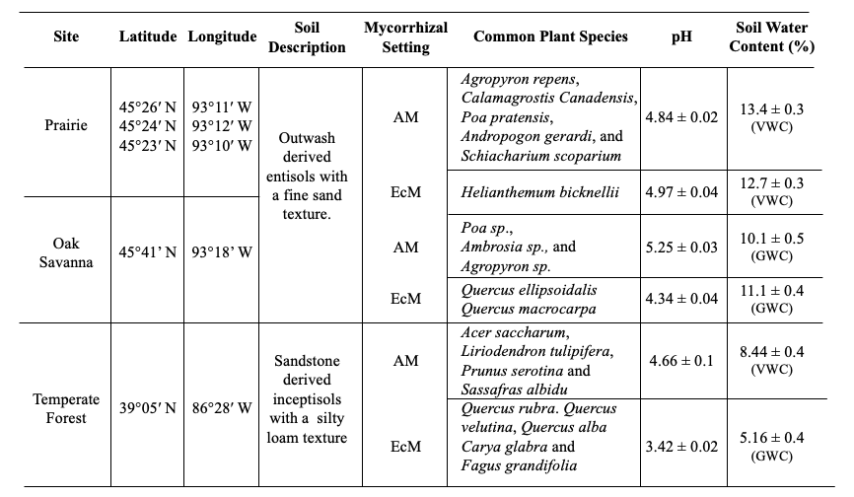

**Table 1:** Soil properties for arbuscular mycorrhizal (AM) and ectomycorrhizal (EcM) settings from the three sitesSoil Water Content was measured gravimetrically at the Oak Savanna site. VWC stands for volumetric water content, GWC stands for gravimetric water content.

Results and Discussion

*Soil Factors*

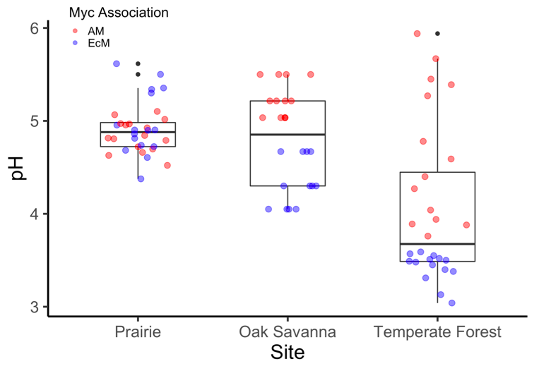

Soil pH differed significantly between mycorrhizal association settings (F1,78 = 57.13, P<.001). However, this difference depended on site, (i.e, there with a significant myc assoc x site interaction term, F2,78 = 26.89, P<.001). Soils under EcM associated vegetation tended to have lower pHs compared with soils under AM associated vegetation, but only in the oak savanna and temperate forest sites (see Figure 2). Prairie and oak savanna soils dominated by AM associated grasses had higher average pH values than soils dominated by EcM associated trees (Table 1; F2,78 = 44.20; P<.001) Temperate forest soils dominated by EcM associated tree species had the lowest pH values for any site/mycorrhizal setting. Soil moisture only differed between mycorrhizal settings at the temperate forest site. Soil moisture was 48% higher in AM dominated forest soils than EcM dominated forest soils (Table 1; F1,37 = 14.60, P<.001). Soil moisture values were similar between temperate forest and oak savanna AM soils, as well as, oak savanna and prairie EcM soils. Sampling date did not have a significant effect on soil moisture at any of the sites and we did not detect a significant effect of soil moisture on mass remaining at the oak savanna and temperate forest sites (See Table 2). Overall, differences in soil moisture and pH between mycorrhizal types were strongest at the temperate forest site. These results support findings from previous studies conducted along mycorrhizal gradients in mixed temperate forests (Phillips *et al*. 2013; Midgley *et al.* 2015; Cheeke *et al.* 2017). At the prairie site, we did not detect any mycorrhizal type differences in either pH or soil moisture. This suggests that the patches of *H. bicknellii* may not have been dense enough to form unique biogeochemical syndromes within prairie fields. It is also possible that within non-forested systems differences in the mycorrhizal association of vegetation may not influence soil properties to the same extent as forested systems.

**Figure 3:** Soil pH observations for vegetation-mycorrhizal associations at the different sites.

*Fungal Necromass Remaining*

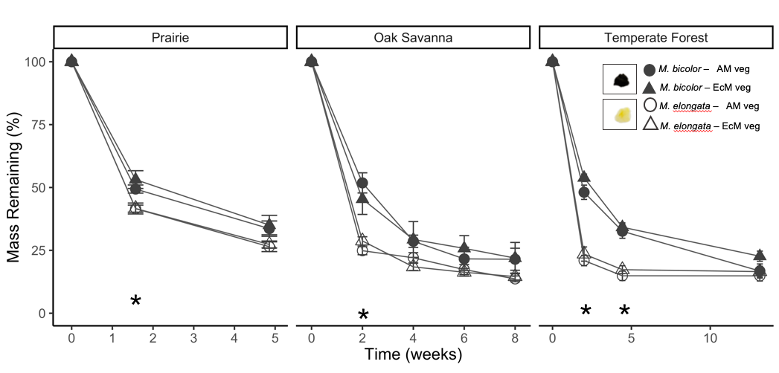

**Figure 4:** Melanized and non-melanized necromass remaining over time at the three sites. Asterisks represent significant differences among necromass species for a given time point (P<0.05).

Mycorrhizal association did not have a significant effect on fungal necromass remaining at any of the sites (See Table 2). Moreover, the species by mycorrhizal association interaction term was not significant, meaning that necromass species decomposed at a similar rate under AM and EcM associated vegetation across sites (See Figure 1). Mass remaining differed significantly among incubation periods and fungal necromass species (See Table 2). On average *M. bicolor* decomposed more quickly than *M. elongata* within each of the sites, in support of H1.2. These results support previous findings that melanized necromass decays more slowly (Fernandez and Koide 2014; Fernandez and Kennedy 2018). However, the effect of necromass species was mediated by a significant necromass species x incubation period interaction at the temperate forest site and a moderately significant interaction at the oak savanna site (Table 2).

**Table 2:** Summary of LME results showing effects of dominant vegetation mycorrhizal association, fungal necromass species and incubation period on fungal necromass remaining

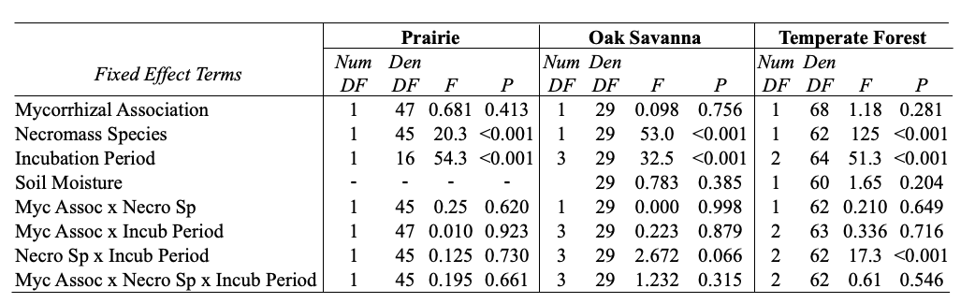

1

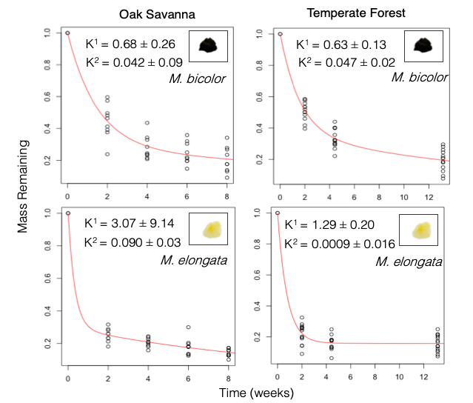We found evidence for a rapid initial phase of fungal necromass decomposition followed by a slower-later phase in agreement with previous findings (Certano *et al.* 2018). The decay rate (K1) for the initial phase was consistently higher for the non-melanized necromass species (Figure 4). The greatest differences in mass remaining between *M. bicolor* and *M. elongata* occurred early on in decomposition (11-14 days) and at the temperate forest site. During this time period ~80%, 60% and 20% more *M. bicolor* mass remained compared with *M. elongata* mass at the temperate forest, oak savanna and prairie sites respectively (see Figures 4 & 5). Faster initial decomposition of *M. elongata* was likely due to higher concentrations of nitrogen and lower concentrations of melanin (Koide and Malcom 2009; Fernandez and Koide 2012; Fernandez and Kennedy 2018)*.*

**Figure 5:** Double exponential decay curves for the oak savanna and temperate forest sites with corresponding decay constant estimates ± standard error.

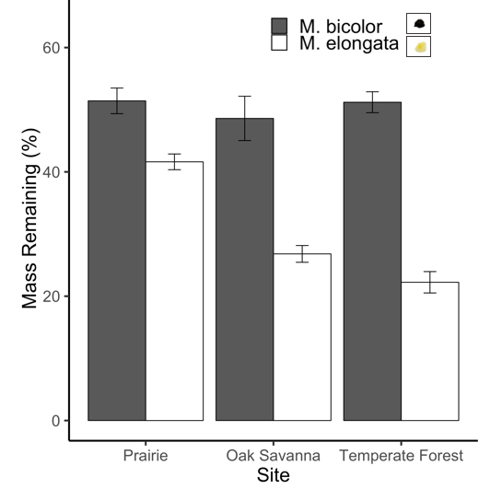During this early stage of decay, there was a significant site x necromass species interaction (F2,73 = 16.61, P<.001). This interaction was largely driven by greater mass remaining for the non-melanized species, *M. elongata,* at the prairie site, which was almost double that of the mass remaining for *M. elongata* at the oak savanna and temperate forest sites. It is unclear what is driving the slower decomposition of non-melanized necromass at the prairie site. It may be due to a lack of decomposer organisms able to degrade EcM fungal tissues. Mass remaining of *M. bicolor* did not differ among sites during this initial phase of decay (Figure 6). In summary, these results support the hypothesis that necromass biochemistry is an important controller of decomposition during the initial phase of decay.

*Decomposer Community*

**Figure 6:** Mass remaining for melanized and non-melanized fungal species during the initial phase of decay (11-14 days).