**Supplementary Information**

**Generic Implementation of Bragg Profile in Reverse Monte Carlo Algorithm and Resolution Correction for Modeling the Total Scattering Data**

**Author:** Yuanpeng Zhang1,2, Maksim Eremenko1,3, Victor Krayzman1, Igor Levin1

1Neutron Scattering Division, Oak Ridge National Laboratory (ORNL), Oak Ridge, Tennessee 37831, United States

2Materials Measurement Science Division, National Institute of Standards and Technology (NIST), 100 Bureau Drive, Gaithersburg, Maryland 20899, United States

3

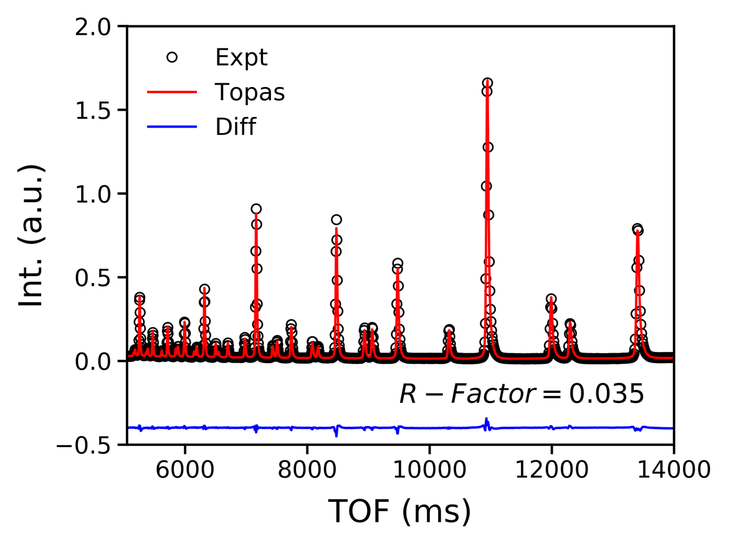

**Figure. S1**. The Rietveld refinement result for CeO2 bank-5 data measured at NOMAD.

**Supplementary results for STO**

**Table S1**. Off-diagonal values of the thermal ellipsoid matrix for STO.

|  |  |  |  |
| --- | --- | --- | --- |
|  | U12 | U13 | U23 |
| Sr-1 | -0.0001 | 0.0000 | 0.0000 |
| Ti-2 | 0.0000 | 0.0000 | 0.0000 |
| O-3 | 0.0000 | 0.0000 | 0.0001 |
| O-4 | -0.0001 | 0.0000 | 0.0000 |
| O-5 | 0.0000 | 0.0000 | 0.0001 |

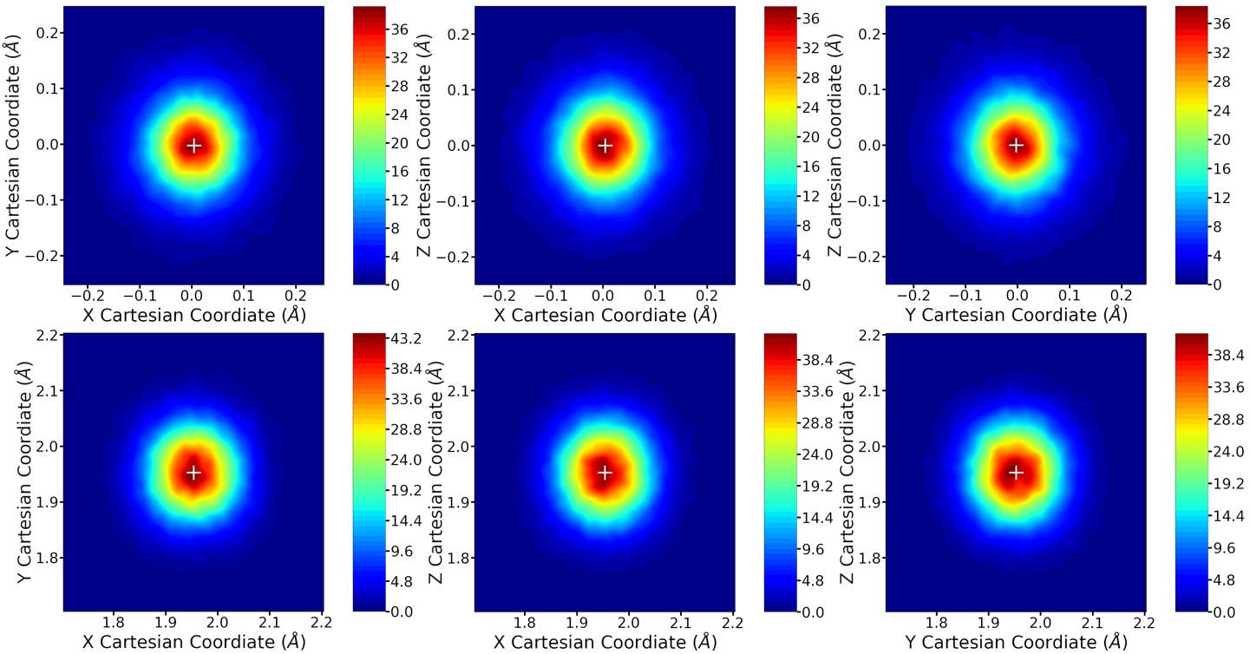

**Figure. S2**. Kernel density estimation for Sr (top) and Ti (bottom) atoms onto *x-y* (left), *x-z* (middle) and *y-z* (right) planes of the collapsed unit cell of STO. The “+” symbol indicates the average position of the corresponding atoms.

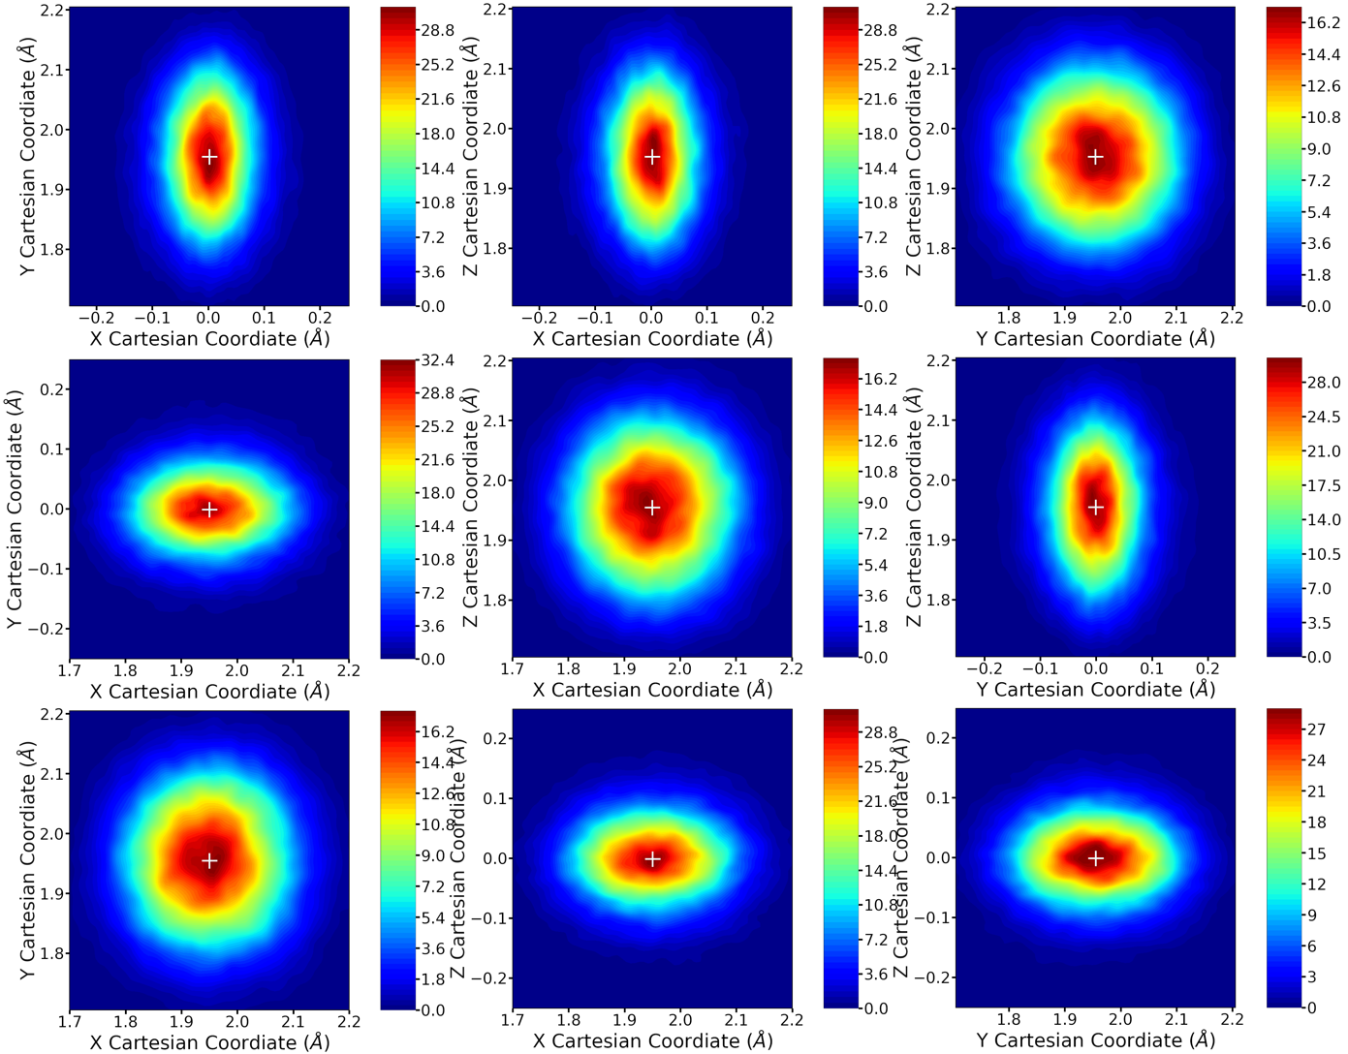

**Figure. S3**. Kernel density estimation for the three O (top, middle and bottom, respectively) atoms onto *x-y* (left), *x-z* (middle) and *y-z* (right) planes of the collapsed unit cell of STO. The “+” symbol indicates the average position of the corresponding atoms.

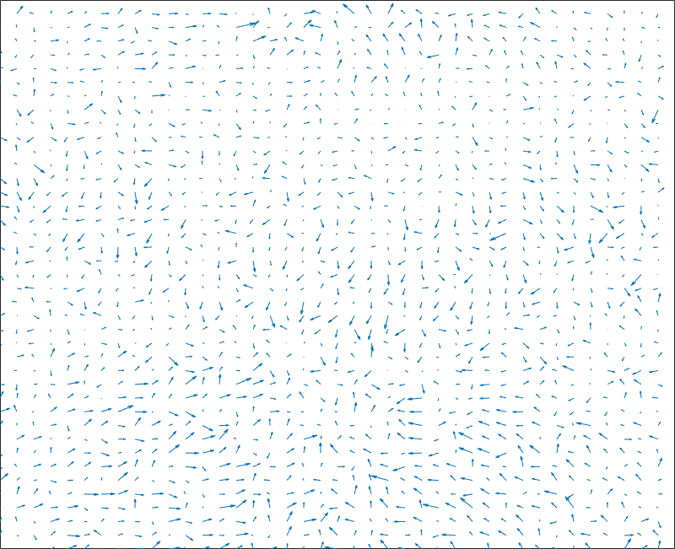

**Figure. S4**. Column projection of atomic displacement for Sr onto *x-y* plane of the supercell.

**Figure. S5**. Column projection of atomic displacement for Sr onto *x-z* plane of the supercell.

**Figure. S6**. Column projection of atomic displacement for Sr onto *y-z* plane of the supercell.

**Figure. S7**. Column projection of atomic displacement for Ti onto *x-y* plane of the supercell.

**Figure. S8**. Column projection of atomic displacement for Ti onto *x-z* plane of the supercell.

**Figure. S9**. Column projection of atomic displacement for Ti onto *y-z* plane of the supercell.

**Supplementary results for bulk ceria**

It should be mentioned that with current data reduction approach for processing the data measured at NOMAD diffractometer, the total scattering pattern is obtained by summing up contributions from all pixels to a certain *Q*-bin (**Joerg’s paper**). However, our approach for correcting the resolution effect is in a bank-by-bank manner. Therefore, one cannot easily follow the principle given in the main context (see Eqn. 4 in the main text) to keep the consistence between data reduction and practical modeling. In such a situation, one has to use an empirical weight scheme. Here in this report, resolution matrices of the 6 banks are weighted by intensities at each *Q*-point, and the suggested *Q*-range used for each bank is given in Table. S2.

**Table S2**. Suggested Q-range used for each bank for weighting the resolution matrices of the 6 banks (bank-6 is not used) of NOMAD diffractometer.

|  |  |  |
| --- | --- | --- |
|  | *Q*min | *Q*max |
| Bank-1 | 0.4 | 3.6 |
| Bank-2 | 1.4 | 3.6 |
| Bank-3 | 2.28 | 34.9 |
| Bank-4 | 3.36 | 39.96 |
| Bank-5 | 4.10 | 39.96 |
| Bank-6 | - | - |

**Table S3**. Off-diagonal values of the thermal ellipsoid matrix for bulk ceria.

|  |  |  |  |
| --- | --- | --- | --- |
|  | U12 | U13 | U23 |
| Ce-1 | 0.0001 | 0.0000 | 0.0000 |
| O-2 | 0.0000 | 0.0000 | 0.0000 |
| O-3 | 0.0001 | -0.0001 | -0.0001 |
| Ce-4 | 0.0000 | 0.0000 | 0.0000 |
| O-5 | 0.0001 | 0.0000 | 0.0000 |
| O-6 | 0.0001 | -0.0001 | 0.0000 |
| Ce-7 | 0.0000 | 0.0000 | 0.0000 |
| O-8 | 0.0000 | 0.0000 | -0.0001 |
| O-9 | 0.0000 | -0.0001 | 0.0000 |
| Ce-10 | 0.0001 | 0.0001 | 0.0000 |
| O-11 | 0.0002 | -0.0001 | 0.0000 |
| O-12 | 0.0001 | 0.0000 | 0.0001 |

**Figure. S10**. Kernel density estimation for the four Ce atoms (corresponding to each row in the figure) atoms onto *x-y* (left), *x-z* (middle) and *y-z* (right) planes of the collapsed unit cell of ceria. The “+” symbol indicates the average position of the corresponding atoms.

**Figure. S11**. Kernel density estimation for all O atoms onto *x-y* (left), *x-z* (middle) and *y-z* (right) planes of the collapsed unit cell of ceria. First row from left to right – O2 & O3, O2 & O6 and O2 & O9; Second row from left to right – O5 & O6, O3 & O5 and O3 & O8; Third row from left to right – O8 & O9, O8 & O12 and O5 & O12; Fourth row from left to right – O11 & O12, O9 & O11 and O6 & O11. The “+” symbol indicates the average position of the corresponding atoms.

**Figure. S12**. Column projection of atomic displacement for Ce onto *x-y* plane of the supercell.

**Figure. S13**. Column projection of atomic displacement for Ce onto *x-z* plane of the supercell.

**Figure. S14**. Column projection of atomic displacement for Ce onto *y-z* plane of the supercell.

**References**