A nanoparticle generator has been written to provide the functionality of generating nanoparticle(s) from the provided bulk configuration in RMCProfile format. This tool could be used to generate single spherical particle or single particle with facets assuming cubic symmetry or no symmetry. Also, it can generate multiple particles in a box – a random walk algorithm is used in this case to fill the box with particles as fully packed as possible (see Fig. X1) while the variation of particle radius and the distance between particles could be controlled via input parameters. For both generation scenarios, the particle surface could be terminated to make sure a complete coordination environment for selected element. This tool was written in Python and has been included in the RMCProfile package release so users can get easy access to the tool via RMCProfile environment. Detailed instructions and documentation could be found in Ref. [1].

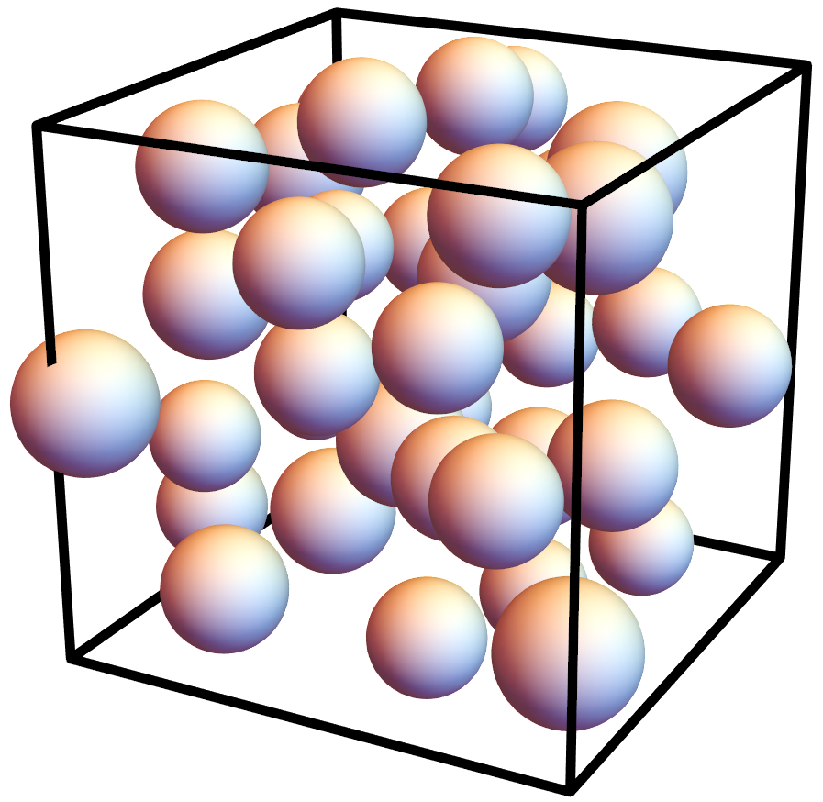

**Figure. X1.** Illustration for the multis-particle generation in a box, in a fully packed manner.

For total scattering measurement on time-of-flight (TOF) instruments, usually a standard calibrant (e.g., diamond) would be measured under the same condition as the measurement for user samples. Given the known $d$-spacing of the standard sample in use, the TOF- $d$ transformation could be calibrated. Typically, a single DIFC parameter would be used for such a calibration purpose, following the relation $d=TOF/DIFC$. A DIFC table could then be obtained for the whole instrument to include the DIFC value for each individual detector, with which the diffraction pattern corresponding to each individual detector could be aligned and focused. However, in practice, such a calibration procedure conducted on standard sample could not account for the potential difference in between the position of standard and user samples. To account for this factor, additional parameters would be introduced in conventional Bragg pattern refinement routine, to give a commonly used formula relating TOF and $d$, as follows,

**Figure. X2.** The main interface of the sofq_calib GUI.

With this regard, a GUI *sofq_calib* (see Fig. X2) with wxPython framework has been developed to further calibrate the total scattering pattern against the Bragg refinement result. Through this further calibration step, a common TOF-d transformation is shared between the total scattering and Bragg data. The GUI was released as a conda package and could be installed conveniently via conda. Detailed instructions about the installation together with documentation of usage could be found in Ref. [2].

**Reference**

[1] <https://rmc-adv-tools.readthedocs.io/en/main/rmc_tools/np_gen.html>

[2] <https://rmc-adv-tools.readthedocs.io/en/main/rmc_tools/sofq_calib.html>