[power supply problems](https://e2e.ti.com/blogs_/archives/b/precisionhub/archive/2015/05/22/caution-your-adc-may-be-only-as-good-as-its-power-supply?DCMP=dsigpsseries&HQS=hpa-pa-dsig-dsigpsseries-thehub-20150625-blog-20150522-en)

[powers supply problem solutions](https://e2e.ti.com/blogs_/archives/b/precisionhub/archive/2015/06/25/four-ways-to-protect-your-adc-system-power-supply-rejection)

Input filtar

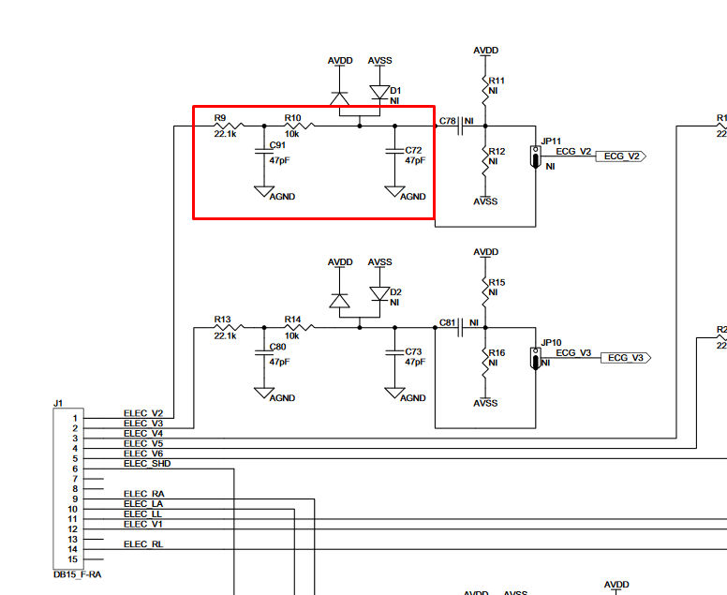

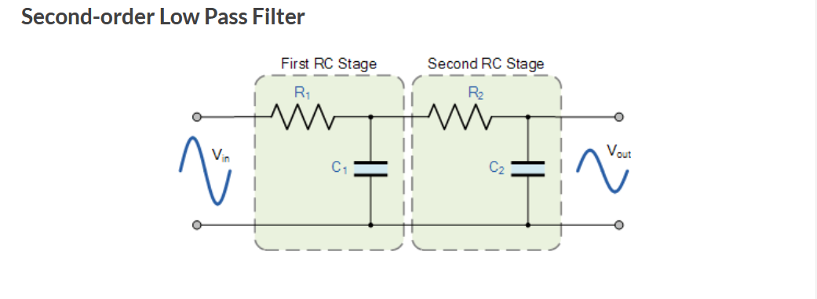

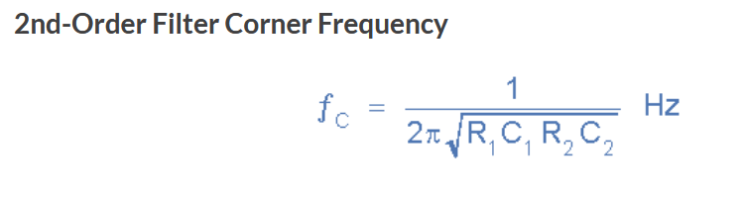

With this values: f= 227.785kHz ?? What is this filtar used for?

## Multiple-Device Configuration

Cascade Configuration

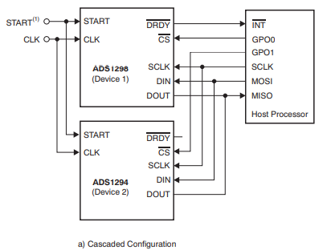

Signal/pins needed

|  |
| --- |
| START |
| CLK |
| /DRDY |
| /CS |
| SCLK |
| DIN |
| DOUT |

Daisy-Chain Configuration

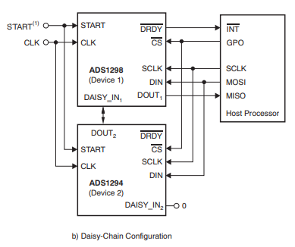

Signal/pins needed

|  |
| --- |
| START |
| CLK |
| /DRDY |
| /CS |
| SCLK |
| DIN |
| DOUT |
| DAISY_IN |
|  |
|  |

## Power supplies

**ESP32s2**

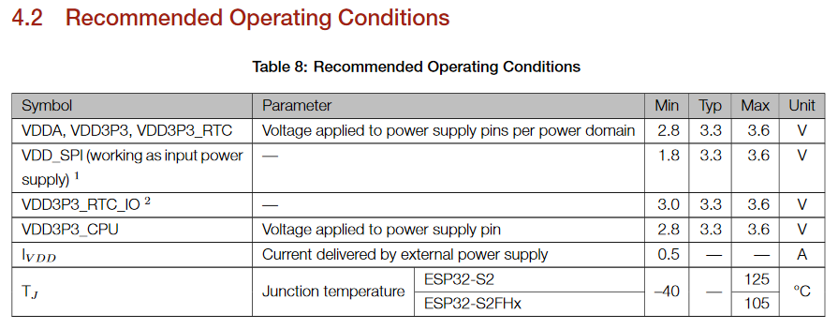

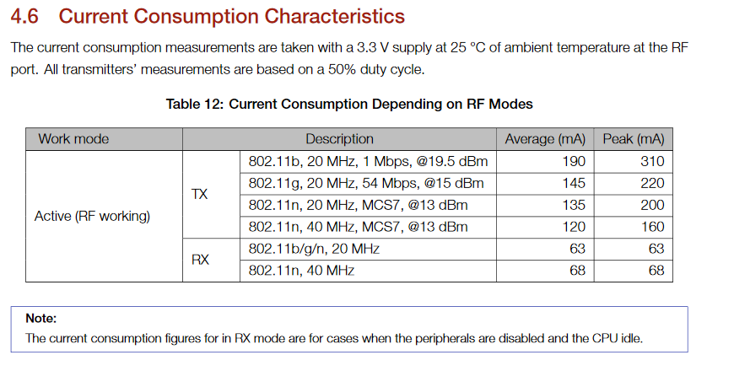

**ADS1298**

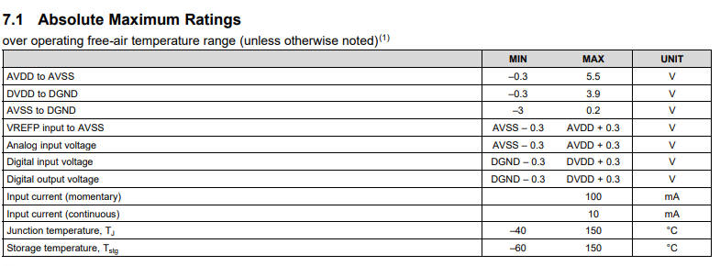

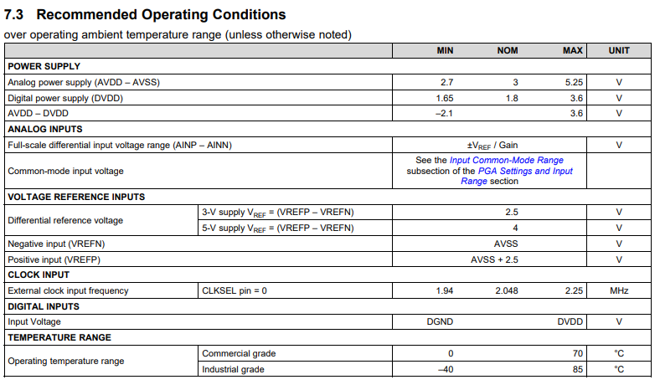

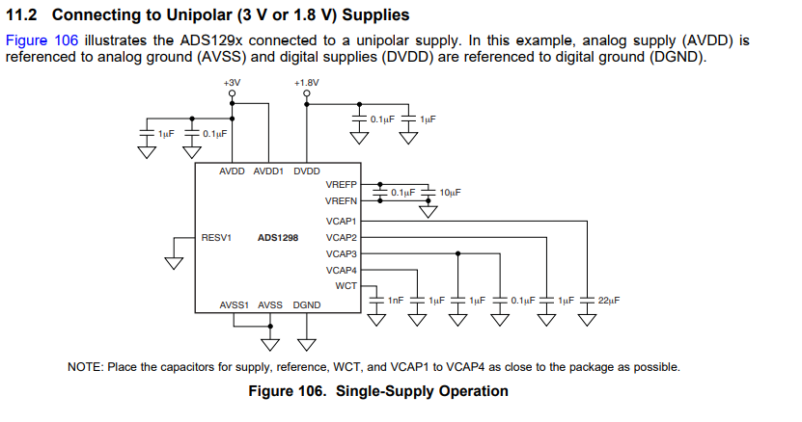

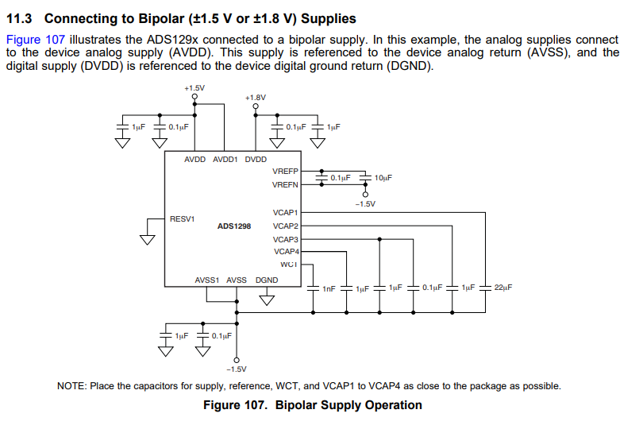

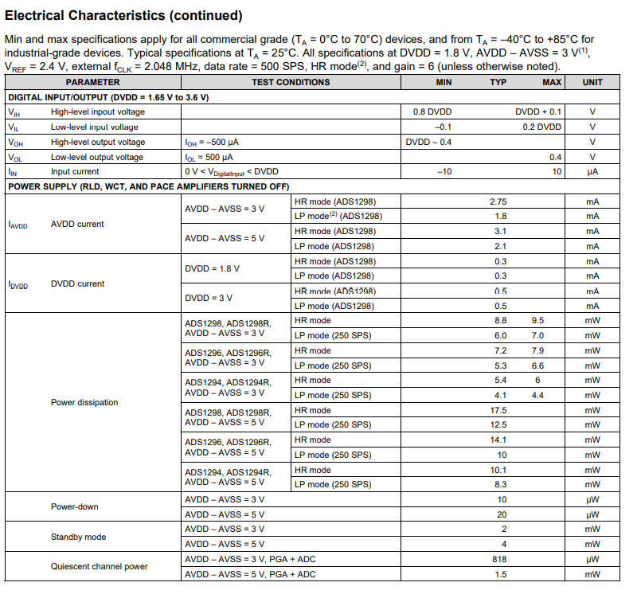

## reference voltage

