SHRI RAMDEOBABA COLLEGE OF ENGINEERING AND MANAGEMENT, NAGPUR.



Digital Signal Processing

TEACHER’S ASSESSMENT

(5TH SEM-B, SESSION 2021-2022, ECT-354)

**“Digital Hearing Aid Using MATLAB”**

Submitted By:

Dikshant Yeasankar (Roll No.-21)

Vipul Jain (Roll No.-81)

Vivek Kaushik (Roll No.-82)

Syed Ayaz Ali (Roll No.-106)

Department of Electronics and Communication Engineering

1. **Introduction:**

**1.1 Problem statement:**

Approximately 10% of the world's population suffers from some type of hearing loss, yet only a small percentage of this statistic use a hearing aid. Using digital signal processing, a new digital hearing aid can be developed which offers what the analog hearing aid cannot offer. It proposes the possibility of performing signal-to noise enhancement, flexible gain-processing, digital feedback reduction, etc.

**1.2 Objectives:**

Through our project, the simulation of a simple digital hearing aid was developed using MATLAB. The implementation of this configurable digital hearing aid (DHA) system includes the noise reduction filter, frequency shaper function, and amplitude compression function. This digital hearing aid system is designed to adapt for mild and moderate hearing loss patients since different gain can be set to map different levels of hearing loss.

1. **Existing Approaches or algorithm:**

**Analog Hearing Aid**: Conventional analog hearing aids are designed with a particular frequency response based on your audiogram. The audiologist tells the manufacturer what settings to install. Although there are some adjustments, the aid essentially amplifies all sounds (speech and noise) in the same way. This technology is the least expensive, and it can be appropriate for many different types of hearing loss.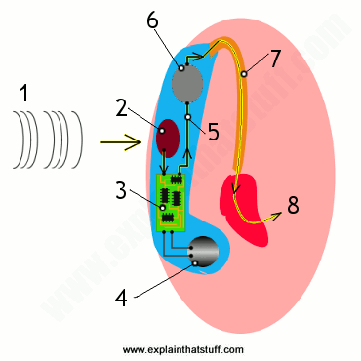

Working of an analog hearing aid: -

1. Sound waves travel toward your ear (pink) and the hearing aid you're wearing behind it (blue).
2. A small microphone picks up the sounds and turns them into an electric current.
3. An amplifier circuit (containing one or more transistors) increases the strength of the current.
4. A small button battery powers the amplifier circuit and other components.
5. The amplified current drives a small loudspeaker.
6. The loudspeaker plays its sound into a tube called the ear hook.
7. The ear hook plays the sound through the ear mold into your ear canal.
8. Sound waves of greatly increased volume travel to your inner ear.
9. **Implemented approach or Algorithm:**

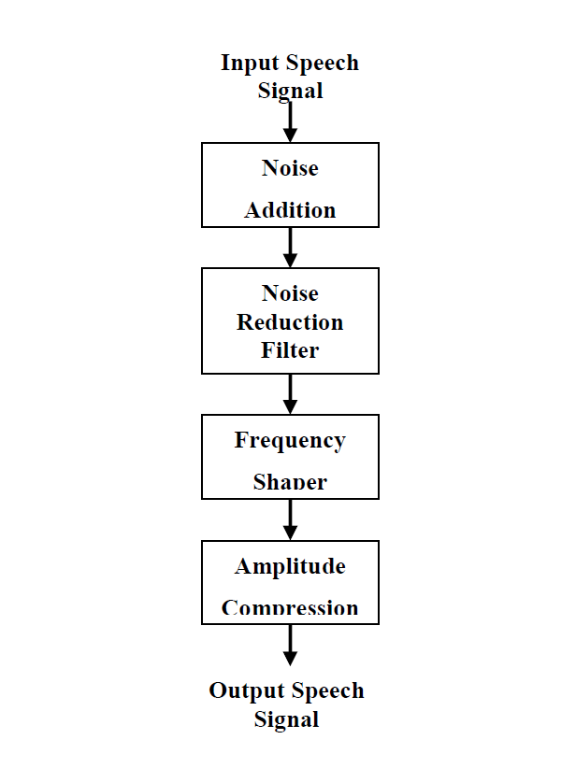

A digital hearing aid works in much the same way, except that the amplifier chip digitizes the sound signals from the microphone, then processes and filters them before it amplifies, producing much clearer sounds. It can be much more closely tuned to your particular hearing difficulties and it automatically adjusts itself to different environments (noisy restaurant, quiet home, or wherever you might be).

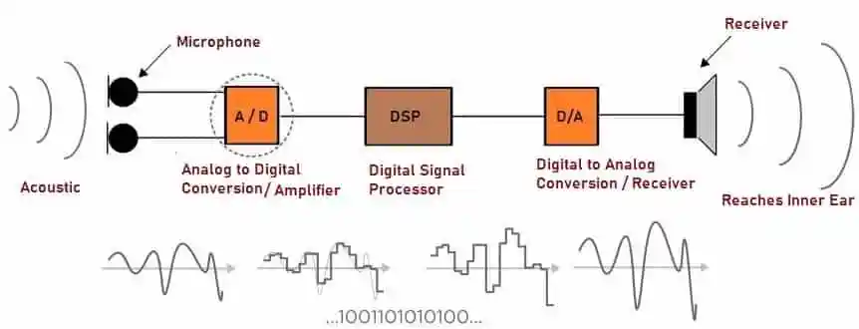

(Block Diagram)

1. **Noise Addition**

Since the input speech signal for this system is a clean signal, some noise is added in order to simulate a real situation. In this system, the Adaptive White Gaussian Noise (AWGN) is added to the input speech signal by using the MATLAB function. Noise (AWGN) has a continuous and uniform frequency spectrum over a specified frequency band and has equal power per Hertz of this band. It consists of all frequencies at equal intensity and has a normal (Gaussian) probability density function.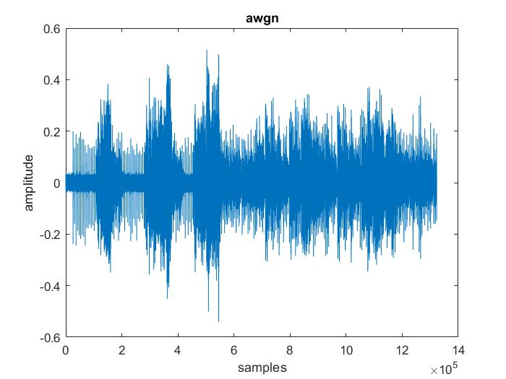

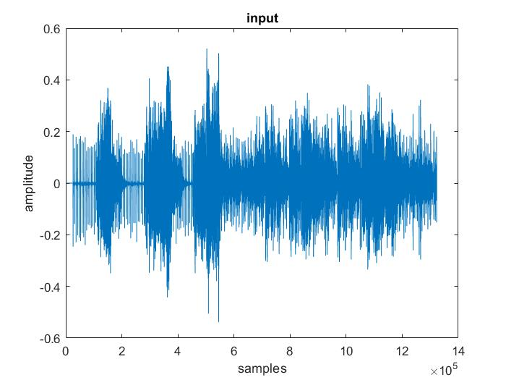

1. **Noise Reduction Filter**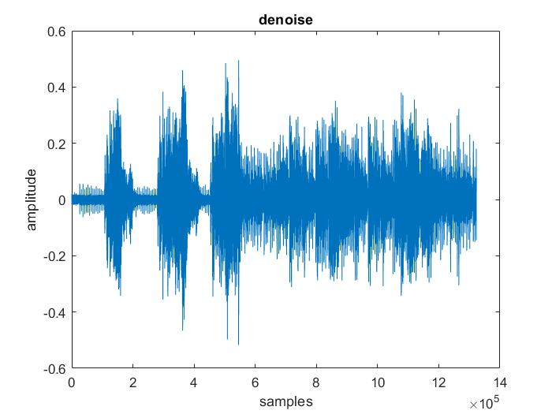

A major anxiety for the people with hearing loss is the capability of hearing aids to differentiate intended speech signals in a noisy environment. Hence, to eliminate the noise, a reduction filter function is used in this design. To suppress the noise in the signal, the lowpass and bandpass filter’s function is used.

1. **Frequency Shaper**

One major complaint of hearing aid users is that the hearing aid amplifies all signals rather than the significant signal that they desire to hear. Most hearing impaired have difficulties hearing high frequency signals. Therefore, the frequency shaper is designed to correct for loss of hearing at certain frequencies. It applies high gain for higher frequencies and vice versa.

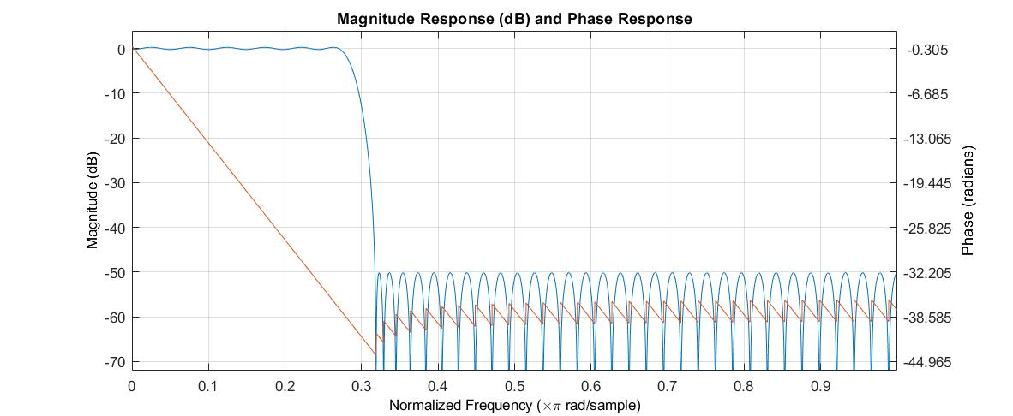

1. **Amplitude Compression**

Fundamentally, amplitude compression function is the task of controlling the overall gain of a speech amplification system. Amplitude compression will ensure that the amplified signal will not exceed saturation power. Saturation power is where the sound signal begins to become uncomfortable.

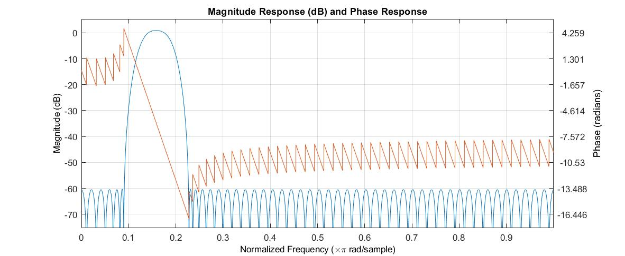

1. **Results:**

In the above original signal, initially we added the AWGN (Adaptive White Gaussian Noise) to the signal to get the corrupted signal. The purpose of this addition was just to simulate noises in the real-life situation. Afterward, the denoising process takes place which removes most of the noise in the signal. Here the filtering of the signal takes place and thus unwanted noise signals get reduced. We can see that the amplitude of the noise in the signal was noticeably reduced. Thus, we got the expected output (Original Signal) as shown in figure.

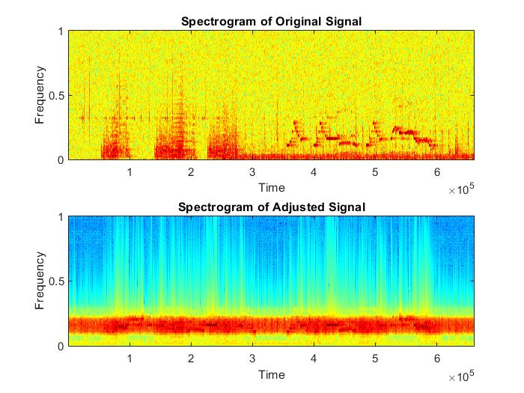 (Spectrograms) (Denoise Signal)

Afterward, the denoising process takes place which removes most of the noise in the signal as shown in figure.

Comparing the spectrograms of the original signal and the filtered signal, we can see that the amplitude of the noise in the signal was noticeably reduced as shown in figure.

The benefits of using digital aids could Improve quality of life by improving sound quality, Higher listening comfort, better communication in noisy environments, better speech intelligibility in group conversations and more flexibility in case of progressive hearing less.

1. **Conclusion:**

The newer digital aids offer more ability to finetune the sound without distorting the quality and help the listener. In this digital hearing aids system implementation using MATLAB, sound processing is digitalized. Thus, it is possible to refine the sound signal, for instance by reducing noise and improving speech signals. In addition, by using digital technology, the amplification can be done only at the frequencies that the user needs to amplify.

**7. References:**

**1.**[**https://www.mathworks.com/help/**](https://www.mathworks.com/help/)

**2.**[**https://en.wikipedia.org/wiki/Digital_signal_processing**](https://en.wikipedia.org/wiki/Digital_signal_processing)

**3.**[**https://www.dspguide.com/ch14/5.htm**](https://www.dspguide.com/ch14/5.htm)

**4.**[**https://www.semanticscholar.org/paper/Frequency-Shaping-of-Audio-Signals-Penrose/d272a11b7e86da4cb5dae278b6d0a2cd42ab5115**](https://www.semanticscholar.org/paper/Frequency-Shaping-of-Audio-Signals-Penrose/d272a11b7e86da4cb5dae278b6d0a2cd42ab5115)

**5.**[**https://www.ncbi.nlm.nih.gov/pmc/articles/PMC3742005/**](https://www.ncbi.nlm.nih.gov/pmc/articles/PMC3742005/)