LAB-01

Name: K V Jaya Harsha

Roll no: CS23B1034 Date: 31-07-2024

Q1. Linear search algorithm. (in cpp)

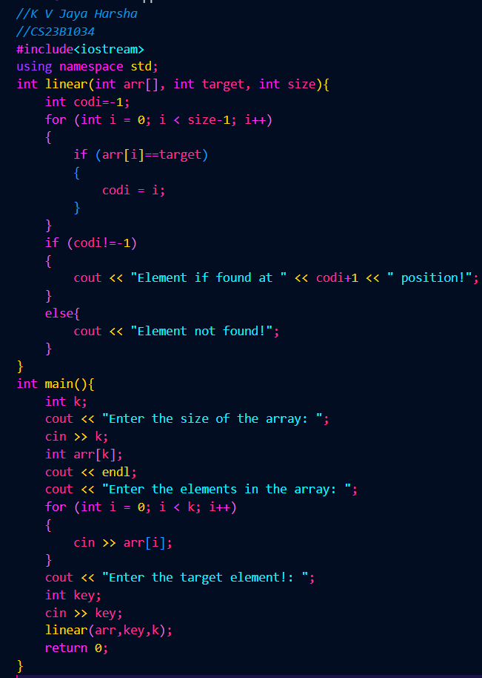

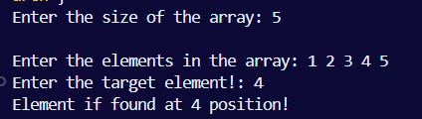

Q2. Binary Search algorithm. (in cpp)

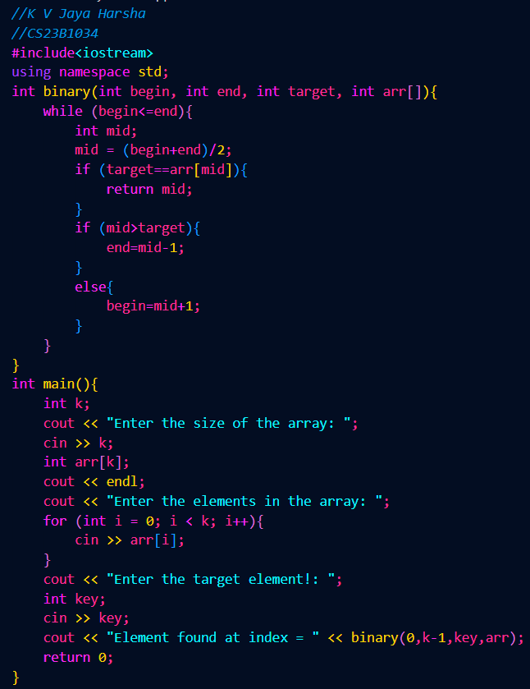

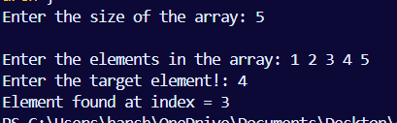

Q3. Bubble sort. (in cpp)

