LAB-10

Name: K V Jaya Harsha

Roll no: CS23B1034 Date: 09-10-2024

Q1. Binary Search Tree with in-order traversal (in cpp)

Lk6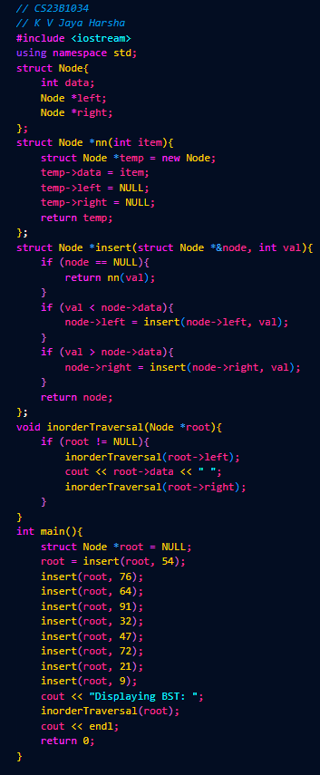



Q3. Delete a node

