LAB-02

Name: K V Jaya Harsha

Roll no: CS23B1034 Date: 07-08-2024

Q1. Merging sorted arrays. (in cpp)

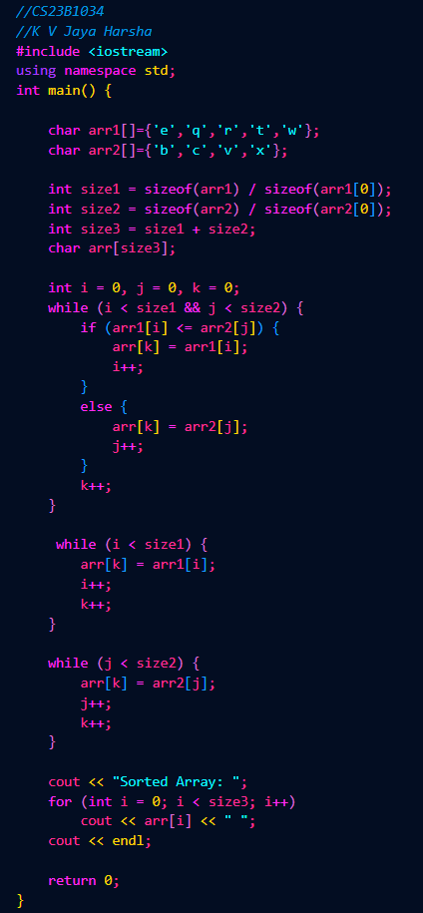

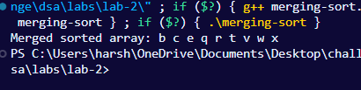

Q2. Selection sort algorithm. (in cpp)

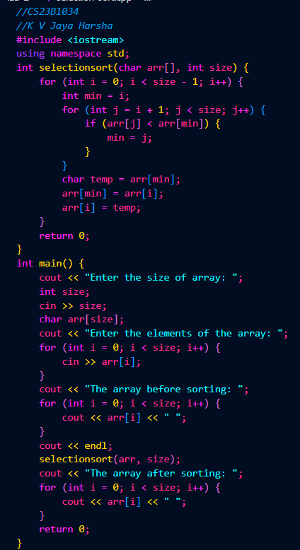

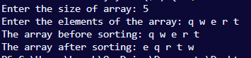

Q3. Insertion sort. (in cpp)

