LAB-05

Name: K V Jaya Harsha

Roll no: CS23B1034 Date: 28-08-2024

Q1. Single Linked List. (in cpp)

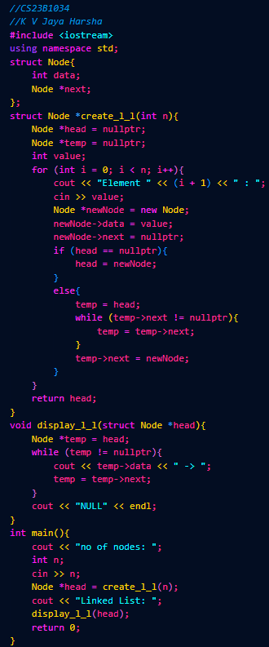

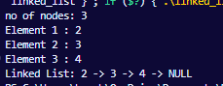

Q2. Sum of odd terms in linked list. (in cpp)

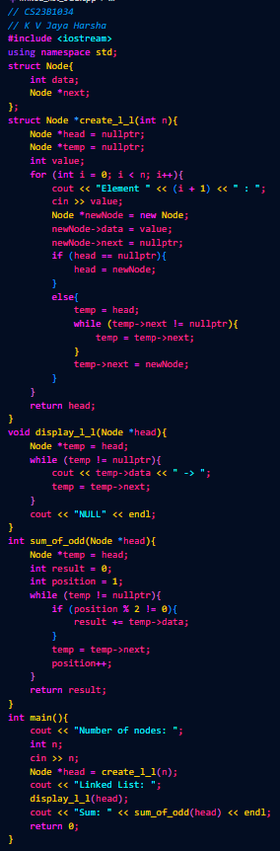

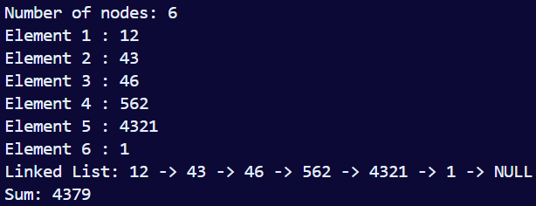

3. Swapping elements in linked list. (in cpp)

