LAB-11-ASSIGNMENT

Name: K V Jaya Harsha

Roll no: CS23B1034 Date: 16-10-2024

Q1. AVL tree (in cpp)

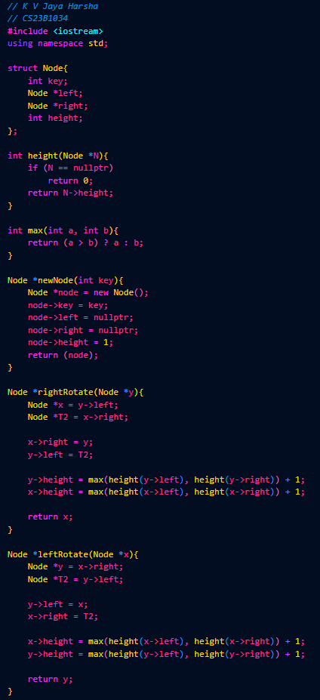

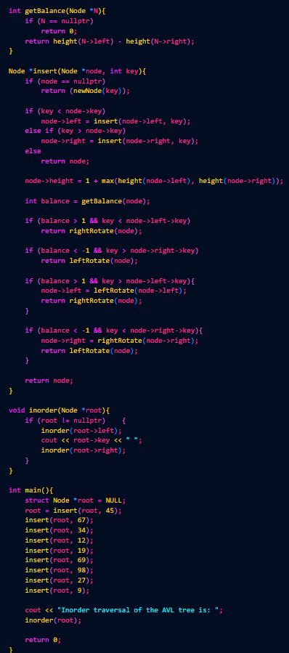



Q2. Delete three nodes one by one from AVL tree (in cpp)





