LAB-13

Name: K V Jaya Harsha

Roll no: CS23B1034 Date: 30-10-2024

Q1. BFS (in cpp)

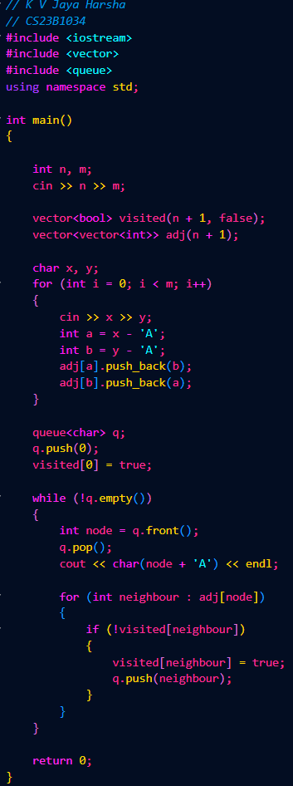

Output (q1)

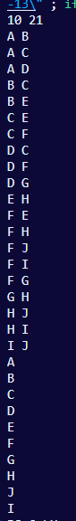

------------

Q2. DFS (in cpp)

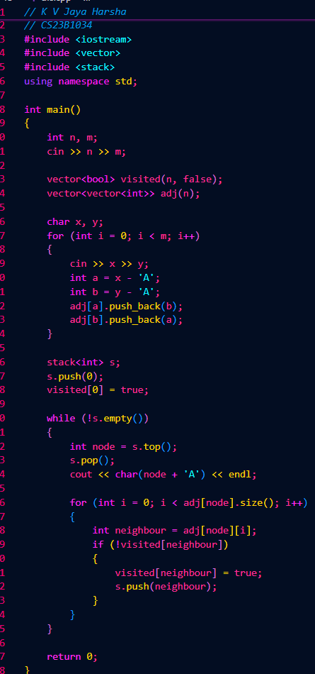

Output (q2)

