LAB-15

Name: K V Jaya Harsha

Roll no: CS23B1034 Date: 13-11-2024

Q1. Quicksort (in cpp)

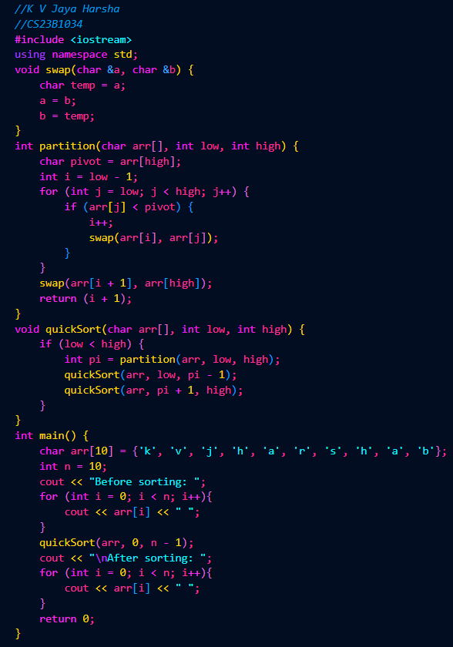

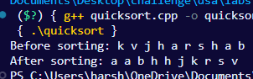

Q2. Heapsort (in cpp)

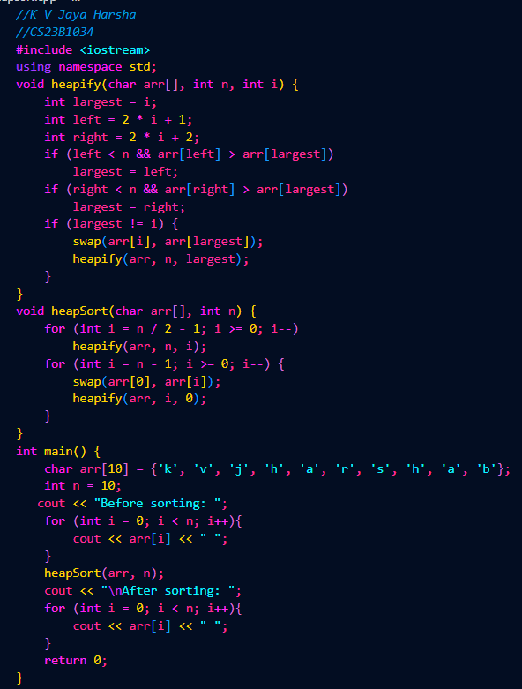

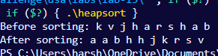

Q3. Count sort (in cpp)

