LAB-06

Name: K V Jaya Harsha

Roll no: CS23B1034 Date: 04-08-2024

Q1. Circular Linked List. (in cpp)

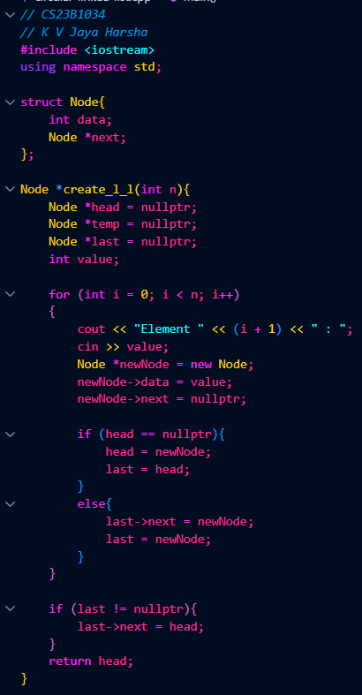

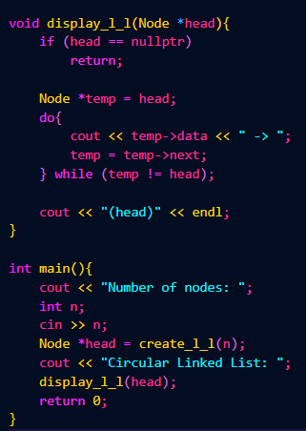

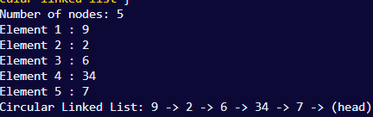

Q2. Interchange kth and k+1th node of circular linked list. (in cpp)



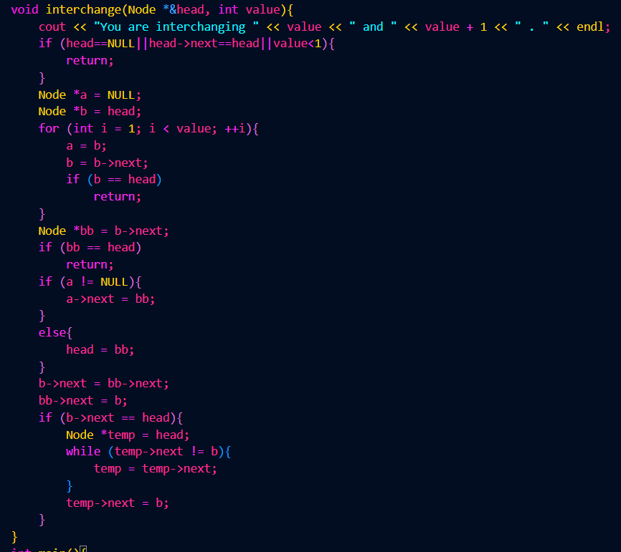

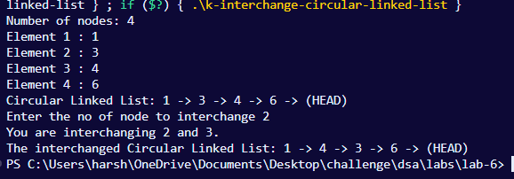

Q3. Doubly linked list with function to count no of non zero nodes. (in cpp)

