LAB-07

Name: K V Jaya Harsha

Roll no: CS23B1034 Date: 22-10-2024

Q1. Multiply two polynomial expressions by considering three variables x,y, and z using a linked list. (in cpp)

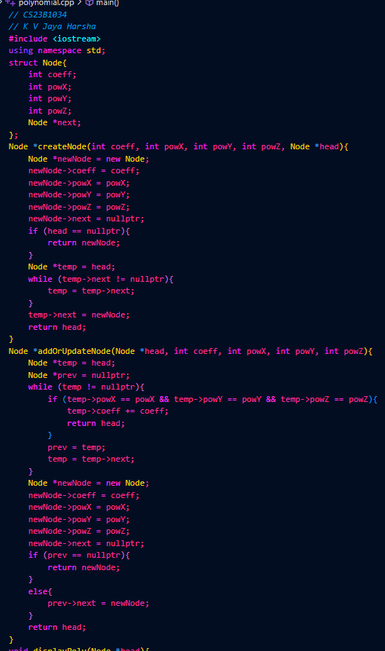

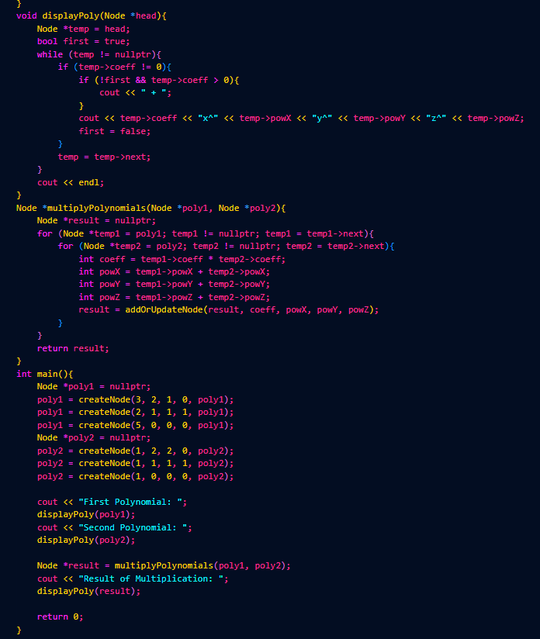



Q2. Implement priority queue. (in cpp)

