LAB-08

Name: K V Jaya Harsha

Roll no: CS23B1034 Date: 18-09-2024

Q1. bubble-sorting-doubly-circular-linked-list. (in cpp)

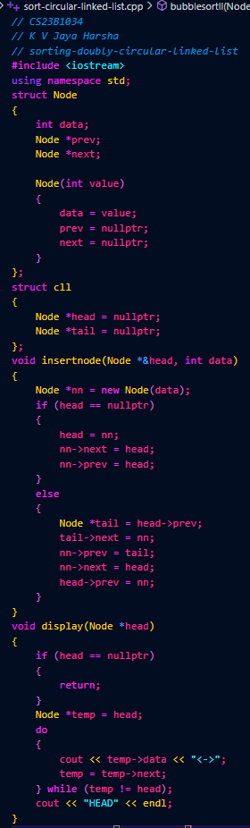

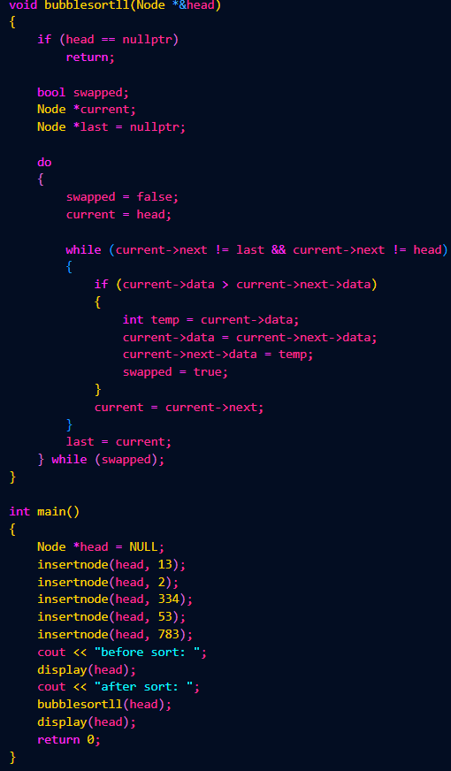



Q2. Merge two sorted circular single linked list. (in cpp)

