LAB-09

Name: K V Jaya Harsha

Roll no: CS23B1034 Date: 25-10-2024

Q1. Binary tree (in cpp)

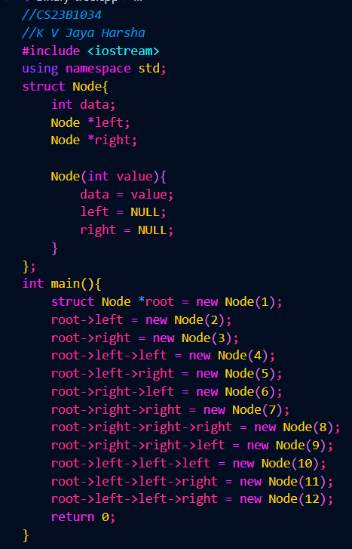

Q2. Traversal (in cpp)

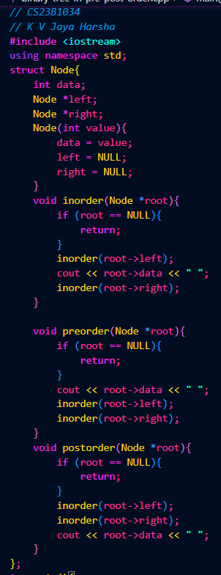

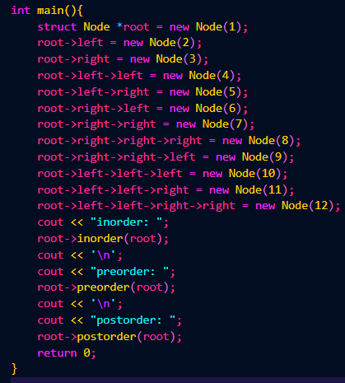

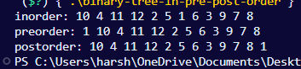

Q3. Binary Search. (in cpp)

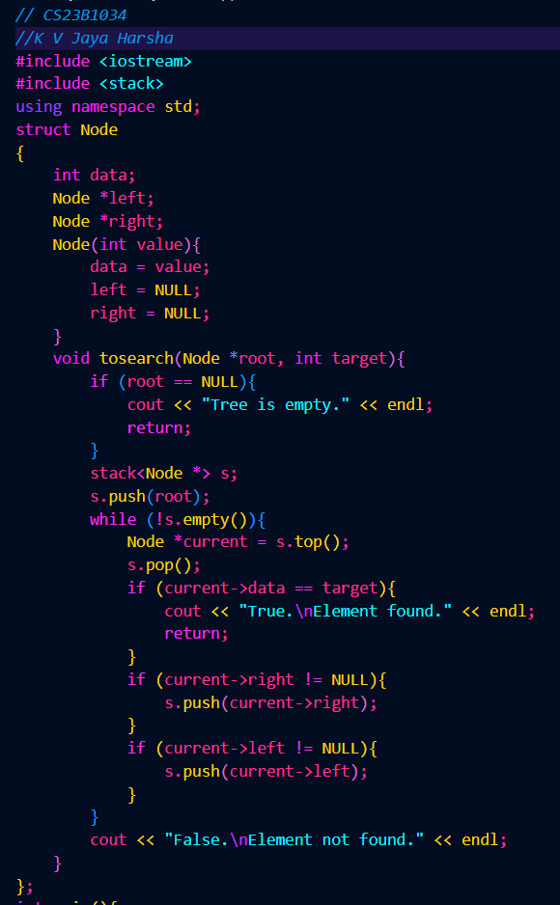

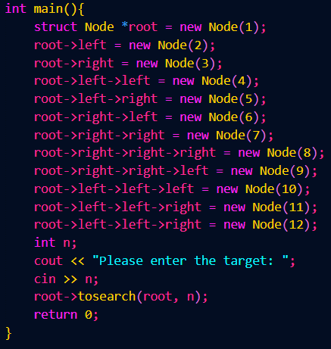

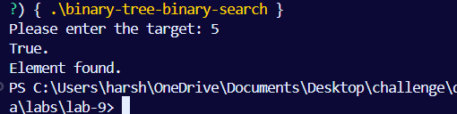

Q4. No of Node in tree (in cpp)

